Supplementary Materials
Table S1. Inflation-adjusted sepsis MS-DRG reimbursement values by hospital
 | MS-DRG 870ª | MS-DRG 871^{b} | MS-DRG 872^{c}
Hospital A | $53 956 | $14 471 | $7101
Hospital B | $65 877 | $15 898 | $7280
Hospital C | $87 235 | $21 095 | $10 733
Hospital D | $75 150 | $39 449 | $18 193
2021 data for the average Medicare payment for each MS-DRG by hospital were collected from the Centers for Medicare & Medicaid Services website (CMS data. https://data.cms.gov. Accessed 27 September 2025) and adjusted for a total inflation rate of 9.4% (3.03% annually) to reflect 2024 values.
ªSepticemia or severe sepsis with mechanical ventilation >96h.
^{b}Septicemia or severe sepsis without mechanical ventilation >96 h with a major complication or comorbidity.
^{c}Septicemia or severe sepsis without mechanical ventilation >96 h and without a major complication or comorbidity.
MS-DRG, Medicare Severity Diagnosis Related Group
Table S2. Demographics and outcome summary by current MS-DRG
 | MS-DRG 870  (n = 89) | MS-DRG 871  (n = 844) | MS-DRG 871  (n = 238) | Other MS-DRGs  (n = 3248) | p-value
Study data site, n (%) |  |  |  |  | <0.001
Hospital A | 37 (41.6) | 351 (41.6) | 108 (45.4) | 1100 (33.9)
Hospital B | 35 (39.3) | 329 (39.0) | 97 (40.8) | 1179 (36.3)
Hospital C | 1 (1.1) | 82 (9.7) | 22 (9.2) | 611 (18.8)
Hospital D | 16 (18.0) | 82 (9.7) | 11 (4.6) | 358 (11.0)
Age, years, median (IQR) | 65 (57, 76) | 72 (60, 83) | 67 (48, 78) | 67 (55, 78) | <0.001
Sex, n (%) |  |  |  |  | 0.004
Female | 31 (34.8) | 384 (45.5) | 132 (55.5) | 1596 (49.1)
Male | 58 (65.2) | 459 (54.4) | 106 (44.5) | 1652 (50.9)
Unknown / not recorded | 0 (0.0) | 1 (0.1) | 0 (0.0) | 0 (0.0)
Race, n (%) |  |  |  |  | 0.001
White | 62 (69.7) | 577 (68.4) | 164 (68.9) | 2141 (65.9)
Black or African American | 25 (28.1) | 215 (25.5) | 46 (19.3) | 832 (25.6)
Asian | 1 (1.1) | 11 (1.3) | 9 (3.8) | 71 (2.2)
American Indian or Alaska Native | 0 (0.0) | 2 (0.2) | 1 (0.4) | 5 (0.2)
Native Hawaiian or other Pacific Islander | 0 (0.0) | 1 (0.1) | 0 (0.0) | 0 (0.0)
Unknown / not recorded | 1 (1.1) | 14 (1.7) | 14 (5.9) | 68 (2.1)
Other | 0 (0.0) | 24 (2.8) | 4 (1.7) | 131 (4.0)
Ethnicity, n (%) |  |  |  |  | 0.18
Not Hispanic or Latino | 81 (91.0) | 807 (95.6) | 218 (91.6) | 3039 (93.6)
Hispanic or Latino | 4 (4.5) | 17 (2.0) | 9 (3.8) | 86 (2.6)
Unknown / not recorded | 4 (4.5) | 20 (2.4) | 11 (4.6) | 123 (3.8)
Inpatients, n (%) | 89 (100) | 839 (99.4) | 233 (97.9) | 3055 (94.1) | <0.001
Maximum SIRS value, median (IQR) | 4 (3, 4) | 3 (2, 4) | 2 (2, 3) | 2 (1, 3) | <0.001
COVID-19, n (%) | 17 (19.1) | 96 (11.4) | 2 (0.8) | 421 (13.0) | <0.001
Comorbidities, n (%)
Acute myocardial infarction | 17 (19.1) | 67 (7.9) | 1 (0.4) | 142 (4.4) | <0.001
AIDS | 0 | 2 (0.2) | 0 (0.0) | 14 (0.4) | 0.576
Cerebrovascular disease | 20 (22.5) | 90 (10.7) | 10 (4.2) | 381 (11.7) | <0.001
Congestive heart failure | 44 (49.4) | 307 (36.4) | 40 (16.8) | 949 (29.2) | <0.001
COPD | 28 (31.5) | 250 (29.6) | 50 (21.0) | 852 (26.2) | 0.029
Dementia | 17 (19.1) | 173 (20.5) | 18 (7.6) | 443 (13.6) | <0.001
Diabetes | 35 (39.3) | 211 (25.0) | 48 (20.2) | 787 (24.2) | 0.004
Diabetes with complications | 29 (32.6) | 176 (20.9) | 34 (14.3) | 780 (24.0) | <0.001
History of myocardial infarction | 8 (9.0) | 78 (9.2) | 15 (6.3) | 255 (7.9) | 0.411
Mild liver disease | 17 (19.1) | 81 (9.6) | 24 (10.1) | 354 (10.9) | 0.05
Moderate or severe liver disease | 8 (9.0) | 29 (3.4) | 2 (0.8) | 143 (4.4) | 0.004
Paralysis | 2 (2.2) | 28 (3.3) | 1 (0.4) | 163 (5.0) | 0.002
Peptic ulcer disease | 4 (4.5) | 19 (2.3) | 2 (0.8) | 69 (2.1) | 0.226
Peripheral vascular disease | 9 (10.1) | 126 (14.9) | 18 (7.6) | 396 (12.2) | 0.014
Renal disease | 41 (46.1) | 311 (36.8) | 62 (26.1) | 1102 (33.9) | 0.002
Rheumatologic disease | 7 (7.9) | 49 (5.8) | 11 (4.6) | 157 (4.8) | 0.412
Hospital length of stay, days, median (IQR) | 15.90 (10.28, 24.00) | 6.62 (4.14, 10.71) | 4.13 (2.85, 6.15) | 5.19 (3.15, 9.35) | <0.001
Died in hospital, n (%) | 40 (44.9) | 113 (13.4) | 0 | 21 | <0.001
ICU transfer, n (%) | 74 (83.1) | 352 (41.7) | 20 (8.4) | 802 (24.7) | <0.001
MV >96 h, n (%) | 89 (100) | 0 | 0 | 162 (5.0) | <0.001
MV (any amount of time), n (%) | 77 (86.5) | 75 (8.9) | 0 | 356 (11.0) | <0.001
Met Sepsis-2 criteria, n (%) | 86 (96.6) | 740 (87.7) | 165 (69.3) | 1643 (50.6) | <0.001
Met Sepsis-3 criteria, n (%) | 83 (93.3) | 607 (71.9) | 80 (33.6) | 1253 (38.6) | <0.001
Maximum sepsis ICD level, n (%) |  |  |  |  | <0.001
None | 0 | 5 (0.6) | 16 (6.7) | 2744 (84.5)
Sepsis | 20 (22.5) | 401 (47.5) | 184 (77.3) | 235 (7.2)
Septic shock | 55 (61.8) | 228 (27.0) | 0 | 174 (5.4)
Severe sepsis | 14 (15.7) | 210 (24.9) | 38 (16.0) | 95 (2.9)
Average Medicare payment amount received, USD, median (IQR) | $65 876.50 ($53 956.08, $65 876.50) | $15 898.19 ($14 471.04, $15 898.19) | $7280.36 ($7101.07, $7280.36) | $13 928.44 ($8774.56, $20 206.48) | <0.001
Sepsis ImmunoScore, median (IQR) | 0.76 (0.41, 0.87) | 0.61 (0.27, 0.83) | 0.23 (0.09, 0.53) | 0.23 (0.08, 0.55) | <0.001
Sepsis ImmunoScore risk category, n (%) |  |  |  |  | <0.001
Low | 7 (7.9) | 90 (10.7) | 80 (33.6) | 1099 (33.8)
Medium | 7 (7.9) | 141 (16.7) | 61 (25.6) | 780 (24.0)
High | 53 (59.6) | 462 (54.7) | 92 (38.7) | 1224 (37.7)
Very High | 22 (24.7) | 151 (17.9) | 5 (2.1) | 145 (4.5)
Sepsis eligible by Sepsis ImmunoScore, n (%) | 75 (84.3) | 613 (72.6) | 97 (40.8) | 1369 (42.1) | <0.001
AIDS, acquired immunodeficiency syndrome; COPD, Chronic Obstructive Pulmonary Disease; ICD, International Classification of Diseases; ICU, intensive care unit; IQR, interquartile range; MCC, major complication or comorbidity; MS-DRG, Medicare Severity Diagnosis Related Group; MV, mechanical ventilation; SIRS, systemic inflammatory response syndrome; USD, US dollars

Fig. S1. Sepsis MS-DRG overview
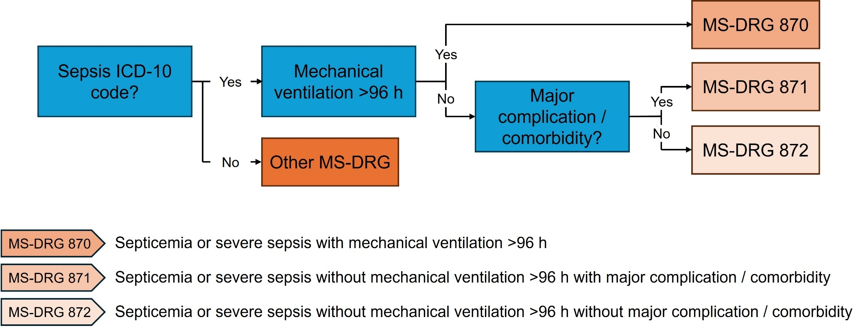

ICD, International Classification of Diseases; MS-DRG, Medicare Severity Diagnosis Related Group

