Supplementary Information

The environmental and health impacts of diets and dietary change in 5,500 cities worldwide

Table of Contents
SI.1 Supplementary information on city-level diets 2
SI.2 Supplementary information on city-level impact assessments 9
SI.3 Supplementary results 15
Supplementary references 30

SI.1 Supplementary information on city-level diets

SI Table 1. Overview of global food intake by food group and residence. The residences include urban, rural, and a population-weighted average (total). Food intake is expressed in grams per person per day (g/d) and in kilocalories per person per day (kcal/d). The analysis was conducted with country-level data.

SI Table 2. Overview of global energy intake by demographic group and residence. The demographic groups include age groups and sex, and the residences include urban, rural, and a population-weighted average (total). Energy intake is expressed in kilocalories per person per day (kcal/d). The analysis was conducted with country-level data.

SI Table 3. Number of cities (top), population of cities (middle), proportion of population in cities (bottom) by size class and geographic region. City sizes include cities with populations of 0.1-0.3 million, 0.3-1 million, 1-5 million, 5-10 million, and more than 10 million. The geographic regions include North America (NAC), Latin America and the Caribbean (LCN), Europe and Central Asia (ECS), the Middle East and North Africa (MEA), South Asia (SAS), East Asia and the Pacific (EAS), Sub-Saharan Africa (SSF), and a global average (WLD).
Number of cities
Population (million)
Population (proportion of total, %)

SI Table 4. Population sizes of cities over 10 million by country and region. Names of urban agglomerations were adopted from Global Urban Polygons and Points Dataset which sometimes denoted cities in several languages and combined several cities within the same urban agglomeration. When a city occurred more than once, it was appended by its (ISO3) country code and its population ranking within the country.

SI Table 5. Food intake (kilocalories per person per day, kcal/d) by residence, food group, and region. The residences include food intake across all cities and total intake across urban and rural residences. The geographic regions include North America (NAC), Latin America and the Caribbean (LCN), Europe and Central Asia (ECS), the Middle East and North Africa (MEA), South Asia (SAS), East Asia and the Pacific (EAS), Sub-Saharan Africa (SSF), and a global average (WLD).
SI Table 6. Reference values for healthy eating expressed as minimum and maximum targets for dietary intake (shown for adults).

SI Table 7. Food intake in cities in line with the planetary health diet by unit, food group, and region. The units include kilocalories per person per day (kcal/d) and grams per person per day (g/d). The geographic regions include North America (NAC), Latin America and the Caribbean (LCN), Europe and Central Asia (ECS), the Middle East and North Africa (MEA), South Asia (SAS), East Asia and the Pacific (EAS), Sub-Saharan Africa (SSF), and a global average (WLD).

SI.2 Supplementary information on city-level impact assessments

SI Table 8. Environmental footprints by food group and environmental domain. The analysis was based on country-specific footprints. The estimates of food demand was disaggregated to the same food-group detail based on food availability data from the FAO.

SI Figure 1. Contribution of mitigation measures to simultaneously reduce environmental impacts below environmental limits (planetary boundaries); adapted from Springmann and colleagues ¹ (Figure 4). The mitigation measures include dietary changes to flexitarian diets (FLX), technological improvements of medium (tech) and high ambition (tech+), halving of food loss and waste (w/2), and socioeconomic development with higher income growth and lower population growth (SSP1). The dietary contributions to mitigation in line with staying within planetary boundaries amounted to 70% for GHG emissions, 18% for land use, 19% for water use, 17% for nitrogen application, and 18% for phosphorus application. Normalised to sum to 100% and assigning the contributions of diet-related reduction in nitrogen and phosphorus application to eutrophication (which ecologically is related to both) resulted in weighing fractions of 46% for GHG emissions, 12% each for land use and water use, and 30% for eutrophication potential.

SI Table 9. Relative risk parameters (mean and low and high values of 95% confidence intervals) for dietary risks and weight-related risks ^{2–10}.

SI Table 10. Overview of existing ratings on the certainty of evidence for a statistically significant association between a risk factor and a disease endpoint. The ratings include those of the Nutrition and Chronic Diseases Expert Group (NutriCoDE)¹¹ , the World Cancer Research Fund¹² , and NutriGrade ^{2–4}.

SI Table 11. Theoretical minimal risk exposure levels for dietary risk factor in adults. A risk of disease is assumed to be present for intake below (fruits, vegetables, legumes, nuts and seeds, whole grains) or above (red meat, processed meat) these values ^{2,5–8,11,13}. For weight-related risks, the normal weight category is assumed to be risk neutral, whereas underweight, overweight, and obesity incur a risk of disease (see SI Table 9) ^{9,10}.

SI Table 12. Overview of healthcare-related costs (USD per case of death) in cities (global average) by cost component, and disease/cause of death. The analysis was conducted with city-specific values.

SI.3 Supplementary results

SI Table 13. Energy intake and differences to the average energy intake in all cities (kilocalories per person per day, kcal/d) in the ten lowest and highest consuming Chinese cities.

SI Figure 2. Diet-related impacts in Chinese cities, including calorie intake, environmental impacts, burden of diet-related disease, and health-related costs.
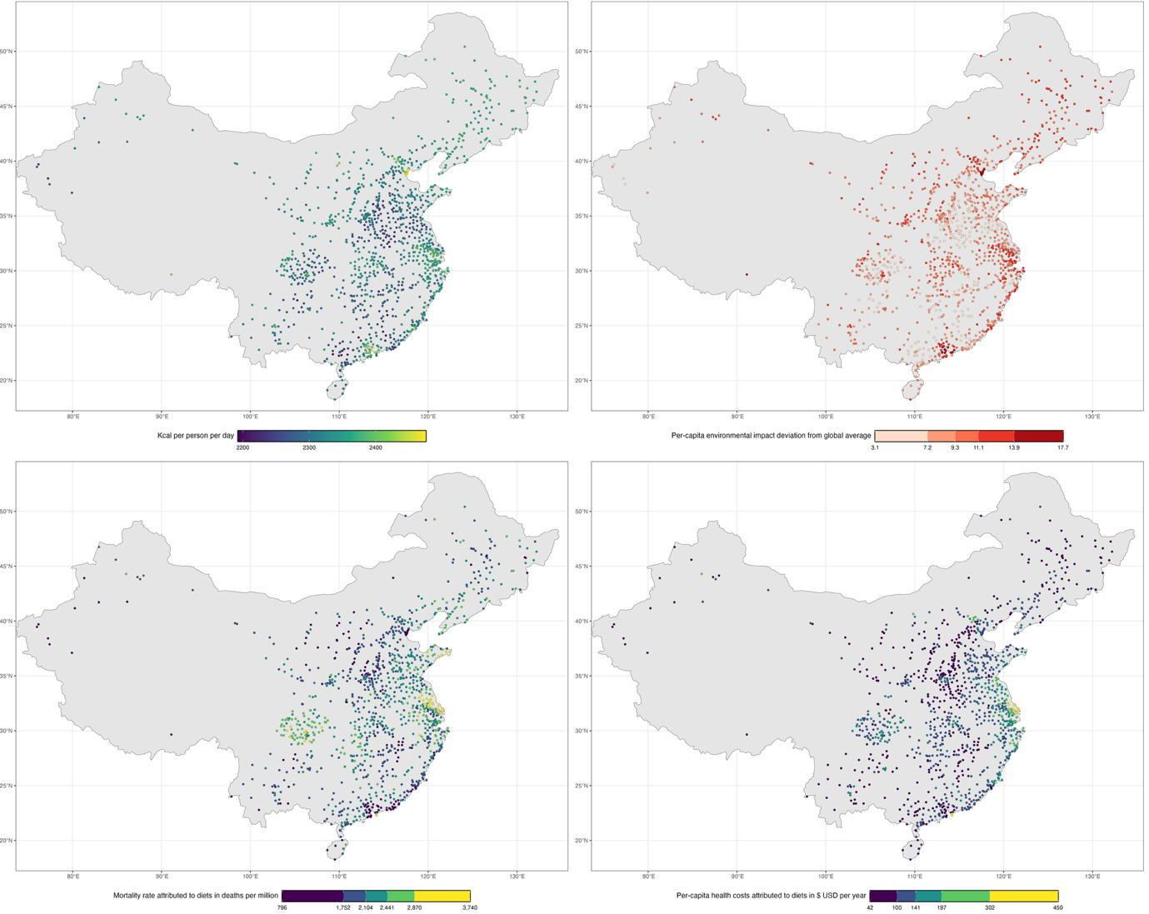

SI Table 14. Food-related environmental impacts by region, residence, food class, and environmental domain. The regions include North America (NAC), Latin America and the Caribbean (LCN), Europe and Central Asia (ECS), the Middle East and North Africa (MEA), South Asia (SAS), East Asia and the Pacific (EAS), Sub-Saharan Africa (SSF), and a global average (WLD). The residences include the sum across all cities and the total across urban and rural residences. The food class include animal-sourced foods (ASF), plant-based foods (PBF), and the total. The estimates for each environmental domain are provided as absolute values and as a proportion of the total.

SI Figure 3. Food-related environmental impacts per person by region, food group, and environmental domain.

SI Table 15. Cities with highest and lowest food-related environmental impacts per person. Impacts are provided as deviation from the globally averaged environmental impact per person in cities.

SI Table 16. Cities with highest and lowest food-related environmental impacts per person. Impacts are provided as deviation from the averaged environmental impact per person in cities of the same country.

SI Table 17. Deaths attributable to dietary risk factors in cities by risk factor, cause, and region. The estimates of attributable deaths are provided as absolute numbers for each risk factor and cause, and as a proportion of the regional total in percent. The causes include coronary heart disease (CHD), stroke, cancer, type-2 diabetes mellitus (T2DM), and respiratory disease (Resp Dis). The regions include North America (NAC), Latin America and the Caribbean (LCN), Europe and Central Asia (ECS), the Middle East and North Africa (MEA), South Asia (SAS), East Asia and the Pacific (EAS), Sub-Saharan Africa (SSF), and a global average (WLD).

SI Figure 4. Diet-related deaths per million people in cities by region and risk factor (top) and cause (bottom). The regions include North America (NAC), Latin America and the Caribbean (LCN), Europe and Central Asia (ECS), the Middle East and North Africa (MEA), South Asia (SAS), East Asia and the Pacific (EAS), Sub-Saharan Africa (SSF), and a global average (WLD).

SI Table 18. Cities with highest and lowest diet-related mortality rates per person in 2020.

SI Figure 5. Proportional contribution of city-level impacts to total impacts by region and impact category. The categories include population, environmental impacts, diet-related health impacts, and health-related costs.

SI Figure 6. Health-related costs in cities by region and cost item, including total costs (top) and costs per person (bottom). The estimates are expressed in US$ adjusted for purchasing power parity. The regions include North America (NAC), Latin America and the Caribbean (LCN), Europe and Central Asia (ECS), the Middle East and North Africa (MEA), South Asia (SAS), East Asia and the Pacific (EAS), Sub-Saharan Africa (SSF), and a global average (WLD).

SI Table 19. Cities with highest and lowest diet-related mortality rates per person in 2020.

SI Table 20. Changes in city-level impacts from dietary changes to planetary health diets by region and indicator. The changes include total changes (top), changes per person (middle), and percentage changes (bottom).

SI Figure 7. Proportional contribution of city-level impacts to total population and environmental impacts by region and food-system intervention. The interventions include a halving of food waste (less waste), dietary changes to planetary health diets (diet change), and their combination (diet & waste).

Supplementary references

1. Springmann, M. et al. Options for keeping the food system within environmental limits. Nature 562, 519–525 (2018).
2. Bechthold, A. et al. Food groups and risk of coronary heart disease, stroke and heart failure: A systematic review and dose-response meta-analysis of prospective studies. Critical Reviews in Food Science and Nutrition 59, 1071–1090 (2019).
3. Schwingshackl, L. et al. Food groups and risk of type 2 diabetes mellitus: a systematic review and meta-analysis of prospective studies. European Journal of Epidemiology 32, 363–375 (2017).
4. Schwingshackl, L. et al. Food groups and risk of colorectal cancer. International Journal of Cancer 142, 1748–1758 (2018).
5. Aune, D. et al. Fruit and vegetable intake and the risk of cardiovascular disease, total cancer and all-cause mortality—a systematic review and dose-response meta-analysis of prospective studies. International Journal of Epidemiology 46, 1029–1056 (2017).
6. Aune, D. et al. Whole grain consumption and risk of cardiovascular disease, cancer, and all cause and cause specific mortality: systematic review and dose-response meta-analysis of prospective studies. BMJ 353, (2016).
7. Aune, D. et al. Nut consumption and risk of cardiovascular disease, total cancer, all-cause and cause-specific mortality: a systematic review and dose-response meta-analysis of prospective studies. BMC Medicine 14, 207 (2016).
8. Afshin, A., Micha, R., Khatibzadeh, S. & Mozaffarian, D. Consumption of nuts and legumes and risk of incident ischemic heart disease, stroke, and diabetes: a systematic review and meta-analysis. The American Journal of Clinical Nutrition ajcn.076901 (2014).
9. Global BMI Mortality Collaboration et al. Body-mass index and all-cause mortality: individual-participant-data meta-analysis of 239 prospective studies in four continents. The Lancet 388, 776–86 (2016).
10. Prospective Studies Collaboration et al. Body-mass index and cause-specific mortality in 900 000 adults: collaborative analyses of 57 prospective studies. The Lancet 373, 1083–1096 (2009).
11. Micha, R. et al. Etiologic effects and optimal intakes of foods and nutrients for risk of cardiovascular diseases and diabetes: Systematic reviews and meta-analyses from the Nutrition and Chronic Diseases Expert Group (NutriCoDE). PLOS ONE 12, e0175149 (2017).
12. World Cancer Research Fund/American Institute for Cancer Research. Diet, Nutrition, Physical Activity and Cancer: A Global Perspective. Continuous Update Project Expert Report. (2018).
13. GBD 2017 Diet Collaborators et al. Health effects of dietary risks in 195 countries, 1990-2017: a systematic analysis for the Global Burden of Disease Study 2017. The Lancet 0, (2019).

