Supplementary table1. Tukey’s HSD grouping of treatments for alcohol content (% v/v).
Treatment | Alcohol (% v/v) | Tukey letter
T4 | 4.5 ± 0.04 | a
T1 | 4.2 ± 0.02 | a
T3 | 4.1 ± 0.04 | a
T2 | 2.6 ± 0.04 | b
T7 | 2.1 ± 0.08 | c
T5 | 2.0 ± 0.03 | c
T6 | 2.0 ± 0.07 | c
Values are expressed as mean ± standard deviation. Different letters within the same column indicate significant differences among treatments according to Tukey’s HSD test at p < 0.05.
Supplementary table 2. Tukey’s HSD grouping of treatments for final pH values.
Treatment | pHf | Tukey letter
T1 | 4.00 ± 0.01 | c
T7 | 4.06 ± 0.04 | c
T4 | 4.24 ± 0.04 | b
T3 | 4.27 ± 0.03 | b
T2 | 4.34 ± 0.03 | a
T5 | 4.36 ± 0.04 | a
T6 | 4.36 ± 0.04 | a
Values are expressed as mean ± standard deviation. Different letters within the same column indicate significant differences among treatments according to Tukey’s HSD test at p < 0.05.
Supplementary table 3. Tukey’s HSD grouping of treatments for final density (°P).
Treatment | Df (°P) | Tukey letter
T4 | 6.5 ± 0.08 | c
T1 | 7.1 ± 0.05 | c
T3 | 7.4 ± 0.08 | c
T2 | 10.1 ± 0.09 | b
T7 | 11.4 ± 0.17 | a
T5 | 11.5 ± 0.06 | a
T6 | 11.5 ± 0.14 | a
Values are expressed as mean ± standard deviation. Different letters within the same column indicate significant differences among treatments according to Tukey’s HSD test at p < 0.05.
Supplementary table 4. Tukey’s HSD grouping of treatments for residual sugars (RSf).
Treatment | RSf | Tukey letter
T5 | 37.8 ± 1.4 | c
T4 | 40.2 ± 1.5 | c
T1 | 42.6 ± 1.6 | c
T3 | 45.0 ± 1.7 | b
T2 | 60.0 ± 2.0 | a
T7 | 67.3 ± 1.14 | a
T6 | 69.0 ± 2.2 | a
Values are expressed as mean ± standard deviation. Different letters within the same column indicate significant differences among treatments according to Tukey’s HSD test at p < 0.05.
Supplementary table 5. Tukey’s HSD grouping of treatments for dissolved oxygen (ppm).
Treatment | O₂ (ppm) | Tukey letter
T1 | 0.10 ± 0.01 | c
T3 | 0.10 ± 0.01 | c
T4 | 0.10 ± 0.01 | c
T5 | 0.10 ± 0.01 | c
T6 | 0.12 ± 0.01 | b
T7 | 0.20 ± 0.01 | a
T2 | 0.40 ± 0.01 | a
Values are expressed as mean ± standard deviation. Different letters within the same column indicate significant differences among treatments according to Tukey’s HSD test at p < 0.05.
Supplementary table 6. Tukey’s HSD grouping of treatments for real extract.
Treatment | RE | Tukey letter
T4 | 7.9 ± 0.06 | c
T1 | 8.41 ± 0.04 | c
T3 | 8.77 ± 0.06 | c
T2 | 10.9 ± 0.07 | b
T7 | 11.9 ± 0.14 | a
T6 | 11.5 ± 0.14 | a
T5 | 12.0 ± 0.05 | a
Values are expressed as mean ± standard deviation. Different letters within the same column indicate significant differences among treatments according to Tukey’s HSD test at p < 0.05.
Supplementary table 7. Tukey’s HSD grouping of treatments for apparent attenuation (%).
Treatment | Att (%) | Tukey letter
T4 | 54.8 ± 0.52 | a
T1 | 51.4 ± 0.34 | a
T3 | 49.1 ± 0.55 | a
T2 | 29.0 ± 0.61 | b
T7 | 21.5 ± 1.15 | c
T5 | 20.7 ± 0.44 | c
T6 | 20.6 ± 0.99 | c
Values are expressed as mean ± standard deviation. Different letters within the same column indicate significant differences among treatments according to Tukey’s HSD test at p < 0.05.
Supplementary table 8. Gompertz Parameters
Treatment | Amax (% v/v) | mu_max | lag (h) | RÂ² | RMSE
T1 | 7.26 | 0.026 | 17.75 | 0.961 | 0.278
T2 | 4.75 | 0.01 | -23.67 | 0.851 | 0.254
T3 | 3.97 | 0.026 | -30.16 | 0.844 | 0.445
T4 | 5.27 | 0.026 | -4.18 | 0.97 | 0.246
T5 | 2.93 | 0.011 | -1.24 | 0.975 | 0.097
T6 | 2.77 | 0.011 | -0.15 | 0.975 | 0.094
T7 | 1.99 | 0.016 | -10.51 | 0.927 | 0.17

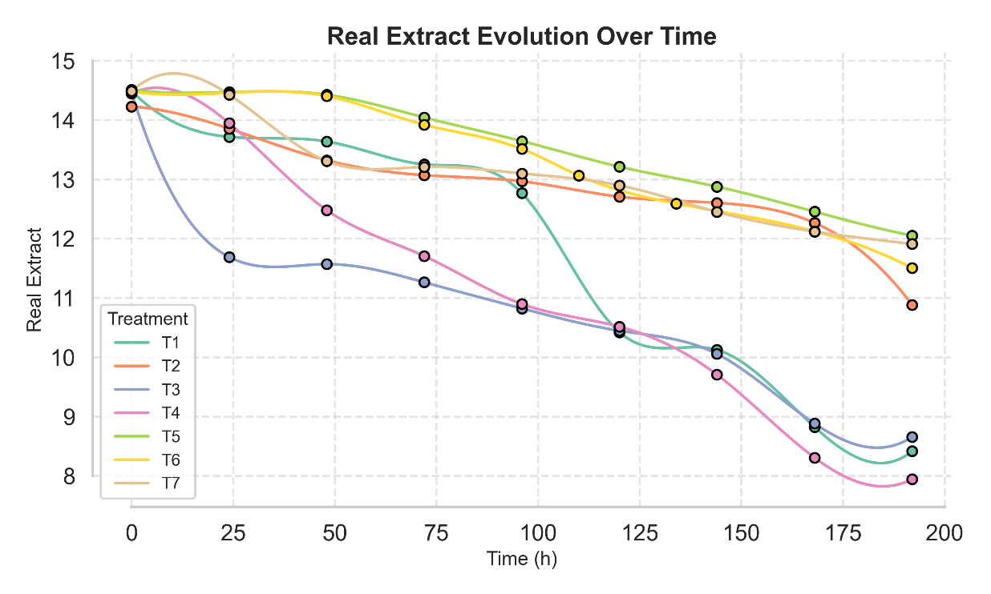
Supplementary figure 1. Evolution of Real Extract over Time
T1: corn amylases, T2: sweet potato amylases, T3: Munkoyo root amylases, T4: corn and sweet potato amylases, T5: corn and Munkoyo root amylases, T6: amylases from Munkoyo roots and sweet potatoes, T7: amylases from corn, Munkoyo roots, and sweet potatoes.
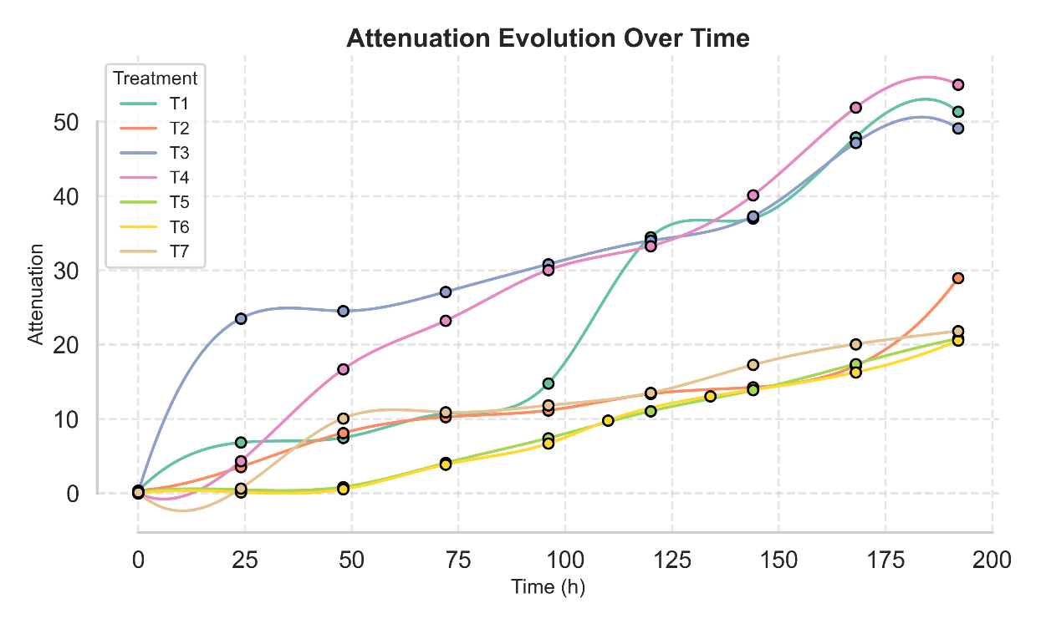
Supplementary figure 2. Evolution of Attenuation over Time
T1: corn amylases, T2: sweet potato amylases, T3: Munkoyo root amylases, T4: corn and sweet potato amylases, T5: corn and Munkoyo root amylases, T6: amylases from Munkoyo roots and sweet potatoes, T7: amylases from corn, Munkoyo roots, and sweet potatoes.
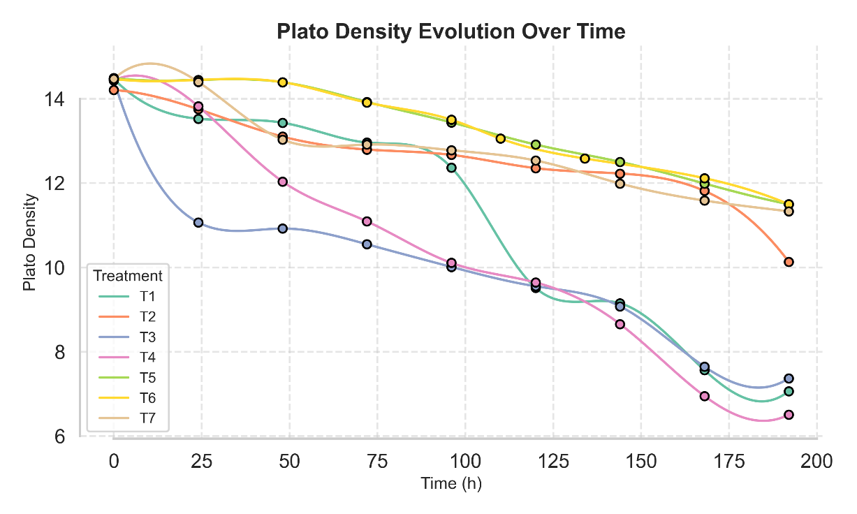
Supplementary figure 3. Evolution of Density (D °P) over Time
T1: corn amylases, T2: sweet potato amylases, T3: Munkoyo root amylases, T4: corn and sweet potato amylases, T5: corn and Munkoyo root amylases, T6: amylases from Munkoyo roots and sweet potatoes, T7: amylases from corn, Munkoyo roots, and sweet potatoes.

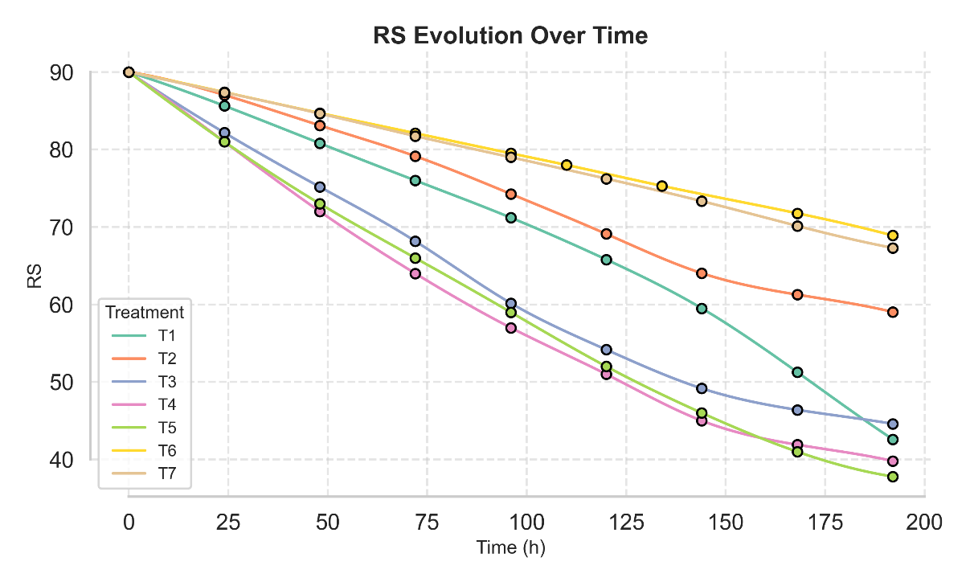
Supplementary figure 4. Evolution of Released sugars over Time
T1: corn amylases, T2: sweet potato amylases, T3: Munkoyo root amylases, T4: corn and sweet potato amylases, T5: corn and Munkoyo root amylases, T6: amylases from Munkoyo roots and sweet potatoes, T7: amylases from corn, Munkoyo roots, and sweet potatoes.
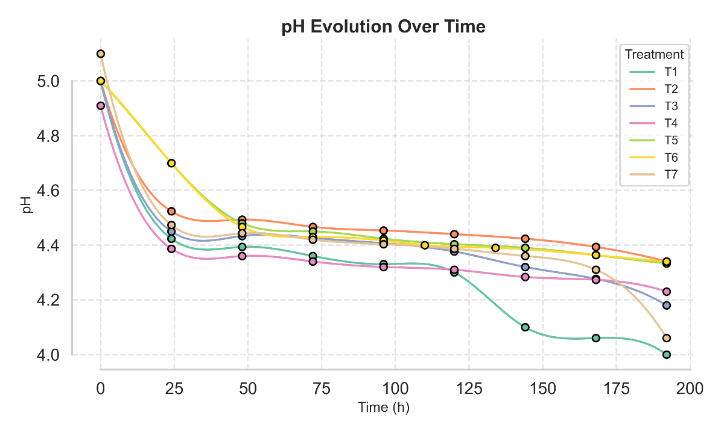
Supplementary figure 5. Evolution of pH over Time
T1: corn amylases, T2: sweet potato amylases, T3: Munkoyo root amylases, T4: corn and sweet potato amylases, T5: corn and Munkoyo root amylases, T6: amylases from Munkoyo roots and sweet potatoes, T7: amylases from corn, Munkoyo roots, and sweet potatoes.
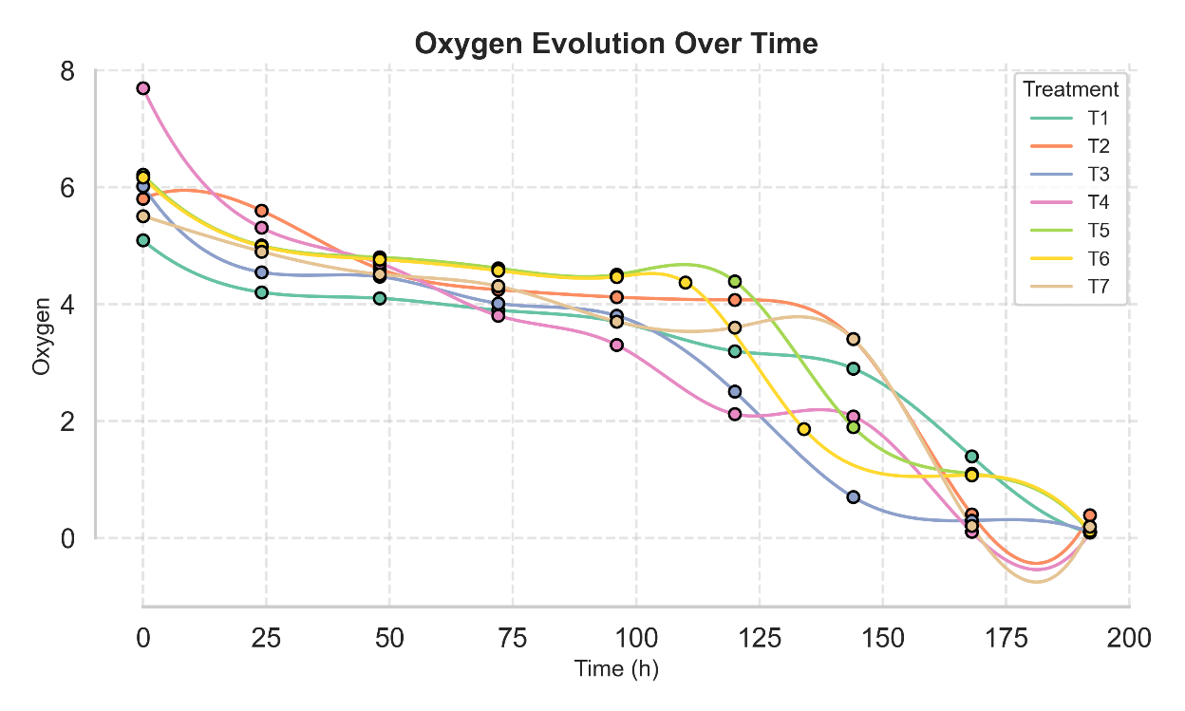
Supplementary figure 6. Evolution of Dissolved oxygen over Time
T1: corn amylases, T2: sweet potato amylases, T3: Munkoyo root amylases, T4: corn and sweet potato amylases, T5: corn and Munkoyo root amylases, T6: amylases from Munkoyo roots and sweet potatoes, T7: amylases from corn, Munkoyo roots, and sweet potatoes.

