Supplementary Materials

S1.0 Study Questionnaire
Tick [] the possible answer(s) that applies to the question(s) below
- Indicate your age group by ticking one box? [Less than 10 years] [10-20] [21-30] [31-40] [41-50] [51-60] [above 61]
- What is your gender? [Male] [Female]
- What is your highest level of Education [Primary] [Secondary] [Polytechnic] [University] [none of the above]
- Do you sell fish as a full time, part time or seasonal hustle? [Full time hustle] Part time hustle] [Seasonal hustle]
- What type of fish do you trade? [Sese] [Scumbian or titus] [meluza] [bonga fish] [crooker fish] [Others (specify)___________________________________]
- Did you directly participate in the smoking process for this fish? [Yes] [No]
- What material do you use for smoking of your fish? [wood smoke] [saw dust smoke] [charcoal] [Others (specify)___________________________________]
- When was this fish smoked or how long has it been since you smoked the fish? [today] [yesterday] [2 days ago] [3 days ago] [more than 3 days ago]
- Any preservative measures for the smoked fish when not completely sold for the day? [Yes] [No]
- How long have you been in the business of selling fish [1-2 years] [3-4 years] [5-6 years] [more than 6 years]
- To your knowledge, can smoke fish become contaminated with microorganisms or germs? [yes] [No]
- What material do you use to wrap the fish? [Paper] [cellophane] [both] [Others (specify)___________________________________]
- Do you cover the fish after smoking before you get to the market? [Yes] [No]
- If yes how often do you wash the covering material? [very often] [sometimes] [once in a while] [none at all] [Others (specify)___________________________________]
- When last did you wash this your covering material? [Today] [Yesterday] [2days ago] [Others (specify)___________________________________]
- What number of fish do you smoke in a batch for sale? [<100 fishes] [101-200 fish] [201-300] [>300 fish]
- Where do you obtain the materials for fish processing from? [purchase them] [sources for them locally]

S2.0 Enumeration of Staphylococcal Isolates

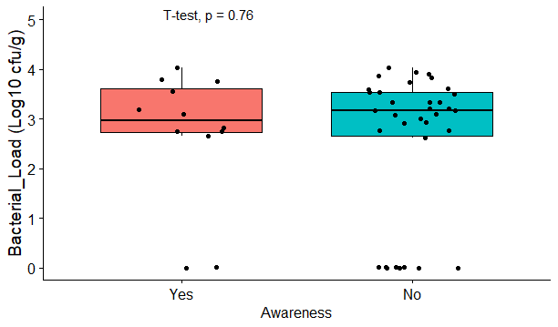
Figure S1. Coagulase-positive staphylococcal counts of smoked fish samples by vendor's knowledge about fish being a reservoir

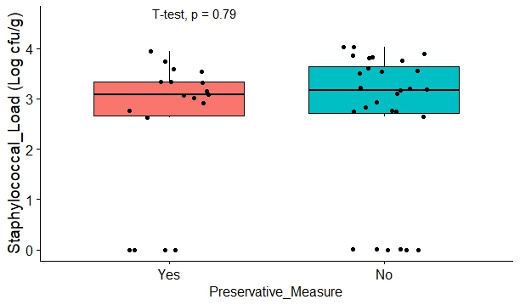
Figure S2. Coagulase-positive staphylococcal counts of smoked fish samples by vendor's use of preservative measure for smoking fish
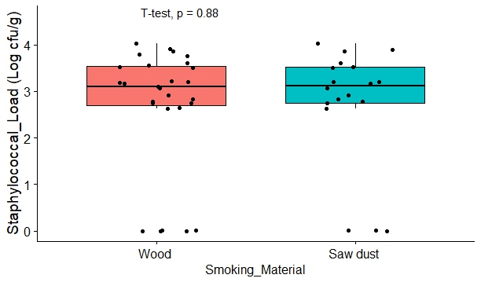
Figure S3. Coagulase-positive staphylococcal counts of smoked fish samples by the type of material used for smoking

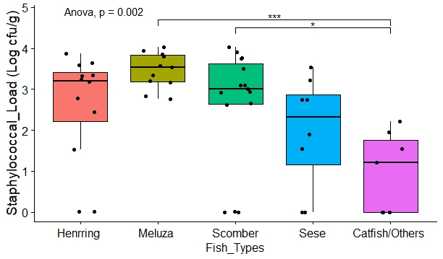
Figure S4. Coagulase-positive staphylococcal counts of smoked fish samples based on fish types

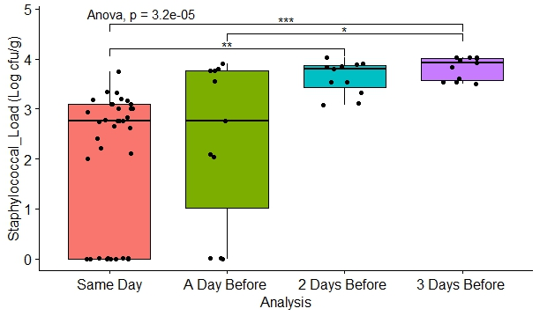
Figure S5. Coagulase-positive staphylococcal counts of smoked fish samples based on smoking duration before purchase

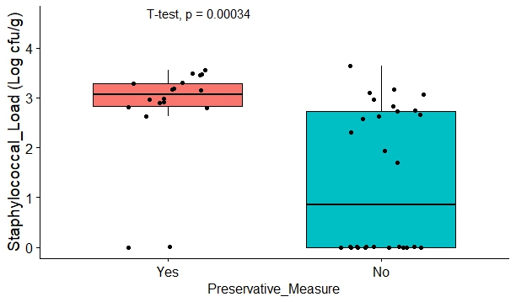
Figure S6. Coagulase-negative staphylococcal counts of smoked fish samples showing the use of any preservative measure for smoking fish
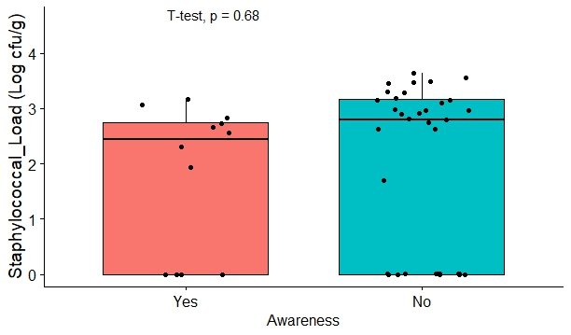
Figure S7. Coagulase-negative staphylococcal counts of smoked fish samples by vendor's awareness/knowledge about smoked fish being a reservoir.

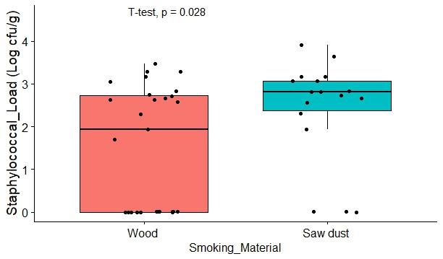
Figure S8. Coagulase-negative staphylococcal counts of smoked fish samples based on the type of material used for smoking
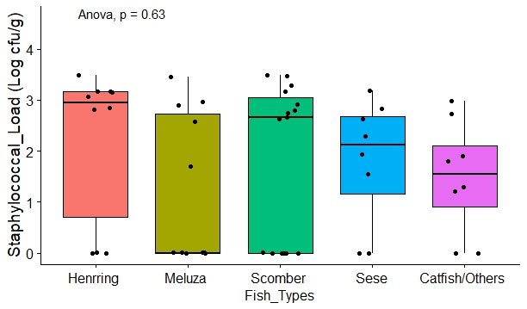
Figure S9. Coagulase-negative staphylococcal counts of smoked fish samples based on fish types

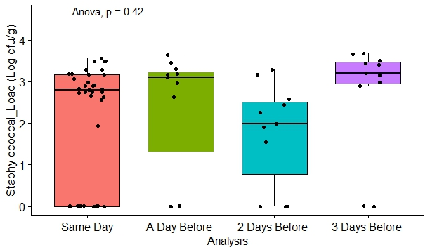
Figure S10. Coagulase-negative staphylococcal counts of smoked fish samples by the smoking duration before purchase

Figure S11. Staphylococcal comparative bar graph for fish type and storage time before analysis

