Supplementary materials
Part 1: Clinical characteristics of the TBI patient cohort
Table S1. Demographics and clinical characteristics of human brain tissues from acute traumatic brain injury and arteriovenous malformation.
Case | Age | Gender | Cause of Injury | Other injuries | Time Post-Injury(h) | Region of Surgery | GCS
Traumatic brain injury | 42 | Male | Traffic accident | None | 8 | Right temporal lobe | 5
Traumatic brain injury | 55 | Male | Traffic accident | None | 7 | Left frontal lobe | 4
Traumatic brain injury | 47 | Male | Traffic accident | None | 10 | Left temporal lobe | 3
Traumatic brain injury | 58 | Male | Traffic accident | None | 6 | Right parietal lobe | 5
Traumatic brain injury | 31 | Male | Traffic accident | None | 5 | Right temporal lobe | 4
Traumatic brain injury | 52 | Male | Traffic accident | None | 7 | Right parietal lobe | 6
Traumatic brain injury | 28 | Male | Assault | None | 9 | Right frontal lobe | 7
Traumatic brain injury | 31 | Male | Assault | None | 6 | Left temporal lobe | 5
Arteriovenous malformation | 24 | Male | - | None | None | Right parietal lobe | -
Arteriovenous malformation | 29 | Male | - | None | None | Left parietal lobe | -
Arteriovenous malformation | 25 | Male | - | None | None | Right temporal lobe | -
Arteriovenous malformation | 21 | Male | - | None | None | Left parietal lobe

Part 2: ELISA information
Table S2. ELISA kits used for quantitative analysis in this study
Analyte | Sample type | Manufacturer | Catalog No. | Species
cell-free DNA | Plasma | Invitrogen | P11496 | Human/ Mouse
MPO–DNA complexes | Plasma | Roche | 11774425001 | Human/ Mouse
H3cit | Plasma | Cayman Chemical | 501620 | Human
UCHL1 | Plasma | Elabscience | E-EL-H2377 | Human
NEFL | Plasma | Elabscience | E-EL-H6203 | Human
Fe²⁺ | Tissue | Elabscience | E-BC-K773-M | Human/ Mouse
MDA | Tissue | Elabscience | E-BC-K025-S | Human/ Mouse
H3cit | Plasma | Cayman Chemical | 501620 | Mouse
H3cit–DNA complexes | Plasma | Roche | 11774425001 | Mouse
MDA | Cells | Elabscience | E-BC-K028-M | Mouse
SOD | Tissue / Cells | Cayman Chemical | 706002 | Mouse
Fe²⁺ | Cells | Elabscience | E-BC-K881-M | Mouse

Part 3: Primary antibody information
Table S3：Primary antibody used for western blot in this study
Antibody | Source | Cat# | Vendor | Country | Dilution | MW (kDa)
Histone H3 | Rabbit | 9715 | CST | USA | 1:1000 | 17
PAD4 | Rabbit | ab96758 | Abcam | UK | 1:1000 | 74
H3Cit | Rabbit | ab5103 | Abcam | UK | 1:1000 | 17
MPO | Rabbit | ab208670 | Abcam | UK | 1:1000 | 89
ACSL4 | Rabbit | Ab155282 | Abcam | UK | 1:500 | 79
GPX4 | Rabbit | 52455 | CST | USA | 1:1000 | 22
4HNE | Rabbit | Ab46545 | CST | USA | 1:1000 | 65
pSTING | Rabbit | 72971 | CST | USA | 1:1000 | 41
STING | Rabbit | 13647 | CST | USA | 1:1000 | 35
pTBK1 | Rabbit | 5483 | CST | USA | 1:1000 | 84
TBK1 | Rabbit | 3504 | CST | USA | 1:1000 | 84
p-AMPK | Rabbit | ab32382 | Abcam | UK | 1:1000 | 65
AMPK | Rabbit | ab32047 | Abcam | UK | 1:1000 | 65
Nrf2 | Rabbit | ab76026 | Abcam | UK | 1:1000 | 110
HO-1 | Rabbit | ab52947 | Abcam | UK | 1:1000 | 32

Table S4：Primary antibody used for immunofluorescence in this study
Antibody | Source | Cat# | Vendor | Country | Dilution
H3Cit | Rabbit | ab5103 | Abcam | UK | 1:1000
MPO | Goat | AF3667 | R&D Systems | USA | 1:500
NeuN | Mouse | ab104224 | Abcam | UK | 1:1000
4HNE | Rabbit | Ab46545 | CST | USA | 1:1000
pSTING | Rabbit | 72971 | CST | USA | 1:1000
Nrf2 | Rabbit | ab76026 | Abcam | UK | 1:1000

Part 4: Supplementary figures
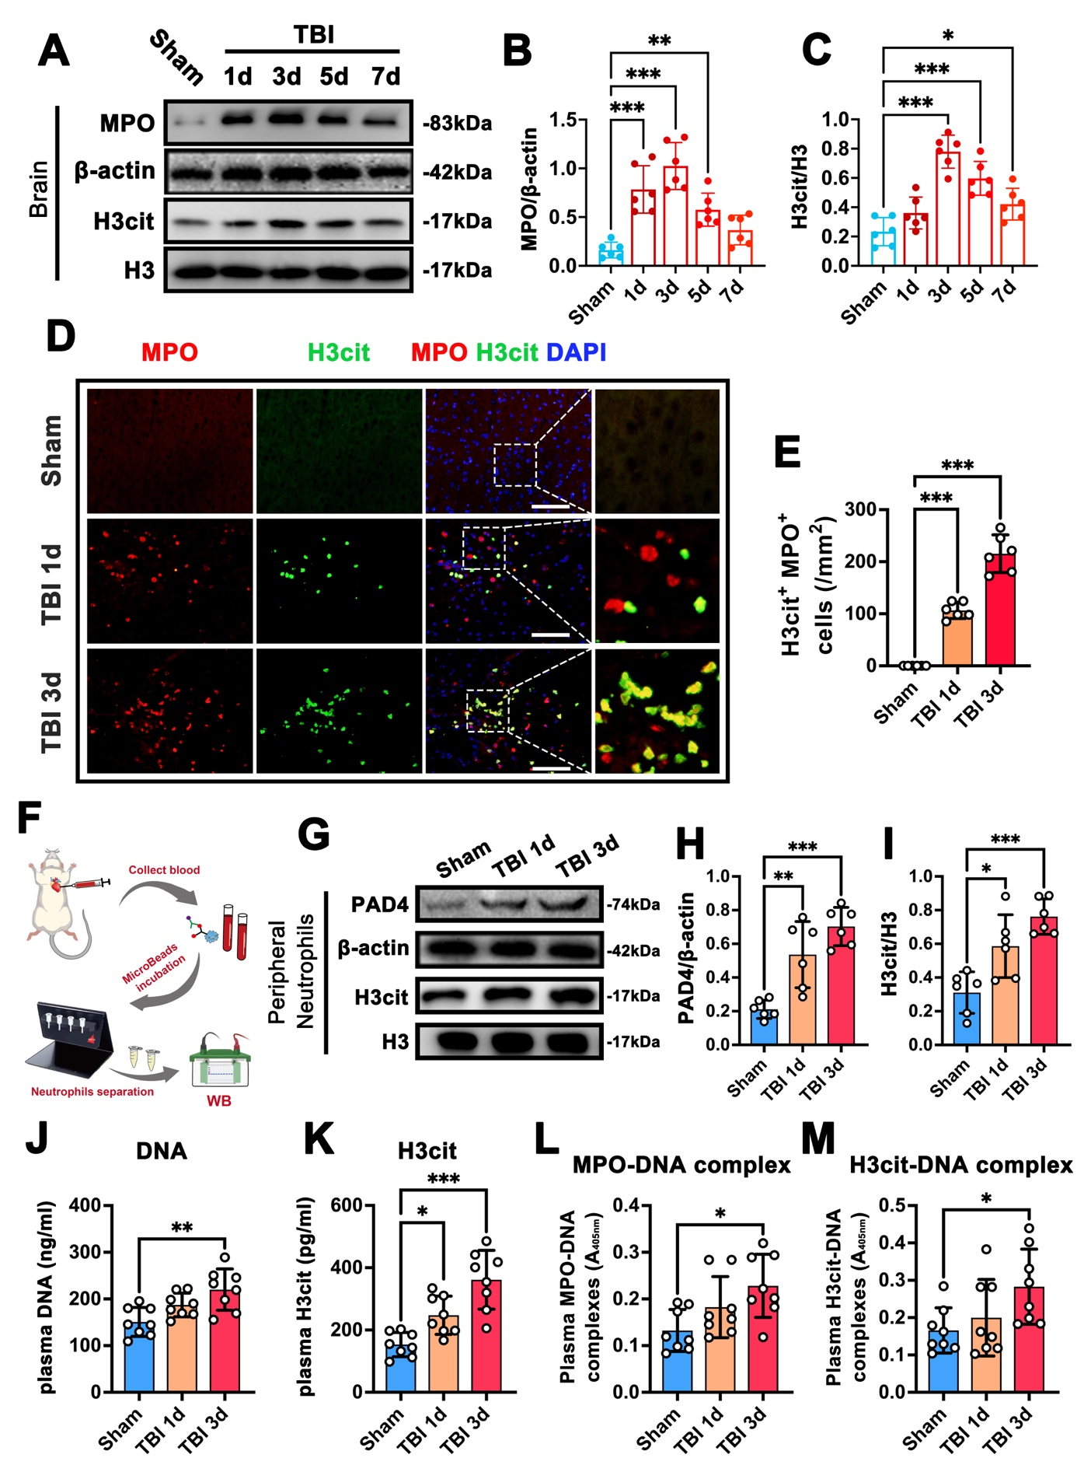
Figure S1. Traumatic brain injury induces robust NET formation in the injured brain and peripheral circulation in mice.

Figure S1. A Representative western blot images showing the temporal expression of myeloperoxidase (MPO) and citrullinated histone H3 (H3cit) in ipsilateral brain tissues from sham-operated mice and mice subjected to traumatic brain injury (TBI) at 1, 3, 5, and 7 days post-injury. β-actin and total histone H3 were used as loading controls. B, C Quantitative densitometric analyses of MPO (B) and H3cit normalized to total H3 (C) in brain tissues. **p < 0.01, ***p < 0.001, n = 6 per group. D Representative immunofluorescence images of MPO (red) and H3cit (green) staining in the peri-lesional cortex of sham and TBI mice at 1 and 3 days post-injury. Nuclei were counterstained with DAPI (blue). Insets show higher-magnification views of MPO⁺H3cit⁺ neutrophils indicative of NET formation. Scale bar = 50 μm. E Quantification of MPO⁺H3cit⁺ cells in the peri-lesional cortex. ***p < 0.001, n = 6 per group. F Schematic illustration of peripheral blood collection, neutrophil isolation, and subsequent western blot analysis. G Representative western blot images showing PAD4 and H3cit expression in peripheral neutrophils isolated from sham and TBI mice at 1 and 3 days post-injury. β-actin and total H3 served as loading controls. H, I Densitometric analyses of PAD4 (H) and H3cit normalized to total H3 (I) in peripheral neutrophils. **p < 0.01, ***p < 0.001, n = 6 per group. J–M Plasma levels of cell-free DNA (J), H3cit (K), MPO–DNA complexes (L), and H3cit–DNA complexes (M) measured by ELISA in sham and TBI mice at 1 and 3 days post-injury. *p < 0.05, **p < 0.01, ***p < 0.001, n = 8 per group.

