Supplementary Figure 1
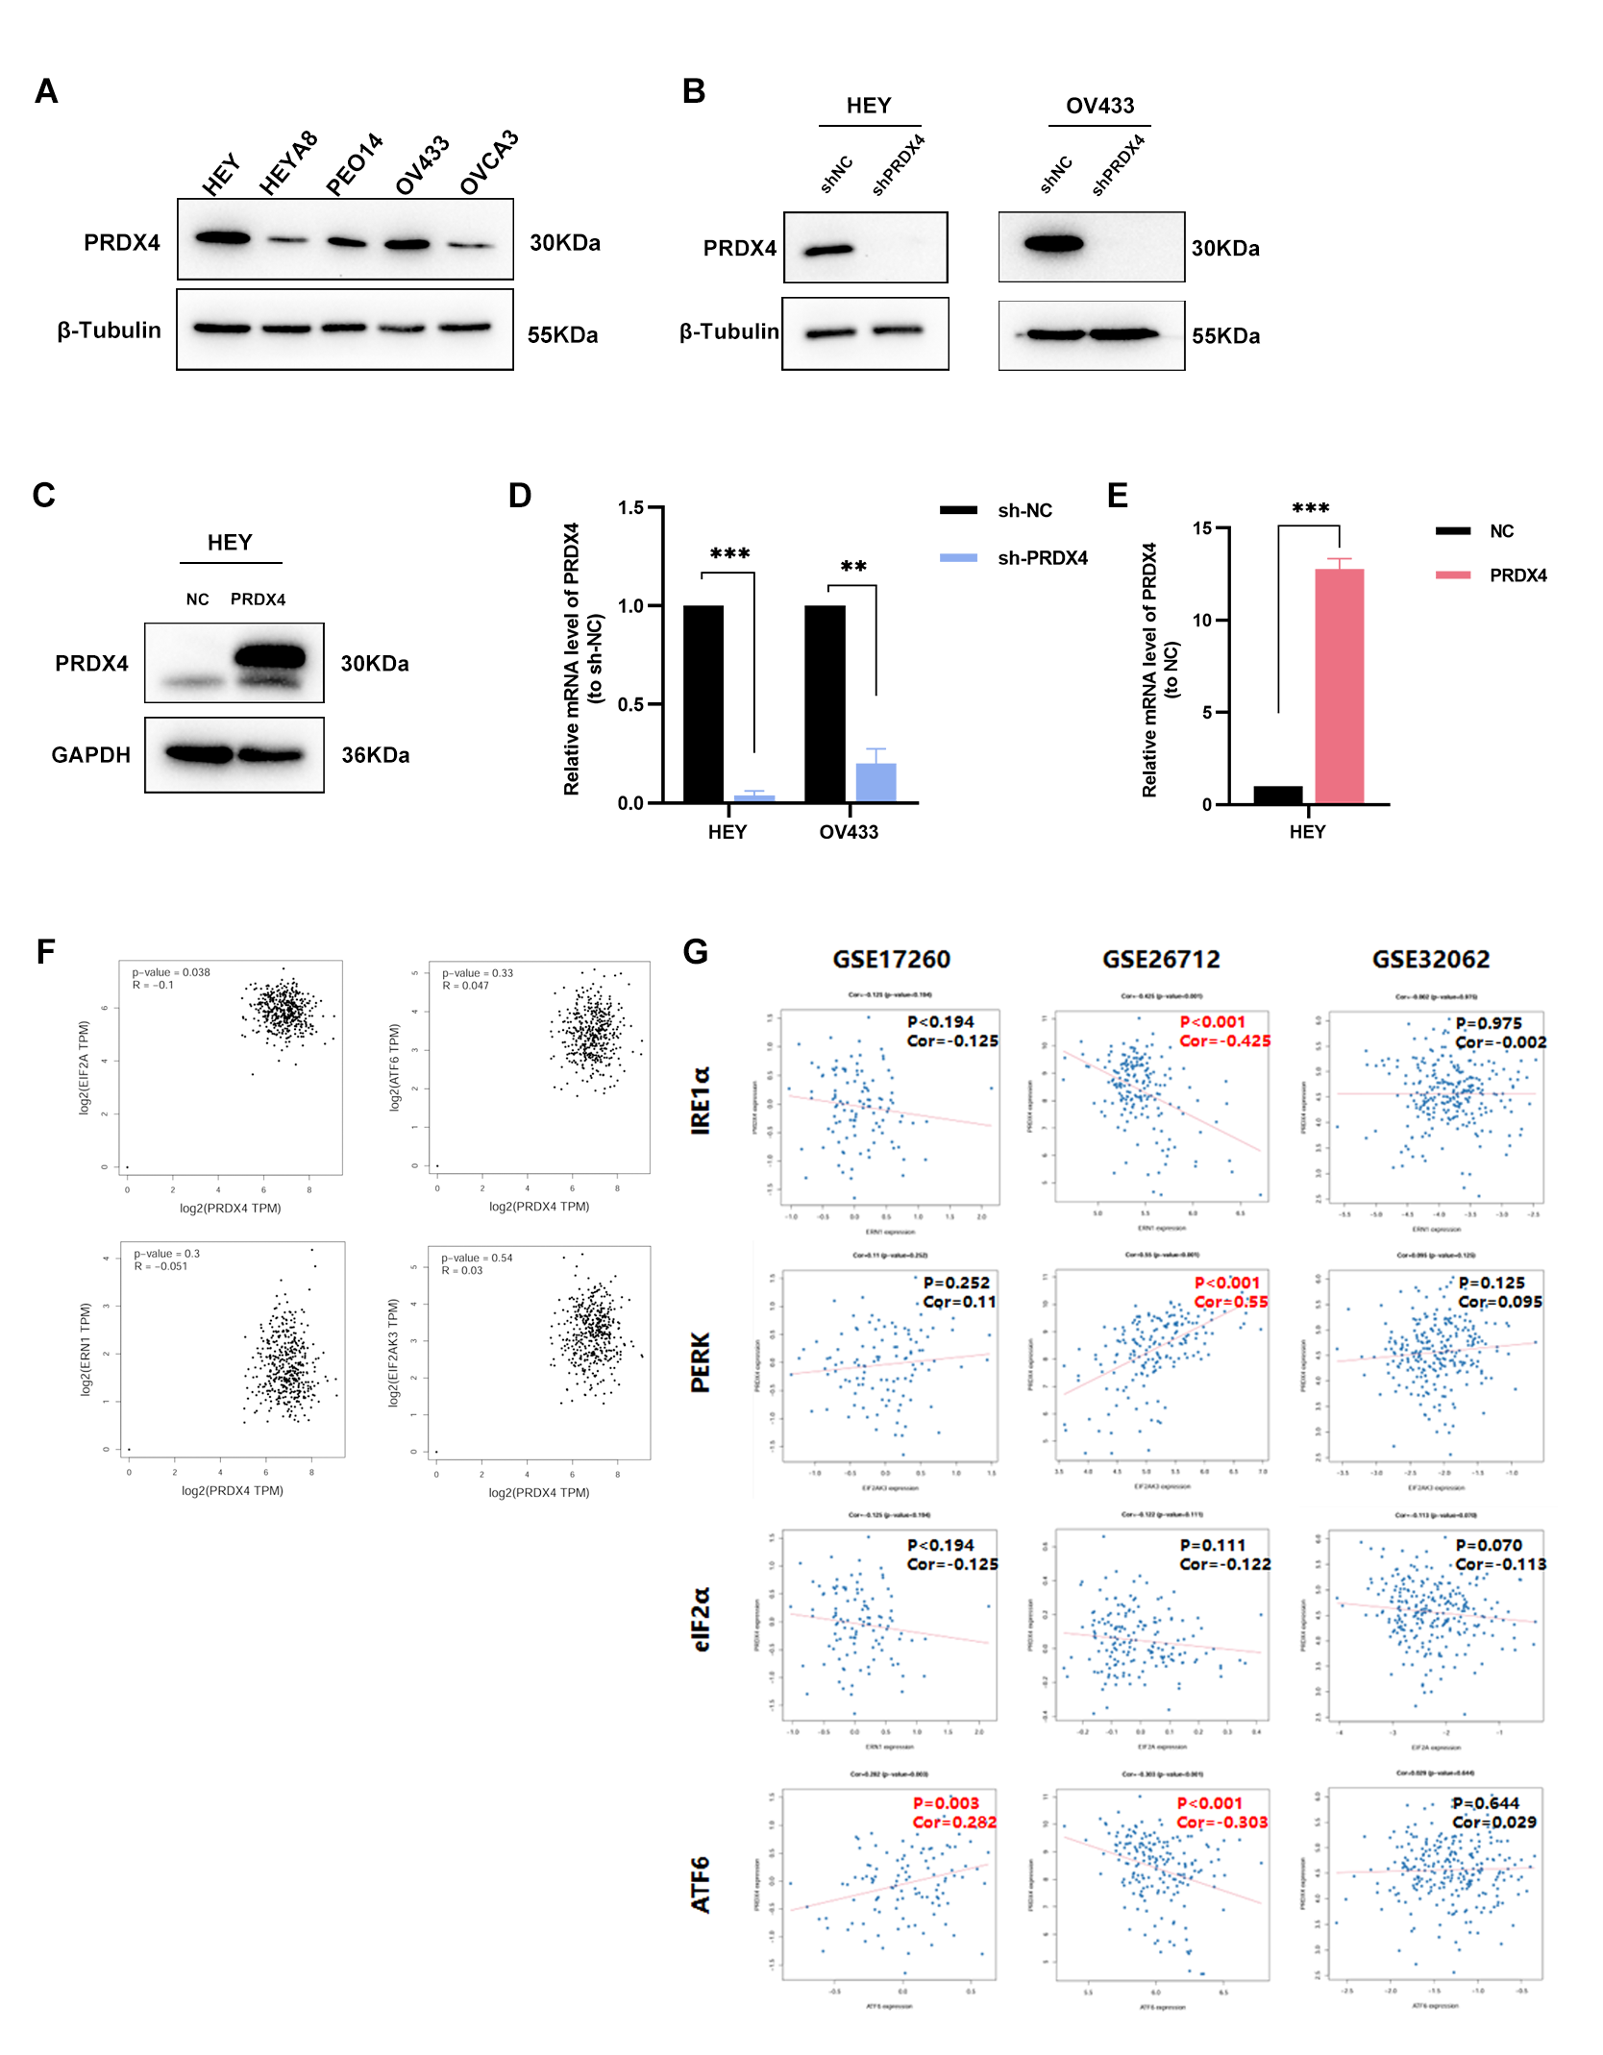
Fig. S1 A. The protein expression levels of PRDX4 in different serous ovarian cancer cell lines. B. The Western blot analysis of PRDX4 expression in HEY and OV433 cells following PRDX4 knockdown. C. The Western blot analysis of PRDX4 expression in HEY cells with PRDX4 overexpression. D. The relative PRDX4 mRNA expression in HEY and OV433 cells with PRDX4 knockdown, as assessed by qRT‑PCR. E. The relative PRDX4 mRNA expression in HEY cells with PRDX4 overexpression, as assessed by qRT-PCR. F. Correlation analysis of PRDX4 expression with PERK, EIF2α, IRE1α, and ATF6, utilizing TCGA ovarian cancer transcriptome data through the GEPIA platform G. Correlation analyses of PRDX4 expression with PERK, EIF2α, IRE1α, and ATF6 across three ovarian cancer transcriptome datasets (GSE17260, GSE26712, and GSE32062).

