Additional File 1. Reliability and validity of predictor and outcome variables.

Author | Reliability reported | If so, for predictor/ outcome | Type of reliability reported | Source of the outcome items | In case of 5, which adaptation? | Form of validity mentioned? (outcome) | Source of the predictor items | In case of 5, which adaptation ? | Form of validity mentioned? (predictor)
Amrein et al., 2021 | No | NA | NA | 5 | Adapted from a list of food categories | No | 5 | adapted from existing scales | Yes, construct validity via factor analysis
Anderson et al., 2020a | Yes | For one predictor | Internal consistency, both at person and at day level (lower than at person level) | 4 |  | No | 5/ 6 | content based on other scales, but the items themselves seem to be custom made for this study | No
Anderson et al., 2020b | Yes | For some predictors but not all | internal consistency at person and at day level | 4 |  | No | 5 | modified validated scales to reflect daily level | No
Ashurst et al., 2018 | no | NA | NA | 3 |  | Yes, Predictive validity at day level compared to dietary recall (regression analysis) done by Bruening et al | 0 |  | No
Berge et al., 2018 | no | NA | NA | 5 | which types of food served, with response options fast food, homemade or pre-prepared food. 'adapted from previous survey research questions', but no info on how it was adapted | No | 5 | adapted from a daily diary, no info on choices of items or nature of adaptation | No
Boh et al., 2016 | No | NA | NA | 0 |  | No | 4 |  | No
Carels et al., 2019 | Yes | Only predictor | Internal consistency for all predictors (but not outcome), unclear if this was on aggregated daily responses, or taking day by day into account | 0 |  | No | 5 | no info on how adaptation was done | No
Clancy et al., 2020 | No | NA | NA | 4 |  | No | 5 | adapted from a survey scale | No
Cnudde et al., 2024 | No | NA | NA | 5 | questions on food consumed, and then transformed into health indicator via UK Nutrient Profiling Model | No (refers to O'connor for validation, but while this showed interrater reliability in coding the healthiness of the diet, it does not measure validity) | 4 |  | No
Comulada et al., 2018 | No | NA | NA | 0 / 6 |  | No | 0 / 6 |  | No
Disabato et al., 2022 | Yes | Only predictor | Within and between person internal consistencies | 4 |  | No | 4 |  | No
Dunton et al.,2017 | No | NA | NA | 0 |  | No | 5 | No info | No
Elliston et al., 2017a | Yes | Only predictor | Internal consistency for all predictors (but not outcome), but it is not clear if this was on aggregated level, or taking moment into account | 4 |  | No (questionnable because the paper itself does not provide validation results) | 5 | six items from a non-EMA scale, no info on adaptation | No
Elliston et al., 2017b | No | NA | NA | 5 | self-classified food as either snack of main meal, with snack types based on Dietary Targets Monitor, and then classified into high or low energy content. The tool for snack types is intended for daily use rather than EMA use | No | 5 | six items from a non-EMA scale, no info on adaptation | No
Finkelstein-Fox et al., 2020 | No | NA | NA | 5 | based on Dietary Screener Questionnaire | No | 4 |  | No
Franja et al., 2021 | No | NA | NA | 5 | validated food composition tables for scores open ended question | No | 3 |  | No
Fredrickson et al., 2021 | Yes | Only predictor | internal consistency (omega) for between-person (higher) and within-person | 0 / 6 |  | No | 4 |  | No
Headrick et al., 2022 | Yes | Only predictor | internal consistency at each time point | 6 |  | No | 5 | 6 items from PANAS; self-efficacy and surface acting not adapted to reflect weekly assessment (general statements) | No
Hill et al., 2023 | No | NA | NA | 4 |  | No | 4 |  | No
Hochgraf et al., 2024 | No | NA | NA | 5 | questions on what the meal consisted of was scored using the Healthy Eating Index | No | 5 | existing validated scales for stress, but not validated in EMA format | No
Inauen et al., 2016 | No | NA | NA | 5 | nine non-core foods adapted; they received the list prior to the survey and were then asked to reflect on whether they had snacked of not, and then to indicate which healthy or unhealthy snack they had eaten + the amount (list of foods adapted from a non-EMA survey, no info on how adaptation was done) | No | 5 | non-validated, non EMA scales (reduced from 2-3 to 1 item) | No
Jeffers et al., 2019 | Yes | predictor and outcome | predictor: internal consistency (unclear how calculated across days); outcome: interrater reliability for coding open-ended answers to food types | 4 |  | No | 5 | selection from PANAS scale | No
Jones et al., 2007 | Yes | predictor and outcome | interrater reliability (other study) was mentioned for outcome; internal consistency (other study) for predictor of affect | 5 | validated food composition tables for scores open ended question | No | 5 | shortened version of PANAS | Yes, construct validity via factor analysis
Jones et al., 2022 | Yes | Only predictor | within and between person internal consistencies | 0 / 6 |  | No | 6 |  | No
Jones et al., 2024 | No | NA | NA | 0 |  | No | 0 |  | No
Kilb et al., 2023 | No | NA | NA | 0 / 6 | two items, no source provided | No | 5 | adapted from the baseline questionnaire | No
Kos et al., 1997 | No | NA | NA | 0 |  | No | 0 |  | No
Li et al., 2019 | Yes | predictor and outcome | internal consistency for both predictor and outcome | 6 |  | No | 5 | daily' for short form perceived stress scale; and daily self-compassion included highest loading items based on a factor analysis | No
Liao et al., 2018 | Yes | Only predictor | internal consistency | 2 |  | No | 2 |  | No
Lin et al., 2021 | No | NA | NA | 5 | adapted from Dietary Screener Questionnaire | No | 5 /2 | based on three different scales / own pilot test | No
Mason et al., 2019 | No | NA |  | 3 |  | Yes, criterion validity; with 24-hour recall as gold standard | 5 | one item from perceived stress scale | No
Masterton et al., 2023 | Yes | Only outcome | interrater reliability for coding as healthy or unhealthy | 5 | open-ended question + image, scored with UK nutrient profiling model | No | 5 | other sources are provided as similar approaches | No
Meule et al., 2019 | Yes | Only predictor | internal consistency | 6 |  | No | 5 | adapted from validated surveys on cravings, unclear how adaptation was done | No
Moore et al., 2022 | Yes | Only predictor | internal consistency | 5 | 16 items from the National Health Interview survey, adapted to daily level | No | 5 | Unclear | Yes, convergent and criterion validity
Moss et al., 2021 | Yes | Only outcome | interrater reliability for coding as healthy or unhealthy | 5 | open-ended question + scores with food composition tables | No | 2 |  | Yes, concurrent validity
O’Connor et al., 2015 | Yes | Only outcome | interrater reliability of coding food | 5 | validated food composition tables for scores open ended question | No | 4 |  | No
O’Connor et al., 2009 | Yes | Some outcomes; predictor | interrater reliability of coding food (other study); interrater reliability (own data). predictor hassles also interrater reliability | 5 | validated food composition tables for scores open ended question | No | 4 |  | No
Papadakis et al., 2021 | No | NA | NA | 5 | validated food composition tables for scores open ended question | No | 6 |  | Yes, construct validity via factor analysis
Powell et al., 2017 | No | NA | NA | 6 |  | No | 5 | go/no go task, which could be considered momentary measurement? | Yes, concurrent validity
Richard et al., 2019 | No | NA | NA | 0 / 6 |  | No | 0 / 6 |  | No
Riley et al., 2019 | Yes | Only predictor | internal consistency (averages across daily measures) | 5 | modified version of the dietary screener questionnaire, to inquire for daily intake | The paper mentions the questionnaire has reasonable validity but does not cite a validation study (the paper cited does not report validity) | 5 | scales for rumination, impulsivity and amotivation were adapted from a different timeframe to ask about daily levels | Yes, construct validity via factor analysis
Riley et al., 2022 | No | NA | NA | 5 | modified to pertain to daily intake' | No | 5 | modified to reflect daily experience (past 24h) | No
Roefs et al., 2019 | No | NA | NA | 0 / 6 |  | No | 0 / 6 |  | No
Schultchen et al., 2019 | No | NA | NA | 6 |  | No | 5 /6 | adapted from Perceived stress scale (two items selected); and 12 emotions, no reference provided | No
Skoyen et al., 2013 | No | NA | NA | 6 |  | No | 6 |  | No
Small et al., 2013 | No | NA | NA | 5 | adapted items from the Youth Risk Behaviour Survey, 'report on prvious day', no info on adaptation | No | 6 |  | No
Wen et al., 2022 | Yes | Only predictor | within and between person internal consistencies | 5 | 6 items from the Adolescent Health Promotion scale | No | 5 | modified from the presence subscale | No
Zenk et al., 2014 | No | NA | NA | 5 | categories for food adapted from the dietary screener questionnaire based on focus groups with target population |  | 4; 5 | PA-NA selection from PANAS; SE one item derived from Hekler | No
Zhong et al., 2024 | Yes | some predictors but not all | internal consistency, level of consistency for the averages of one day, not sure if this was then the alpha for day 1 | 0 |  | No | 4 & 5 | reduced number of items | Yes, construct validity via confirmatory factor analysis
Legend for source of items : 0) no info; 1) pilot study with experts; 2) pilot study with users; 3) validated as EMA; 4) from non-validated EMA scales; 5) adapted from non-EMA scales; 6) self-constructed

Additional file 2. Adherence

Author | Compliance reported as % meeting end of data collection phase | Compliance reported as number of prompts answered (Yes/No/unclear) | Compliance reported as number of prompts completed (Yes/No/unclear) | Cut-off used for consideration as completed prompt (Yes/No) | Disabling of prompt after a certain time (Yes/No/unclear) | Backfilling reported (if no deactivation) | Reactivity on outcomes reported (Yes/No)
Amrein et al., 2021 | No | No | No | No | No | No | No
Anderson et al., 2020a | Yes, 73.08% | No | Yes, 84% | No | Unclear | No | No
Anderson et al., 2020b | Yes, 73.08% | No | No | Yes, excluded if less than 7 usable daily surveys (21%) | Unclear | No | No
Ashurst et al., 2018 | No | No | Yes, 60.3% | NR | Unclear (closed after 30 minutes but unclear whether retrospective reporting was still possible) | Yes, 53% after retrospective assessment excluded | No
Berge et al., 2018 | Yes, 100% | No | No | NA | Unclear | Unclear | No
Boh et al., 2016 | No | No | Yes, between 80.91% and 79.73% | NR | Unclear | Unclear | No
Carels et al., 2019 | No | No | Yes, 93% | NR | Unclear | Yes, cluster entering was examined and none was observed (0%) | No
Clancy et al., 2020 | No | No | Yes, 91% | Yes, have at least 4 usable diaries (83%) | No | No | No
Cnudde et al., 2024 | No | No | Yes, 71.4% | Yes, excluded if completed less than 33% | Yes | NA | No
Comulada et al., 2018 | No | No | Yes, 32% | Yes, included if 'majority' of possible diaries were filled out | No | No | No
Disabato et al., 2022 | Yes, 81.64% | Yes, 79% | No | Yes, less than 2 standard deviations below mean compliance was used as inclusion for participants | Unclear | No | No
Dunton et al.,2017 | Yes, 89.01% | Yes, 78.50% | No | Y, if less than 70% complete, they are asked to redo the wave | Yes (after 3*3 minutes) | NA | No
Elliston et al., 2017a | No | Yes, 95.29% | No | Yes, if 50% answered | Unclear | Unclear | No
Elliston et al., 2017b | No | Yes, 100% | No | Yes, excluded if compliance below 50% | Unclear | No | No
Finkelstein-Fox et al., 2020 | Yes, 89.69% | No | Yes, 89.2% | No | No | Yes, mentioned carefully inspecting for backfilling, but no figures reported | Yes, 4% decrease in comfort foods eaten over the course of the study
Franja et al., 2021 | No | No | No | No | Unclear | No | No
Fredrickson et al., 2021 | Yes, 93.94% | No | No | No | No | No | No
Headrick et al., 2022 | Yes, 65% | No | No | No | Unclear | No | No
Hill et al., 2023 | No | No | No | No | Unclear | Yes, 2.9% backfilling | No
Hochgraf et al., 2024 | No | No | Yes, 99.6% | No | No | No | No
Inauen et al., 2016 | No | No | No | No | Unclear | No | No
Jeffers et al., 2019 | No | Yes, 85% | Yes, 85.6% | No | Yes (after 30 minutes) | Yes, 2.6% backfilling | No
Jones et al., 2007 | No | No | No | No | Unclear | No | No
Jones et al., 2022 | No | No | Yes, 92% | No | No | No | No
Jones et al., 2024 | No | No | Yes, 68% | No | Unclear | No | No
Kilb et al., 2023 | Yes, 85.42% | No | No | No | Unclear | No | No
Kos et al., 1997 | No | No | No | No | Unclear | No | No
Li et al., 2019 | Yes, 92.13% | No | No | No | Unclear | No | No
Liao et al., 2018 | Yes, 97.52% | Yes, 81% | No | No | Unclear | No | No
Lin et al., 2021 | Yes, 94.59% | No | No | No | Yes (1 hour) | No | No
Mason et al., 2019 | No | Yes, 79.3% | No | No | Yes (10 minutes) | NA | No
Masterton et al., 2023 | Yes, 98.00% | No | Yes, 81% | Yes, excluded if less than. 50% of assessment filled out | No | No, approach to reduce backfilling reported: instructed not to + checked in data, in which case only the first was retained | No
Meule et al., 2019 | No | No | Yes, 86% | No | Unclear | No | No
Moore et al., 2022 | No | No | No | No | No | No | No
Moss et al., 2021 | Yes, 96.15% | No | No | No | No | Y (after 3 AM, 11/192 cases were removed) | No
O’Connor et al., 2015 | Yes, 96.80% | No | Yes, 75% | No | Unclear | No, procedures against backfilling were reported but no rates (could not be filled out after 2 AM) | No
O’Connor et al., 2009 | Yes, 99.50% | No | Yes, 90.6% | Yes, threshold of 90% complete | Unclear | Unclear | No
Papadakis et al., 2021 | No | No | Yes, 85.4% | Yes, included if at least two days of reporting | No | No | No
Powell et al., 2017 | Yes, 94.12% | No | No | No | Unclear | No | No
Richard et al., 2019 | Yes, 84.62% | Yes, 90.7% | No | No | Unclear | No | Yes, level not reported, only mentioned reactivity was assessed without further info on how or on results
Riley et al., 2019 | Yes, 100% | Yes, 97% | Yes, 88.3% | No | Unclear | No | No
Riley et al., 2022 | Yes, 100% | No | Yes, 84.6% | No | No | No | No
Roefs et al., 2019 | Yes, 90.09% | No | Yes, 81.4% | Y, excluded when less than 10% compliant with EMA protocol | Unclear | No | No
Schultchen et al., 2019 | Yes, 91.07% | No | Yes, 84.2% | Yes, participants were excluded if compliance was below 50% | Yes (60 minutes) | NA | Y, average of 20,7 on a 0-100 scale for self-reported reactivity
Skoyen et al., 2013 | No | No | Yes, 23% | No | Unclear | No | No
Small et al., 2013 | No | No | Yes, 86% | Yes, included if at least 12/14 surveys | Unclear | No | No
Wen et al., 2022 | Yes, 93.39% | No | Yes, 96.2% | Yes, excluded if completing less than half of the assessment days | No | No | No
Zenk et al., 2014 | No | No | No | No | Yes (1 hour) | NA | No
Zhong et al., 2024 | No | No | No | Yes, excluded if less than 70% completed prompts | Unclear | No | No
Legend: NR: not reported; NA: not applicable

Additional file 3. Funnel plots

Funnel plot for the meta-analysis on healthy eating behaviours and negative triggers (standardized coefficients).
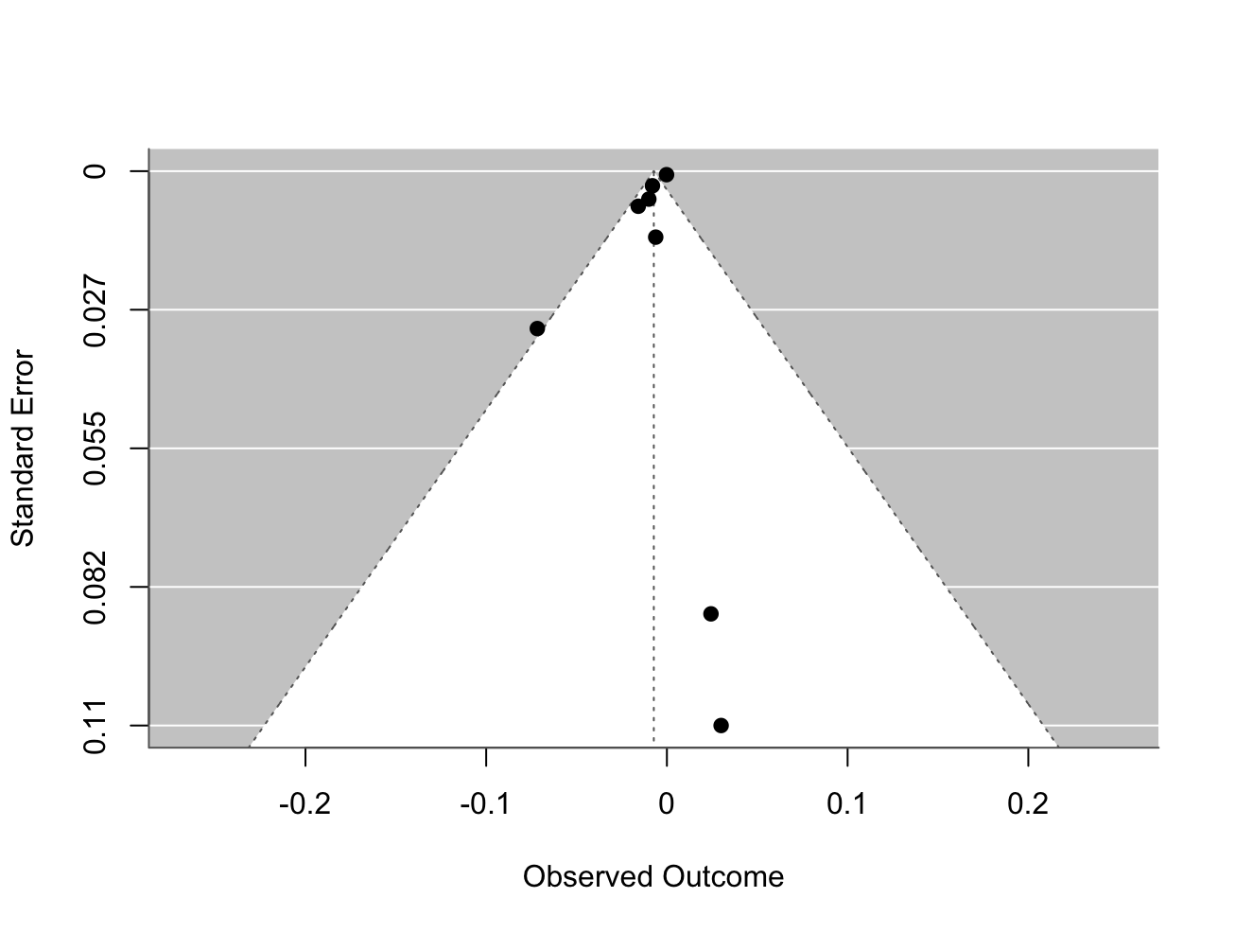

Funnel plot for the meta-analysis on unhealthy eating behaviours and negative triggers (standardized coefficients).

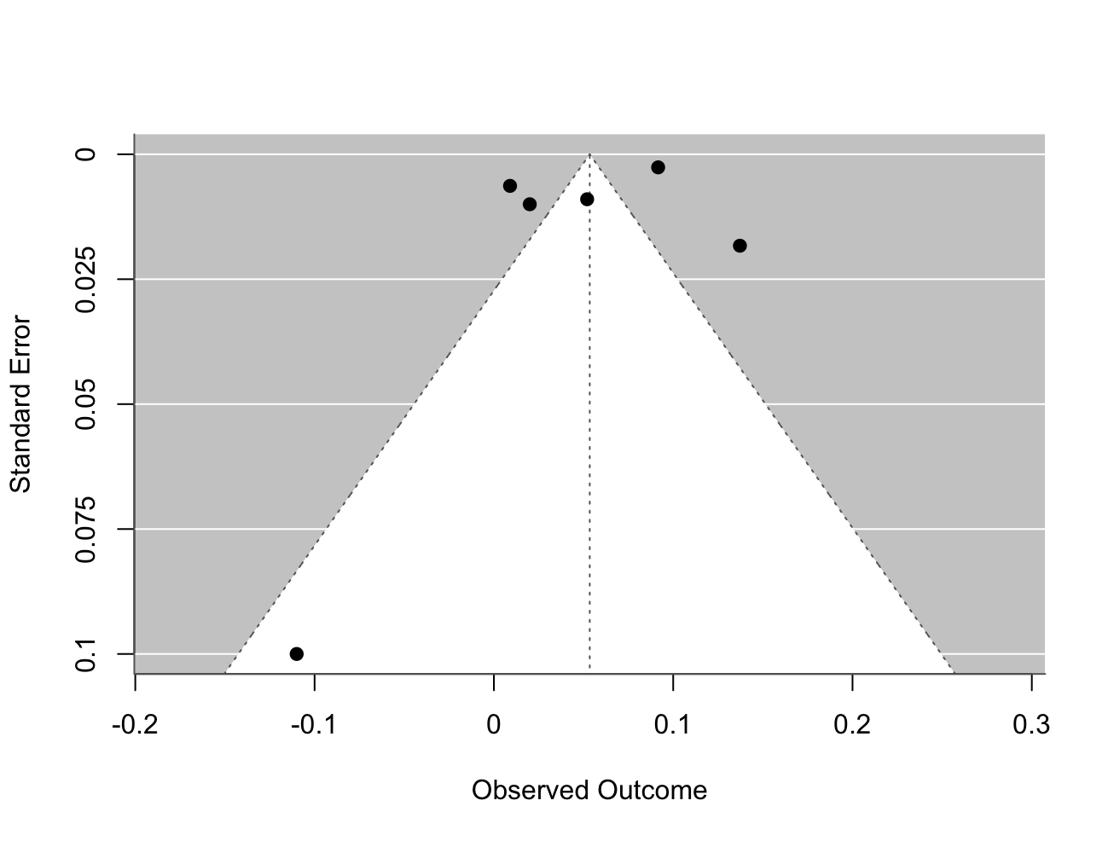

Funnel plot for the meta-analysis on unhealthy eating behaviours and negative triggers (logOR coefficients).

