Supporting Information
Atomic design and fine-tuning of sub-nanometric Pt catalysts to tame hydrogen generation
Yang et al.

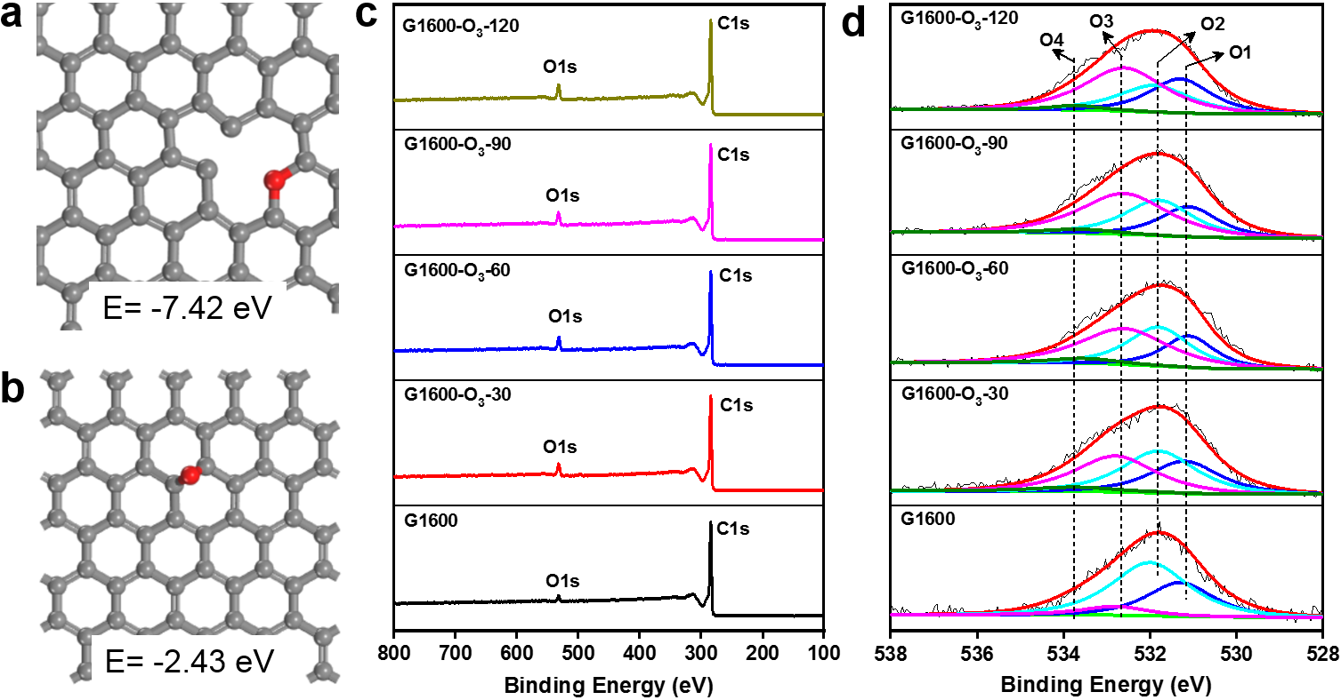
Figure S1. a-b, The theoretical stability of in-plane and out-of-plane epoxy group by DFT calculation. The balls in grey and red represent carbon and oxygen. XPS survey spectrum (c) and the high-resolution O1s XPS spectra (d) of G1600/O₃-y. The O1s spectra of G1600/O₃-y can be deconvoluted into four peaks corresponding to O-C=O (O1, centered at 531.2 eV, ascribed to ester groups), C=O (O2, centered at 531.8 eV, related to carbonyls), C-O (O3, centered at 532.7 eV, associated to epoxies), and O-H (O4, centered at 533.6 eV, assigned to phenols), respectively, in line with the literature.^{1, 2, 3}
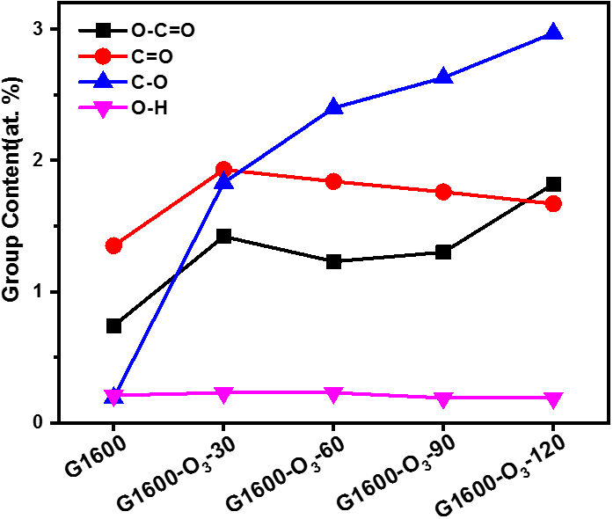
Figure S2. The evolution of OCGs contents in G1600 based on the above XPS data. It can be found that the content of hydroxyl, carbonyl, and ester groups vary slightly after the O₃ pre-etching process. In strong contrast, the number of epoxy groups is considerably lineally increased with the cycle number of O₃ pulse, confirming that abundant and predominant epoxy groups are controllably created on G1600 by adjusting the cycle number of O₃ pulse.

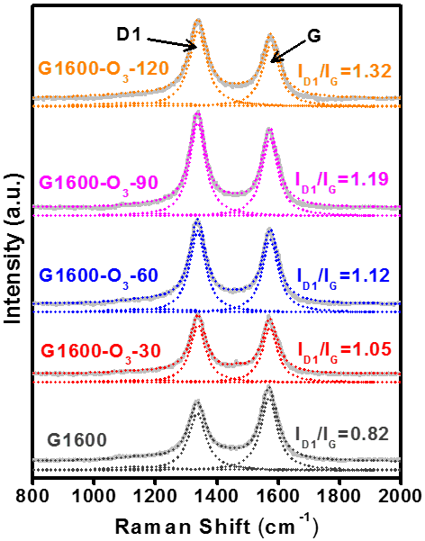
Figure S3. Raman spectrum of G1600-O₃-y (y=0, 30, 60, 90, 120). Two broad bands around 1350 and 1580 cm⁻¹ could be observed, which relate to the D₁ and G band, respectively. The I_{D1}/I_{G} value is determined to be 0.82, 1.05, 1.12 and 1.19 and 1.32 for G1600, G1600-O₃-30, G1600-O₃-60, G1600-O₃-90 and G1600-O₃-120, respectively.
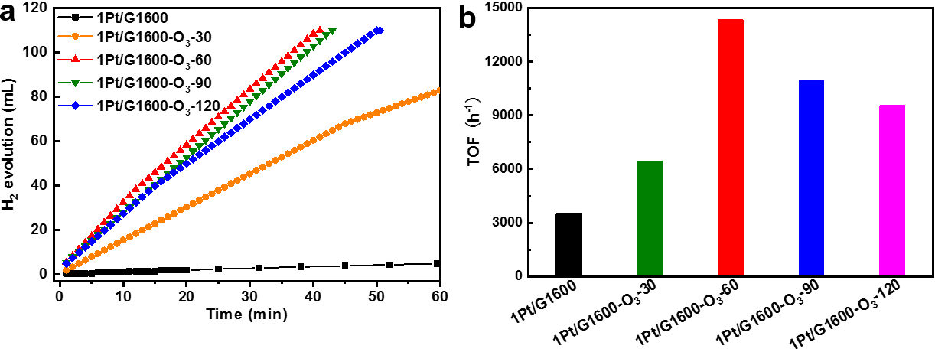
Figure S4. a, Plots of time versus volume of AB dehydrogenation reaction over the 1Pt/G1600-O₃-y catalysts (y=0, 30, 60, 90, 120). b, The initial TOF of AB hydrolysis reaction over the 1Pt/G1600-O₃-y catalysts.
As shown in Figure S4, the number of O₃ pulse pre-etching cycle has important effect on the catalytic activities of resultant Pt/graphene catalysts prepared by ALD for AB hydrolysis. As clearly shown in Figure S4, the hydrogen generation rate on 1Pt/G1600-O₃-y (y=0, 30, 60, 90, 120) catalysts follow a “volcanic curve” with the increase of O₃ pulse cycles and the catalysts prepared with 60 cycles O₃ pulse have the highest activity. Thus, G1600-O₃-60 was selected as the support for Pt sub-nanocatalysts in this work to systematically investigate their structure-property relationship.

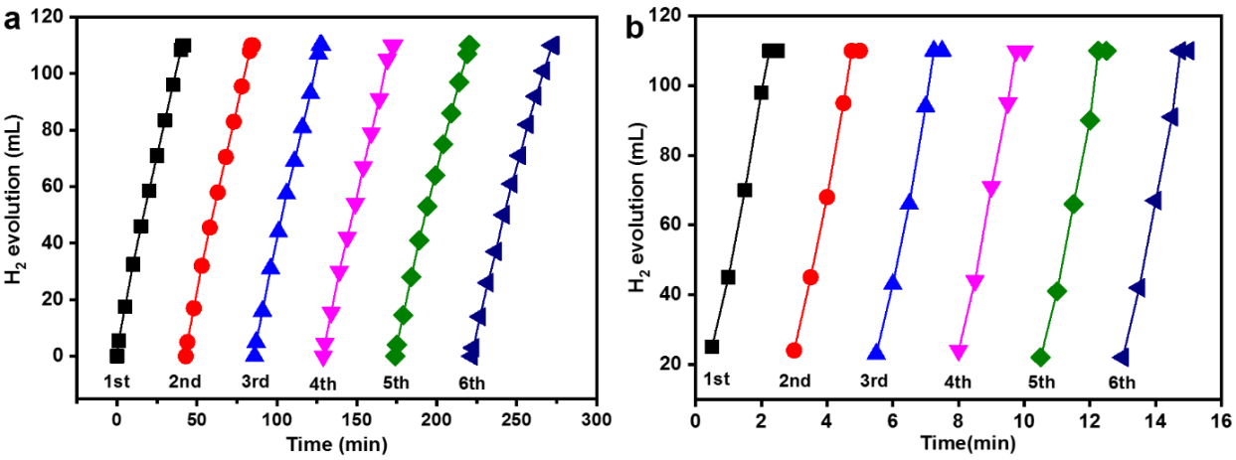
Figure S5. Catalytic durability results of the xPt/G1600-O₃-60 (x=1, 5) catalysts. Six cycles in the dehydrogenation of AB at 25 ± 0.5 °C over 1Pt/G1600-O₃-60 (a) and 5Pt/G1600-O₃-60 (b) by adding additional 1.5 mmol of pure AB into the reaction flask after each run.
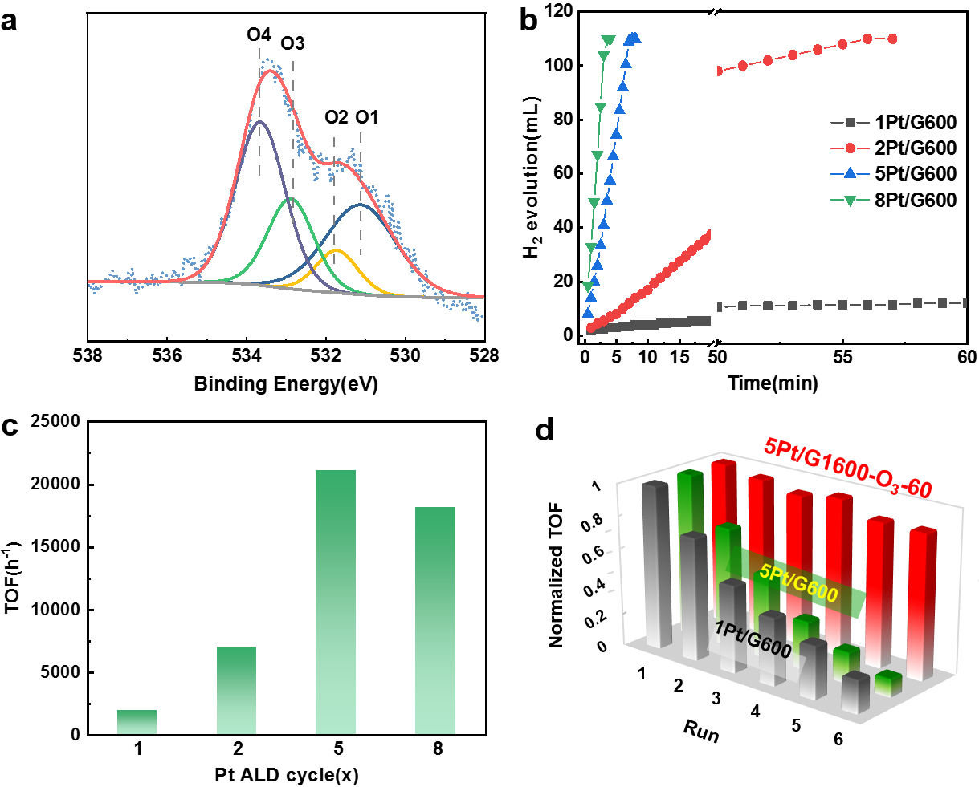
Figure S6. a, The O1s XPS spectra of G600. O1 refers to O-C=O, O2 refers to C=O, O3 refers to C-O, and O4 refers to O-H. b, The hydrogen evolution as a function of reaction time over xPt/G600 catalysts at 25 ºC. c, The TOF values of xPt/G600 catalysts for ammonia borane hydrolysis. d, A comparison for the durability of 1Pt/G600, 5Pt/G600 and 5Pt/G1600-O₃-60 catalysts.
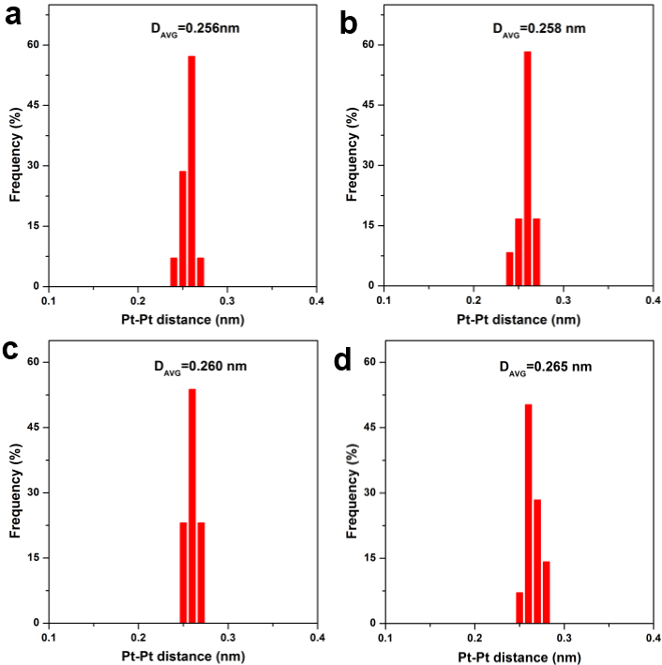
Figure S7. Statistical Pt-Pt distance in the observed Pt dimer for xPt/G1600-O₃-60. The average Pt-Pt distance (D_{AVG}) of the Pt dimer based on the AC-HAADF-STEM results for 2Pt/G1600-O₃-60 (a), 3Pt/G1600-O₃-60 (b), 4Pt/G1600-O₃-60 (c) and 5Pt/G1600-O₃-60 (d).
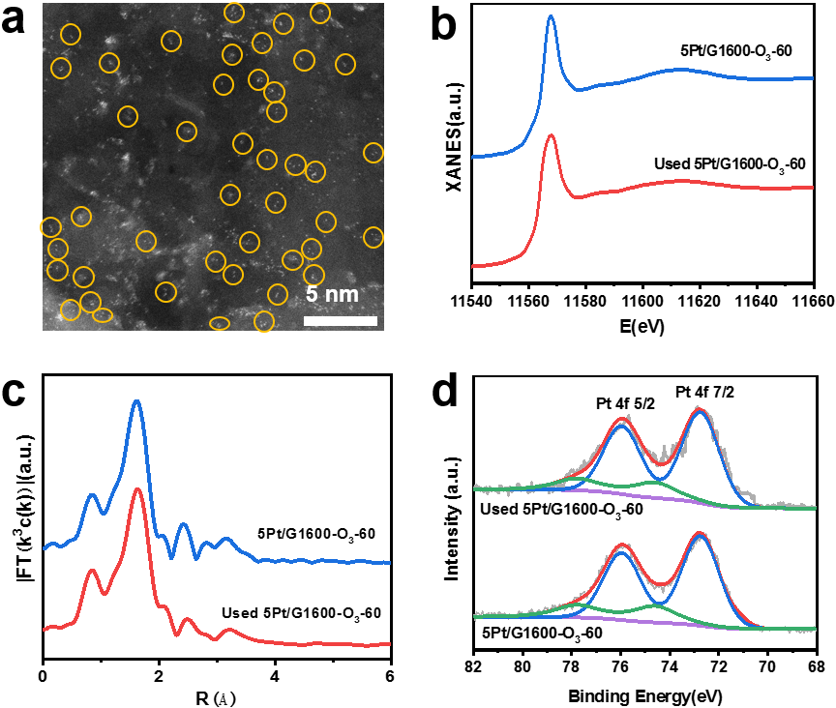
Figure S8. Characterization of the used 5Pt/G1600-O₃-60 sample. a, AC-HAADF-STEM images of used 5Pt/G1600-O₃-60. b, The Pt L₃-edge XANES spectra of the used 5Pt/G1600-O₃-60. c, The corresponding k³-weighted Fourier transform spectra. The black circles are the corresponding fitted curves. d, The high-resolution XPS Pt 4f of the used 5Pt/G1600-O₃-60 catalysts.
The AC-HAADF-STEM, XAFS and XPS characterizations for the used 5Pt/G1600-O₃-60 catalysts were conducted. AC-HAADF-STEM measurements showed that there was no any visible Pt nanoparticles formation and Pt dimers remained as the main features in the used sample (Figure S8a). In addition, both the Pt L₃-edge XANES and the corresponding k³-weighted Fourier transform spectra of the used 5Pt/G1600-O₃-60 have almost no change compared to those of fresh 5Pt/G1600-O₃-60 (Figure S8b and S8c). Moreover, from the XPS results (Figure S8d and Table S2), it can be seen that the valence and peak position of Pt^{δ+} species are nearly unchanged, further revealing that the 5Pt/G1600-O₃-60 catalyst is stable during hydrolysis of ammonia borane. According to the above results, it can be concluded that the Pt dimer structure is stable and is not prone to migrate and agglomerate to nanoclusters or nanoparticles under reaction conditions.
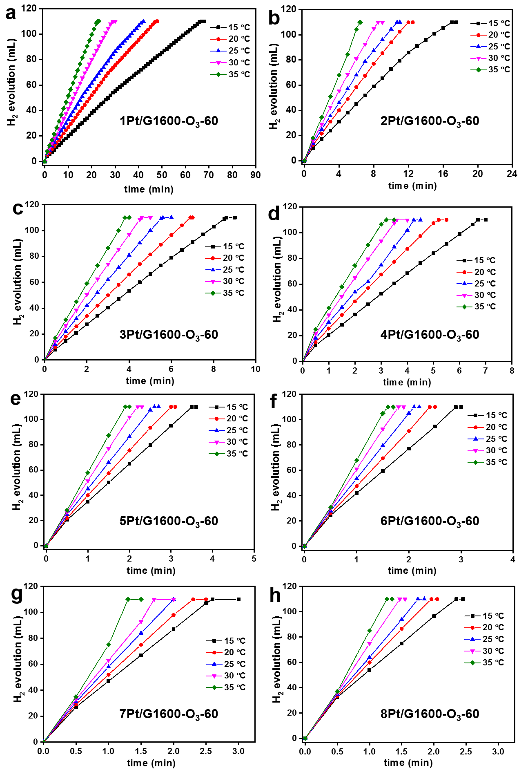
Figure S9. Kinetic results over xPt/G1600-O₃-60 (x=1-8) catalysts. Hydrogen generation as a function of time at 15, 20, 25, 30 and 35 ºC for 1Pt/G1600-O₃-60 (a), 2Pt/G1600-O₃-60 (b), 3Pt/G1600-O₃-60 (c), 4Pt/G1600-O₃-60 (d), 5Pt/G1600-O₃-60 (e), 6Pt/G1600-O₃-60 (f), 7Pt/G1600-O₃-60 (g), and 8Pt/G1600-O₃-60 (h). Reaction conditions: 0.013g catalyst, 10 mL H₂O, 1.5 mmol AB.
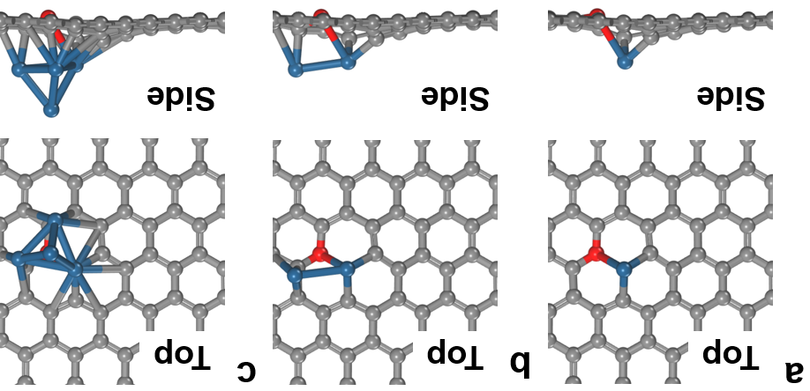
Figure S10. The optimized model for Pt single atom (a), dimer (b) and Pt₄ cluster (c). The balls in grey, red and blue represent carbon, oxygen and platinum atoms, respectively.
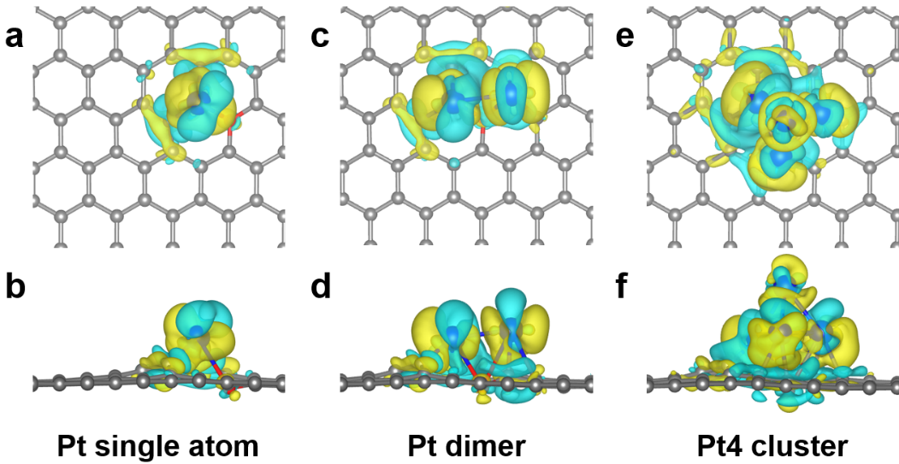
Figure S11. Top (a, c, e) and side (b, d, f) view of the charge density distribution of Pt single atom, dimer and cluster. Yellow and blue bubbles represent charge accumulation and depletion, respectively. Yellow and light blue isosurfaces denote increases and decreases of 0.002 e/Å³, respectively.
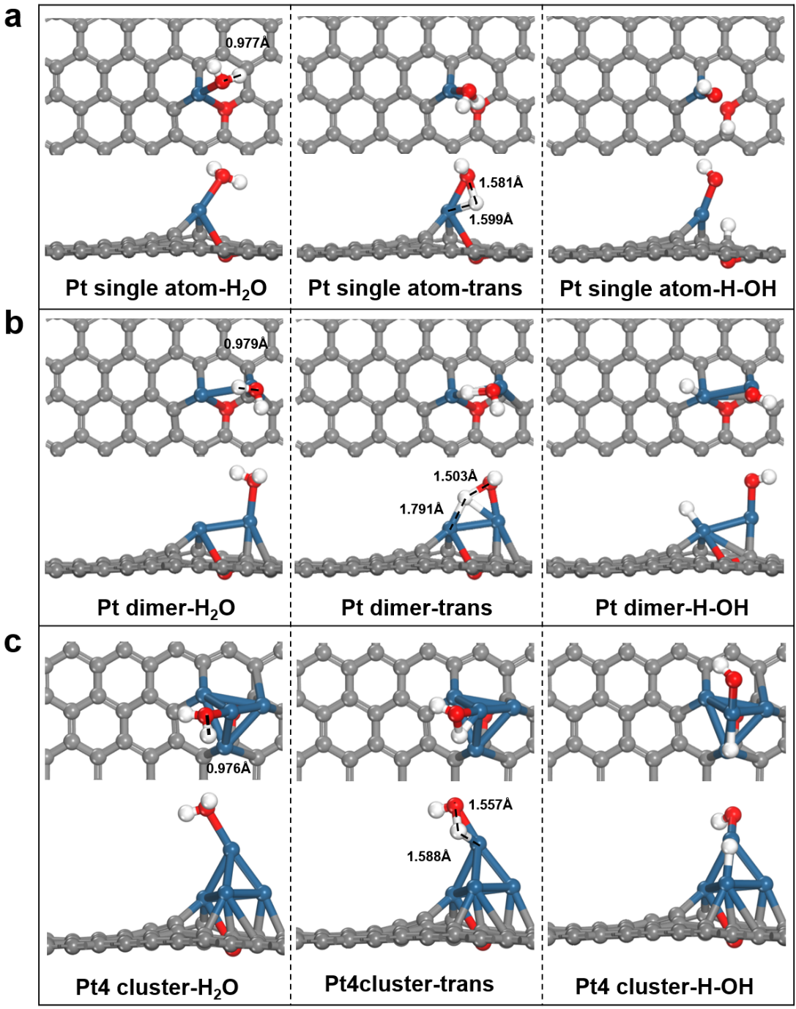
Figure S12. The reaction pathway of H₂O molecule on Pt single atom catalyst (a), Pt dimer catalyst (b), and Pt cluster catalyst (c), respectively. The adsorption states, transition states, and dissociation states of H₂O for each catalyst are shown from left to right in sequence. The ball in gray, blue, red, and white represent carbon, platinum, oxygen, and hydrogen atoms, respectively.
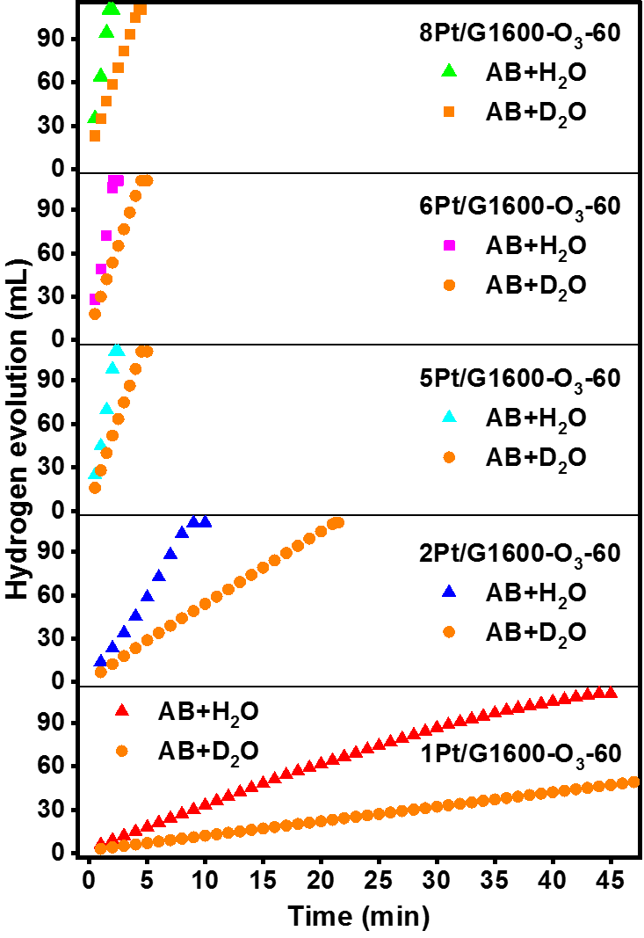
Figure S13. Kinetic isotopic results of xPt/G1600-O₃-60. Hydrogen generation as a function of time by using H₂O and D₂O as the reactants at 25 ± 0.5 ºC for xPt/G1600-O₃-60.
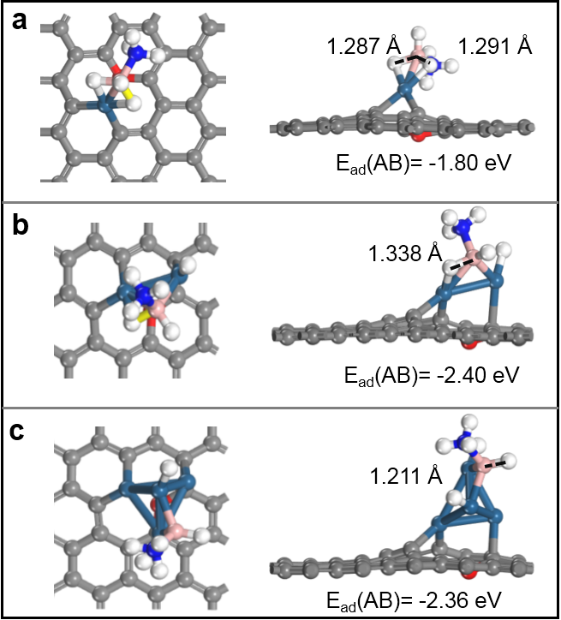
Figure S14. The optimized most stable configurations of the adsorption of ammonia borane (AB) on Pt single atom, dimer and cluster catalysts. a-c, The final (NH₃BH₂*+H*) state over Pt single atom, dimer and cluster, respectively. Top view of the optimized structure in the left, and main view of the optimized structure in the right. The ball in gray, dark blue, red, white, pink, and light blue represent carbon, platinum, oxygen, hydrogen, boron, and nitrogen atoms, respectively.
Table S1. The Pt loading of xPt/G1600-O₃-y catalysts determined by ICP-AES.
x
y | 1 | 2 | 5 | 8
0 | 0.1 | 0.3 | 1.1 | 2.5
30 | 0.9 | 1.9 | 4.5 | 7.5
60 | 1.1 | 2.00 | 5.0 | 7.8
90 | 1.2 | 2.3 | 5.1 | 8.0
120 | 1.3 | 2.6 | 5.3 | 8.2
x: the cycle number of Pt ALD; y: the cycle number of O₃ pulse pre-etching.
Table S2. Summary of XPS results of Pt 4f for xPt/G1600-O₃-60 (x=1-6) and used 5Pt/G1600-O₃-60.
Catalysts | Binding energy (eV) | Relative content (%) | Assignment
1Pt/G1600-O₃-60 | 72.9 | 69.6 | Pt²⁺
1Pt/G1600-O₃-60 | 74.5 | 30.4 | Pt⁴⁺
2Pt/G1600-O₃-60 | 72.85 | 82.7 | Pt²⁺
2Pt/G1600-O₃-60 | 74.6 | 17.3 | Pt⁴⁺
3Pt/G1600-O₃-60 | 72.45 | 85.2 | Pt²⁺
3Pt/G1600-O₃-60 | 74.15 | 14.8 | Pt⁴⁺
4Pt/G1600-O₃-60 | 72.1 | 86.9 | Pt²⁺
4Pt/G1600-O₃-60 | 73.9 | 13.1 | Pt⁴⁺
5Pt/G1600-O₃-60 | 72.7 | 80.9 | Pt²⁺
5Pt/G1600-O₃-60 | 74.6 | 19.1 | Pt⁴⁺
Used 5Pt/G1600-O₃-60 | 72.7 | 82.1 | Pt²⁺
Used 5Pt/G1600-O₃-60 | 74.6 | 17.9 | Pt⁴⁺
6Pt/G1600-O₃-60 | 70.8 | 4.9 | Metallic Pt⁰
6Pt/G1600-O₃-60 | 72.4 | 66.8 | Pt²⁺
6Pt/G1600-O₃-60 | 74.3 | 28.3 | Pt⁴⁺

Table S3. The activation energy (E_{a}) and the logarithm of pre-exponential factor (lnA) values for xPt/G1600-O₃-60 (x=1-8).
Catalysts | E_{a} (kJ/mol) | lnA
1Pt/G1600-O₃-60 | 36.6 | 19.91
2Pt/G1600-O₃-60 | 31.9 | 18.8
3Pt/G1600-O₃-60 | 28.3 | 17.62
4Pt/G1600-O₃-60 | 26.2 | 16.95
5Pt/G1600-O₃-60 | 24.3 | 16.07
6Pt/G1600-O₃-60 | 28.2 | 17.76
7Pt/G1600-O₃-60 | 29.1 | 18.15
8Pt/G1600-O₃-60 | 29.7 | 18.39

Table S4. EXAFS data fitting results of xPt/G1600-O₃-y samples with different Pt ALD cycles.
Sample | Shell | CN | R(Å) | σ²×10⁻³(Å²) | r-factor (%)
Pt foil | Pt-Pt | 12.0 | 2.80
PtO₂ | Pt-O | 6.0 | 1.99
1Pt/G1600-O₃-60 | Pt-O/C | 4.5±0.5 | 2.00±0.01 | 5.5±1.7 | 1.8
1Pt/G1600-O₃-60 | Pt-Pt | 0.5±0.1 | 2.58±0.03 | 1.5±2.7 | 1.8
2Pt/G1600-O₃-60 | Pt-O/C | 4.5±0.6 | 2.00±0.01 | 5.9±1.9 | 1.8
2Pt/G1600-O₃-60 | Pt-Pt | 1.3±0.1 | 2.59±0.03 | 6.2±6.5 | 1.8
3Pt/G1600-O₃-60 | Pt-O/C | 3.7±0.5 | 2.00±0.01 | 4.6±1.7 | 2.1
3Pt/G1600-O₃-60 | Pt-Pt | 1.1±0.1 | 2.62±0.03 | 6.4±6.9 | 2.1
4Pt/G1600-O₃-60 | Pt-O/C | 3.8±0.4 | 2.01±0.01 | 6.5±1.6 | 1.9
4Pt/G1600-O₃-60 | Pt-Pt | 1.4±0.1 | 2.62±0.03 | 7.5±2.4 | 1.9
5Pt/G1600-O₃-60 | Pt-O/C | 4.3±0.4 | 2.00±0.01 | 5.2±1.2 | 1.3
5Pt/G1600-O₃-60 | Pt-Pt | 1.7±0.2 | 2.61±0.03 | 8.8±5.0 | 1.3
6Pt/G1600-O₃-60 | Pt-O/C | 4.5±0.6 | 2.00±0.01 | 6.3±1.8 | 2.2
6Pt/G1600-O₃-60 | Pt-Pt | 2.0±0.2 | 2.72±0.03 | 4.5±1.2 | 2.2
2Pt/G1600 | Pt-O/C | 5.7±0.6 | 2.05±0.01 | 12.4±2.0 | 1.0
2Pt/G1600 | Pt-Pt | 3.0±0.7 | 2.75±0.02 | 8.6±1.9 | 1.0
CN, coordination number; R, distance between absorber and backscatter atoms; σ², Debye-Waller factor to account for both thermal and structural disorders; R-factor (%) indicate the goodness of the fit. The obtained S₀² of Pt foil was 0.81 and it was fixed in the subsequent fitting of Pt foil L₃-edge data for the catalyst. Pt L₃-edge EXAFS curves fitting parameters: ∆k=3.0–12.5Å⁻¹, ∆R = 1.0–3.0 Å.

References
1. Arrigo R, et al. Tuning the Acid/Base Properties of Nanocarbons by Functionalization via Amination. Journal of the American Chemical Society 132, 9616-9630 (2010).
2. Kong Q-Q, Chen C-M, Zhang Q, Zhang X-H, Wang M-Z, Cai R. Small Particles of Chemically-Reduced Graphene with Improved Electrochemical Capacity. The Journal of Physical Chemistry C 117, 15496-15504 (2013).
3. Chen C-M, Zhang Q, Yang M-G, Huang C-H, Yang Y-G, Wang M-Z. Structural evolution during annealing of thermally reduced graphene nanosheets for application in supercapacitors. Carbon 50, 3572-3584 (2012).

