Table 1. Taxonomic identification of the bacterial strains selected for genomic analysis.
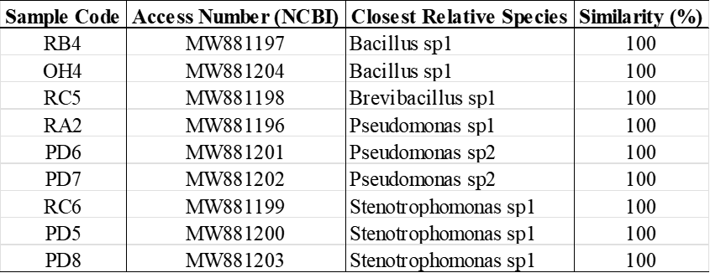

Table 2. Parameters of the chromatographic analysis by GC/FID.
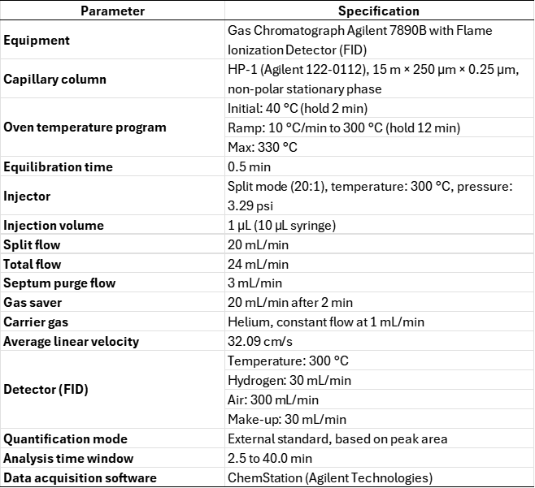

Table 3. Quality parameters of the sequencing and assembly of the bacterial genomes.
