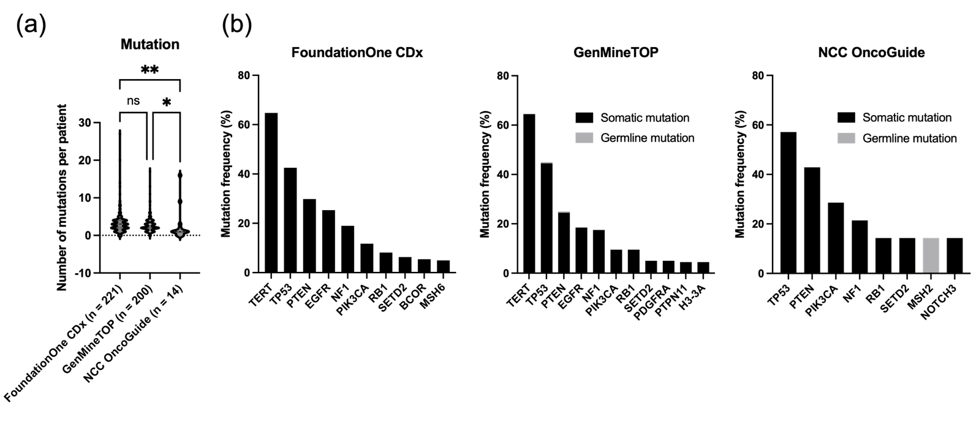
Supp Figure 1. Comparison of mutations detected in glioblastoma patients across the three CGPTs. (a) The number of mutations detected by FoundationOne CDx, GenMineTOP, and NCC OncoGuide. (b) Representative somatic and germline mutations identified by each CGPT are listed for comparison.

