Supplementary Material
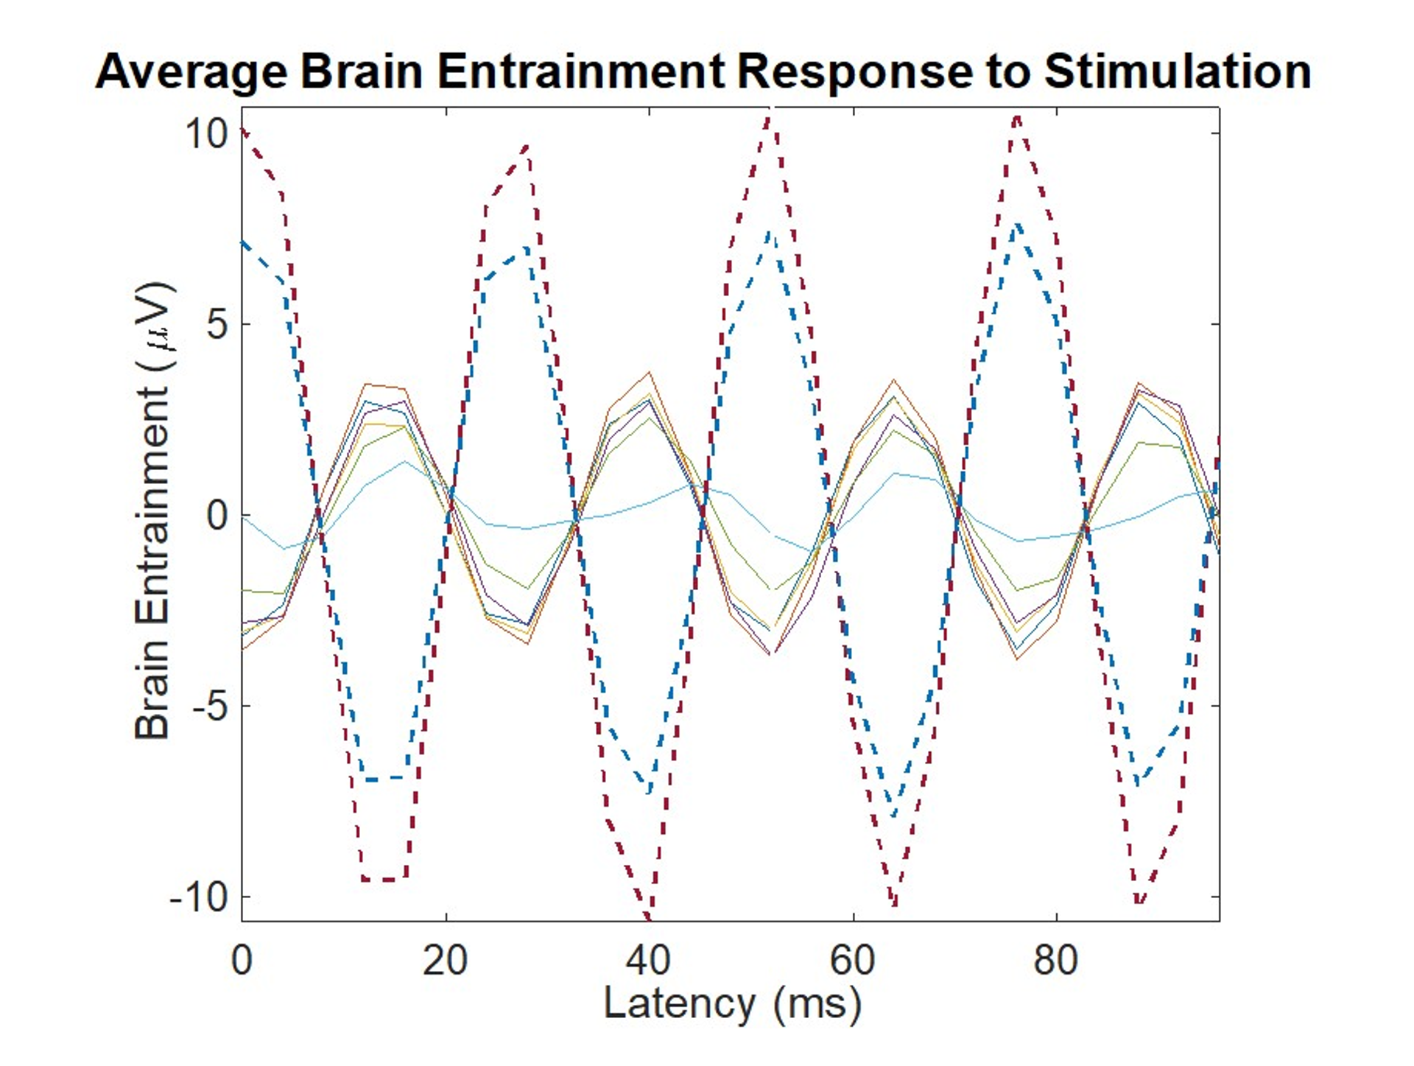
Supplementary Figure 1. Event-related potentials for one subject during VAS. Solid lines represent the prefrontal, frontal and central cortex and dotted lines represent the occipital cortex.

