Figure 2
OE-Control
shPrdx1
shControl
OE-Prdx1

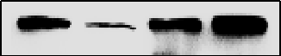 Prdx1 22 KD
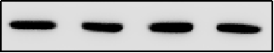 GAPDH 37 KD
Figure 3 A
shPrdx1
shControl
shPrdx1
shControl
EC9706
EC9706
Prdx1 22 KD
NEDD9 115 KD
p-Aurora A 48 KD
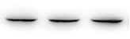 Aurora A 46 KD
HDAC6 131 KD
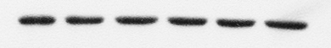GAPDH 37 KD
Figure 3 C
OE-Prdx1
EC9706
OE-Control
OE-Prdx1
OE-Control
EC9706

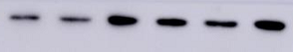 Prdx1 22 KD
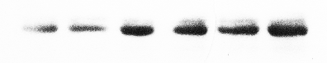NEDD9 115 KD
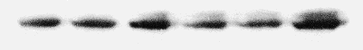p-Aurora A 48 KD
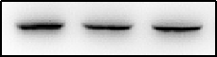 Aurora A 46 KD
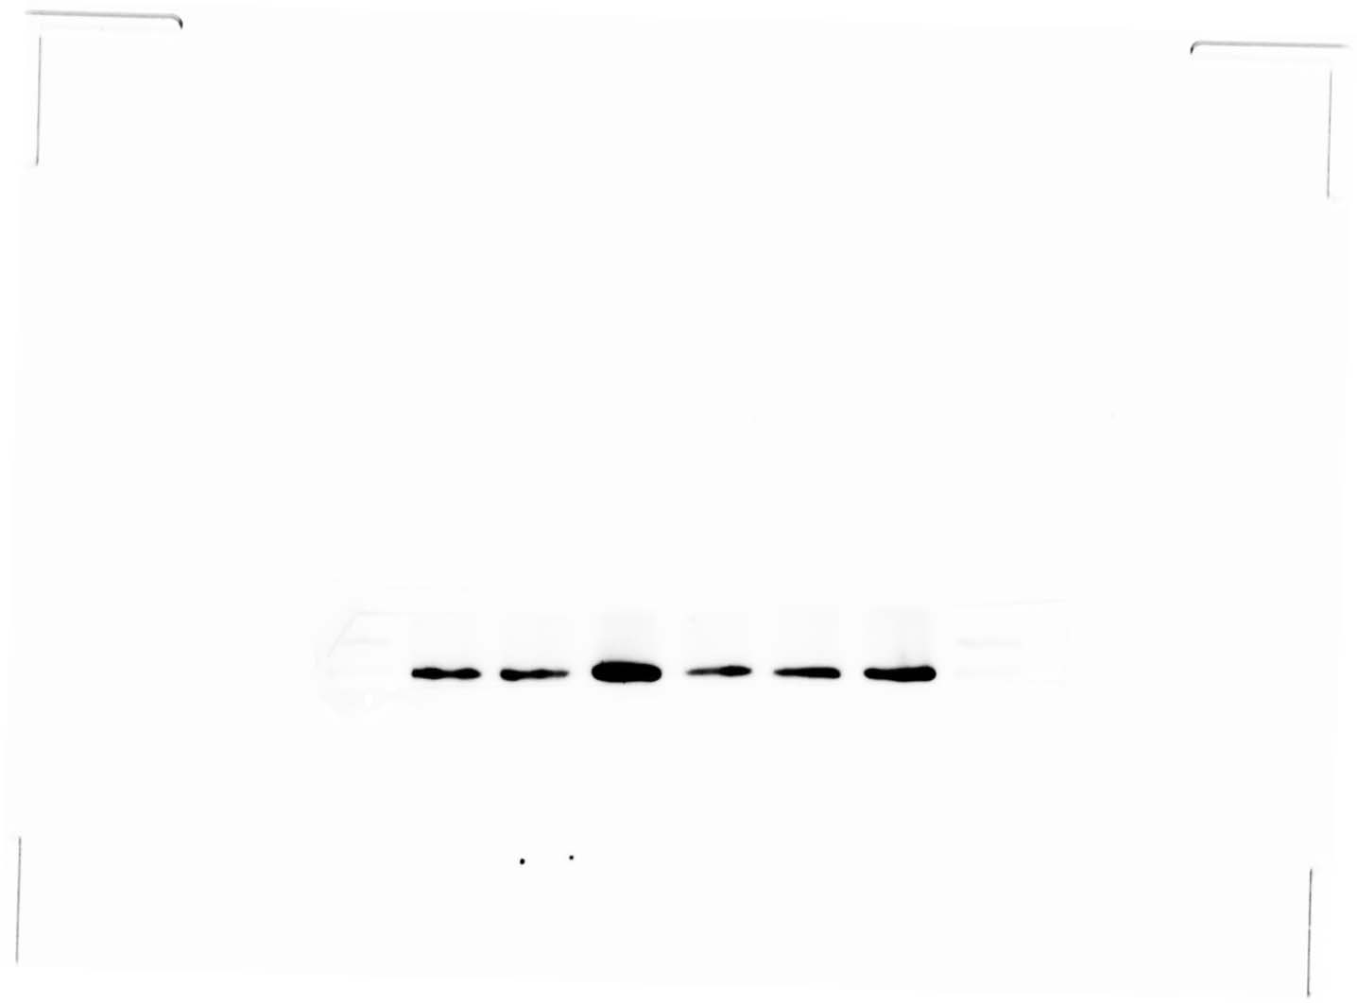 HDAC6 131 KD
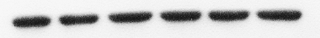 GAPDH 37 KD

Figure 4 A
Tripolin A：
0 1.5 4.5 7.5 10.5 (µmol/L)
p-Aurora A 48 KD
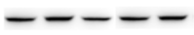 Aurora A 46 KD
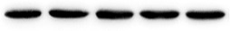 GAPDH 37 KD

Figure 4 C
Tripolin A (4.5 µmol/L)
0 2 4 8 12 (h)
p-Aurora A 48 KD
Aurora A 46 KD
GAPDH 37 KD
Figure 4 E
EC9706+Tripolin A
EC9706

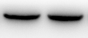 NEDD9 115 KD
p-Aurora A 48 KD
Aurora A 46 KD
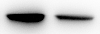 HDAC6 131 KD
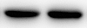 GAPDH 37 KD

Figure 4 G
OE-Prdx1+Tripolin A
OE-Prdx1
OE-Control

 NEDD9 115 KD
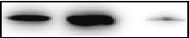 p-Aurora A 48 KD
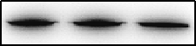 Aurora A 46 KD
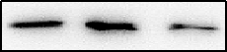 HDAC6 131 KD
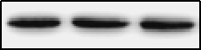 GAPDH 37 KD

Figure 7 A
shControl shPrdx1
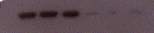 Prdx1 22 KD
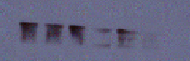 NEDD9 115 KD
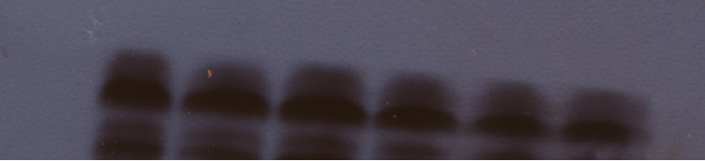 p-Aurora A 48 KD
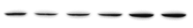 Aurora A 46 KD
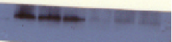 HDAC6 131 KD
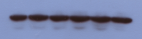 GAPDH 37 KD

