Urban mammals in Italy: how common species shape communities’ differentiation

URBAN ECOSYSTEMS
Limonciello L.^{1,2,3}, Mirone E^{2,3}., Avramo V.^{2,3}, Jamwal Singh P.^{2,3}, Ieraci G.⁴, Coccia C.⁴, Mori E.^{2,5} Ancillotto L. ^{2,5}, Viviano A.⁵, Di Febbraro M.³, Loy A.^{2,3}
- Department of Earth and Marine Sciences, University of Palermo, Via Archirafi 22, 90123, Palermo, Italy.
- NBFC, National Future Biodiversity Centre, Piazza Marina, 61, 90133, Palermo, Italy.
- Envix Lab, Department of Biosciences and Territory, University of Molise, 96090 Pesche, Isernia, Italy.
- Department of Environmental Biology, Sapienza University, Piazzale Aldo Moro 5, 00185 Rome, Italy.
- Research Institute on Terrestrial Ecosystems (IRET), National Research Council of Italy (CNR), Via Madonna del Piano 10, 50019, Sesto Fiorentino (FI), Italy.
Corresponding author: Vasco Avramo, vasco.avramo@gmail.com

SUPPLEMENTARY

SUPP1: Target species list
We focused on medium and large sized mammals (mean weight >1 kg, Lim and Pacheco 2016) regularly present in the Italian territory (Loy et al. 2019) and potentially occurring in the study areas. We selected a total of 21 target species, belonging to the order Carnivora (10 species), Cetartiodactyla (6 species), Eulipotyphla (1 species), Lagomorpha (3 species) and Rodentia (1 species). The complete species list is in Table S1.
Order | Species | Order | Species
Carnivora | Canis lupus | Cetartiodactyla | Capreolus capreolus
Carnivora | Canis lupus familiaris | Cetartiodactyla | Cervus elaphus
Carnivora | Martes foina | Cetartiodactyla | Dama dama
Carnivora | Martes martes | Cetartiodactyla | Ovis aries
Carnivora | Meles meles | Cetartiodactyla | Sus scrofa
Carnivora | Felis catus | Eulipotyphla | Erinaceous europaeus
Carnivora | Felis silvestris | Lagomorpha | Lepus europaeus
Carnivora | Mustela nivalis | Lagomorpha | Oryctolagus cuniculus
Carnivora | Mustela putorius | Lagomorpha | Sylvilagus floridanus
Carnivora | Vulpes vulpes | Rodentia | Hystrix cristata
Cetartiodactyla | Bos taurus

Table S1. Complete target species list, with species listed by order.

SUPP2: Sampling design
We relied on a standardized design shared across the other working groups of the National Biodiversity Future Centre (NBFC) – Spoke Urban. The study areas were divided into 1 × 1 km² gridcells, each characterized by a combination of green area extent and fragmentation gradients, resulting in 16 cell categories. Green areas included all the vegetated surfaces except agricultural land, according to the National Land Cover Map provided by Italian Institute for Environmental Protection and Research (ISPRA 2019).
The extent of green areas was calculated as the cumulative area of all green patches intersecting a cell. Each cell was then assigned to a class A to D (A: 0–0.02 km², B: 0.02–0.24 km², C: 0.24–1 km², D: >1 km²). An Aggregation Index (AI) for green areas fragmentation was computed within a 1.5 km radius circular buffer centred on the cell centroid. The index spans from 0-100, with 0=extreme fragmentation and 100=no fragmentation. Cells were then assigned a class 1 to 4 based on AI (AI <67, highly fragmented), 2 (67–73), 3 (73–81), 4 (>81, minimally fragmented) (Dondina et al. 2025).
The final cell selection included a total of 48 cells, 11 in Milan, 14 in Florence, 14 in Rome and 9 in Campobasso. In Table S2, we provide additional information relative to each gridcell.

Cell ID | Study Area | Green cover area (km2) | Green cover category | Green Fragmentation index (AI) | Green fragmentation category | Cell category | CT latitude | CT longitude
1184 | MI | 0.117185 | B | 55.59 | 1 | B1 | 45,40900 | 9,050600
1282 | MI | 0.145402 | B | 71.83 | 2 | B2 | 45,43386 | 9,077583
1041 | MI | 0.179138 | B | 76.09 | 3 | B3 | 45,44978 | 9,010441
1191 | MI | 0.095873 | B | 81.89 | 4 | B4 | 45,46773 | 9,048679
897 | MI | 0.282706 | C | 64.98 | 1 | C1 | 45,56076 | 8,966732
1049 | MI | 0.279198 | C | 69.13 | 2 | C2 | 45,52375 | 9,015411
1659 | MI | 0.51269 | C | 71.84 | 2 | C2 | 45,47393 | 9,181100
1570 | MI | 0.698538 | C | 78.25 | 3 | C3 | 45,50869 | 9,150497
893 | MI | 0.91913 | C | 81.18 | 4 | C4 | 45,51899 | 8,972986
405 | MI | 6378074 | D | 96.73 | 4 | D4 | 45,40959 | 8,850228
1380 | MI | 1711755 | D | 83.54 | 4 | D4 | 45,48586 | 9,098554
1948 | FI | 0.160405 | B | 72,08 | 2 | B2 | 43,83533 | 11,16804
3064 | FI | 0.145894 | B | 79.28 | 3 | B3 | 43,77983 | 11,33802
3150 | FI | 0.108894 | B | 83.29 | 4 | B4 | 43,77643 | 11,34992
2372 | FI | 0.307401 | C | 66.24 | 1 | C1 | 43,79468 | 11,23724
1940 | FI | 0.313912 | C | 69.71 | 2 | C2 | 43,75765 | 11,17579
2117 | FI | 0.783221 | C | 72.04 | 2 | C2 | 43,82141 | 11,19904
2034 | FI | 0.559317 | C | 75.99 | 3 | C3 | 43,84558 | 11,18421
2977 | FI | 0.313387 | C | 78.91 | 3 | C3 | 43,77503 | 11,32198
1945 | FI | 0.811942 | C | 82.35 | 4 | C4 | 43,80268 | 11,18028
2199 | FI | 1367032 | D | 77.87 | 3 | D3 | 43,78687 | 11,20946
2460 | FI | 2704757 | D | 80.20 | 3 | D3 | 43,81868 | 11,24136
1536 | FI | 2102794 | D | 82.46 | 4 | D4 | 43,76155 | 11,10604
2294 | FI | 499741847 | D | 97.70 | 4 | D4 | 43,86546 | 11,22460
2893 | FI | 1883311 | D | 86.74 | 4 | D4 | 43,80478 | 11,30557
2462 | RM | 0.158711 | B | 57.83 | 1 | B1 | 41,79798 | 12,37901
3411 | RM | 0.183562 | B | 71.76 | 2 | B2 | 41,90337 | 12,52099
4003 | RM | 0.138274 | B | 77.34 | 3 | B3 | 41,91316 | 12,58472
3612 | RM | 0.193496 | B | 79.36 | 3 | B3 | 41,99616 | 12,53891
2875 | RM | 0.226149 | B | 84.02 | 4 | B4 | 41,90954 | 12,44139
4015 | RM | 0.166687 | B | 85.91 | 4 | B4 | 42,01717 | 12,58742
3503 | RM | 0.298001 | C | 66.91 | 1 | C1 | 41,87336 | 12,52425
3045 | RM | 0.844293 | C | 72.62 | 2 | C2 | 41,89277 | 12,46268
3224 | RM | 0.639985 | C | 73.08 | 3 | C3 | 41,88321 | 12,49573
3912 | RM | 0.615309 | C | 88.12 | 4 | C4 | 42,01247 | 12,58529
3227 | RM | 0.991327 | C | 82.93 | 4 | C4 | 41,91462 | 12,49035
3220 | RM | 1446 | D | 72.51 | 2 | D2 | 41,84754 | 12,49531
3605 | RM | 1249 | D | 80.63 | 3 | D3 | 41,93256 | 12,54688
2873 | RM | 3353 | D | 86.97 | 4 | D4 | 41,88478 | 12,44565
1720 | CB | 0.228377 | B | 70.25 | 2 | B2 | 41,57749 | 14,69256
1721 | CB | 0.174764 | B | 78.09 | 3 | B3 | 41,59298 | 14,69659
1806 | CB | 0.147345 | B | 85.95 | 4 | B4 | 41,58717 | 14,70780
1473 | CB | 0.489465 | C | 72.26 | 2 | C2 | 41,56602 | 14,65434
1472 | CB | 0.346084 | C | 77.19 | 3 | C3 | 41,55583 | 14,64847
1395 | CB | 0.414519 | C | 87.79 | 4 | C4 | 41,58271 | 14,64607
1632 | CB | 1499501 | D | 70.58 | 2 | D2 | 41,53784 | 14,67930
1550 | CB | 1566705 | D | 77.78 | 3 | D3 | 41,53992 | 14,66932
1159 | CB | 22946103 | D | 97.88 | 4 | D4 | 41,54576 | 14,60430
Table S2. Gridcells selected for the study, with absolute and categorical values of green cover and green fragmentation, and coordinates of the camera traps placed in each cell.

SUPP3: Species’ independent detections
We recorded a total of 24 mammal species (18 native, 3 domestic, and 3 exotic) over 8,759 trap-days. For each species, the table below (Table S3) reports the number of independent detection events.
Common name | Scientific name | # of ind. obs. | Common name | Scientific name | # of ind. obs.
Grey Wolf | Canis lupus | 18 | House mouse | Mus musculus | 30
Domestic dog | Canis lupus familiaris | 1649 | Least weasel | Mustela nivalis | 1
Roe deer | Capreolus capreolus | 239 | European polecat | Mustela putorius | 6
Red deer | Cervus elaphus | 2 | Coypu | Myocastor coypus | 3
Fallow deer | Dama dama | 26 | Domestic sheep | Ovis aries | 24
European hedgehog | Erinaceous europaeus | 259 | Rats | Rattus spp. | 86
Domestic cat | Felis catus | 742 | Grey squirrel | Sciurus carolinensis | 604
Wild cat | Felis silvestris | 1 | Red squirrel | Sciurus vulgaris | 100
Crested porcupine | Hystrix cristata | 669 | Wild boar | Sus scrofa | 3678
European hare | Lepus europaeus | 204 | Eastern cottontail rabbit | Sylvilagus floridanus | 816
Pine and Stone martens | Martes spp. | 104 | Red fox | Vulpes vulpes | 3003
European badger | Meles meles | 446
Table S3. Number of independent observations for each of the 24 mammal species detected in the study, listed alphabetically by scientific name. Species included in the statistical analysis are underlined.

SUPP4: Species accumulation curves
The sampling effort varied among study areas due to personnel availability, ranging from 8 to 24 months of camera-trap activity. Devices were active from early May to the end of December 2024 in Milan; from early January 2023 to December 2024 in Florence (with intermittent sampling); from mid-March to December 2024 in Rome; and from January to mid-November 2024 in Campobasso.
Species accumulation curves were generated to assess whether the sampling effort was sufficient to capture the mammal species diversity in each study area. Curves were built using the vegan R package (Oksanen et al. 2008) and illustrate the relationship between species richness and sampling effort in the four cities.
The results suggest that Campobasso (CB) and Rome (RM) were sampled sufficiently to capture local diversity whereas Milan (MI) and Florence (FI) could have benefitted from a longer sampling period. Additional data collection is ongoing in these latter two cities and will be included into future analyses.
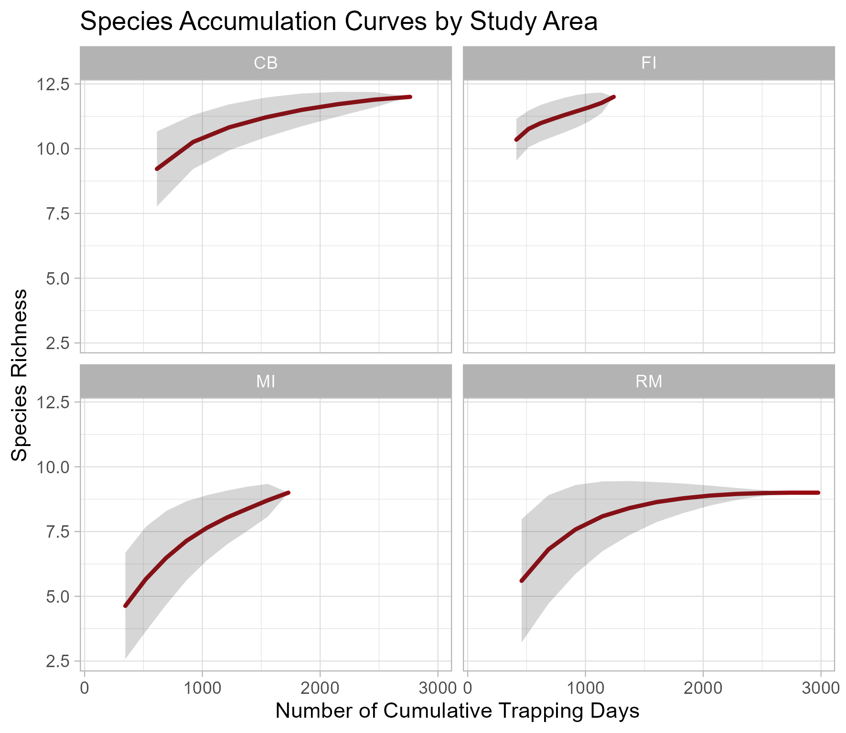
Figure S4. Species Accumulation Curves for each study area, illustrating the relationship between sampling effort (trap-days) and estimated mammal species richness.

SUPP5: PERMANOVA results
We tested for the differences in mean species observation frequencies employing a PERMANOVA approach. The 4 tests were performed grouping the gridcells according to a different variable each time: Study Area, Green Cover, Green Fragmentation and Cell category. Additionally, we performed pairwise comparisons for group dispersion (Tuckey HSD test) and centroid separation (pairwise PERMANOVA).
In this section, we illustrate the graphic results for the 3 grouping variables for which the mean species observation frequency differences were not significant: Green Cover, Green Fragmentation and Cell Category. Furthermore, we illustrate pairwise comparison test results for each PERMANOVA test.
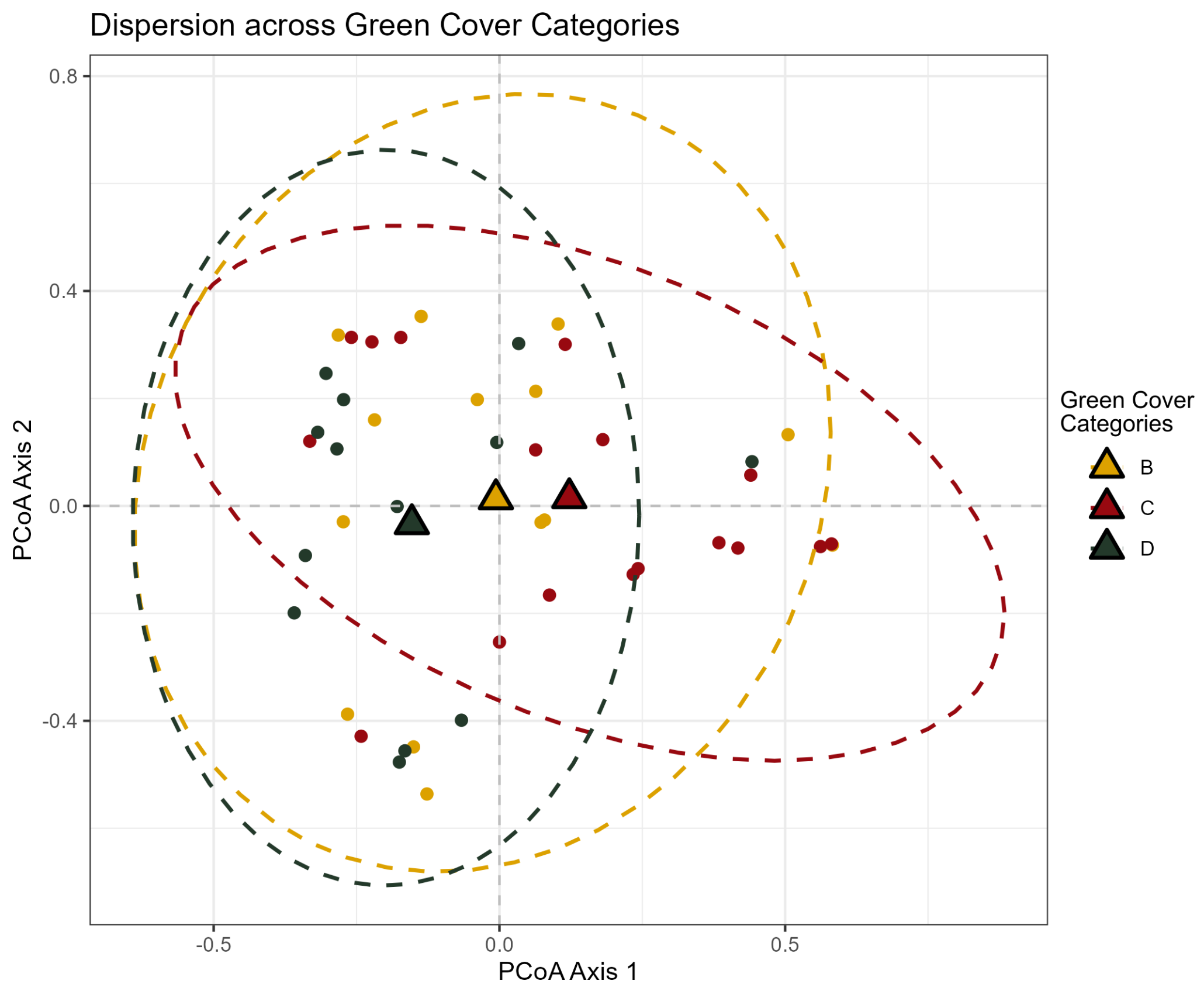
Figure S5a). Dispersion plot for the 48 sites grouped by Green Cover category.
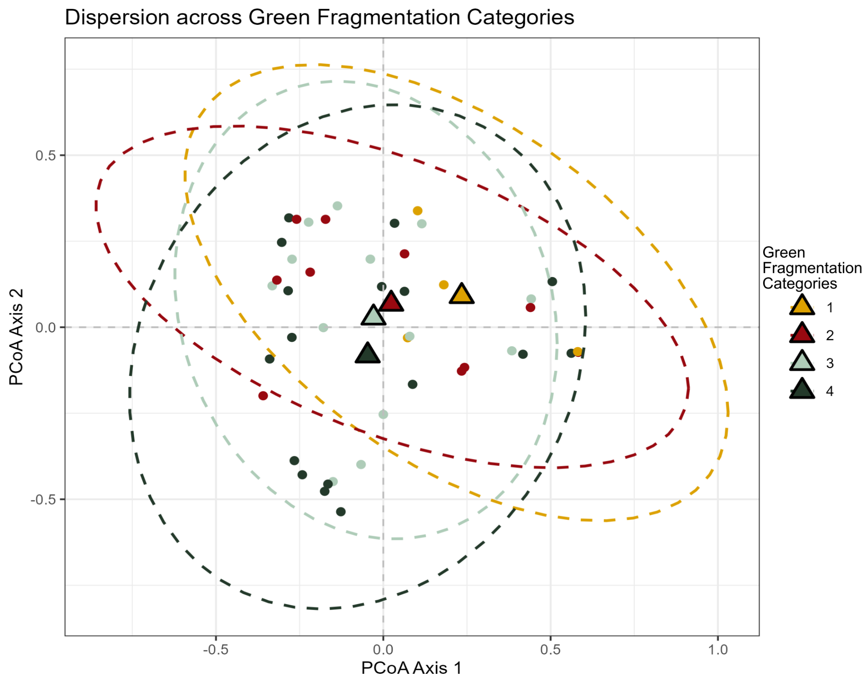
Figure S5b). Dispersion plot for the 48 sites grouped by Green Fragmentation category.
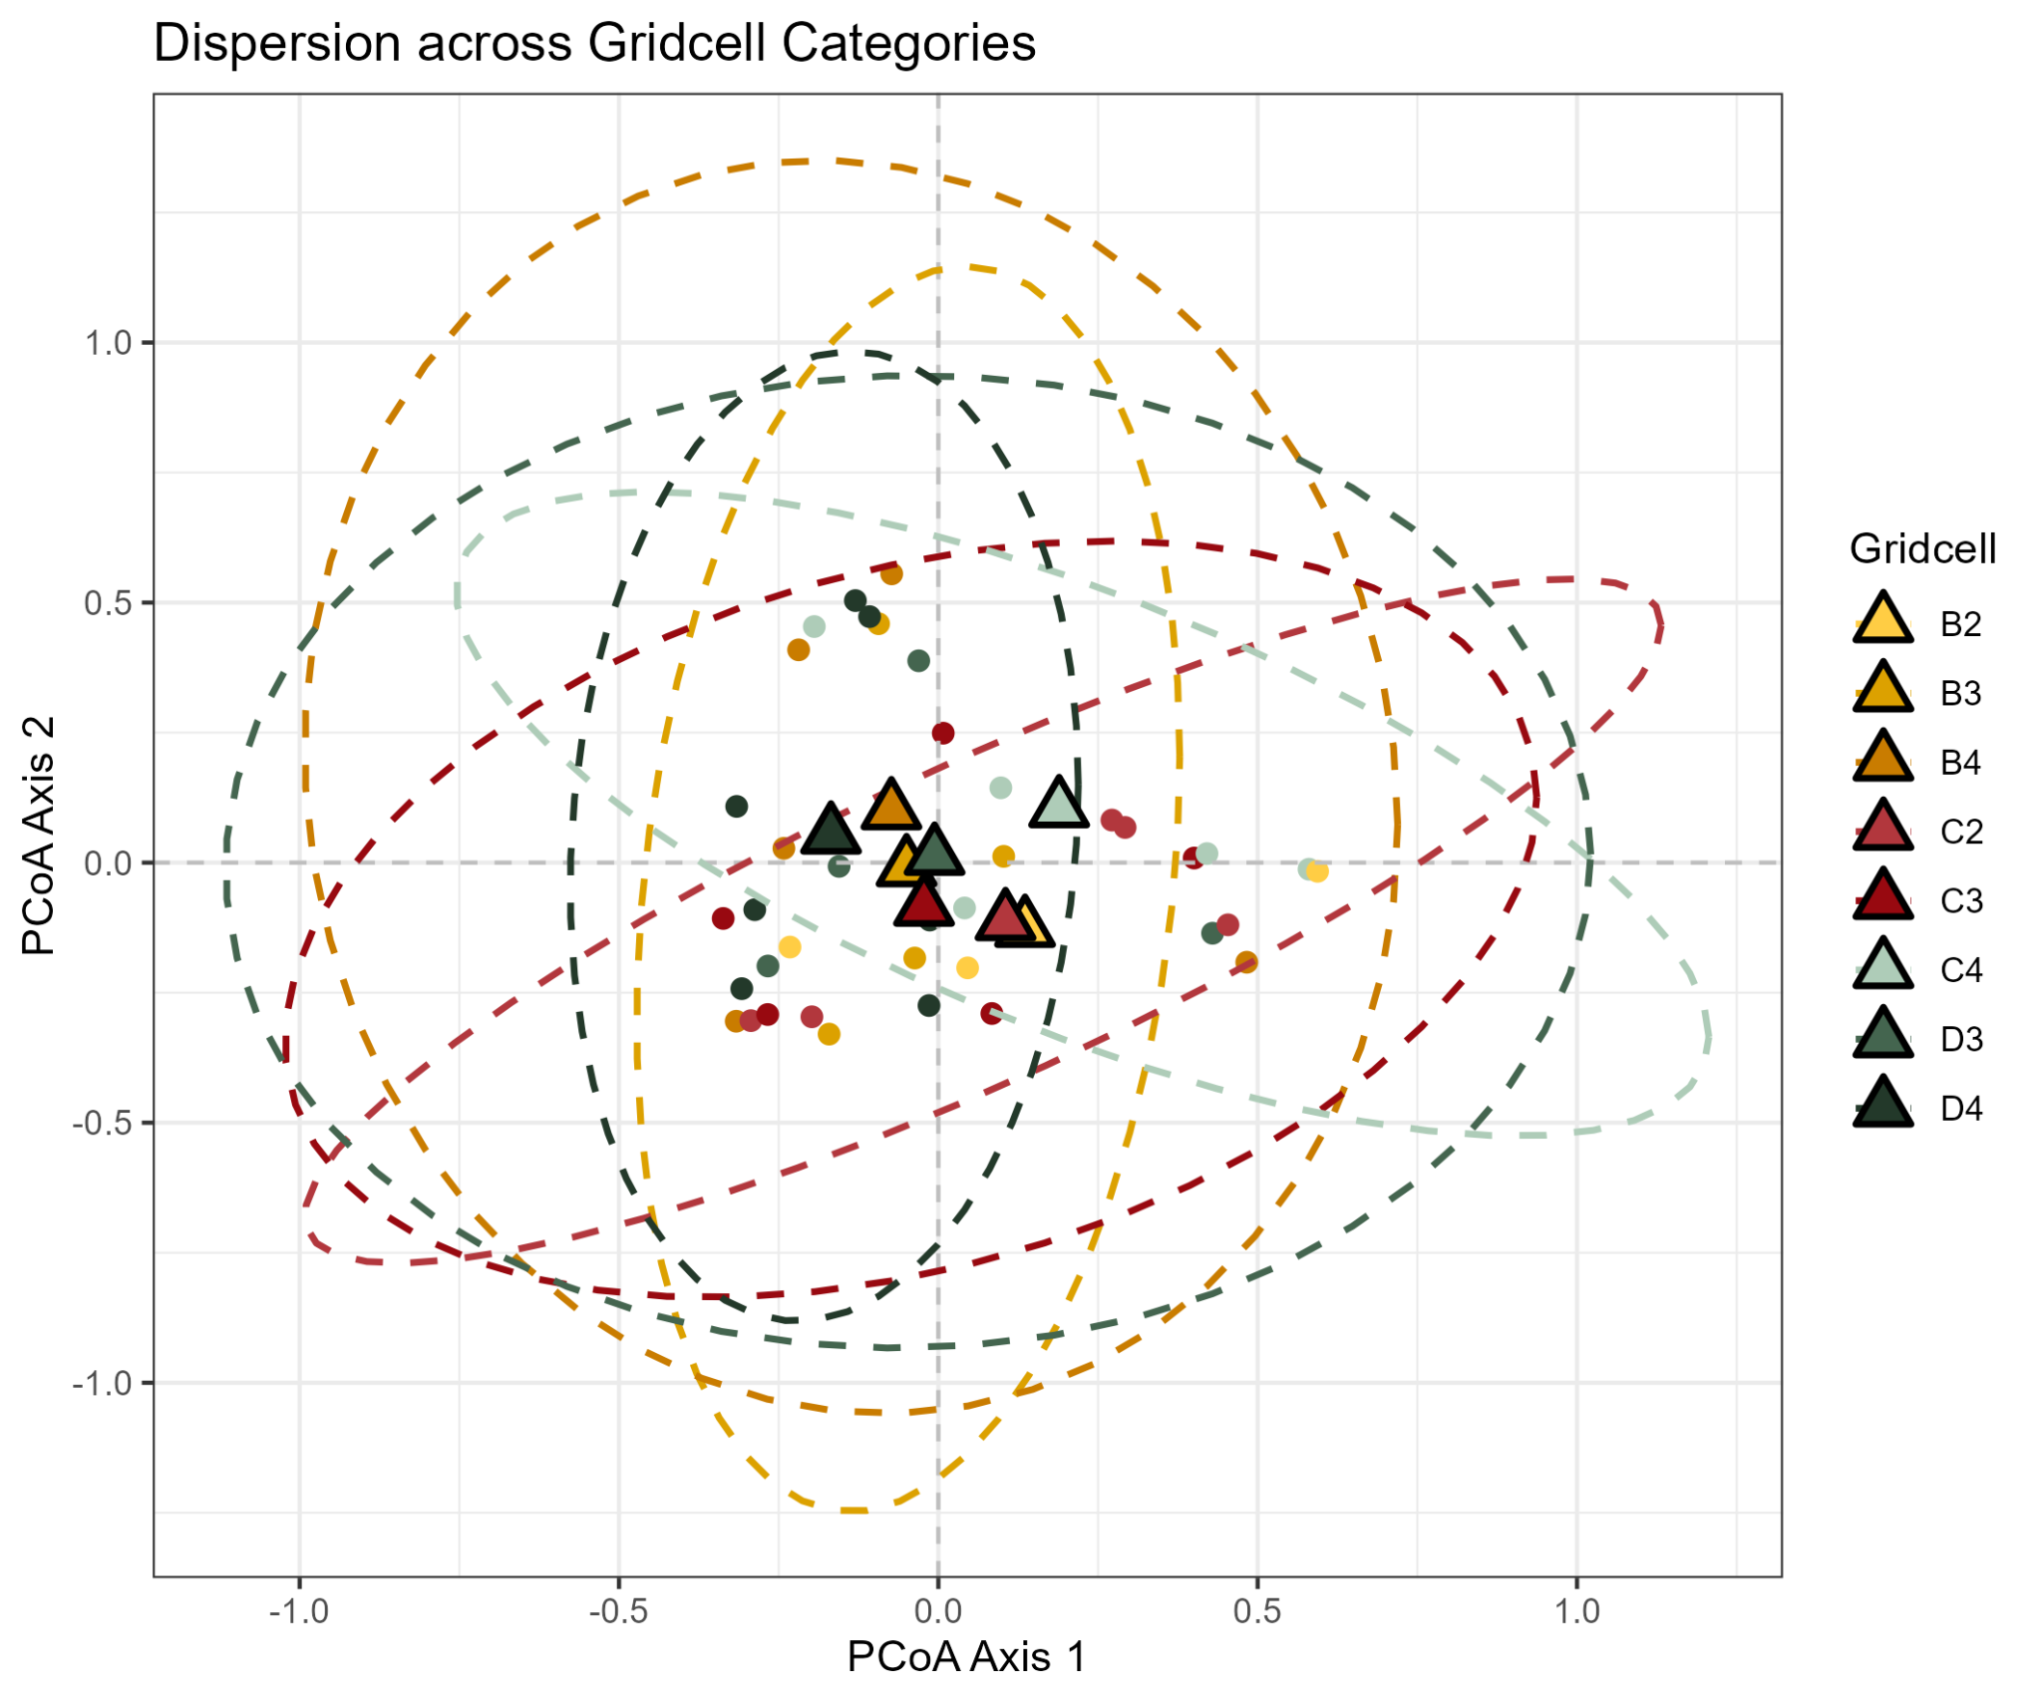
Figure S5c). Dispersion plot for the 48 sites grouped by Gridcell category.
pairs | Df | SumsOfSqs | F.Model | R2 | p.value | p.adjusted
CELL CATEGORIES
B2 vs B3 | 1 | 0.3771158 | 1.0219359 | 0.1697022 | 0.470 | 1
B2 vs B4 | 1 | 0.2353409 | 0.6230264 | 0.0940697 | 0.727 | 1
B2 vs C2 | 1 | 0.2325475 | 0.5858204 | 0.0889518 | 0.710 | 1
B2 vs C3 | 1 | 0.1655735 | 0.3963087 | 0.0619590 | 0.934 | 1
B2 vs C4 | 1 | 0.2179218 | 0.4602244 | 0.0712397 | 1.000 | 1
B2 vs D3 | 1 | 0.2243485 | 0.4956670 | 0.0901923 | 0.918 | 1
B2 vs D4 | 1 | 0.3659406 | 1.0368262 | 0.1147334 | 0.387 | 1
B3 vs B4 | 1 | 0.4130436 | 1.3100592 | 0.1576474 | 0.213 | 1
B3 vs C2 | 1 | 0.5117693 | 1.5425779 | 0.1805752 | 0.145 | 1
B3 vs C3 | 1 | 0.3939123 | 1.1267014 | 0.1386419 | 0.335 | 1
B3 vs C4 | 1 | 0.6197349 | 1.5595602 | 0.1822010 | 0.077 | 1
B3 vs D3 | 1 | 0.4065529 | 1.1069336 | 0.1557540 | 0.362 | 1
B3 vs D4 | 1 | 0.2876812 | 0.9366934 | 0.0942661 | 0.486 | 1
B4 vs C2 | 1 | 0.4703930 | 1.3715773 | 0.1463550 | 0.239 | 1
B4 vs C3 | 1 | 0.3477526 | 0.9698070 | 0.1081190 | 0.484 | 1
B4 vs C4 | 1 | 0.3452204 | 0.8622506 | 0.0972948 | 0.499 | 1
B4 vs D3 | 1 | 0.2083442 | 0.5555853 | 0.0735331 | 0.781 | 1
B4 vs D4 | 1 | 0.1346264 | 0.4226302 | 0.0405493 | 0.885 | 1
C2 vs C3 | 1 | 0.3991144 | 1.0700238 | 0.1179736 | 0.369 | 1
C2 vs C4 | 1 | 0.4818942 | 1.1617845 | 0.1268077 | 0.319 | 1
C2 vs D3 | 1 | 0.3149492 | 0.8045183 | 0.1030837 | 0.556 | 1
C2 vs D4 | 1 | 0.5638714 | 1.7082995 | 0.1459050 | 0.105 | 1
C3 vs C4 | 1 | 0.3423684 | 0.7954482 | 0.0904386 | 0.654 | 1
C3 vs D3 | 1 | 0.2012232 | 0.4915931 | 0.0656193 | 0.875 | 1
C3 vs D4 | 1 | 0.2770214 | 0.8086451 | 0.0748147 | 0.625 | 1
C4 vs D3 | 1 | 0.3582187 | 0.7836921 | 0.1006839 | 0.773 | 1
C4 vs D4 | 1 | 0.5284701 | 1.4054737 | 0.1232280 | 0.158 | 1
D3 vs D4 | 1 | 0.2551931 | 0.7217657 | 0.0742422 | 0.737 | 1
GREEN COVER CATEGORIES
B vs C | 1 | 0.4415478 | 1.168310 | 0.0387264 | 0.297 | 0.891
B vs D | 1 | 0.3404165 | 1.041272 | 0.0399854 | 0.432 | 1.000
C vs D | 1 | 0.7441473 | 2.026555 | 0.0674921 | 0.027 | 0.081
GREEN FRAGMENTATION CATEGORIES
2 vs 3 | 1 | 0.2979554 | 0.8180116 | 0.0374925 | 0.570 | 1.000
2 vs 4 | 1 | 0.4297806 | 1.1972728 | 0.0457022 | 0.270 | 1.000
2 vs 1 | 1 | 0.4386492 | 1.2042347 | 0.0912006 | 0.297 | 1.000
3 vs 4 | 1 | 0.3536299 | 0.9740210 | 0.0336170 | 0.463 | 1.000
3 vs 1 | 1 | 0.3528127 | 0.9513810 | 0.0596425 | 0.497 | 1.000
4 vs 1 | 1 | 0.5478921 | 1.5113857 | 0.0736852 | 0.138 | 0.828
STUDY AREAS
CB vs FI | 1 | 0.5094409 | 1.450738 | 0.0709382 | 0.153 | 0.918
CB vs MI | 1 | 0.8515100 | 3.184732 | 0.1577793 | 0.004 | 0.024
CB vs RM | 1 | 0.6850967 | 2.014357 | 0.0915020 | 0.056 | 0.336
FI vs MI | 1 | 1.2108685 | 3.715092 | 0.1566552 | 0.001 | 0.006
FI vs RM | 1 | 0.4333024 | 1.135663 | 0.0470533 | 0.322 | 1.000
MI vs RM | 1 | 1.1649781 | 3.679573 | 0.1490939 | 0.002 | 0.012
Table S5. Pairwise comparison for PERMANOVA tests performed after grouping the gridcells according to 4 grouping variables. P values (in bold, significant ones in green) are listed in the last column; significant pairwise differences are only found for the study area variable, specifically, between Milan and every other city.

SUPP6: Random Forest model selection
We used a Random Forest (RF) approach to identify the species most influential in group differentiation among the four cities.
To optimize model performance, we performed a full Cartesian grid search, evaluating every possible combination of four hyperparameters (Boehmke and Greenwell 2020):
- the number of features considered at every split of the classification tree (m_{try}: 2, 2.8, 3.5, 4.0, 4.5);
- the complexity of each tree, represented by the minimum node size (the number of samples in a terminal node, min_rows: 1, 3, 5, 10) and the maximum number of splits (max_depth: 10, 20, 30);
- the sample rate, i.e. how many observations are drawn for each tree training (0.55, 0.632, 0.70, 0.80).
Model tuning was based on R² and Mean Squared Residual Error (MSRE) values, while final model performance was evaluated using classification accuracy under a 10-fold cross-validation framework (Boehmke & Greenwell, 2020). RF models were implemented in R using the “h2o” package (Fryda et al., 2024). The best-performing model included 120 classification trees and the following hyperparameter configuration:
mtry = 2, min_rows = 1, max_depth = 20, sample_rate = 0.70.

REFERENCES
Boehmke B, Greenwell B (2020) Hands-On Machine Learning with R, 1st edition. CRC Press
Dondina O, Tirozzi P, Viviano A, et al (2025) Spatial and habitat determinants of small-mammal biodiversity in urban green areas: Lessons for nature-based solutions. Urban For Urban Green 104:128641. https://doi.org/10.1016/J.UFUG.2024.128641
ISPRA (2019) Annuario dei dati ambientali - Turismo nei Parchi
Lim B, Pacheco V (2016) SMALL NON-VOLANT MAMMALS. In: Biodiversity Sampling Protocols
Loy A, Aloise G, Ancillotto L, et al (2019) Mammals of Italy: An annotated checklist. Hystrix 30:. https://doi.org/10.4404/hystrix-00196-2019
Oksanen J, Kindt R, Legendre P, et al (2008) The vegan package. Community ecology package

