Supplementary Materials
Table S1 Comparison of Variables across Sex.
 | Male ($\overline{x}$ ± s) | Female ($\overline{x}$ ± s) | t | p
Perceived Distress | 20.57±5.969 | 19.99±5.335 | 2.373 | 0.018
Perceived Coping | 23.28±7.006 | 24.35±6.035 | -3.701 | 0.000
Cognitive Reappraisal | 26.65±7.526 | 26.12±5.771 | 1.758 | 0.079
Expressive Suppression | 17.34±4.807 | 16.59±3.792 | 3.834 | 0.000
Depression | 17.28±7.531 | 16.57±6.506 | 2.286 | 0.022
Table S2 Multicollinearity Test Results after Centering.
 | Standardized Coefficients | t | p | Collinearity Statistics
 | Beta | t | p | Tolerance | VIF
(Constant) |  | 6.035 | 0
ERQcog | -0.06 | -1.826 | 0.068 | 0.27 | 3.699
ERQes | 0.079 | 2.528 | 0.012 | 0.307 | 3.261
Sex | 0.022 | 1.24 | 0.215 | 0.969 | 1.032
Age | 0.005 | 0.273 | 0.785 | 0.822 | 1.217
Isolation Status | -0.041 | -2.158 | 0.031 | 0.815 | 1.228
c_Perceived Distress | 0.555 | 21.109 | 0 | 0.428 | 2.334
c_Perceived Coping Difficulty | 0.126 | 4.366 | 0 | 0.356 | 2.807
gen_Perceived Coping Difficulty | 0.011 | 0.415 | 0.678 | 0.408 | 2.45
gen_Perceived Distress | 0.066 | 2.496 | 0.013 | 0.428 | 2.334
Figure S1 Histogram of Standardized Residuals for Depression: Normality Check.
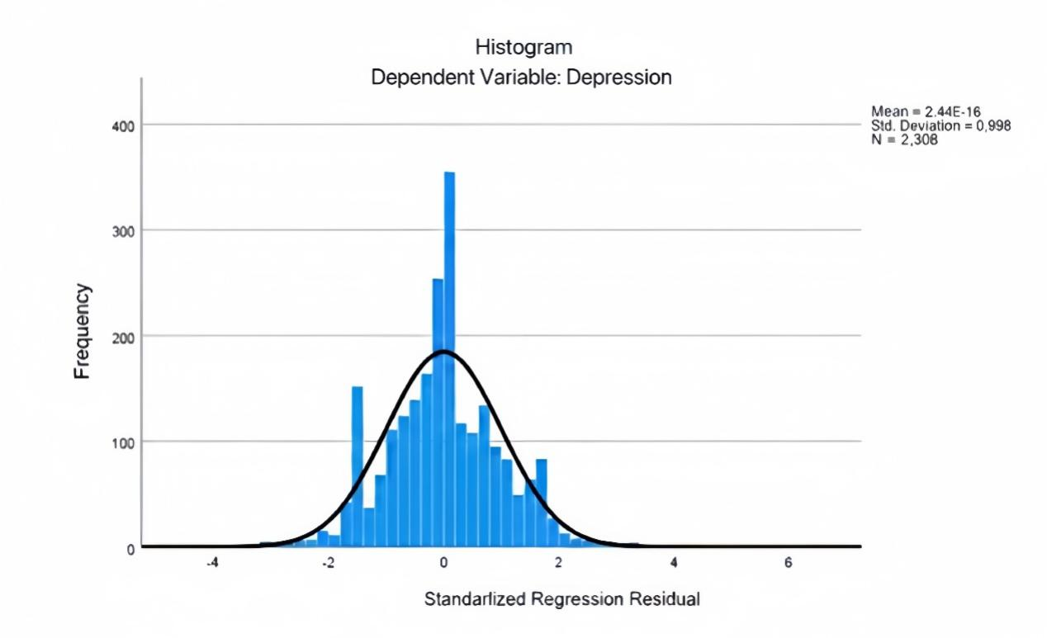
Note. The histogram displays the distribution of standardized residuals for the dependent variable, Depression. The superimposed curve represents the normal distribution. The distribution approximates normality (N = 2,308, M = 0.00, SD = 1.00), satisfying the assumption for regression analysis.
Figure S2 Normality Assessment of Regression Residuals.
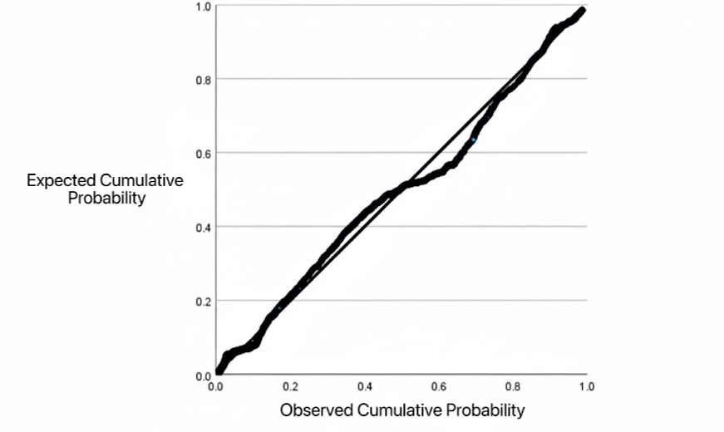
Note. The Normal P-P plot compares the observed cumulative probability of the standardized residuals against the expected cumulative probability of a normal distribution. The points adhere closely to the diagonal line, confirming that the residuals are normally distributed.

3.3.3 Homoscedasticity Test
The scatter plot of residuals versus predicted values shows that the data points are randomly distributed around the predicted values, with no obvious funnel-like pattern or systematic trends observed. This indicates that the homoscedasticity assumption of the regression model is satisfied (see Supplementary Figure 3).
Figure S3 Scatter Plot of Standardized Residuals vs. Predicted Values.
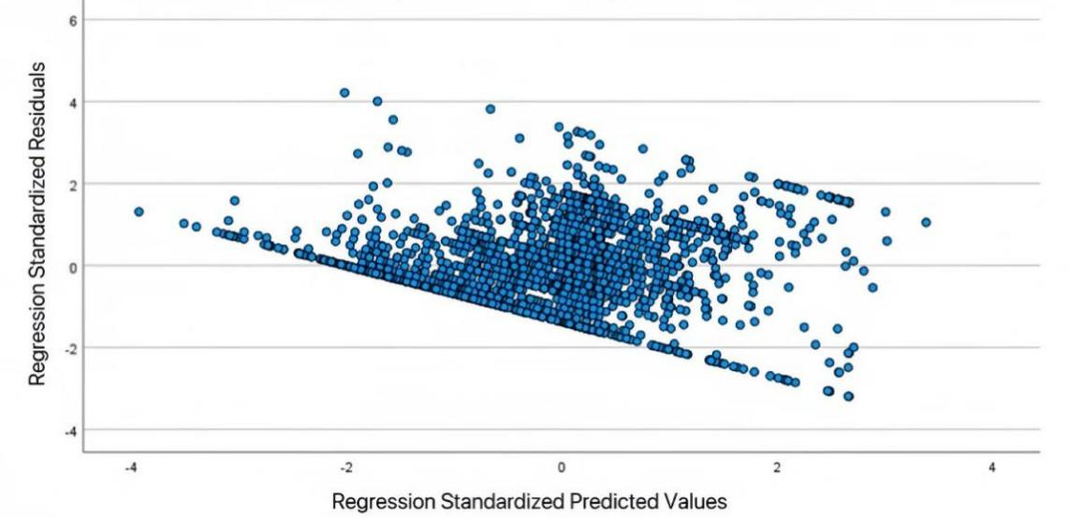
Note. Scatter plot of the regression standardized residuals against the regression standardized predicted values. The random dispersion of points around zero indicating no violation of the homoscedasticity assumption.
Table S3 Regression Diagnostics Statistics.
 | Minimum | Maximum | Mean | Std. Deviation | N
Predicted Value | 1.53 | 30.01 | 16.82 | 3.894 | 2308
Standardized Predicted Value | -3.928 | 3.386 | .000 | 1.000 | 2308
Standard Error of Predicted Value | .156 | 1.320 | .346 | .145 | 2308
Adjusted Predicted Value | 1.10 | 29.87 | 16.82 | 3.898 | 2308
Residual | -18.217 | 24.034 | .000 | 5.690 | 2308
Standardized Residual | -3.195 | 4.216 | .000 | .998 | 2308
Studentized Residual | -3.211 | 4.242 | .000 | 1.000 | 2308
Deleted Residual | -18.395 | 24.335 | .002 | 5.718 | 2308
Studentized Deleted Residual | -3.217 | 4.258 | .000 | 1.001 | 2308
Mahalanobis Distance | .727 | 122.713 | 8.996 | 10.153 | 2308
Cook's Distance | .000 | .027 | .000 | .001 | 2308
Centered Leverage Value | .000 | .053 | .004 | .004 | 2308
a. Dependent Variable: Depression
Table S6 Results of Sex Measurement Invariance Tests.
 | CMIN/DF | p | CFI | TLI | RMSEA | ΔCFI | ΔTLI | ΔRMSEA
Configural Invariance | 11.667 | 0.000 | 0.970 | 0.958 | 0.068 | - | - | -
Metric Invariance | 11.667 | 0.000 | 0.970 | 0.958 | 0.068 | 0.000 | 0.000 | 0.000
Scalar Invariance | 10.562 | 0.000 | 0.969 | 0.962 | 0.064 | -0.001 | 0.004 | -0.004
Strict Invariance | 9.364 | 0.000 | 0.967 | 0.967 | 0.060 | -0.002 | 0.005 | -0.004
RMSEA: root mean square error of approximation; CFl: comparative fit index; TLl: Tucker-Lewis's index; SRMR: standardized root mean square residual
Table S4 Summary of Confirmatory Factor Analysis Model Fit Results.
Fit Indicators | CMIN/df | p | CFI | TLI | RMSEA | RMR
Criteria | <5 | 0.000 | >0.9 | >0.9 | <0.08 | <0.05
Model | 22.03 |  | 0.974 | 0.059 | 0.095 | 0.047
RMSEA: root mean square error of approximation; CFl: comparative fit index; TLl: Tucker-Lewis's index; SRMR: standardized root mean square residual
Table S5 Confirmatory Factor Analysis Results for Variables.
Latent Variables | Observed Variables | Unstandardized Loading | CR Value | AVE | p
ERQcog | ER1 | 1.000 | --- | 0.624 | ---
ERQcog | ER3 | 1.017 | 60.345 | 0.672 | 0.000
ERQcog | ER5 | 0.105 | 50.105 | 0.792 | 0.000
ERQcog | ER7 | 1.147 | 52.678 | 0.846 | 0.000
ERQcog | ER8 | 1.125 | 50.992 | 0.846 | 0.000
ERQcog | ER10 | 1.098 | 50.739 | 0.81 | 0.000
ERQes | ER2 | 1.000 | --- | 0.462 | ---
ERQes | ER4 | 1.068 | 42.399 | 0.518 | 0.000
ERQes | ER6 | 1.304 | 36.274 | 0.81 | 0.000
ERQes | ER9 | 1.228 | 34.503 | 0.706 | 0.000

3.3.3 Inhibition Effect Analysis
After controlling for ERQes (expressive suppression), the partial correlation coefficient between ERQcog (cognitive reappraisal) and DP (depression) was r_partial = –0.108 (p < 0.001), with the direction reversed compared to the zero-order correlation. This indicates that ERQcog exerts a significant inhibition effect on DP. Specifically, the negative effect of ERQcog was masked when ERQes was not controlled for.
Table S6 Partial Correlation Analysis of ERQcog and Depression (DP) Controlling for ERQes.
Control Variables |  |  | Depression | ERQcog
ERQes | Depression | Correlation | 1 | -0.108
ERQes | ERQcog | Correlation | -0.108 | 1

3.5 Moderated mediating effect test
3.5.1 Moderated Mediation Analysis of Perceived Distress on Depression
1. Direct Effect
The direct effect analysis showed that perceived distress (here referring to the "stress-related sense of tension" dimension) had a significant positive predictive effect on depression; that is, the higher the level of perceived distress, the higher an individual’s depression level. Regarding mediating variables, cognitive reappraisal had a significant negative effect on depression, indicating that cognitive reappraisal can effectively alleviate depression levels; in contrast, expressive suppression had a significant positive effect on depression, suggesting that expressive suppression exacerbates depressive symptoms.
IV | B | SE | t | p | LLCI | ULCI
Stress | 0.861 | 0.040 | 21.443 | 0.000 | 0.782 | 0.940
ERQcog | -0.156 | 0.031 | -5.044 | 0.000 | -0.217 | -0.096
ERQes | 0.157 | 0.051 | 3.074 | 0.002 | 0.057 | 0.257
Sex | 0.231 | 0.253 | 9.12 | 0.362 | -0.265 | 0.726
Stress× Sex | 0.152 | 0.059 | 2.577 | 0.010 | 0.036 | 0.268
Age | 0.022 | 0.111 | 0.194 | 0.846 | -0.197 | 0.240
Isolation | -0.373 | 0.165 | -2.260 | 0.024 | -0.696 | -0.049
2. Indirect Effect
The indirect effect analysis showed that perceived distress (stress-related sense of tension) could exert an indirect influence on depression through cognitive reappraisal and expressive suppression. Specifically, the indirect effect via cognitive reappraisal was -0.092, and the indirect effect via expressive suppression was 0.079; both were statistically significant. The total indirect effect was not statistically significant, but the difference between the two pathways was significant. This indicates that the two emotion regulation strategies play opposite-directional roles in the mechanism by which stress affects depression.
Mediation Pathway | Effect | BootSE | 95%CI Lower Bound | 95%CI Upper Bound | Description
ERQcog | -0.092 | 0.020 | -0.134 | -0.055 | Significant
ERQes | 0.079 | 0.027 | 0.024 | 0.133 | Significant
Total Indirect Effect | -0.014 | 0.020 | -0.054 | 0.024 | Not Significant
ERQcog - ERQes Contrast | -0.171 | 0.044 | -0.261 | -0.087 | Significant
3. Moderating Effect
The moderating effect analysis showed that gender significantly moderated the direct effect of perceived distress (stress-related sense of tension) on depression. Further simple effect analysis revealed that in the female group, the effect of perceived distress on depression was 0.861, while this effect was stronger in the male group. This indicates that perceived distress exerts a more significant impact on depression among males.
Sex | B | SE | t | p | LLCI | ULCI
Female (0) | 0.861 | 0.040 | 21.443 | 0.000 | 0.782 | 0.940
Male (1) | 1.013 | 0.049 | 20.474 | 0.000 | 0.916 | 1.111
In summary, perceived distress (stress-related sense of tension) not only directly promotes the development of depression but also exerts an indirect effect on depression through two emotion regulation strategies—cognitive reappraisal and expressive suppression and is significantly moderated by gender. Among these two strategies, cognitive reappraisal exerts a buffering effect, while expressive suppression amplifies the negative impact of stress on depression.

3.5.2 Moderated Mediation Analysis of Perceived Lack of Control (Stress-Related Sense of Uncontrollability) on Depression
1. Direct Effect
The direct effect analysis showed that perceived lack of control (stress-related sense of uncontrollability) had a significant negative predictive effect on depression; that is, the stronger the sense of uncontrollability, the lower an individual’s depression level. Further analysis revealed that cognitive reappraisal had a significant negative effect on depression, indicating that cognitive reappraisal can alleviate depressive symptoms; while expressive suppression had a significant positive effect on depression, suggesting that the higher the tendency toward expressive suppression, the higher an individual’s depression level.
IV | B | SE | t | p | LLCI | ULCI
Stress | -0.123 | 0.035 | -3.472 | 0.001 | -0.193 | -0.054
ERQcog | -0.273 | 0.040 | -6.845 | 0.000 | -0.352 | -0.195
ERQes | 0.639 | 0.055 | 11.591 | 0.000 | 0.531 | 0.747
Sex | 0.182 | 0.291 | 0.625 | 0.532 | -0.389 | 0.753
Stress× Sex | -0.067 | 0.047 | -1.406 | 0.160 | -0.159 | 0.026
Age | 0.032 | 0.128 | 0.248 | 0.804 | -0.219 | 0.283
Isolation | -0.293 | 0.189 | -1.547 | 0.122 | -0.664 | 0.078
2. Indirect Effect
The indirect effect analysis showed that perceived lack of control (stress-related sense of uncontrollability) could indirectly affect depression levels through cognitive reappraisal and expressive suppression. Specifically, the indirect effect via cognitive reappraisal was -0.197, and the indirect effect via expressive suppression was 0.248; both were statistically significant. The total indirect effect was -0.050, which was significantly negative, while the difference between the two indirect pathways was also significant. This indicates that cognitive reappraisal and expressive suppression exhibit opposite psychological mechanisms in the process by which the sense of uncontrollability influences depression.
Mediation Pathway | Effect | BootSE | 95%CI Lower Bound | 95%CI Upper Bound | Description
ERQcog | 0.197 | 0.025 | -0.100 | -0.003 | Significant
ERQes | -0.248 | 0.030 | 0.139 | 0.258 | Significant
Total Indirect Effect | -0.050 | 0.026 | -0.301 | -0.198 | Significant
ERQcog - ERQes Contrast | 0.445 | 0.051 | 0.347 | 0.549 | Significant
3. Moderating Effect
The moderating effect analysis showed that gender did not significantly moderate the direct effect of perceived lack of control (stress-related sense of uncontrollability) on depression. Although the moderating effect was not significant, the simple effect analysis revealed that in the female group, the negative predictive effect of perceived lack of control on depression was -0.123, while this effect was slightly stronger in the male group. This suggests that males exhibit a relatively more pronounced depressive response when facing experiences of uncontrollability.
Sex | B | SE | t | p | LLCI | ULCI
Female (0) | -0.123 | 0.035 | -3.472 | 0.001 | -0.193 | -0.054
Male (1) | -0.190 | 0.043 | -4.391 | 0.000 | -0.274 | -0.105
In summary, the impact of perceived lack of control (stress-related sense of uncontrollability) on depression includes not only a direct pathway but also indirect pathways through cognitive reappraisal and expressive suppression. Among these pathways, cognitive reappraisal exerts a buffering effect, while expressive suppression amplifies the negative effect. Although gender did not significantly moderate this relationship, overall, males exhibit a slightly higher risk of depression than females under high levels of perceived lack of control—this reflects the gender-specific characteristics of individuals in contexts of stress-related uncontrollability.

