Prospective Evaluation of High-risk Assessment Strategy for Esophageal Cancer: a community-based cancer screening cohort in rural China
Author: Hang Yu^{1,2#}, Hengmin Ma^{2#,} Xinyi Wang^{2,3}, Zunlong Fang^{2,} Boyu Liu^{2,3}, Wenxuan Yan^{1,2}, Nan Zhang²*
Table of Contents

Table S1: Criteria for identifying high-risk individuals in the screening program 2
Table S2: Characteristics of incident cases of esophageal cancer 3
Table S3: Characteristics of incident cases of gastric cancer 4
Table S4: Characteristics of incident cases of upper gastrointestinal cancer 5
Table S5: Sensitivity analysis of hazard ratios of EC, GC and UGI incidence when excluding patients with a history of cancer. 6
Table S6: Sensitivity analysis of hazard ratios of EC, GC and UGI incidence when excluding individuals lost to follow-up. 7
Table S7: Sensitivity analysis for 5-year follow-up outcomes 8
Table S8: Sensitivity analysis for 10-year follow-up outcomes 9

Figure S1: Flowchart of the enrolment of study participants, risk assessment, baseline endoscopy screening, management of follow-up and surveillance processes 2
Figure S1: Flowchart of the enrolment of study participants, risk assessment, baseline endoscopy screening, management of follow-up and surveillance processes
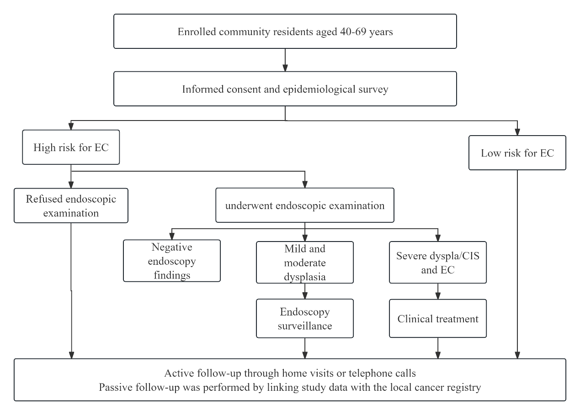

Table S1: Criteria for identifying high-risk individuals in the screening program
Coding | Identified items | Score
A1 | Smoking: 20 cigarettes per day for more than 10 years | 1
A2 | Drinking: half a liter of liquor per week for more than 10 years | 1
A3 | Eating salted or moldy food often | 1
A4 | Eating high-temperature food often | 1
A5 | Family history of upper gastrointestinal cancer | 2
A6 | Any current clinical symptoms | 2
ALL | High-risk individual | ≥2
A6 Any current clinical symptoms, including dysphagia, odynophagia, chest pain, back pain, neck pain, or progressive emaciation.

Table S2: Characteristics of incident cases of esophageal cancer
Characteristic | Non-high-risk group (n, %) | High-risk group (n, %)
Total | 215(36.26) | 378(63.74)
Sex
Male | 136(34.00) | 264(66.00)
Female | 79(49.93) | 114(59.07)
Age,yr
Mean (SD) | 60.55（6.28） | 60.65（6.02）
40-49 | 14(40.00) | 21(60.00)
50-59 | 65(35.71) | 117(64.29)
60-69 | 136(36.17) | 240(63.83)
Education level
Primary school and below | 146(41.36) | 207(58.64)
Secondary school and above | 69(28.75) | 171(71.25)
Income level
<20,000 RMB | 57(40.71) | 83(59.29)
≥20,000 RMB | 158(34.88) | 295(65.12)
BMI, kg/m2
<22 | 43(36.13) | 76(63.87)
≥22 | 172(36.29) | 302(63.71)
Cancer staging
0/I/II | 53(21.90) | 189(78.10)
III/IV | 26(47.27) | 29(52.73)
NA | 136(45.95) | 160(54.05)
SD = stand deviation; yr = year; RMB = Renminbi; BMI = body mass index.

Table S3: Characteristics of incident cases of gastric cancer
Characteristic | Non-high-risk group (n, %) | High-risk group (n, %)
Total | 164（43.85） | 210（56.15）
Sex
Male | 111（41.73 | 155（58.27）
Female | 53（49.07） | 55（50.93）
Age,yr
Mean (SD) | 60.01（7.62） | 60.41（6.24）
40-49 | 24（55.81） | 19（44.19）
50-59 | 32（38.55） | 51（61.45）
60-69 | 108（43.55） | 140（56.45）
Education level
Primary school and below | 116（49.79） | 117（50.21）
Secondary school and above | 48（34.04） | 93（65.96）
Income level
<20,000 RMB | 45（49.45） | 46（50.55）
≥20,000 RMB | 119（42.05） | 164（57.95）
BMI, kg/m2
<22 | 37（52.11） | 34（47.89）
≥22 | 127（41.91） | 176（58.09）
Cancer staging
0/I/II | 45（35.16） | 83（64.84）
III/IV | 15（44.12） | 19（55.88）
NA | 104（49.01） | 108（50.94）
SD = stand deviation; yr = year; RMB = Renminbi; BMI = body mass index.

Table S4: Characteristics of incident cases of upper gastrointestinal cancer
Characteristic | Non-high-risk group (n, %) | High-risk group (n, %)
Total | 379(39.19) | 588(60.81)
Sex
Male | 247(37.09) | 419(62.91)
Female | 132(43.85) | 169(56.15)
Age,yr
Mean (SD) | 60.32 (6.89) | 60.56 (6.10)
40-49 | 38(48.72) | 40(51.28)
50-59 | 97(36.60) | 168(63.40)
60-69 | 244(39.10) | 380(60.90)
Education level
Primary school and below | 262(44.71) | 324(55.29)
Secondary school and above | 117(30.71) | 264(69.29)
Income level
<20,000 RMB | 102(44.16) | 129(55.84)
≥20,000 RMB | 277(37.64) | 459(62.36)
BMI, kg/m2
<22 | 80(42.11) | 110(57.89)
≥22 | 299(38.48) | 478(61.52)
Cancer staging
0/I/II | 98(26.49) | 272(73.51)
III/IV | 41(46.07) | 48(53.93)
NA | 240(47.24) | 268(52.76)
SD = stand deviation; yr = year; RMB = Renminbi; BMI = body mass index.

Table S5: Sensitivity analysis of hazard ratios of EC, GC and UGI incidence when excluding patients with a history of cancer.
Stratified variables | Esophageal cancer |  |  |  | Gastric cancer |  |  |  | UGI cancer
Stratified variables | Person-years (cases) | Crude HR (95% CI) | Adjusted HR (95% CI) |  | Person-years (cases) | Crude HR (95% CI) | Adjusted HR (95% CI) |  | Person-years (cases) | Crude HR (95% CI) | Adjusted HR (95% CI)
ALL
Non-high-risk group | 511375.53  (201) | Ref. | Ref. |  | 511375.53  (154) | Ref. | Ref. |  | 511375.53  (355) | Ref. | Ref.
High-risk group | 150244.40  (104) | 1.77  (1.40-2.25) | 1.74  (1.47-2.06) |  | 150244.40  (66) | 1.47  (1.10-1.96) | 1.29  (1.05-1.58) |  | 150244.40  (170) | 1.64  (1.37-1.97) | 1.55  (1.36-1.76)
Men
Non-high-risk group | 223086.57  (132) | Ref. | Ref. |  | 223086.57  (106) | Ref. | Ref. |  | 223086.57  (238) | Ref. | Ref.
High-risk group | 91055.12  (84) | 1.63  (1.24-2.15) | 1.60  (1.21-2.11) |  | 91055.12  (54) | 1.31  (0.94-1.82) | 1.32  (0.94-1.84) |  | 91055.12  (138) | 1.49  (1.21-1.84) | 1.47  (1.19-1.82)
Women
Non-high-risk group | 278871.75  (69) | Ref. | Ref. |  | 278871.75  (48) | Ref. | Ref. |  | 278871.75  (117) | Ref. | Ref.
High-risk group | 59189.28  (20) | 1.39  (0.85-2.29) | 1.31  (0.80-2.17) |  | 59189.28  (12) | 1.18  (0.63-2.22) | 1.09  (0.58-2.06) |  | 59189.28  (32) | 1.31  (0.88-1.93) | 1.22  (0.83-1.81)
Ref=reference. CI=confidence interval. HR=hazard ratio.

Table S6: Sensitivity analysis of hazard ratios of EC, GC and UGI incidence when excluding individuals lost to follow-up.
Stratified  variables | Esophageal cancer |  |  |  | Gastric cancer |  |  |  | UGI cancer
Stratified  variables | Person-years (cases) | Crude HR (95% CI) | Adjusted HR (95% CI) |  | Person-years (cases) | Crude HR (95% CI) | Adjusted HR (95% CI) |  | Person-years (cases) | Crude HR (95% CI) | Adjusted HR (95% CI)
ALL
Non-high-risk group | 525931.76  (215) | Ref. | Ref. |  | 525931.76  (164) | Ref. | Ref. |  | 525931.76  (379) | Ref. | Ref.
High-risk group | 465692.25  (378) | 2.01  (1.70-2.37) | 1.74  (1.47-2.06) |  | 465692.25  (210) | 1.46  (1.19-1.79) | 1.29  (1.05-1.58) |  | 465692.25  (588) | 1.77  (1.55-2.01) | 1.55  (1.36-1.76)
Men
Non-high-risk group | 234554.68  (136) | Ref. | Ref. |  | 234554.68  (111) | Ref. | Ref. |  | 234554.68  (247) | Ref. | Ref.
High-risk group | 218276.17  (264) | 2.11  (1.71-2.60) | 1.82  (1.48-2.25) |  | 218276.17  (155) | 1.51  (1.18-1.93) | 1.35  (1.05-1.72) |  | 218276.17  (419) | 1.84  (1.57-2.15) | 1.61  (1.37-1.89)
Women
Non-high-risk group | 291377.08  (79) | Ref. | Ref. |  | 291377.08  (53) | Ref. | Ref. |  | 291377.08  (132) | Ref. | Ref.
High-risk group | 247416.08  (114) | 1.72  (1.29-2.29) | 1.61  (1.21-2.14) |  | 247416.08  (55) | 1.23  (0.84-1.80) | 1.17  (0.80-1.70) |  | 247416.08  (169) | 1.53  (1.21-1.92) | 1.43  (1.39-1.80)
Ref=reference. CI=confidence interval. HR=hazard ratio.

Table S7: Sensitivity analysis for 5-year follow-up outcomes
Stratified variables | Esophageal cancer |  |  |  | Gastric cancer |  |  |  | UGI cancer
Stratified variables | Person-years (cases) | Crude HR (95% CI) | Adjusted HR (95% CI) |  | Person-years (cases) | Crude HR (95% CI | Adjusted HR (95% CI) |  | Person-years (cases) | Crude HR (95% CI) | Adjusted HR (95% CI)
ALL
Non-high-risk group | 324130.25  (130) | Ref. | Ref. |  | 324130.25  (103) | Ref. | Ref. |  | 324130.25  (233) | Ref. | Ref.
High-risk group | 276444.06  (209) | 1.89  (1.51-2.35) | 1.65  (1.32-2.06) |  | 276444.06  (109) | 1.24  (0.95-1.62) | 1.12  (0.85-1.47) |  | 276444.06  (318) | 1.60  (1.35-1.90) | 1.42  (1.20-1.68)
Men
Non-high-risk group | 146434.46  (77) | Ref. | Ref. |  | 146434.46  (71) | Ref. | Ref. |  | 146434.46  (148) | Ref. | Ref.
High-risk group | 129365.73  (152) | 2.23  (1.70-2.94) | 1.94  (1.47-2.57) |  | 129365.73  (81) | 1.29  (0.94-1.78) | 1.16  (0.84-1.60) |  | 129365.73  (233) | 1.78  (1.45-2.19) | 1.57  (1.27-1.93)
Women
Non-high-risk group | 177695.79  (53) | Ref. | Ref. |  | 177695.79  (32) | Ref. | Ref. |  | 177695.79  (85) | Ref. | Ref.
High-risk group | 147078.33  (57) | 1.30  (0.89-1.89) | 1.22  (0.84-1.77) |  | 147078.33  (28) | 1.06  (0.64-1.76) | 1.03  (0.62-1.71) |  | 147078.33  (85) | 1.21  (0.89-1.63) | 1.15  (0.85-1.55)
Ref=reference. CI=confidence interval. HR=hazard ratio.

Table S8: Sensitivity analysis for 10-year follow-up outcomes
Stratified variables | Esophageal cancer |  |  |  | Gastric cancer |  |  |  | UGI cancer
Stratified variables | Person-years (cases) | Crude HR (95% CI) | Adjusted HR (95% CI) |  | Person-years (cases) | Crude HR (95% CI) | Adjusted HR (95% CI) |  | Person-years (cases) | Crude HR (95% CI) | Adjusted HR (95% CI)
ALL
Non-high-risk group | 527701.20  (213) | Ref. | Ref. |  | 527701.20  (164) | Ref. | Ref. |  | 527701.20  (377) | Ref. | Ref.
High-risk group | 461451.78  (319) | 1.72  (1.45-2.05) | 1.51  (1.27-1.80) |  | 461451.78  (186) | 1.29  (1.05-1.59) | 1.15  (0.93-1.42) |  | 461451.78  (505) | 1.53  (1.34-1.75) | 1.35  (1.18-1.55)
Men
Non-high-risk group | 236743.73  (135) | Ref. | Ref. |  | 236743.73  (111) | Ref. | Ref. |  | 236743.73  (246) | Ref. | Ref.
High-risk group | 217846.66  (227) | 1.84  (1.49-2.28) | 1.62  (1.30-2.01) |  | 217846.66  (141) | 1.37  (1.07-1.76) | 1.24  (0.96-1.60) |  | 217846.66  (368) | 1.63  (1.38-1.91) | 1.45  (1.23-1.71)
Women
Non-high-risk group | 290957.47  (78) | Ref. | Ref. |  | 290957.47  (53) | Ref. | Ref. |  | 290957.47  (131) | Ref. | Ref.
High-risk group | 243605.12  (92) | 1.41  (1.04-1.91) | 1.32  (0.98-1.79) |  | 243605.12  (45) | 1.01  (0.68-1.51) | 0.97  (0.65-1.44) |  | 243605.12  (137) | 1.25  (0.98-1.59) | 1.18  (0.93-1.50)
Ref=reference. CI=confidence interval. HR=hazard ratio.

