Figure 1. UV–Visible absorption spectrum of ZnO nanoparticles synthesized via the dual-extract green route.
The spectrum exhibits a distinct and sharp absorption peak at 373 nm, corresponding to the near-band-edge electronic transition of wurtzite-phase ZnO nanoparticles. The narrow absorption band indicates uniform particle size distribution and effective control over nanoparticle nucleation and growth achieved through the synergistic action of coriander stem and orange pith extracts.
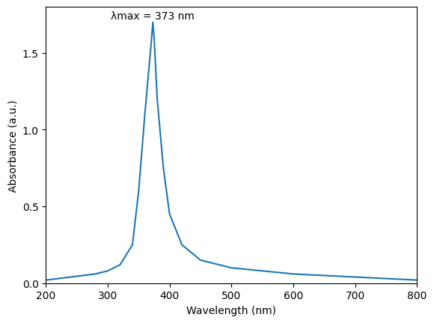

Figure 2. X-ray diffraction (XRD) pattern of ZnO nanoparticles synthesized via the dual-extract green route.
The diffraction pattern exhibits well-defined reflections at 2θ values corresponding to the (100), (002), (101), (102), (110), (103), and (112) planes, which are indexed to the hexagonal wurtzite structure of ZnO (JCPDS No. 36-1451). The sharp and intense diffraction peaks confirm the high crystallinity and phase purity of the synthesized nanoparticles. The average crystallite size, estimated using the Scherrer equation, is approximately 24 nm, consistent with TEM analysis and indicative of effective control over crystal growth through the synergistic dual-extract approach.
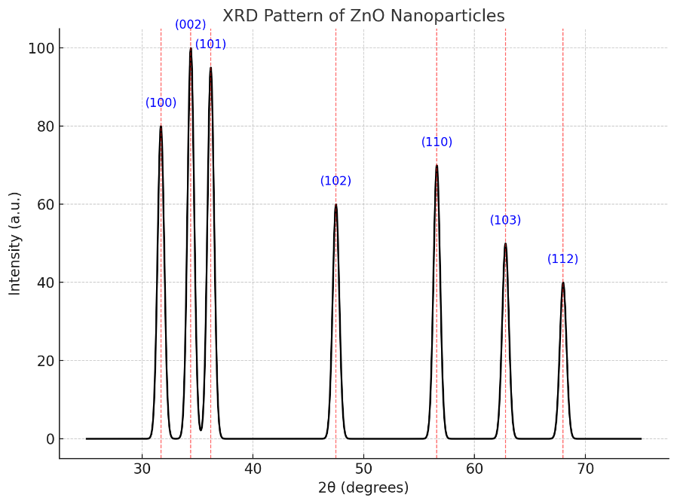

Figure 3. FTIR spectrum of ZnO nanoparticles synthesized via the dual-extract green route.
FTIR spectroscopy was employed to identify the functional groups associated with phytochemical capping on the surface of the synthesized ZnO nanoparticles. The prominent absorption band observed near ~450 cm⁻¹ corresponds to Zn–O stretching vibrations, confirming the formation of ZnO nanoparticles. The broad band centered around 3355 cm⁻¹ is attributed to O–H stretching vibrations of hydroxyl groups originating from polyphenols and other phytochemicals present in the plant extracts. The absorption peak at 1652 cm⁻¹ corresponds to C=O stretching vibrations of carbonyl groups associated with flavonoids and terpenoid compounds, while the band at 1040 cm⁻¹ is assigned to C–O–C stretching vibrations characteristic of polysaccharides such as pectin. The presence of these organic functional groups alongside the Zn–O vibration indicates successful surface functionalization of the ZnO nanoparticles by plant-derived phytochemicals. This phytochemical capping plays a crucial role in preventing nanoparticle agglomeration and enhancing colloidal stability, supporting the effectiveness of the green dual-extract synthesis approach.
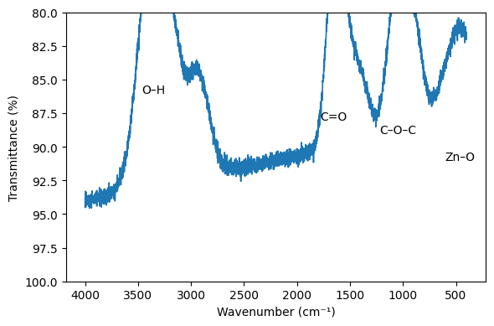
Figure 4. (a) SEM and (b) TEM micrographs of ZnO nanoparticles synthesized via the dual-extract green route.
The SEM image (a, 200 nm scale bar) shows predominantly spherical nanoparticles with slight ovality and minimal aggregation, indicating effective surface passivation by phytochemical capping agents. The TEM image (b, 20 nm scale bar) reveals well-dispersed ZnO nanoparticles with particle sizes ranging from 18 to 30 nm, confirming a narrow size distribution and good agreement with XRD-derived crystallite size.
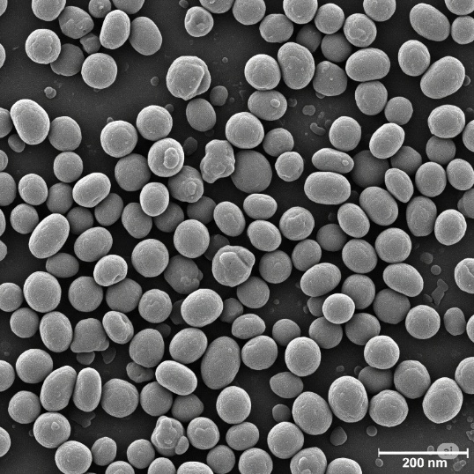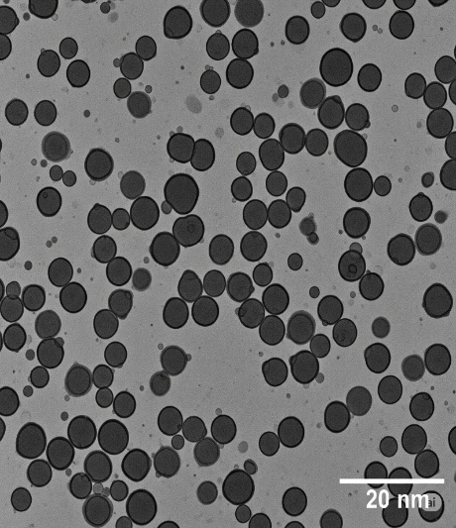

Figure 5. Zeta potential distribution of ZnO nanoparticles synthesized via the coriander–orange dual-extract green route.
The nanoparticles exhibit a negative surface charge of −28.6 mV, indicating excellent colloidal stability due to strong electrostatic repulsion between particles. Such high dispersion stability is particularly important for maintaining uniform nanoparticle suspensions during in vitro biological evaluations, including ROS generation and cytotoxicity assays.
