Table 1: Synthetic polymers tested for epifluorescence upon excitation at 390nm and an emission recorded >420nm using a Long Pass filter. This was done on a Nikon microscope equipped with the PARISS® hyperspectral imaging system. Plastics used are standards from the PolymerKit 1.0; Hawaii Pacific University.
Synthetic polymer | Abbreviation | Wavelength (color) of epifluorescence (nm)
Acrylonitrile Butadiene Styrene | ABS | 530 (Blue/Green) | 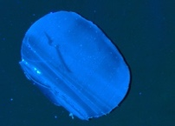
Cellulose Acetate | CA | 505 (Blue) | 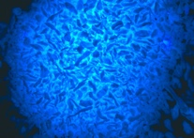
Crumb Rubber (tire) | CR | None | 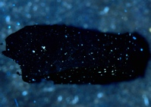
Ethylene Vinyl Acetate | EVA | None | 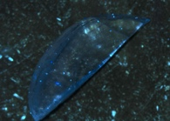
Polyamide 66 (nylon) | PA66 | 495 (Blue/Green) | 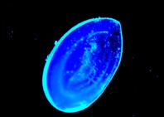
Polyester | PEST | 460 (Blue) | 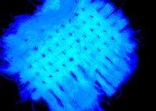
Polyester (with line dyed black) | PEST | None for black line | 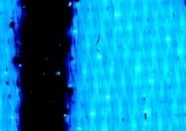
Polyethylene Terephthalate | PET | 475 (Blue/Green) | 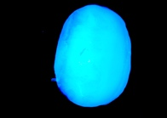
Polypropylene | PP | 465 (Blue) | 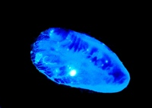
Polystyrene | PS | 475 (Blue) | 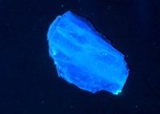
Polyurethane (Elastane/Spandex) | EA/SP | 450 (Blue) | 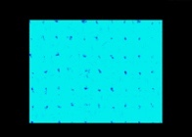
Polyvinyl Chloride | PVC | 530 (Blue/Green) | 