SUPPLEMENTARY APPENDIX

Association between triglyceride-lipase index and clinical outcomes in patients with hypertriglyceridemia-associated acute pancreatitis
Supplemental Content
Supplement Section 1. Definition of other secondary outcomes 3
Supplement Table 1. Association between triglyceride-lipase index quartiles and incidence and duration of organ failure in patients with organ failure at baseline 4
Supplement Figure 1. Distribution of OFFDs to 14 days of enrollment in the four quartiles 5
Supplement Figure 2. Directed acyclic graph for OFFDs to 14 days of enrollment 6

Supplement Section 1. Definition of other secondary outcomes
New-onset organ failure within 14 days of enrollment: Organ failure that is not present at any time in the 24h after enrollment within 14 days of enrollment.
Persistent organ failure (POF) within 14 days of enrollment: Organ failure that persists for more than 48h within 14 days of enrollment.
ICU-free days 14 days of enrollment: The number of days alive and not admitted to an ICU after the patient’s latest discharge from the ICU before day 14. If the patient is admitted to an ICU on day 14 or dies prior to day 14, ICU-free days will be 0.
Hospital duration: Hospital days measured from hospital admission to discharge.

Supplement Table 1. Association between triglyceride-lipase index quartiles and incidence and duration of organ failure in patients with organ failure at baseline
Variables | Q1 | Q2 | Q3 | Q4 | P for trend
Range of baseline triglyceride-lipase index levels, mmol×U/L² | 321.76 - 4400.69 | 4400.69 - 11804.98 | 11804.98 - 32576.41 | 32576.41 - 652301.69
N of participants | 10 | 14 | 16 | 25
OFFD, median (IQR), days | 13.50 (10.50,14.00) | 10.00 (4.00,14.00) | 9.50 (5.75,12.25) | 9.00 (1.00,12.00)
Unadjusted IRRs (95% CI) | 1.0(reference) | 0.70(0.35, 1.36) | 0.69(0.35, 1.32) | 0.57(0.30, 1.03) | 0.089
Adjusted IRRs (95% CI) | 1.0(reference) | 0.70(0.35, 1.36) | 0.70(0.34, 1.42) | 0.57(0.31, 1.02) | 0.084
Time to organ failure resolution, median (IQR), days | 0.50 (0.00,3.50) | 4.00 (0.00,10.00) | 4.50 (1.75,8.25) | 5.00 (2.00,13.00)
Unadjusted hazard ratio (95% CI) | 1.0(reference) | 0.39(0.16,0.91) | 0.36(0.15,0.84) | 0.28(0.12,0.62) | 0.010
Adjusted hazard ratio (95% CI) | 1.0(reference) | 0.57(0.22,1.48) | 0.36(0.14,0.88) | 0.34(0.14,0.83) | 0.013
OFFD: organ failure–free day; OF: organ failure; IQR: interquartile range; CI: confidence interval.
#Adjusted for gender, age, diabetes history, time interval from the symptom onset to study enrollment and baseline APACHE II score.

Supplement Figure 1. Distribution of OFFDs to 14 days of enrollment in the four quartiles
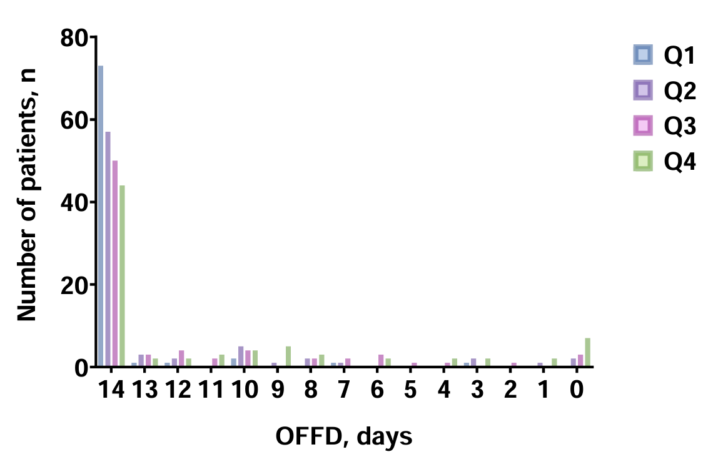

Supplement Figure 2. Directed acyclic graph for OFFDs to 14 days of enrollment
