Flood generation processes shape socio-economic impacts by modulating adaptation efficiency

Jiarui Yu^{1,2,*}, Dominik Paprotny^{3,4}, Ralf Merz², Larisa Tarasova²
¹Faculty of Arts and Sciences, Beijing Normal University, Zhuhai, China
²Helmholz Centre for Environmental Research - UFZ, Department Catchment Hydrology, Halle (Saale), Germany
³Institute of Marine and Environmental Sciences, University of Szczecin, Szczecin, Poland
⁴Research Department Transformation Pathways, Potsdam Institute for Climate Impact Research (PIK), Member of the Leibniz Association, Potsdam, Germany

*Corresponding author: Jiarui Yu, Faculty of Arts and Sciences, Beijing Normal University, Zhuhai, China; Email: Jiarui.Yu@bnu.edu.cn

Supporting Information
Text S1. Counterfactual flood impacts
We use the modeled flood catalog that forms the Historical Analysis of Natural Hazards in Europe (HANZE) database (Paprotny et al. 2024). Driven by climate reanalysis, the catalog contains nearly 15,000 events with considerable flood impact potential recorded between 1950 and 2020 in 42 European countries. Of these, 1678 impact footprints correspond to historical damaging flood records (Paprotny, Terefenko, and Śledziowski 2024) that caused at least one of the following impacts: (a) at least 1000 ha inundation area; (b) at least one person killed or is missing and presumed deceased; (c) at least 200 people are evacuated or affected as their homes were flooded; (d) at least 1 million euro in asset damage (in 2020 prices and exchange rates). In this analysis, the impacts of those events are modeled (constrained by historically observed losses and their spatial distribution) under counterfactual scenario fixing exposure, flood protection and vulnerability at 1950 levels, thus removing the direct socioeconomic influence on changes in flood losses over time, leaving only the effects of climate change and catchment alteration (Paprotny et al. 2025). Impact location is defined by subnational regions largely based on the European Union’s Nomenclature of Territorial Units for Statistics (NUTS 3 level, version 2010) (EU 2011) and the impacts are estimated per region. The flood impacts in the HANZE dataset include information on fatalities, economic loss and the number of people affected. In this study, we only consider fatalities and economic loss, as the number of people affected is associated with larger uncertainty and highly correlated with economic damage (Rentschler, Salhab, and Jafino 2022). We also exclude coastal and compound events (i.e., the combination of riverine and coastal floods) and floods that would not be significant under the counterfactual scenario. The analysis is performed using the remaining 1133 impact footprints in the period 1960-2010. As an impact footprint may contain the flood impacts spanning multiple NUTS-3 regions, these 1133 impact footprints are disaggregated to the NUTS 3 level, resulting in 4754 NUTS-3-level records.
Text S2. Identification and characteristics of flood events
We use the observed annual maximum floods in 1206 European catchments during the period from 1960 to 2010 from the European flood database (Blöschl et al. 2017; Blöschl et al. 2019). This database provides the date and the maximum peak discharge of flood events and the corresponding beginning and end points are extracted from the routed streamflow time series simulated by the regional hydrological mHM model (Samaniego, Kumar, and Attinger 2010; Kumar, Livneh, and Samaniego 2013) using an automated time-series-based event separation method procedure (Tarasova et al. 2018). The mHM model is driven by the downscaled 5 km E-OBS product (Haylock et al. 2008; Samaniego et al. 2017) at daily resolution and streamflow is routed by the multiscale routing algorithm (Thober et al. 2019). This model was successfully cross-validated for streamflow simulation accuracy across 357 European catchments (Samaniego et al. 2019) and was also tested in terms of the accuracy of timing and magnitude of annual flood simulations in our study catchments (Tarasova et al. 2023).
The time-series-based event separation method employed the observed rainfall and simulated streamflow and snowmelt time series to identify flood events, consisting of three steps: base flow separation, rainfall and snowmelt attribution and an iterative procedure for refinement of multiple-peak events (Tarasova et al. 2018). As the original method for event separation was developed for mesoscale German catchments, applying it to a much more diverse set of European catchments led to issues with exceedingly steep baseflow increases. Therefore, the method was adjusted by identifying events with a slope of baseflow increase higher than the 75th percentile of all events and merging them with the following event, and this procedure was repeated until all slopes exceeding the specified threshold are corrected (Tarasova et al. 2023).
We use peak discharge and onset time to characterize the identified flood events. The observed peak discharge is normalized by dividing it by mean maximum annual flood of each catchment, providing an indicator of the hazard level of each flood. The onset time, defined as the onset duration (days) from the beginning of the event till the day when peak discharge was observed, is derived from the simulated time series of identified flood events and represents how fast the peak is reached.
Text S3. Obtaining impactful flood events and corresponding impacts
We link the 1133 impact footprints with the observed annual maximum floods in 1206 European catchments based on their locations and occurrence times to obtain impactful flood events (Figure S1). First, we link the impact footprints reported for different administrative units (i.e., 4754 NUTS-3-level records) with river catchments available from the European Flood Database (Blöschl et al. 2017; Blöschl et al. 2019). Once the impact footprints and catchments are linked in space, we temporally link impact records and corresponding flood events using their start and end dates for all catchments that contain at least one impact event. We also add a tolerance window of days (where A is the catchment area in km²) (Ganguli and Merz 2019) that represents a lag time to consider flood wave propagation time downstream and reconcile the possible temporal discrepancies of the records due to the unknown exact location of the impact event within the catchment, uncertainties of the counterfactual simulation of HANZE and the uncertainties of the mHM simulations. Since the choice of the window length is unavoidably subjective, we test the sensitivity of this choice (Table S1). The bias in identifying impactful flood events between the selected tolerance window (i.e., area-specific lag time as mentioned above) and alternative options (i.e., 0, 1, 2, 5, 10 and 20 days) ranges from -0.68% to 10.00%, indicating that the choice of the tolerance window does not considerably affect the number of impactful floods available for analysis. With the outlined procedure for each of the reported impact footprints, we obtain the list of annual maximum flood events that occurred in river catchments that are (partly) located within the reported impact footprint (i.e., 2342 NUTS-3-level records).
Table S1. Number of impact events linked to flood footprints and impactful flood events identified based on different tolerance windows.
Tolerance window (days) | Number of  impactful flood events | Bias  (compared with Lag time)
0 | 4705 | -0.68%
1 | 4721 | -0.34%
Lag time () | 4737 | 0.00%
2 | 4745 | 0.17%
5 | 4814 | 1.63%
10 | 4934 | 4.16%
20 | 5211 | 10.00%
Note: A is the catchment area in km².
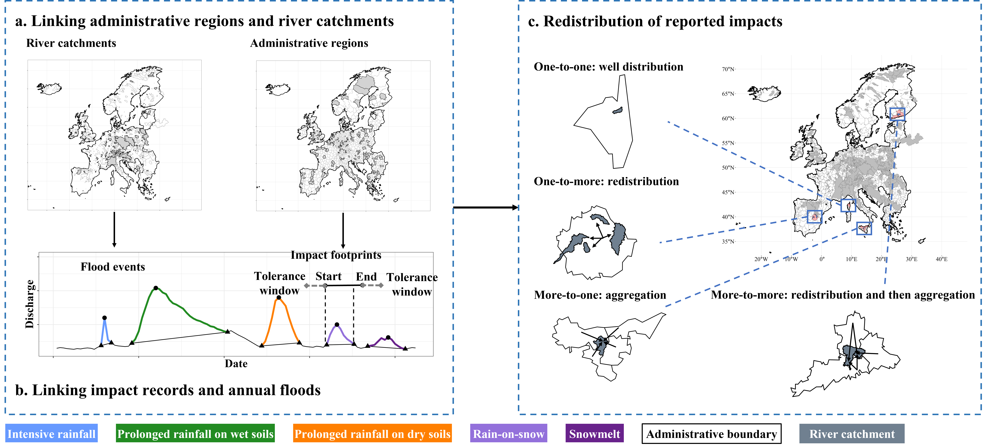
Figure S1. The steps to obtain impactful flood events: The first step is to link the impact footprints reported for different administrative units (i.e., European Union’s Nomenclature of Territorial Units for Statistics (NUTS) 3 level) with river catchments available from the European Flood Database. Then, for all catchments that contain at least one impact footprint, their start and end dates are used to link impact records and corresponding flood events. The tolerance window of days (A is the catchment area in km²) is added to account for the possible uncertainties (see the effect of different choices of the tolerance window in Table S1). Four possible situations are considered to obtain impactful flood events (i.e., annual maximum flood with a corresponding impact record): single impact record corresponds to a single flood event (i.e., one-to-one case that requires no additional processing); single impact record corresponds to two or more flood events (one-to-more case that require a redistribution of the impact between multiple floods), more impact records correspond to a single flood event (more-to-one case that requires aggregation of multiple impacts) and more impact records to more flood events (more-to-more case where multiple impacts have to be redistributed and aggregated to several corresponding flood events). The redistribution is performed proportionally to the peak discharges of target flood events scaled by the mean maximum annual flood peaks for each corresponding river catchment. Impactful flood events are divided into five types (see Text S4).
There are 215 out of 2342 NUTS-3-level records corresponding to a single flood event (i.e., one-to-one case that requires no redistribution of impacts; Figure S2). For 459 NUTS-3-level records where two or more impact records correspond to a single flood event (more-to-one case that requires aggregation of multiple impacts; Figure S2), we sum the impacts of the impact records corresponding to each single flood event to obtain its total impacts. The remaining 1668 NUTS-3-level records require redistributions that follows one of the two situations (Figure S2): single impact record corresponds to two or more flood events (one-to-more case that require a redistribution of the impact between multiple floods) and two or more impact records to two or more flood events (more-to-more case where multiple impacts have to be redistributed and then aggregated to several corresponding flood events). For these 1668 NUTS-3-level records linked to two or more flood events in two or more river catchments, we redistribute the impacts according to the peak discharges of these flood events scaled by the mean maximum annual flood peaks for each corresponding river catchment. After redistributing the impacts to each linked flood event, we sum the redistributed impacts corresponding to each single flood event to obtain its total impacts, as done in the more-to-one case. We also test the sensitivity of this redistribution using alternative flood attributes, such as flood duration and volume, as well as two different scaling methods (e.g., normalization and frequency analysis) to ensure the robustness of redistribution. Specifically, the three scaling methods can be expressed as follows:
(M1) The peak discharges of these flood events scaled by the mean maximum annual flood peaks for each corresponding river catchment:
where is the series of annual peak discharge of a catchment; is the mean of the series of the catchment.
(M2) The peak discharges of these flood events scaled by the normalization method:
(M3) The probability of peak discharges of these flood events calculated by the Generalized Extreme Value (GEV) distribution.
where is the location parameter, is the scale parameter, and is the shape parameter.
The two-sided Kolmogorov-Smirnov test and Wilcox test with false discovery rate correction are employed to evaluate the effect of different redistribution methods and the test result shows the insignificant (p>0.05) impacts of different redistribution methods on the results of redistributed flood impacts.
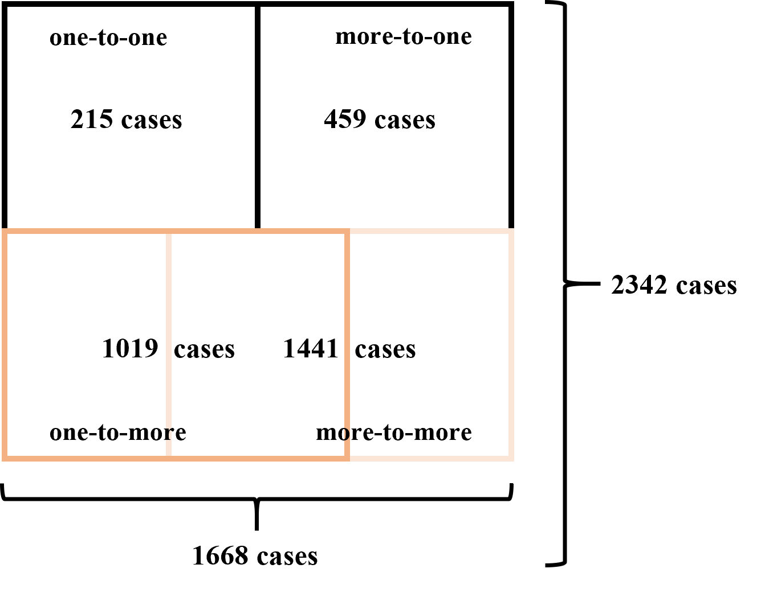
Figure S2. The cases of different situations to redistribute reported impacts. Here a case is an impact record reported for an administrative unit (i.e., European Union’s Nomenclature of Territorial Units for Statistics (NUTS) 3 level). The one-to-one case means that one impact record corresponds to a single flood event, which requires no redistribution of impacts. The more-to-one case means that two or more impact records correspond to a single flood event, which requires aggregation of multiple impacts. The one-to-more case means that a single impact record corresponds to two or more flood events, which requires a redistribution of the impact between multiple floods. The more-to-more case means that two or more impact records correspond to two or more flood events, which requires that multiple impacts have to be redistributed and then aggregated to several corresponding flood events.
Text S4. Causative classification of impactful flood events
We attribute each impactful flood events into one of the five event types according to their flood generation processes using the classification proposed in Tarasova et al. (2020): (1) flood events generated by snowmelt only; (2) flood events generated by simultaneous rainfall and snowmelt (rain-on-snow); (3) flood events generated by intensive rainfall; (4) flood events generated by prolonged rainfall on dry soils and (5) flood events generated by prolonged rainfall on wet soils. The indicators, i.e., the portion of catchment- and event-averaged snowmelt M_{x,y,t} relative to the total volume of precipitation P_{x,y,t} event (i.e., ), the catchment-averaged antecedent soil moisture one day prior the start of the corresponding flood event SM_{x,y}(t₀) and the ratio of maximum precipitation rate max(P_{x,y}(t)) and total precipitation volume P_{x,y,t}, (i.e., ) are used for this classification. The antecedent soil moisture max(κ) is the point of maximum curvature of the fitted exponential function that describes a non-linear behavior of runoff event coefficients and antecedent soil moisture for all runoff events identified. Below this threshold, event runoff coefficients are rather low and increase only slightly with increasing soil moisture, corresponding to dry antecedent conditions. Above this threshold, event runoff coefficients are higher and increase rapidly with increasing soil moisture, corresponding to wet antecedent conditions. The critical thresholds for these indicators are similar to the thresholds in Tarasova et al. (2023): The threshold for is 0.7 and 0.3, respectively, used to classify impactful flood events into the snowmelt type (), the rain-on-snow type () and the rainfall-generated type (). For the rainfall-generated type, the threshold for is 0.5 (Tarasova et al. 2020), classifying these events into flood events generated by intensive rainfall () and by prolonged rainfall (). For these flood events generated by prolonged rainfall, if , the events are the flood events generated by prolonged rainfall on wet soils; otherwise, they are the flood events generated by prolonged rainfall on dry soils. The extracted beginning and end points of each impactful flood event using a time-series-based event separation method (Tarasova et al. 2018) were used to attribute flood-inducing precipitation and snowmelt and to identify antecedent soil moisture prior to each flood event. Among these indicators, observed precipitation was obtained from a downscaled 5 km E-OBS product (Haylock et al. 2008; Samaniego et al. 2017), while snowmelt and soil moisture were simulated using the mHM model (Samaniego, Kumar, and Attinger 2010; Kumar, Samaniego, and Attinger 2013).
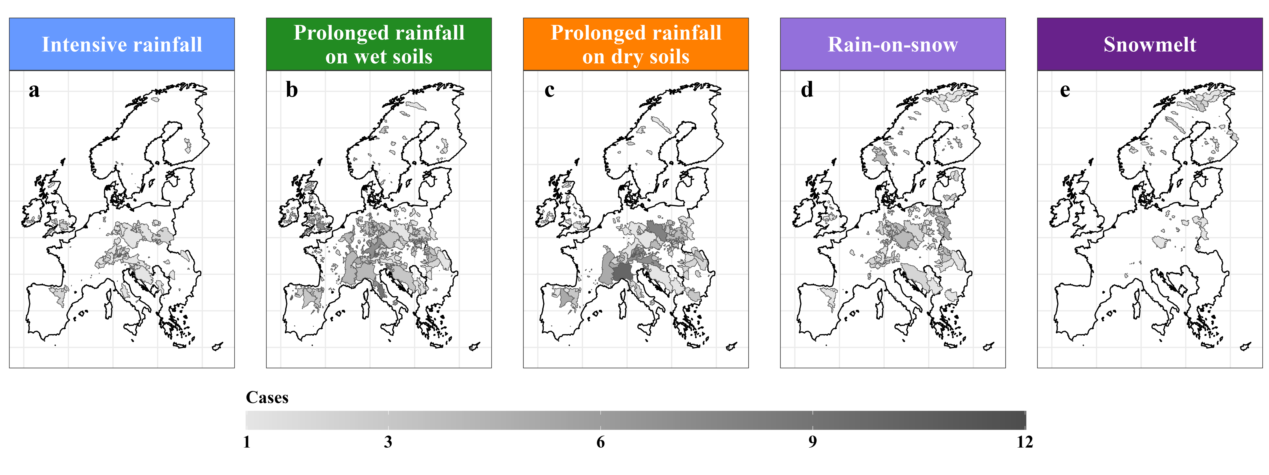
Figure S3. The spatial distribution of impactful flood events generated by five processes: (a) intensive rainfall (388 events), (b) prolonged rainfall on wet soils (2288 events), (c) prolonged rainfall on dry soils (1214 events), (d) simultaneous rainfall and snowmelt (rain-on-snow, 740 events) as well as (e) snowmelt (107 events) in Europe.
Text S5. Adaptation effects from frequent experience of floods generated by the most common processes using relative impacts
In addition to the absolute impacts (i.e., fatalities and economic losses directly obtained from the HANZE dataset using the method described above), we also examined the relative impacts (i.e., fatalities and economic losses per unit area, obtained by dividing the absolute impacts by the corresponding catchment area of each impactful flood event). This allows us to account for the influence of catchment size, as larger catchments typically encompass greater population and assets and therefore may incur higher impacts. As shown in Figure S4, the results based on relative impacts are similar to those based on absolute impacts (Fig. 2). Similarly, we also observe positive adaptation effects in the Northern and Mediterranean regions (Figure S4b, c), although only for fatalities in the latter case (Figure S4b).
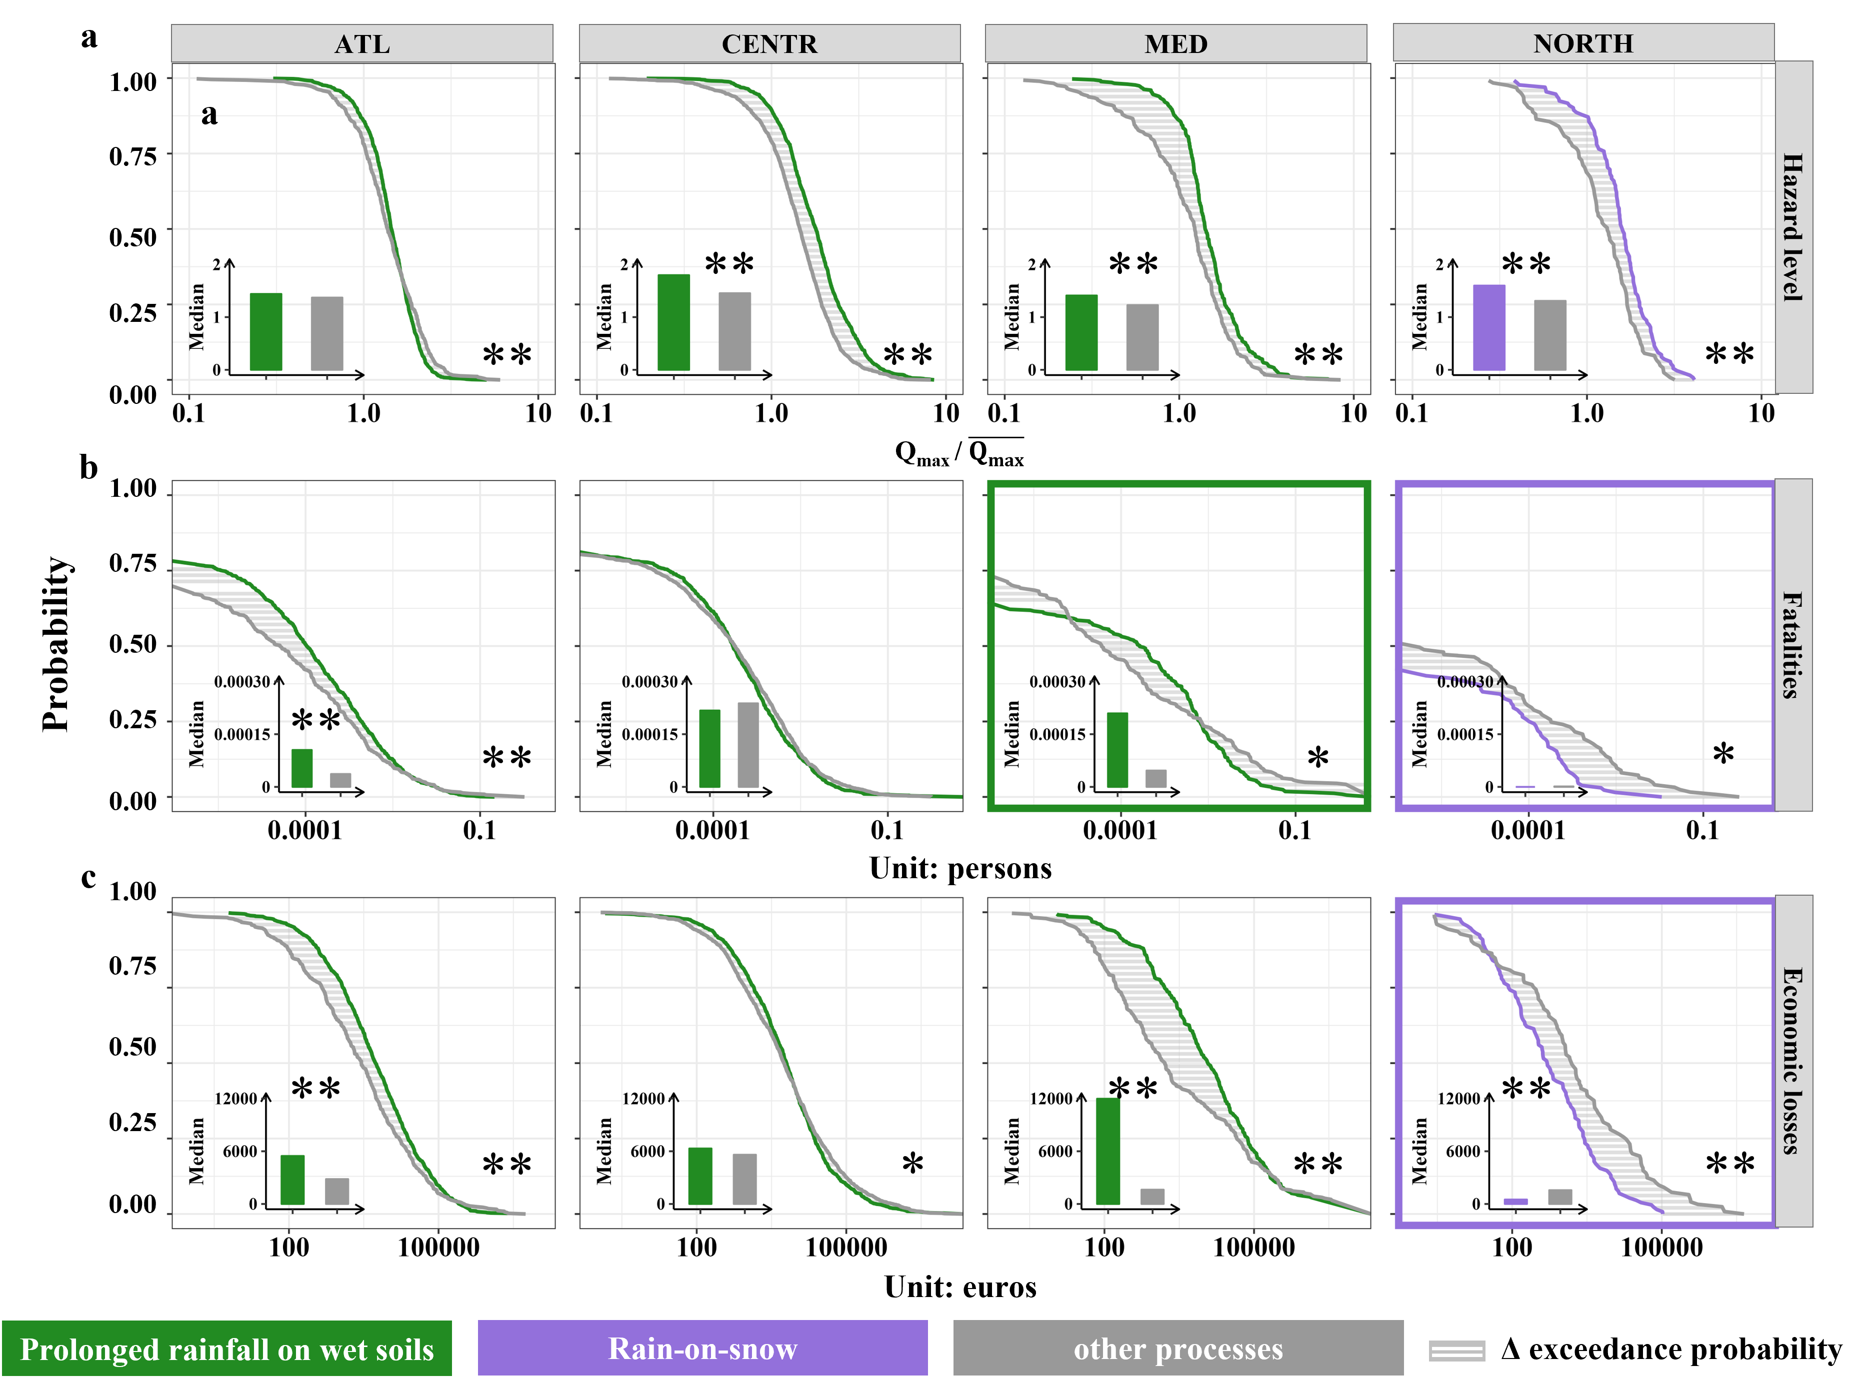
Figure S4. Adaptation effects of frequent exposures to floods generated by the most common process: Regional exceedance probability of (a-d) hazard level defined as observed flood magnitude scaled by mean maximum annual flood for each catchment, (e-h) fatalities per unit area and (i-l) economic losses per unit area of impactful floods generated by the most common process (i.e., that generated most of impactful floods in the period 1960-2010. Fig. 1b) and all other processes in four European regions. The grey shaded areas are the difference between the exceedance probability of the most common process and all other processes. Semi-log plots of the exceedance probability of hazard level, fatalities and economic losses per unit area visualize particularly the upper tails of regional distributions. The inset bar plots show the median values of hazard level (a), median numbers of fatalities per unit area (b) and median amounts of economic losses per unit area (c) of impactful floods generated by the most common process and all other processes. The two-sided Kolmogorov-Smirnov test and Wilcox test with false discovery rate correction are employed to evaluate the significance of differences between exceedance probability and medians. The sign * corresponds to the significance level p <0.05. The sign ** corresponds to the significance level p<0.01. Regions with positive adaptation effects are highlighted by a colored outline of the corresponding panel.
Text S6. The most hazardous processes of impactful flood events
In this study, we define the most hazardous processes of impactful flood events as the processes whose upper decile of the exceedance probability correspond to higher hazard level. In the Atlantic region, prolonged rainfall on dry soils is the most hazardous process (Figure S5) and the exceedance probability of this process is on average 0.03, 3.27 and 3.10 percentage points higher than intensive rainfall, prolonged rainfall on wet soils and simultaneous rainfall and snowmelt (Table S2), respectively. Prolonged rainfall on wet soils is the most hazardous process in the Central and Mediterranean region (Figure S5). Simultaneous rainfall and snowmelt is the most hazardous process in the Northern region (Figure S5).
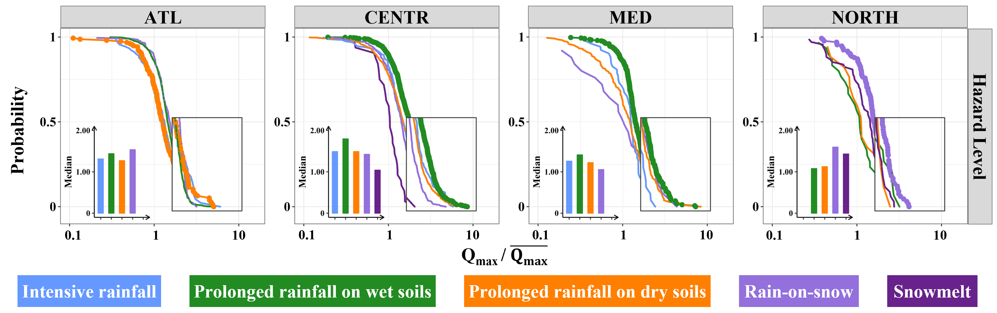
Figure S5. The most hazardous processes of impactful flood events: Regional exceedance probability of hazard level (i.e., defined as observed flood magnitude scaled by mean maximum annual flood for each catchment) of impactful floods generated by different generation processes for each European region. The most hazardous processes (i.e., defined as the process resulting in higher chances of higher hazard level in the upper decile of the distribution compared to all other processes) are displayed as larger points. The inset bar plot in each panel shows the median values of the hazard level of impactful floods generated by different processes. Only exceedance probability distributions with at least 11 impactful floods generated by the same process are displayed. This number corresponds to the average expected frequency in 51 years if the five processes were equally frequent in each region.

Table S2. The differences [%] in the exceedance probability of hazard level above the upper decile between the most hazardous process and all other processes in the four European regions. The names of each region are color-coded according to their corresponding most hazardous flood generation processes. Only exceedance probability distributions with at least 11 impactful floods generated by the same process are calculated. This number corresponds to the average expected frequency in 51 years if the five processes were equally frequent in each region.
Processes | ATL | CENTR | MED | NORTH
Intensive rainfall | 0.03 | 0.79 | 3.55 | —
Prolonged rainfall on wet soils | 3.27 | 0.00 | 0.00 | 2.07
Prolonged rainfall on dry soils | 0.00 | 1.82 | 0.75 | 6.18
Rain-on-snow | 3.10 | 4.16 | 0.22 | 0.00
Snowmelt | — | 8.81 | — | 5.65

Text S7. The most impactful processes of impactful flood events
In this study, we define the most impactful processes of impactful flood events as the processes whose upper decile of the exceedance probability correspond to higher fatalities and economic losses. In terms of fatalities, prolonged rainfall on dry soils is the most impactful process in the Atlantic, Central and Mediterranean regions, while prolonged rainfall on wet soils is the most impactful process in the Northern region (Figure S6a and Table S3). In terms of economic losses, prolonged rainfall on dry soils is the most impactful process in the Atlantic, Central and Northern regions, while prolonged rainfall on wet soils is the most impactful process in the Mediterranean region (Figure S6b and Table S4).
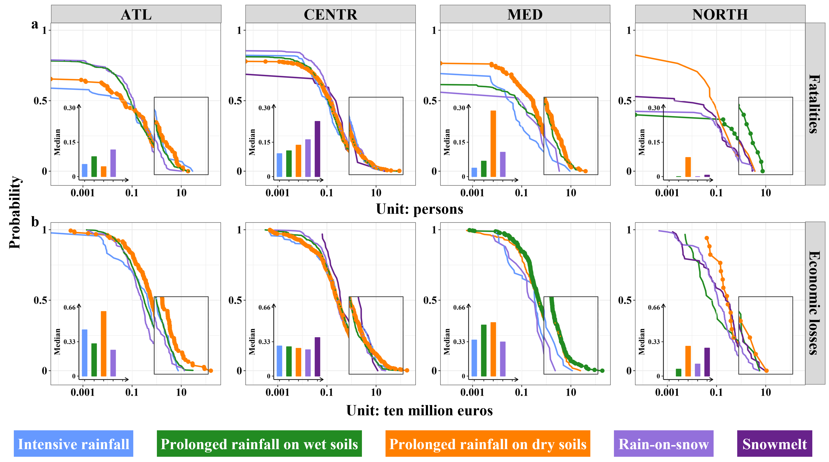
Figure S6. The most impactful processes of impactful flood events: Regional exceedance probability of (a) fatalities and (b) economic losses of impactful floods generated by different generation processes for each European region. The most impactful processes (i.e., defined as the process resulting in higher chances of higher fatalities and economic losses in the upper decile of the distribution compared to all other processes) are displayed as larger points. The inset bar plot in each panel shows the median numbers of fatalities (a) and median amounts of economic losses (b) of impactful floods generated by different processes. Only exceedance probability distributions with at least 11 impactful floods generated by the same process are displayed. This number corresponds to the average expected frequency in 51 years if the five processes were equally frequent in each region.

Table S3. The differences [%] in the exceedance probability of fatalities above the upper decile between the most impactful process and all other processes in the four European regions. The names of each region are color-coded according to their corresponding most impactful flood generation processes. Only exceedance probability distributions with at least 11 impactful floods generated by the same process are calculated. This number corresponds to the average expected frequency in 51 years if the five processes were equally frequent in each region.
Processes | ATL | CENTR | MED | NORTH
Intensive rainfall | 0.26 | 0.02 | 5.52 | —
Prolonged rainfall on wet soils | 2.70 | 0.28 | 1.35 | 0.00
Prolonged rainfall on dry soils | 0.00 | 0.00 | 0.00 | 7.85
Rain-on-snow | 5.04 | 0.06 | 4.09 | 12.81
Snowmelt | — | 0.16 | — | 10.33

Table S4. The differences [%] in the exceedance probability of economic losses above the upper decile between the most impactful process and all other processes in the four European regions. The names of each region are color-coded according to their corresponding most impactful flood generation processes. Only exceedance probability distributions with at least 11 impactful floods generated by the same process are calculated. This number corresponds to the average expected frequency in 51 years if the five processes were equally frequent in each region.
Processes | ATL | CENTR | MED | NORTH
Intensive rainfall | 3.58 | 0.23 | 2.83 | —
Prolonged rainfall on wet soils | 2.72 | 1.25 | 0.00 | 4.78
Prolonged rainfall on dry soils | 0.00 | 0.00 | 1.32 | 0.00
Rain-on-snow | 4.58 | 1.55 | 6.32 | 9.07
Snowmelt | — | 0.87 | — | 5.69

Table S5. The significance of the differences in exceedance probability distributions of hazard level defined as observed flood magnitude scaled by mean maximum annual flood for each catchment, fatalities and economic losses of impactful floods generated by different generation processes for each European region according to the two-sided Kolmogorov-Smirnov test with false discovery rate correction. The sign * corresponds to the significance level p<0.05. The sign ** corresponds to the significance level p<0.01. The sign — denotes a missing value as fewer than 11 impactful flood events are available.
Variable | Region | Processes | Intensive rainfall | Prolonged rainfall on wet soils | Prolonged rainfall on dry soils | Rain-on-snow | Snowmelt
Hazard level | ATL | Intensive rainfall |  | ** | 1.00 | * | —
Hazard level | ATL | Prolonged rainfall on wet soils | ** |  | ** | * | —
Hazard level | ATL | Prolonged rainfall on dry soils | 1.00 | ** |  | ** | —
Hazard level | ATL | Rain-on-snow | * | * | ** |  | —
Hazard level | ATL | Snowmelt | — | — | — | — | —
Hazard level | CENTR | Intensive rainfall |  | ** | 0.33 | ** | **
Hazard level | CENTR | Prolonged rainfall on wet soils | ** |  | ** | ** | **
Hazard level | CENTR | Prolonged rainfall on dry soils | 0.33 | ** |  | ** | **
Hazard level | CENTR | Rain-on-snow | ** | ** | ** |  | **
Hazard level | CENTR | Snowmelt | ** | ** | ** | **
Hazard level | MED | Intensive rainfall |  | * | 0.85 | 0.31 | —
Hazard level | MED | Prolonged rainfall on wet soils | * |  | ** | * | —
Hazard level | MED | Prolonged rainfall on dry soils | 0.85 | ** |  | 0.86 | —
Hazard level | MED | Rain-on-snow | 0.31 | * | 0.86 |  | —
Hazard level | MED | Snowmelt | — | — | — | — | —
Hazard level | NORTH | Intensive rainfall | — | — | — | — | —
Hazard level | NORTH | Prolonged rainfall on wet soils | — |  | 1.00 | ** | 0.12
Hazard level | NORTH | Prolonged rainfall on dry soils | — | 1.00 |  | 0.06 | 0.65
Hazard level | NORTH | Rain-on-snow | — | ** | 0.06 |  | 0.06
Hazard level | NORTH | Snowmelt | — | 0.12 | 0.65 | 0.06
Fatalities | ATL | Intensive rainfall |  | * | 0.99 | * | —
Fatalities | ATL | Prolonged rainfall on wet soils | * |  | * | 0.8 | —
Fatalities | ATL | Prolonged rainfall on dry soils | 0.99 | * |  | * | —
Fatalities | ATL | Rain-on-snow | * | 0.8 | * |  | —
Fatalities | ATL | Snowmelt | — | — | — | — | —
Fatalities | CENTR | Intensive rainfall |  | 0.4 | 0.10 | * | 0.26
Fatalities | CENTR | Prolonged rainfall on wet soils | 0.40 |  | 0.29 | 0.10 | 0.50
Fatalities | CENTR | Prolonged rainfall on dry soils | 0.10 | 0.29 |  | 0.10 | 0.73
Fatalities | CENTR | Rain-on-snow | * | 0.10 | 0.1 |  | 0.53
Fatalities | CENTR | Snowmelt | 0.26 | 0.50 | 0.73 | 0.53
Fatalities | MED | Intensive rainfall |  | 0.28 | ** | 0.65 | —
Fatalities | MED | Prolonged rainfall on wet soils | 0.28 |  | ** | 0.93 | —
Fatalities | MED | Prolonged rainfall on dry soils | ** | ** |  | 0.51 | —
Fatalities | MED | Rain-on-snow | 0.65 | 0.93 | 0.51 |  | —
Fatalities | MED | Snowmelt | — | — | — | — | —
Fatalities | NORTH | Intensive rainfall | — | — | — | — | —
Fatalities | NORTH | Prolonged rainfall on wet soils | — |  | 0.09 | 0.24 | 0.49
Fatalities | NORTH | Prolonged rainfall on dry soils | — | 0.09 |  | * | 0.21
Fatalities | NORTH | Rain-on-snow | — | 0.24 | * |  | 0.6
Fatalities | NORTH | Snowmelt | — | 0.49 | 0.21 | 0.6
Economic losses | ATL | Intensive rainfall |  | 0.11 | 0.17 | ** | —
Economic losses | ATL | Prolonged rainfall on wet soils | 0.11 |  | ** | ** | —
Economic losses | ATL | Prolonged rainfall on dry soils | 0.17 | ** |  | ** | —
Economic losses | ATL | Rain-on-snow | ** | ** | ** |  | —
Economic losses | ATL | Snowmelt | — | — | — | — | —
Economic losses | CENTR | Intensive rainfall |  | 0.49 | 0.59 | 0.27 | 0.27
Economic losses | CENTR | Prolonged rainfall on wet soils | 0.49 |  | 0.27 | 0.27 | 0.4
Economic losses | CENTR | Prolonged rainfall on dry soils | 0.59 | 0.27 |  | 0.27 | 0.27
Economic losses | CENTR | Rain-on-snow | 0.27 | 0.27 | 0.27 |  | 0.27
Economic losses | CENTR | Snowmelt | 0.27 | 0.4 | 0.27 | 0.27
Economic losses | MED | Intensive rainfall |  | 0.13 | 0.13 | 1.00 | —
Economic losses | MED | Prolonged rainfall on wet soils | 0.13 |  | 0.13 | 0.13 | —
Economic losses | MED | Prolonged rainfall on dry soils | 0.13 | 0.13 |  | 0.13 | —
Economic losses | MED | Rain-on-snow | 1.00 | 0.13 | 0.13 |  | —
Economic losses | MED | Snowmelt | — | — | — | — | —
Economic losses | NORTH | Intensive rainfall | — | — | — | — | —
Economic losses | NORTH | Prolonged rainfall on wet soils | — |  | * | 0.33 | 0.3
Economic losses | NORTH | Prolonged rainfall on dry soils | — | * |  | 0.08 | 0.36
Economic losses | NORTH | Rain-on-snow | — | 0.33 | 0.08 |  | *
Economic losses | NORTH | Snowmelt | — | 0.3 | 0.36 | *

Table S6. The significance of the differences in exceedance probability distributions of hazard level defined as observed flood magnitude scaled by mean maximum annual flood for each catchment, fatalities and economic losses of impactful floods generated by different generation processes for each European region according to the two-sided Wilcox test with false discovery rate correction. The sign * corresponds to the significance level p<0.05. The sign ** corresponds to the significance level p<0.01. The sign — denotes a missing value as fewer than 11 impactful flood events are available.
Variable | Region | Processes | Intensive rainfall | Prolonged rainfall on wet soils | Prolonged rainfall on dry soils | Rain-on-snow | Snowmelt
Hazard level | ATL | Intensive rainfall |  | * | 1.00 | * | —
Hazard level | ATL | Prolonged rainfall on wet soils | * |  | ** | 0.07 | —
Hazard level | ATL | Prolonged rainfall on dry soils | 1.00 | ** |  | ** | —
Hazard level | ATL | Rain-on-snow | * | 0.07 | ** |  | —
Hazard level | ATL | Snowmelt | — | — | — | — | —
Hazard level | CENTR | Intensive rainfall |  | ** | 0.61 | * | **
Hazard level | CENTR | Prolonged rainfall on wet soils | ** |  | ** | ** | **
Hazard level | CENTR | Prolonged rainfall on dry soils | 0.61 | ** |  | * | **
Hazard level | CENTR | Rain-on-snow | * | ** | * |  | **
Hazard level | CENTR | Snowmelt | ** | ** | ** | **
Hazard level | MED | Intensive rainfall |  | ** | 0.93 | 0.77 | —
Hazard level | MED | Prolonged rainfall on wet soils | ** |  | ** | * | —
Hazard level | MED | Prolonged rainfall on dry soils | 0.93 | ** |  | 0.77 | —
Hazard level | MED | Rain-on-snow | 0.77 | * | 0.77 |  | —
Hazard level | MED | Snowmelt | — | — | — | — | —
Hazard level | NORTH | Intensive rainfall | — | — | — | — | —
Hazard level | NORTH | Prolonged rainfall on wet soils | — |  | 0.89 | ** | 0.30
Hazard level | NORTH | Prolonged rainfall on dry soils | — | 0.89 |  | 0.08 | 0.89
Hazard level | NORTH | Rain-on-snow | — | ** | 0.08 |  | **
Hazard level | NORTH | Snowmelt | — | 0.30 | 0.89 | **
Fatalities | ATL | Intensive rainfall |  | 0.39 | 0.86 | 0.39 | —
Fatalities | ATL | Prolonged rainfall on wet soils | 0.39 |  | 0.39 | 0.86 | —
Fatalities | ATL | Prolonged rainfall on dry soils | 0.86 | 0.39 |  | 0.39 | —
Fatalities | ATL | Rain-on-snow | 0.39 | 0.86 | 0.39 |  | —
Fatalities | ATL | Snowmelt | — | — | — | — | —
Fatalities | CENTR | Intensive rainfall |  | 0.95 | 0.95 | 0.10 | 0.95
Fatalities | CENTR | Prolonged rainfall on wet soils | 0.95 |  | 0.95 | 0.07 | 0.95
Fatalities | CENTR | Prolonged rainfall on dry soils | 0.95 | 0.95 |  | 0.15 | 0.95
Fatalities | CENTR | Rain-on-snow | 0.10 | 0.07 | 0.15 |  | 0.95
Fatalities | CENTR | Snowmelt | 0.95 | 0.95 | 0.95 | 0.95
Fatalities | MED | Intensive rainfall |  | 0.63 | * | 1.00 | —
Fatalities | MED | Prolonged rainfall on wet soils | 0.63 |  | * | 1.00 | —
Fatalities | MED | Prolonged rainfall on dry soils | * | * |  | 0.32 | —
Fatalities | MED | Rain-on-snow | 1.00 | 1.00 | 0.32 |  | —
Fatalities | MED | Snowmelt | — | — | — | — | —
Fatalities | NORTH | Intensive rainfall | — | — | — | — | —
Fatalities | NORTH | Prolonged rainfall on wet soils | — |  | 0.60 | 0.72 | 1.00
Fatalities | NORTH | Prolonged rainfall on dry soils | — | 0.60 |  | 0.20 | 0.44
Fatalities | NORTH | Rain-on-snow | — | 0.72 | 0.20 |  | 0.60
Fatalities | NORTH | Snowmelt | — | 1.00 | 0.44 | 0.60
Economic losses | ATL | Intensive rainfall |  | 1.00 | * | 0.23 | —
Economic losses | ATL | Prolonged rainfall on wet soils | 1.00 |  | ** | * | —
Economic losses | ATL | Prolonged rainfall on dry soils | * | ** |  | ** | —
Economic losses | ATL | Rain-on-snow | 0.23 | * | ** |  | —
Economic losses | ATL | Snowmelt | — | — | — | — | —
Economic losses | CENTR | Intensive rainfall |  | 1.00 | 1.00 | 1.00 | 0.29
Economic losses | CENTR | Prolonged rainfall on wet soils | 1.00 |  | 0.80 | 1.00 | 0.22
Economic losses | CENTR | Prolonged rainfall on dry soils | 1.00 | 0.80 |  | 1.00 | 0.22
Economic losses | CENTR | Rain-on-snow | 1.00 | 1.00 | 1.00 |  | 0.22
Economic losses | CENTR | Snowmelt | 0.29 | 0.22 | 0.22 | 0.22
Economic losses | MED | Intensive rainfall |  | * | 0.10 | 0.95 | —
Economic losses | MED | Prolonged rainfall on wet soils | * |  | 0.34 | * | —
Economic losses | MED | Prolonged rainfall on dry soils | 0.10 | 0.34 |  | 0.10 | —
Economic losses | MED | Rain-on-snow | 0.95 | * | 0.10 |  | —
Economic losses | MED | Snowmelt | — | — | — | — | —
Economic losses | NORTH | Intensive rainfall | — | — | — | — | —
Economic losses | NORTH | Prolonged rainfall on wet soils | — |  | 0.10 | 0.62 | 0.62
Economic losses | NORTH | Prolonged rainfall on dry soils | — | 0.10 |  | 0.10 | 0.62
Economic losses | NORTH | Rain-on-snow | — | 0.62 | 0.10 |  | 0.39
Economic losses | NORTH | Snowmelt | — | 0.62 | 0.62 | 0.39

Figure S7. The seasonality index calculated using window lengths (1-4 months). For each window length, the year is partitioned into all possible sets of consecutive months without overlap, and different starting months define distinct partitioning schemes, denoted by circles, triangles, plus signs and crosses.
Figure S8. The seasonality of impactful flood events generated by five processes in four European regions. Each proportion represents the ratio of the monthly occurrence of impactful flood events generated by a process in a region to its peak monthly occurrence within a year in this region.

References:
Blöschl, Günter, Julia Hall, Juraj Parajka, Rui A. P. Perdigão, Bruno Merz, Berit Arheimer, Giuseppe T. Aronica, Ardian Bilibashi, Ognjen Bonacci, Marco Borga, Ivan Čanjevac, Attilio Castellarin, Giovanni B. Chirico, Pierluigi Claps, Károly Fiala, Natalia Frolova, Liudmyla Gorbachova, Ali Gül, Jamie Hannaford, Shaun Harrigan, Maria Kireeva, Andrea Kiss, Thomas R. Kjeldsen, Silvia Kohnová, Jarkko J. Koskela, Ondrej Ledvinka, Neil Macdonald, Maria Mavrova-Guirguinova, Luis Mediero, Ralf Merz, Peter Molnar, Alberto Montanari, Conor Murphy, Marzena Osuch, Valeryia Ovcharuk, Ivan Radevski, Magdalena Rogger, José L. Salinas, Eric Sauquet, Mojca Šraj, Jan Szolgay, Alberto Viglione, Elena Volpi, Donna Wilson, Klodian Zaimi, and Nenad Živković. 2017. 'Changing climate shifts timing of European floods', Science, 357: 588-90.
Blöschl, Günter, Julia Hall, Alberto Viglione, Rui A. P. Perdigão, Juraj Parajka, Bruno Merz, David Lun, Berit Arheimer, Giuseppe T. Aronica, Ardian Bilibashi, Miloň Boháč, Ognjen Bonacci, Marco Borga, Ivan Čanjevac, Attilio Castellarin, Giovanni B. Chirico, Pierluigi Claps, Natalia Frolova, Daniele Ganora, Liudmyla Gorbachova, Ali Gül, Jamie Hannaford, Shaun Harrigan, Maria Kireeva, Andrea Kiss, Thomas R. Kjeldsen, Silvia Kohnová, Jarkko J. Koskela, Ondrej Ledvinka, Neil Macdonald, Maria Mavrova-Guirguinova, Luis Mediero, Ralf Merz, Peter Molnar, Alberto Montanari, Conor Murphy, Marzena Osuch, Valeryia Ovcharuk, Ivan Radevski, José L. Salinas, Eric Sauquet, Mojca Šraj, Jan Szolgay, Elena Volpi, Donna Wilson, Klodian Zaimi, and Nenad Živković. 2019. 'Changing climate both increases and decreases European river floods', Nature, 573: 108-11.
EU. 2011. "Commission Regulation (EU) No 31/2011 of 17 January 2011 amending annexes to Regulation (EC) No 1059/2003 of the European Parliament and of the Council on the establishment of a common classification of territorial units for statistics (NUTS)." In, 3-4.
Ganguli, Poulomi, and Bruno Merz. 2019. 'Trends in Compound Flooding in Northwestern Europe During 1901–2014', Geophysical Research Letters, 46: 10810-20.
Haylock, M. R., N. Hofstra, A. M. G. Klein Tank, E. J. Klok, P. D. Jones, and M. New. 2008. 'A European daily high-resolution gridded data set of surface temperature and precipitation for 1950–2006', Journal of Geophysical Research: Atmospheres, 113.
Kumar, R., B. Livneh, and L. Samaniego. 2013. 'Toward computationally efficient large-scale hydrologic predictions with a multiscale regionalization scheme', Water Resources Research, 49: 5700-14.
Kumar, Rohini, Luis Samaniego, and Sabine Attinger. 2013. 'Implications of distributed hydrologic model parameterization on water fluxes at multiple scales and locations', Water Resources Research, 49: 360-79.
Paprotny, Dominik, Belinda Rhein, Michalis I. Vousdoukas, Paweł Terefenko, Francesco Dottori, Simon Treu, Jakub Śledziowski, Luc Feyen, and Heidi Kreibich. 2024. 'Merging modelled and reported flood impacts in Europe in a combined flood event catalogue for 1950–2020', Hydrology and Earth System Sciences, 28: 3983-4010.
Paprotny, Dominik, Paweł Terefenko, and Jakub Śledziowski. 2024. 'HANZE v2.1: an improved database of flood impacts in Europe from 1870 to 2020', Earth System Science Data, 16: 5145-70.
Paprotny, Dominik, Aloïs Tilloy, Simon Treu, Anna Buch, Michalis I. Vousdoukas, Luc Feyen, Heidi Kreibich, Bruno Merz, Katja Frieler, and Matthias Mengel. 2025. 'Attribution of flood impacts shows strong benefits of adaptation in Europe since 1950', Science Advances, 11: eadt7068.
Rentschler, J., M. Salhab, and B. A. Jafino. 2022. 'Flood exposure and poverty in 188 countries', Nat Commun, 13: 3527.
Samaniego, L., R. Kumar, S. Thober, O. Rakovec, M. Zink, N. Wanders, S. Eisner, H. Müller Schmied, E. H. Sutanudjaja, K. Warrach-Sagi, and S. Attinger. 2017. 'Toward seamless hydrologic predictions across spatial scales', Hydrol. Earth Syst. Sci., 21: 4323-46.
Samaniego, Luis, Rohini Kumar, and Sabine Attinger. 2010. 'Multiscale parameter regionalization of a grid‐based hydrologic model at the mesoscale', Water Resources Research, 46.
Samaniego, Luis, Stephan Thober, Niko Wanders, Ming Pan, Oldrich Rakovec, Justin Sheffield, Eric F. Wood, Christel Prudhomme, Gwyn Rees, Helen Houghton-Carr, Matthew Fry, Katie Smith, Glenn Watts, Hege Hisdal, Teodoro Estrela, Carlo Buontempo, Andreas Marx, and Rohini Kumar. 2019. 'Hydrological Forecasts and Projections for Improved Decision-Making in the Water Sector in Europe', Bulletin of the American Meteorological Society, 100: 2451-72.
Tarasova, L., S. Basso, D. Wendi, A. Viglione, R. Kumar, and R. Merz. 2020. 'A Process‐Based Framework to Characterize and Classify Runoff Events: The Event Typology of Germany', Water Resources Research, 56.
Tarasova, L., S. Basso, M. Zink, and R. Merz. 2018. 'Exploring Controls on Rainfall-Runoff Events: 1. Time Series-Based Event Separation and Temporal Dynamics of Event Runoff Response in Germany', Water Resources Research, 54: 7711-32.
Tarasova, Larisa, David Lun, Ralf Merz, Günter Blöschl, Stefano Basso, Miriam Bertola, Arianna Miniussi, Oldrich Rakovec, Luis Samaniego, Stephan Thober, and Rohini Kumar. 2023. 'Shifts in flood generation processes exacerbate regional flood anomalies in Europe', Communications Earth & Environment, 4.
Thober, Stephan, Matthias Cuntz, Matthias Kelbling, Rohini Kumar, Juliane Mai, and Luis Samaniego. 2019. 'The multiscale routing model mRM v1.0: simple river routing at resolutions from 1 to 50 km', Geoscientific Model Development, 12: 2501-21.

