Journal of Neural Transmission
Transdiagnostic monoamine-based subtyping for attention-deficit/hyperactivity disorder and autism spectrum disorder via unsupervised machine learning
Masatoshi Yamashita ^{1,2*}, Qiulu Shou ^{1,2}, Sayo Hamatani ^{1,2,3}, Hideo Matsuzaki ^{1,2,3}, Masanori Fujieda ^{1,2,3}, Yoshiyuki Hirano ^{2,4}, Kuriko Kagitani-Shimono ^{2,5}, Hidehiko Okazawa ^{2,6}, and Yoshifumi Mizuno ^{1,2,3#}
*Corresponding author
Masatoshi Yamashita, Research Center for Child Mental Development, University of Fukui, Fukui, Japan, email: myamashita.fatiguepsychology@gmail.com
#Co-corresponding author
Yoshifumi Mizuno, Research Center for Child Mental Development, University of Fukui, Fukui, Japan, email: mizunoy@u-fukui.ac.jp

Online Resource 3: Other cognitive performances
Cognitive data are shown in Fig. 2a of the main text and in Online Resource 3 Fig. In the main effect of group in the linear mixed-effect model, there were no significant differences between the NDD-A type and TD group for the TMT-A (β = -0.10 95% CI [-0.68, 0.48], R² = 0.001, t = 0.34, p-FDR = 0.731, p-FWE > 0.999), TMT-B (β = 0.37, 95% CI [-0.20, 0.95], R² = 0.02, t = 1.27, p-FDR = 0.308, p-FWE = 0.617), TMT-Δ (β = 0.48, 95% CI [-0.08, 1.06], R² = 0.04, t = 1.65, p-FDR = 0.304, p-FWE = 0.608), stop signal task (stop signal reaction time, β = -0.17, 95% CI [-0.75, 0.40], R² = 0.03, t = 0.60, p-FDR = 0.862, p-FWE > 0.999; direction errors on go trials, β = -0.003, 95% CI [-0.59, 0.58], R² = 0.0005, t = 0.01, p-FDR = 0.991, p-FWE > 0.999; direction errors on stop trials, β = 0.16, 95% CI [-0.41, 0.75], R² = 0.04, t = 0.56, p-FDR = 0.862, p-FWE > 0.999), and spatial working memory task (between errors, β = 0.40, 95% CI [-0.17, 0.99], R² = 0.03, t = 1.36, p-FDR = 0.175, p-FWE = 0.350; within errors, β = 0.66, 95% CI [0.09, 1.23], R² = 0.05, t = 2.30, p-FDR = 0.046, p-FWE = 0.093). Moreover, there were no significant differences between the NDD-B type and TD groups for the TMT-A (β = 0.31, 95% CI [-0.02, 0.65], R² = 0.32, t = 1.81, p-FDR = 0.071, p-FWE = 0.142), stop signal reaction time (β = 0.14, 95% CI [-0.18, 0.47], R² = 0.31, t = 0.88, p-FDR = 0.377, p-FWE = 0.754) and direction error on stop trials (β = 0.43, 95% CI [0.04, 0.82], R² = 0.06, t = 2.19, p-FDR = 0.044, p-FWE = 0.089) in the stop signal task, and spatial working memory task (between errors, β = 0.35, 95% CI [-0.008, 0.71], R² = 0.15, t = 1.91, p-FDR = 0.115, p-FWE = 0.230; within errors, β = 0.06, 95% CI [-0.31, 0.43], R² = 0.02, t = 0.32, p-FDR = 0.742, p-FWE > 0.999).
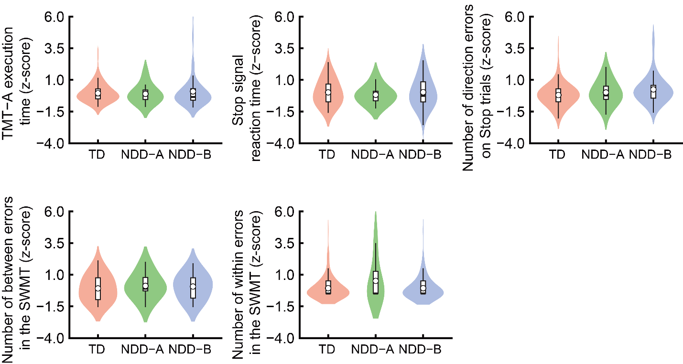
Online Resource 3 Fig. Cognitive results for each NDD subtype and the TD group. The NDD-A and NDD-B types did not show significant differences for the TMT-A, stop signal reaction time and direction errors on stop trials in the SST, and between errors and within errors in the SWMT. NDD, neurodevelopmental disorder; SST, stop signal task; SWMT, spatial working memory task; TD, typical development; TMT, trail making test.

