Supplementary information

Supplement 1: Supplementary Methods
Student Curriculum Investment Instrument (SCII)

Supplement 2: Respondent Distribution
Supplementary Table 1. Survey respondent distribution
Supplementary Figure 1. Scatter diagram of STEM problem-solving process

Supplement 3: Measurements Quantitative Results
Supplementary Figure 2: Path map of three evidences model and standardized estimations of teacher effectiveness (N=126).
Supplementary Table 2: Loading factor value of teacher effectiveness (N=63).
Supplementary Table 3. Mean effectiveness of teacher effectiveness
Supplementary Figure 3: Scatter diagram of teacher effectiveness about Electromagnet-ism group and Mechanics group

Supplementary Figure 4: Path map of three evidences model and standardized estimations of curriculum attractiveness (N=126).
Supplementary Table 4: Loading factor value of curriculum attractiveness (N=63).
Supplementary Table 5. Mean effectiveness of curriculum attractiveness
Supplementary Figure 5: Scatter diagram of curriculum attractiveness about Electromagnetism group and Mechanics group

Supplementary Figure 6: Path map of three evidences model and standardized estimations of student enthusiasm (N=126).
Supplementary Table 6: Loading factor value of student enthusiasm (N=63).
Supplementary Table 7. Mean effectiveness of student enthusiasm
Supplementary Figure 7: Scatter diagram of student enthusiasm about Electromagnet-ism group and Mechanics group

Supplement 4: Results of RIEBP comprehension analysis
Supplementary Table 7. Results of RIEBP comprehension analysis in STEM field.

Supplement 5: Results of RIEBP experimental report scores
Supplementary Figure 8. Distribution of experimental and control group experimental report scores
Supplementary Table 8. The comparison of experimental and control group's academic achievement pre-tests and post-tests

Data
Data-1.xlsx, Data-2.xlsx, Data-3.xlsx
Supplement 1: Supplementary Methods

1. 1. Student Classroom Investment Instrument (SCII)
Survey: Mean effectiveness of RIEBP, grouped by initiative type/survey question (Teacher-acceptability; Curriculums-attractiveness; Student-enthusiasm).

Description and definitions
This survey evaluates the cultivation of high-quality classroom engagement with the subject matter. We define the following terms relevant to classroom engagement in the RIEBP model as:
- Classroom engagement: Behavioral Engagement (BE), Cognitive Engagement (CE), Emotional Engagement (EE).
- BE: Behavioral engagement includes five observable indicators $P_{i}$ (for $i=1,2,⋯,5$)
- Reviewing class-room content in a timely manner, (2) Maintaining consistent daily learning habitus rather than cramming before exams, (3) Previewing upcoming lesson content, (4) Planning weekly academic tasks in advance, and (5) Dedicating fixed times each week to complete homework.
- CE: Cognitive engagement is indicated by four behaviors $P_{i}$ (for $i=6,7,⋯,9$)
(6) Formulating original ideas during learning, (7) Discerning teacher’s instructional intentions, (8) Pausing during reading to reflect on the material, and (9) Critically questioning or challenging learned content.
- EE: Emotional engagement is represented by three indicators $P_{i}$ (for $i=10,11,12$)
(10) Experiencing satisfaction from learning, (11) Expressing curiosity about lesson content, and (12) Putting forth effort driven by intrinsic interest.
Main survey
- Behavioral investment of SMF
Experimental ID:
(1) Reviewing class-room content in a timely manner?
(2) Maintaining consistent daily learning habitus rather than cramming before exams?
(3) Previewing upcoming lesson content?
(4) Planning weekly academic tasks in advance?
(5) Dedicating fixed times each week to complete homework?
- Cognitive investment of SMF
Experimental ID:
(6) Formulating original ideas during learning?
(7) Discerning teacher’s instructional intentions?
(8) Pausing during reading to reflect on the material?
(9) Critically questioning or challenging learned content?
- Emotional investment of SMF
Experimental ID:
(10) Experiencing satisfaction from learning？
(11) Expressing curiosity about lesson content？
(12) Putting forth effort driven by intrinsic interest？

- Which initiatives do you think are, or could be, effective at improving any aspect of RIEBP in your classroom (excluding behavioral, cognitive, and emotional engagement in this survey)?
Response type: 5-factor Likert scale (Not effective; slightly effective; moderately effective; very effective; extremely effective; NA/I don’t know)
Initiative as displayed in survey | Abbreviation used in text
Behavioral engagement | BE
Cognitive engagement | CE
Emotional engagement | EE
Observable indicators | $P_{i}$ (for $i=1,2,⋯,12$)
twelve confirmatory components | $E_{i}$ (for $i=1,2,…,12$)
Teacher effectiveness | EF
Curriculum attractiveness | AT
Students’ enthusiasm | EN
Electromagnetism group | EG
Mechanics group | MG
Achievement level of teacher | ALT
Achievement level of curriculum | ALC
Achievement level of student | ALS
A five-point Likert scale for RIEBP (RIEBP-FLS) (i.e. behavioral, cognitive, and emotional engagement) | $Q_{i}$ (for$i=1,2,…,12$)
experimental report scores | ERS
Other (please describe)

Supplement 2: Survey respondent distribution
Supplementary Table 1: Distribution of advanced levels of problem-solving
 | Micro-fairness evaluation |  | Standardized estimations of teacher effectiveness |  | Standardized estimations of curriculum attractiveness. |  | Standardized estimation of student enthusiasm |  | Experimental report scores
 | Experim-ental Class | Control class | Experim-ental Class | Control class | Experim-ental Class | Control class | Experim-ental class | Control class | Experim-ental class | Control class
Understanding problems | 10 | 12 | 17 | 20 | 16 | 14 | 12 | 10 | 10 | 10
Problems representation | 12 | 15 | 17 | 18 | 18 | 21 | 14 | 14 | 10 | 10
Seeking solutions | 12 | 14 | 16 | 18 | 18 | 17 | 15 | 17 | 12 | 10
Solving problems | 12 | 14 | 15 | 17 | 19 | 16 | 16 | 16 | 11 | 10
Evaluation Reflection | 10 | 11 | 14 | 19 | 17 | 19 | 19 | 16 | 11 | 10
Average | 11 | 13 | 16 | 18 | 18 | 17 | 15 | 15 | 11 | 10
Supplementary Figure 1: Scatter diagram of STEM problem-solving process
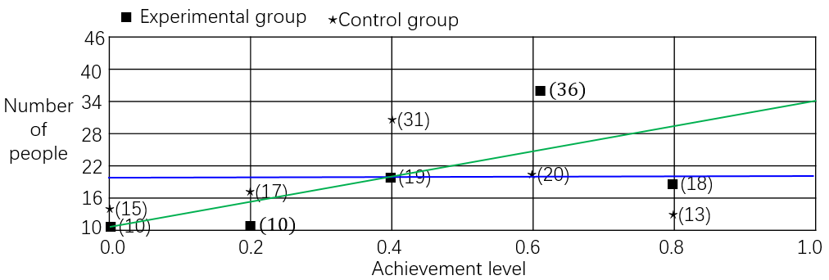
Supplement 3: Measurements Quantitative Results
Supplementary Figure 2: Path map of three evidences model and standardized estimations of teacher effectiveness (N=126).
Supplementary Table 2: Loading factor value of teacher effectiveness (N=126).

No | Variable | observed variables | Loading factor | Error | Verification
1 | BE | ↔ CE | 0.62 | 0.12 | Valid
2 | BE | ↔ EE | 0.66 | 0.20 | Valid
3 | CE | ↔ EE | 0.58 | 0.07 | Valid
4 | BE | → P1 | 0.88 | 0.11 | Valid
5 | BE | → P2 | 0.86 | 0.12 | Valid
6 | BE | → P3 | 0.78 | 0.07 | Valid
7 | BE | → P4 | 0.76 | 0.21 | Valid
8 | BE | → P5 | 0.66 | 0.08 | Valid
9 | CE | → P6 | 0.84 | 0.16 | Valid
10 | CE | → P7 | 0.76 | 0.06 | Valid
11 | CE | → P8 | 0.72 | 0.17 | Valid
12 | CE | → P9 | 0.73 | 0.13 | Valid
13 | EE | → P10 | 0.68 | 0.08 | Valid
14 | EE | → P11 | 0. 86 | 0.10 | Valid
15 | EE | → P12 | 0. 82 | 0.15 | Valid
16 | P1 | → E1 | 0. 79 | 0.16 | Valid
17 | P2 | → E2 | 0. 76 | 0.10 | Valid
18 | P3 | → E3 | 0. 66 | 0.09 | Valid
19 | P4 | → E4 | 0. 59 | 0.06 | Valid
20 | P5 | → E5 | 0. 49 | 0.04 | Valid
21 | P6 | → E6 | 0. 69 | 0.05 | Valid
22 | P7 | → E7 | 0. 59 | 0.07 | Valid
23 | P8 | → E8 | 0. 58 | 0.11 | Valid
24 | P9 | → E9 | 0. 77 | 0.14 | Valid
25 | P10 | → E10 | 0. 48 | 0.04 | Valid
26 | P11 | → E11 | 0. 89 | 0.17 | Valid
27 | P12 | → E12 | 0. 86 | 0.16 | Valid
28 | E1 | → EF | 0. 67 | 0.06 | Valid
29 | E2 | → EF | 0. 62 | 0.05 | Valid
30 | E3 | → EF | 0. 87 | 0.08 | Valid
31 | E4 | → EF | 0. 56 | 0.05 | Valid
32 | E5 | → EF | 0. 47 | 0.04 | Valid
33 | E6 | → EF | 0. 76 | 0.10 | Valid
34 | E7 | → EF | 0. 67 | 0.09 | Valid
35 | E8 | → EF | 0. 55 | 0.06 | Valid
36 | E9 | → EF | 0. 44 | 0.07 | Valid
37 | E10 | → EF | 0. 87 | 0.11 | Valid
38 | E11 | → EF | 0. 81 | 0.08 | Valid
39 | E12 | → EF | 0. 65 | 0.06 | Valid

Supplementary Table 3. Mean effectiveness of teacher effectiveness
$$EF←$$ | $$E_{1}$$ | $$E_{2}$$ | $$E_{3}$$ | $$E_{4}$$ | $$E_{5}$$ | $$E_{6}$$ | $$E_{7}$$ | $$E_{8}$$ | $$E_{9}$$ | $$E_{10}$$ | $$E_{11}$$ | $$E_{12}$$
EG | 0.67 | 0.62 | 0.87 | 0.56 | 0.47 | 0.76 | 0.67 | 0.55 | 0.44 | 0.87 | 0.81 | 0.65
ALT | 0.60 | 0.50 | 0.80 | 0.80 | 0.50 | 0.90 | 0.80 | 0.70 | 0.60 | 0.90 | 0.90 | 0.70
MG | 0.25 | 0.31 | 0.45 | 0.60 | 0.40 | 0.41 | 0.57 | 0.42 | 0.45 | 0.67 | 0.55 | 0.60
ALT | 0.20 | 0.30 | 0.40 | 0.40 | 0.50 | 0.60 | 0.60 | 0.70 | 0.80 | 0.80 | 0.90 | 0.90
Supplementary Figure 3: Scatter diagram of teacher effectiveness about Electromagnetism group and Mechanics group
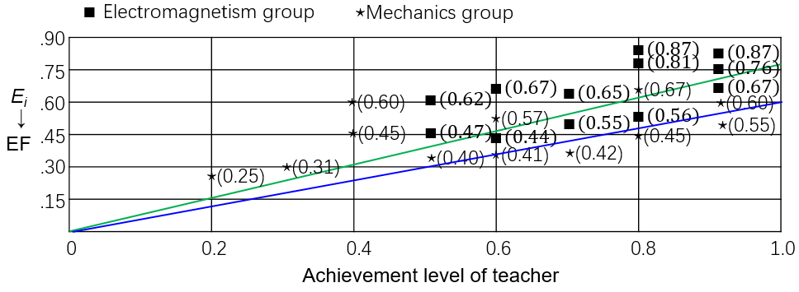

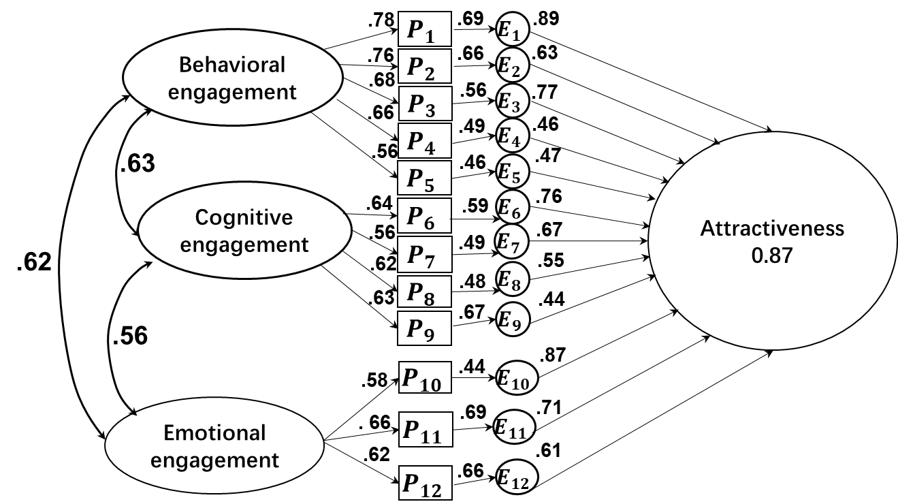
Supplementary Figure 4: Path map of three evidences model and standardized estimations of curriculum attractiveness (N=126).
Supplementary Table4: Loading factor value of curriculum attractiveness (N=126).

No | Variable | observed variables | Loading factor | Error | Verification
1 | BE | ↔ CE | 0.63 | 0.13 | Valid
2 | BE | ↔ EE | 0.56 | 0.18 | Valid
3 | CE | ↔ EE | 0.62 | 0.17 | Valid
4 | BE | → P1 | 0.78 | 0.10 | Valid
5 | BE | → P2 | 0.76 | 0.09 | Valid
6 | BE | → P3 | 0.68 | 0.06 | Valid
7 | BE | → P4 | 0.66 | 0.30 | Valid
8 | BE | → P5 | 0.56 | 0.18 | Valid
9 | CE | → P6 | 0.64 | 0.13 | Valid
10 | CE | → P7 | 0.56 | 0.05 | Valid
11 | CE | → P8 | 0.62 | 0.11 | Valid
12 | CE | → P9 | 0.63 | 0.10 | Valid
13 | EE | → P10 | 0.58 | 0.07 | Valid
14 | EE | → P11 | 0.66 | 0.09 | Valid
15 | EE | → P12 | 0. 62 | 0.05 | Valid
16 | P1 | → E1 | 0. 69 | 0.15 | Valid
17 | P2 | → E2 | 0. 66 | 0.09 | Valid
18 | P3 | → E3 | 0. 56 | 0.07 | Valid
19 | P4 | → E4 | 0. 49 | 0.05 | Valid
20 | P5 | → E5 | 0. 46 | 0.06 | Valid
21 | P6 | → E6 | 0. 59 | 0.07 | Valid
22 | P7 | → E7 | 0. 49 | 0.04 | Valid
23 | P8 | → E8 | 0. 48 | 0.09 | Valid
24 | P9 | → E9 | 0. 67 | 0.08 | Valid
25 | P10 | → E10 | 0. 44 | 0.06 | Valid
26 | P11 | → E11 | 0. 69 | 0.10 | Valid
27 | P12 | → E12 | 0. 66 | 0.04 | Valid
28 | E1 | → AT | 0.89 | 0.26 | Valid
29 | E2 | → AT | 0.63 | 0.12 | Valid
30 | E3 | → AT | 0.77 | 0.17 | Valid
31 | E4 | → AT | 0. 46 | 0.05 | Valid
32 | E5 | → AT | 0. 47 | 0.04 | Valid
33 | E6 | → AT | 0. 76 | 0.10 | Valid
34 | E7 | → AT | 0. 67 | 0.09 | Valid
35 | E8 | → AT | 0. 55 | 0.06 | Valid
36 | E9 | → AT | 0. 44 | 0.07 | Valid
37 | E10 | → AT | 0. 87 | 0.21 | Valid
38 | E11 | → AT | 0.71 | 0.18 | Valid
39 | E12 | → AT | 0. 61 | 0.16 | Valid

Supplementary Table 5. Mean effectiveness of curriculum attractiveness

$$AT←$$ | $$E_{1}$$ | $$E_{2}$$ | $$E_{3}$$ | $$E_{4}$$ | $$E_{5}$$ | $$E_{6}$$ | $$E_{7}$$ | $$E_{8}$$ | $$E_{9}$$ | $$E_{10}$$ | $$E_{11}$$ | $$E_{12}$$
EG | 0.89 | 0.63 | 0.77 | 0.46 | 0.47 | 0.76 | 0.67 | 0.55 | 0.44 | 0.87 | 0.71 | 0.61
ALC | 0.60 | 0.50 | 0.80 | 0.80 | 0.50 | 0.90 | 0.80 | 0.70 | 0.60 | 0.90 | 0.90 | 0.70
MG | 0.27 | 0.21 | 0.50 | 0.30 | 0.41 | 0.39 | 0.59 | 0.42 | 0.45 | 0.67 | 0.56 | 0.65
ALC | 0.20 | 0.30 | 0.40 | 0.40 | 0.50 | 0.60 | 0.60 | 0.70 | 0.80 | 0.80 | 0.90 | 0.90

Supplementary Figure 5: Scatter diagram of curriculum attractiveness about Electromagnet-ism group and Mechanics group
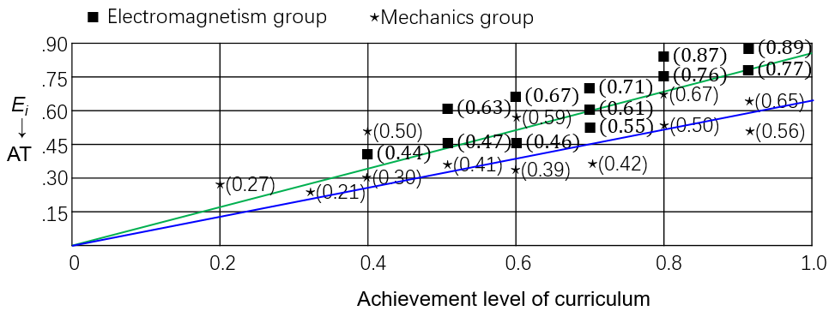
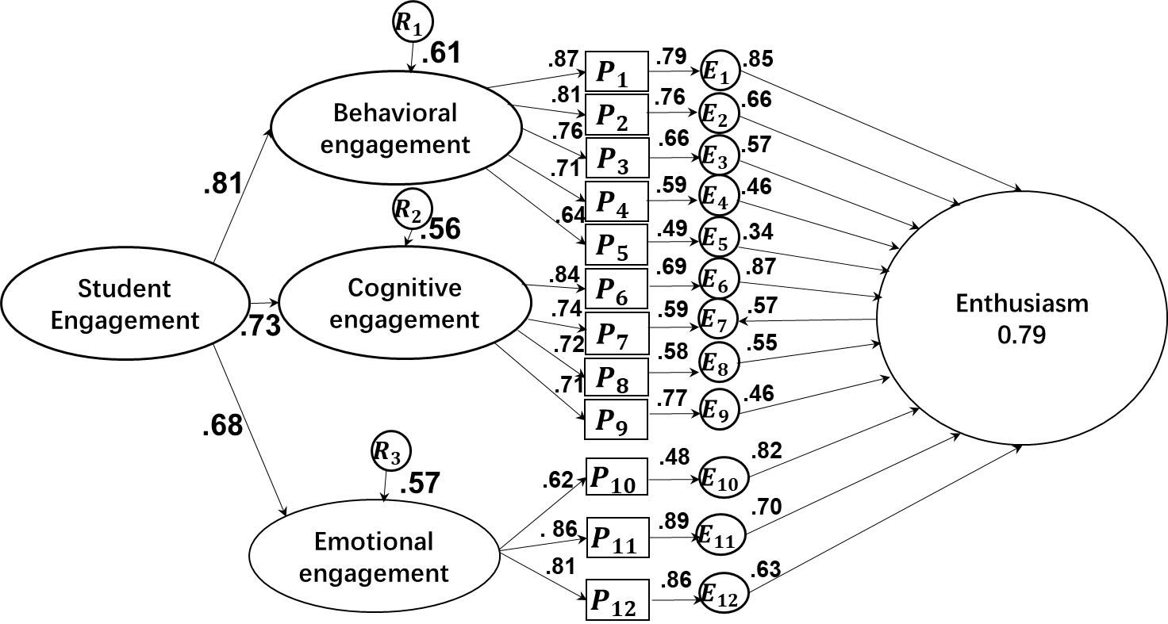
Supplementary Figure 6: Path map of three evidences model and standardized estimations of curriculum attractiveness (N=126).

Supplementary Table 6: Loading factor value of student enthusiasm(N=126).
No | Variable | Observed variables | Loading factor | Error | Verification
1 | SE | → BE | 0.81 | 0.19 | Valid
2 | SE | → CE | 0.73 | 0.16 | Valid
3 | SE | → EE | 0.68 | 0.12 | Valid
4 | R1 | → BE | 0.61 | 0.10 | Valid
5 | R2 | → CE | 0.56 | 0.11 | Valid
6 | R3 | → EE | 0.57 | 0.09 | Valid
7 | BE | → P1 | 0.87 | 0.08 | Valid
8 | BE | → P2 | 0.81 | 0.15 | Valid
9 | BE | → P3 | 0.76 | 0.07 | Valid
10 | BE | → P4 | 0.71 | 0.23 | Valid
11 | BE | → P5 | 0.64 | 0.21 | Valid
12 | CE | → P6 | 0.84 | 0.33 | Valid
13 | CE | → P7 | 0.74 | 0.25 | Valid
14 | CE | → P8 | 0.72 | 0.21 | Valid
15 | CE | → P9 | 0.71 | 0.19 | Valid
16 | EE | → P10 | 0.62 | 0.17 | Valid
17 | EE | → P11 | 0.86 | 0.19 | Valid
18 | EE | → P12 | 0.81 | 0.15 | Valid
19 | P1 | → E1 | 0.79 | 0.14 | Valid
20 | P2 | → E2 | 0.76 | 0.19 | Valid
21 | P3 | → E3 | 0.66 | 0.17 | Valid
22 | P4 | → E4 | 0.59 | 0.15 | Valid
23 | P5 | → E5 | 0.49 | 0.16 | Valid
24 | P6 | → E6 | 0. 69 | 0.07 | Valid
25 | P7 | → E7 | 0. 59 | 0.14 | Valid
26 | P8 | → E8 | 0. 58 | 0.19 | Valid
27 | P9 | → E9 | 0. 77 | 0.18 | Valid
28 | P10 | → E10 | 0. 48 | 0.16 | Valid
29 | P11 | → E11 | 0. 89 | 0.12 | Valid
30 | P12 | → E12 | 0. 86 | 0.14 | Valid
31 | E1 | → EN | 0. 85 | 0.15 | Valid
32 | E2 | → EN | 0. 66 | 0.13 | Valid
33 | E3 | → EN | 0. 57 | 0.14 | Valid
34 | E4 | → EN | 0. 46 | 0.15 | Valid
35 | E5 | → EN | 0. 34 | 0.09 | Valid
36 | E6 | → EN | 0. 87 | 0.19 | Valid
37 | E7 | → EN | 0. 57 | 0.13 | Valid
38 | E8 | → EN | 0. 55 | 0.11 | Valid
39 | E9 | → EN | 0. 46 | 0.10 | Valid
40 | E10 | → EN | 0. 82 | 0.18 | Valid
41 | E11 | → EN | 0. 70 | 0.16 | Valid
42 | E12 | → EN | 0. 63 | 0.13 | Valid
Supplementary Table 6. Mean effectiveness of student enthusiasm
$$EN←$$ | $$E_{1}$$ | $$E_{2}$$ | $$E_{3}$$ | $$E_{4}$$ | $$E_{5}$$ | $$E_{6}$$ | $$E_{7}$$ | $$E_{8}$$ | $$E_{9}$$ | $$E_{10}$$ | $$E_{11}$$ | $$E_{12}$$
EG | 0.85 | 0.66 | 0.57 | 0.46 | 0.34 | 0.87 | 0.57 | 0.55 | 0.46 | 0.82 | 0.70 | 0.63
ALS | 0.60 | 0.50 | 0.80 | 0.80 | 0.50 | 0.90 | 0.80 | 0.70 | 0.60 | 0.90 | 0.90 | 0.70
MG | 0.15 | 0.22 | 0.30 | 0.60 | 0.28 | 0.57 | 0.33 | 0.41 | 0.44 | 0.62 | 0.45 | 0.56
ALS | 0.20 | 0.30 | 0.40 | 0.40 | 0.50 | 0.60 | 0.60 | 0.70 | 0.80 | 0.80 | 0.90 | 0.90

Supplementary Figure 7: Scatter diagram of student enthusiasm about Electromagnetism group and Mechanics group

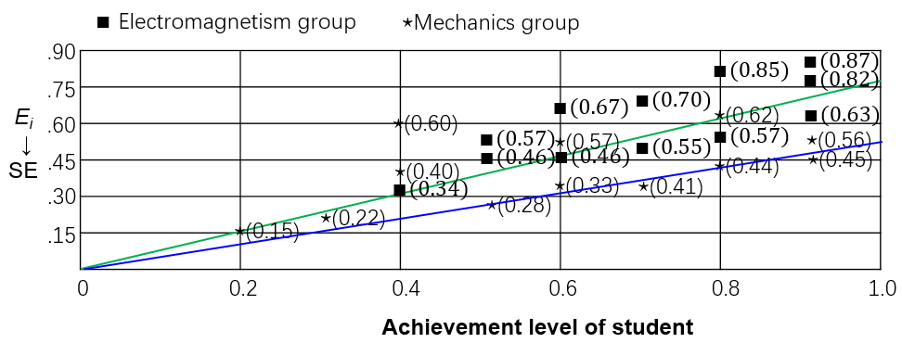

Supplement 4: Results of RIEBP comprehension analysis
Supplementary Table 7. Results of RIEBP comprehension analysis in STEM field.
 | N | Mean value | Standard deviation | CQV | Skewness | Kurtosis
$$Q_{1}$$ | 126 | 4.68 | 0.28 | 0.07 | -0.38 | -0.98
$$Q_{2}$$ | 126 | 4.35 | 0.43 | 0.20 | -0.61 | -0.95
$$Q_{3}$$ | 126 | 4.56 | 0.45 | 0.19 | -0.59 | -0.56
$$Q_{4}$$ | 126 | 4.27 | 0.44 | 0.17 | -0.06 | -1.24
$$Q_{5}$$ | 126 | 4.74 | 0.18 | 0.18 | -0.35 | -0.91
$$Q_{6}$$ | 126 | 4.33 | 0.42 | 0.03 | -0.69 | 0.24
$$Q_{7}$$ | 126 | 4.46 | 0.26 | 0.06 | -0.36 | -0.97
$$Q_{8}$$ | 126 | 4.36 | 0.41 | 0.20 | -0.62 | -0.93
$$Q_{9}$$ | 126 | 4.35 | 0.40 | 0.16 | -0.55 | -0.59
$$Q_{10}$$ | 126 | 4.24 | 0.42 | 0.16 | -0.05 | -1.10
$$Q_{11}$$ | 126 | 4.23 | 0.49 | 0.14 | -0.36 | 0.09
$$Q_{12}$$ | 126 | 4.22 | 0.46 | 0.12 | -0.68 | 0.20

Supplement 5: Results of RIEBP experimental report scores
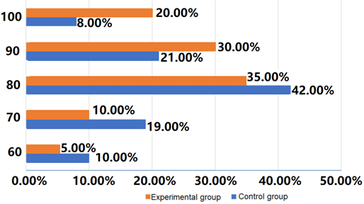
Supplementary Figure 8. Distribution of experimental and control group experimental report scores (ERS)
Supplementary Table 8. The comparison of experimental and control group's experimental report scores pre-tests and post-tests
 |  | Experimental Group |  |  |  |  |  | Control Group
Tests |  | N | M | SD | t | p | η² | N | M | SD | t | p | d
1 | Pretest | 63 | 11,87 | 5,30 | 11,42* | 0,00 | 2,02 | 63 | 11,18 | 4,53 | 3,90* | 0,00 | 0,69
1 | Posttest | 63 | 20,18 | 4,89 | 11,42* | 0,00 | 2,02 | 63 | 13,87 | 4,93 | 3,90* | 0,00 | 0,69
2 | Pretest | 63 | 4,13 | 0,93 | 2,15* | 0,039 | 0,48 | 63 | 4,34 | 0,92 | 1,66 | 0,107 | -
2 | Posttest | 63 | 4,43 | 0,74 | 2,15* | 0,039 | 0,48 | 63 | 4,01 | 1,03 | 1,66 | 0,107 | -

