Supplement.
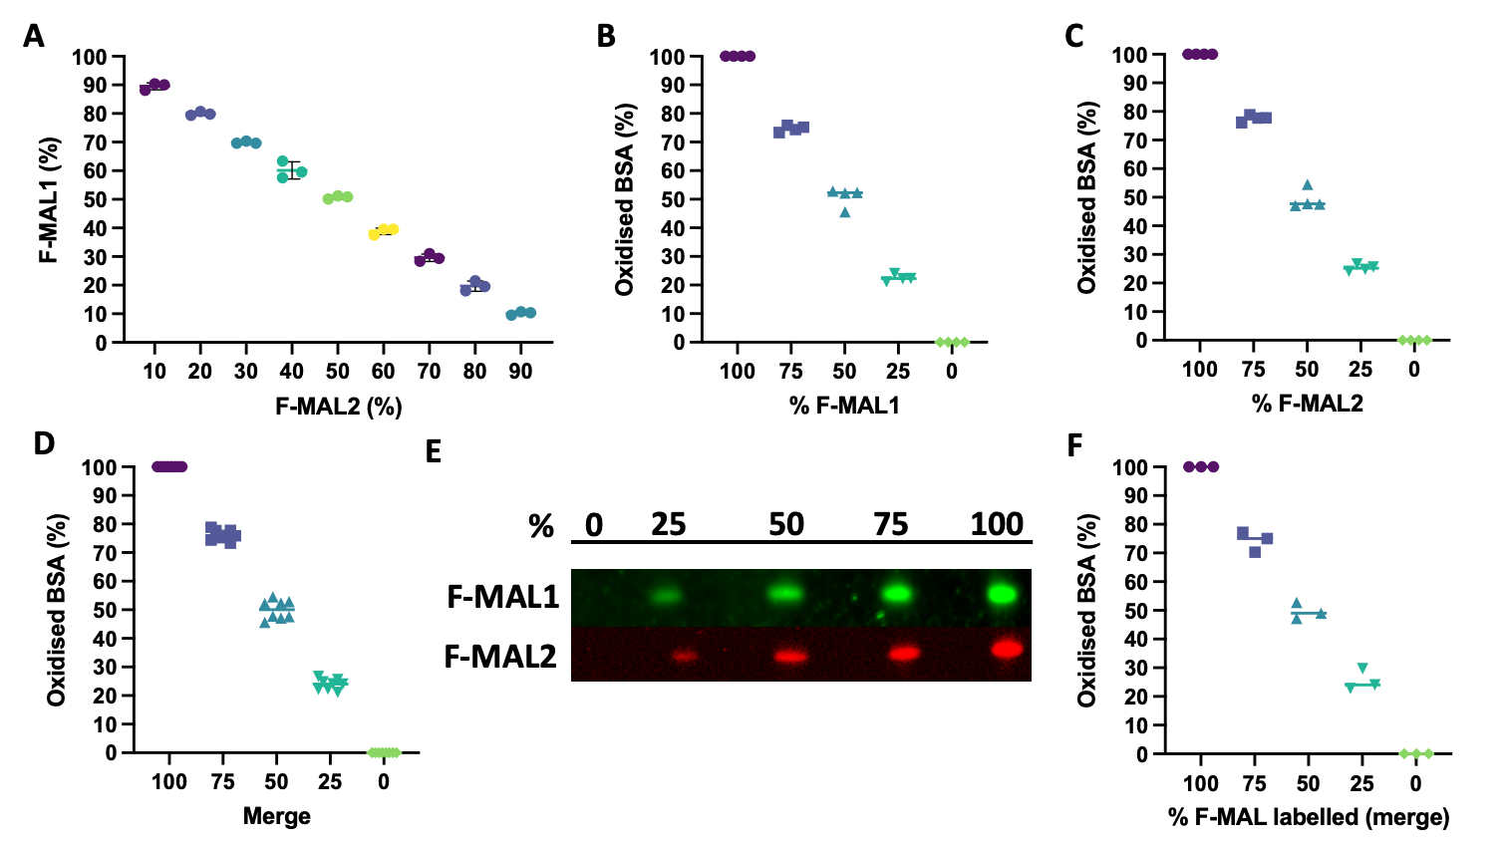
Supplementary Figure 1. Proof-of-principle RedoxiFluor experiments. A. RedoxiFluor can discern between 10 to 90% reversibly oxidised redox states obtained by mixing equimolar amounts of F-MAL1 and F-MAL2 (i.e., a protein free system) in a plate reader. RedoxiFluor can discern between different redox states of a recombinant protein (i.e., bovine serum albumin, BSA, D) in a plate reader regardless of whether F-MAL1 (B) or 2 (C) is used first. States were obtained by mixing fully labelled F-MAL1 and 2 BSA standards as appropriate to a final concentration of 1 ug (see methods). Representative image (E) and quantification data (F) showing that RedoxiFluor can discern between different BSA redox states in a gel following SDS-PAGE.

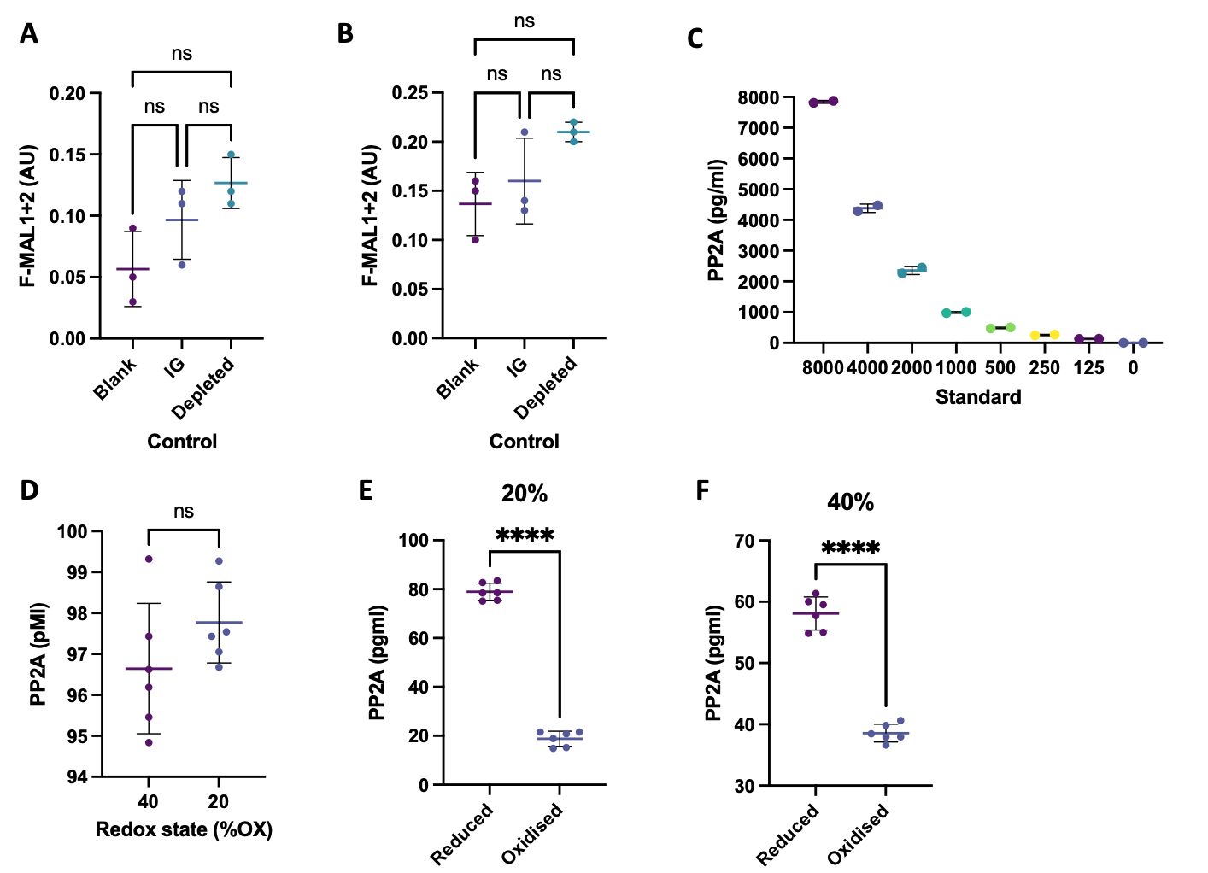
Supplementary Figure 2. RedoxiFluor controls and extended data. Protein A (A) and ELISA (B) mode RedoxiFluor controls showing no significant difference (P > 0.05) in summed F-MAL1-2 signal in rabbit immunoglobin (IG, n = 3) and PP2A immunodepleted (n = 3) controls compared to blank wells (n = 3) as determined by a one-way ANOVA. C. A representative ELISA mode recombinant mouse PP2A standard curve (range 8,000 to 125 PP2A pg/ml). D. No significant (unpaired t-test, P = 0.172, n = 6) difference in PP2A protein content between the 40 and 20% reversibly oxidised standards. Significant differences (paired-tests, P = < 0.0001 in panel E-F, n = 6) in the amount of reduced compared to reversibly oxidised PP2A in the 20 (panel E) and 40% (panel F) reversibly oxidised standards.

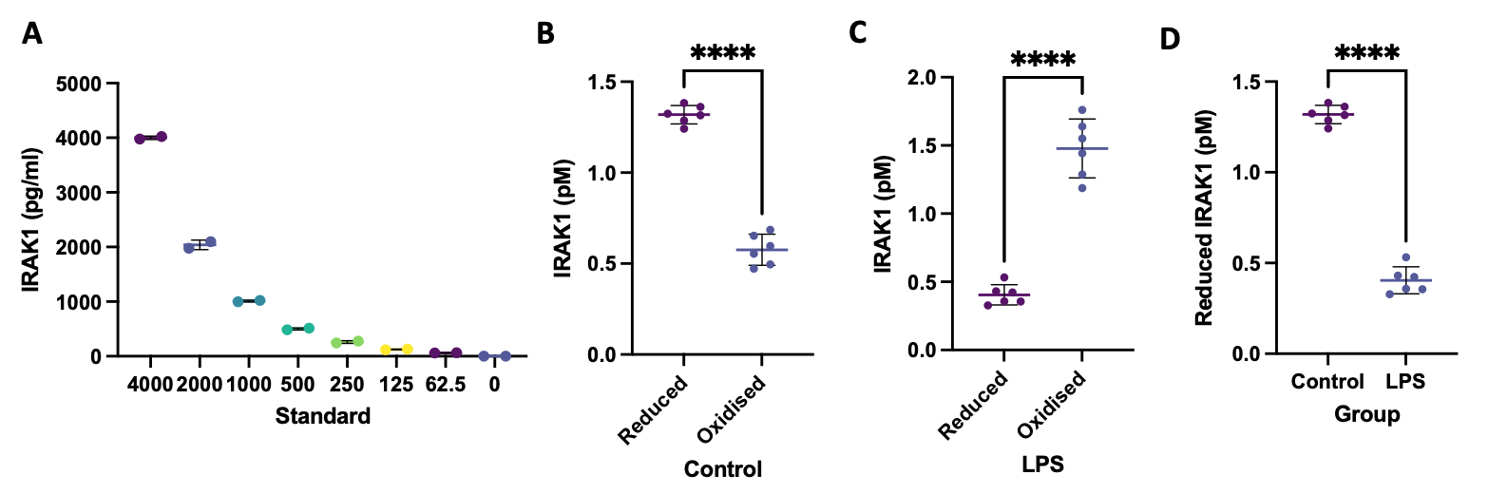
Supplementary Figure 3. Redox immunology part 1. LPS increases IRAK1 oxidation extended data. A. A representative ELISA mode recombinant human IRAK1 standard curve (range 4,000 to 62.5 IRAK1 pg/ml). B. In ELISA mode, picomoles of reduced IRAK1 are significantly (paired t-test, < 0.0001, n = 6) greater than picomoles of oxidised IRAK1 in unstimulated human monocytes. C. In ELISA mode, picomoles of oxidised IRAK1 are significantly (paired t-test, < 0.0001, n = 6) greater than picomoles of reduced IRAK1 in LPS stimulated human monocytes D. A significant (unpaired t-test, P = < 0.0001, n = 6) LPS induced decrease in picomoles of reduced IRAK1 in LPS stimulated compared to unstimulated human monocytes.

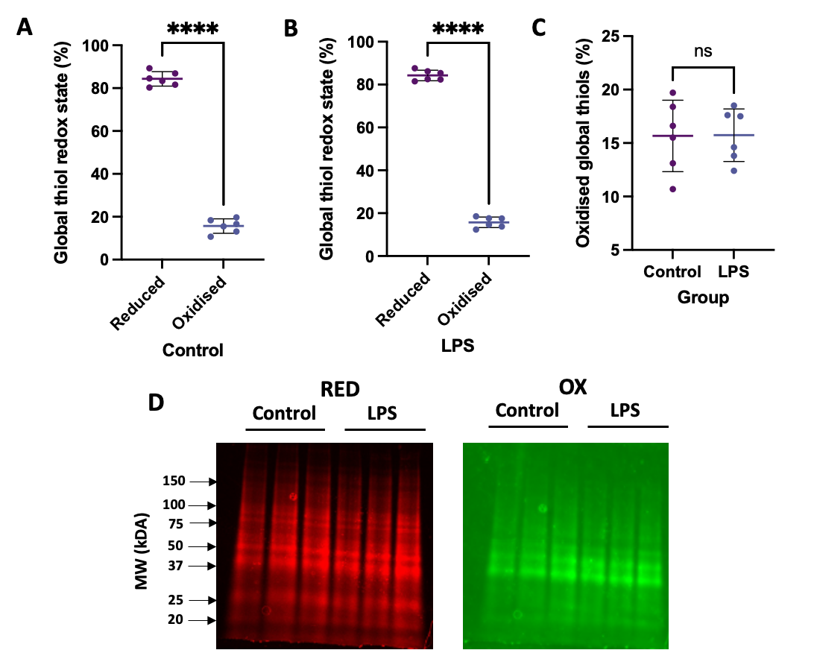
Supplementary Figure 4. No difference in the redox state of the bulk thiol proteome in unstimulated (control) and LPS stimulated human monocytes. Significant differences (paired t-tests, P = < 0.0001 in panels A-B, n = 6) in percent reduced compared to percent oxidised protein in unstimulated (control, panel A) and LPS stimulated (panel B) human monocytes. C. No significant difference (unpaired t-test, P = 0.9694, n = 6) in percent reversibly oxidised protein in LPS stimulated compared to unstimulated human monocytes. D. A representative SDS-PAGE gel image confirming that both proteomes are highly reduced and showing the similarity in band patterns in the reduced (red channel, F-MAL1) and reversibly oxidised (green channel, F-MAL2) between the control and LPS groups.

Supplementary Figure 5. Selected array mode RedoxiFluor protein A microplate layout by sample (1-2) state (control: 1-6, LPS: 7-12) and protein phosphatase (rows B-H).

Supplementary Figure 6. Array mode RedoxiFluor extended data: redox state of the seven protein phosphatases in unstimulated human macrophages. Percentage reduced protein is significantly greater (paired t-tests, all P values are < 0.0001, n = 6) than percent reversibly oxidised protein for all of the measured protein phosphatases as determined by array mode RedoxiFluor in unstimulated human monocytes.

Supplementary Figure 7. Array mode RedoxiFluor extended data: redox state of the seven protein phosphatases in LPS stimulated human macrophages. Percentage reduced protein is significantly greater (paired t-tests, aside from CD45 [P = 0.0002) all P values are < 0.0001, n = 6) than percent reversibly oxidised protein for all of the measured protein phosphatases as determined by array mode RedoxiFluor in LPS stimulated human monocytes.

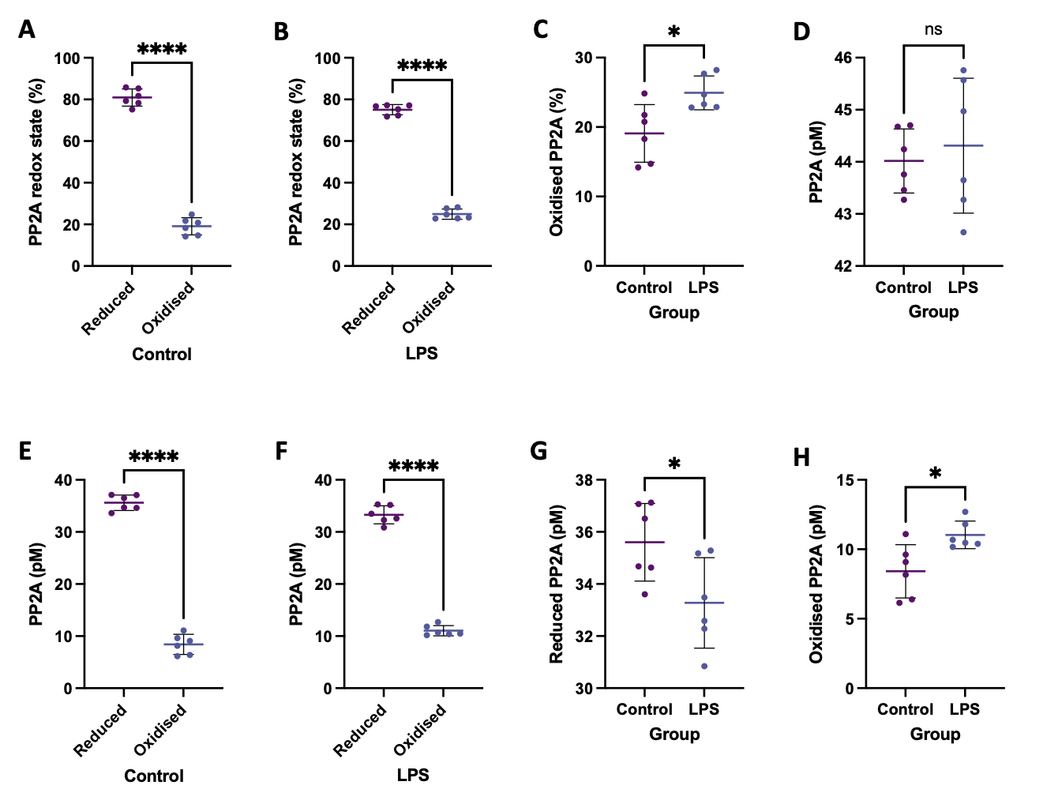
Supplementary Figure 8. ELISA mode RedoxiFluor reveals a significant LPS induced increased in PP2A specific reversible thiol oxidation. Significant differences (paired t-tests, P = < 0.0001 in panels A-B, n = 6) in percent reduced compared to percent oxidised PP2A in unstimulated (control, panel A) and LPS stimulated (panel B) human monocytes. C. A significant (unpaired t-test, P = 0.0140, n = 6) LPS induced increase in PTEN specific reversible thiol oxidation in stimulated compared to unstimulated human monocytes. D. No significant (unpaired t-test, P = 0.6278, n = 6) difference in picomoles of PP2A in LPS stimulated compared to unstimulated human monocytes. Significant differences (paired t-tests, P = < 0.0001 in panels E-F, n = 6) in picomoles of reduced compared to oxidised PP2A in unstimulated (control, panel A) and LPS stimulated (panel B) human monocytes. G. A significant (unpaired t-test, P = 0.0319, n = 6) decrease in picomoles of reduced PP2A in LPS stimulated compared to unstimulated human monocytes. H. A corresponding significant (unpaired t-test, P = 0.0140, n = 6) increase in picomoles of reduced PP2A in LPS stimulated compared to unstimulated human monocytes.

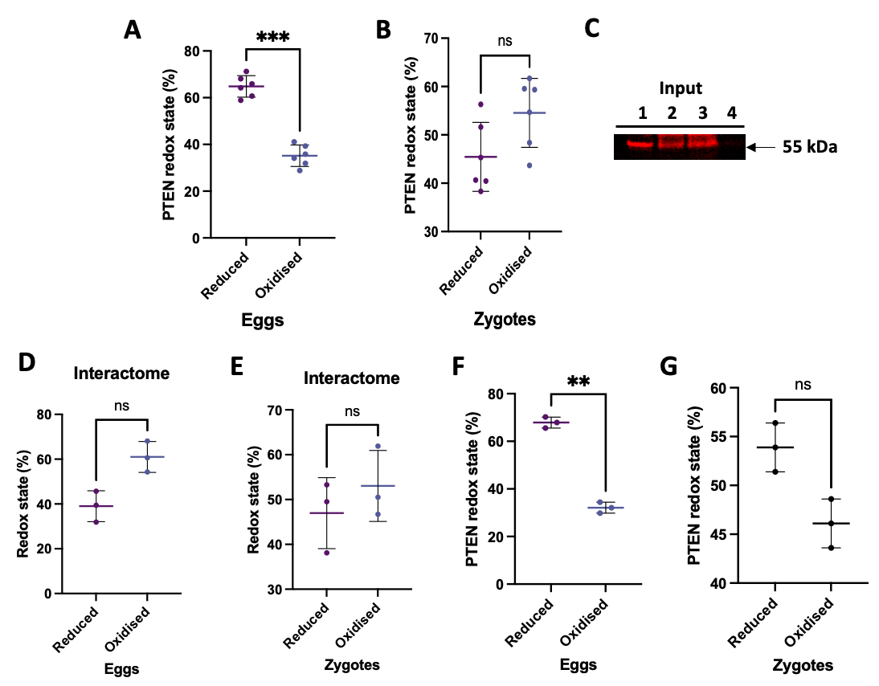
Supplementary Figure 9. Fertilisation increases PTEN specific reversible thiol oxidation extended data. A. A significant difference (paired t-test, P = 0.0005, n = 6) in percent reduced compared to percent oxidised PTEN in unfertilised X. laevis eggs as determined by protein A mode RedoxiFluor. B. No significant difference (paired t-test, P = 0.1796, n = 6) in percent reduced compared to percent oxidised PTEN in 1-cell X. laevis zygotes as determined by protein A mode RedoxiFluor. C. An immunoblot image showing successful PTEN immunoprecipitation (IP) in unfertilised eggs (lane 2) and 1-cell zygotes (lane 3). No PTEN was eluted in the rabbit IG control (lane 4). Lane 1 is a X. laevis lysate (i.e., no IP) control. D. Macroscale RedoxiFluor reveals no significant (unpaired t-tests, n = 3) in PTEN interactome redox state in unfertilised eggs (panel D, P = 0.1102) and 1-cell zygotes (panel E, P = 0.5749). F. A. A significant difference (paired t-test, P = 0.0055, n = 3) in percent reduced compared to percent oxidised PTEN in unfertilised X. laevis eggs as determined by macroscale RedoxiFluor. B. No significant difference (paired t-test, P = 0.1140, n = 3) in percent reduced compared to percent oxidised PTEN in 1-cell X. laevis zygotes as determined by macroscale RedoxiFluor.

Supplementary Table 1. Redox regulated phosphatases selected for array mode RedoxiFluor. MW denotes molecular weight.
Phosphatase | Uniport ID | Type | MW (kDa) | Thiols (#) | Catalytic thiol (residue)
PTEN | P60484 | Lipid, Ser/Ther, Tyrosine | 47.1 | 10 | Yes (Cys124)
PP2A | P67775 | Ser/Ther | 35.6 | 10 | No
Calcineurin | P48454 | Ser/Ther | 58.1 | 12 | No
SHP-1 | P29350 | Tyrosine | 67.5 | 7 | Yes (Cys453)
SHP-2 | Q06124 | Tyrosine | 68 | 11 | Yes (Cys459)
PTP1B | P18031 | Tyrosine | 50 | 10 | Yes (Cys215)
CD45 | P08575 | Tyrosine | 147.6 | 26 | Yes (Cys853)
Range | n/a | Lipid to all protein types | 35.6 to 147.6 | 7-26 | Yes and No

