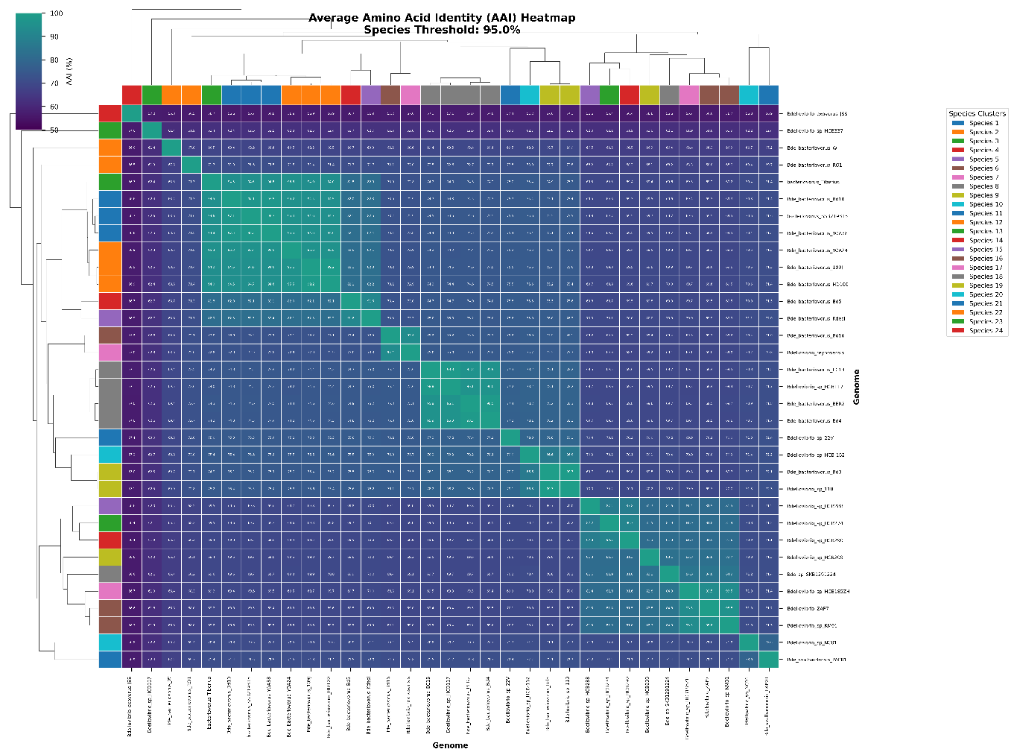
Figure S1. Pairwise AAI similarity matrix among Bdellovibrio strains.
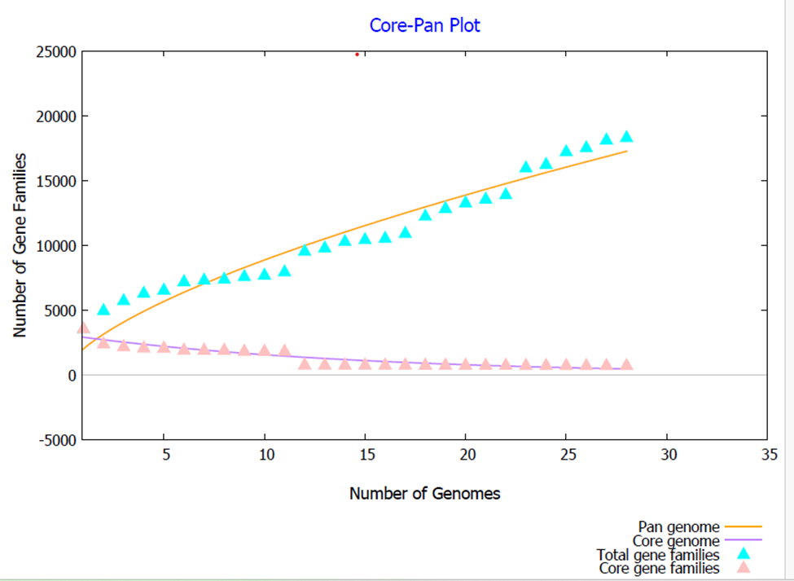
Figure S2a: Heaps’ law curve showing open pan-genome structure.

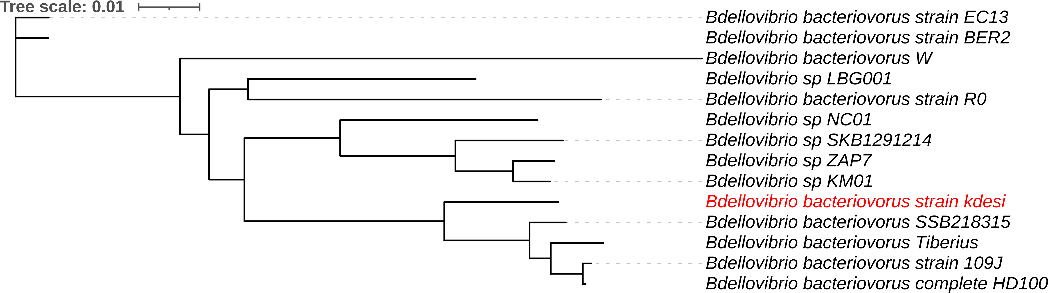
Figure S2b: A phylogeny based on single nucleotide polymorphism; SNP was analyzed, and tree generated with REALPHY, an online complete genome drawing tool. The tree was visualized with iTOL l(https://realphy.unibas.ch/REALPHY/scratch/data_qz7qbh8a/report/)

Figure S2. Core-genome SNP (cgSNP) phylogeny and Heaps’ law curve showing open pan-genome structure.

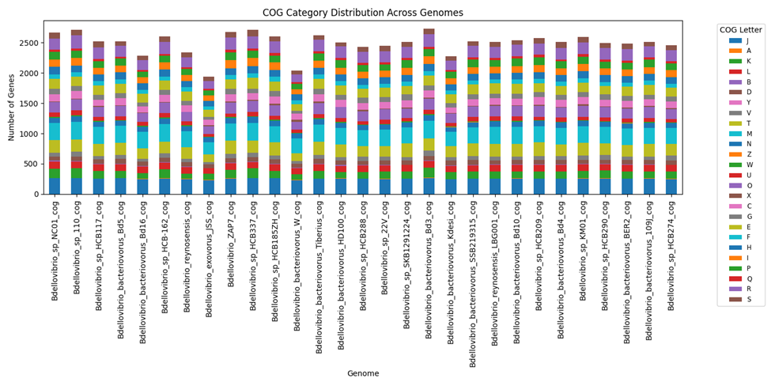
Figure S3. COG category distribution and functional annotation of the core genome.
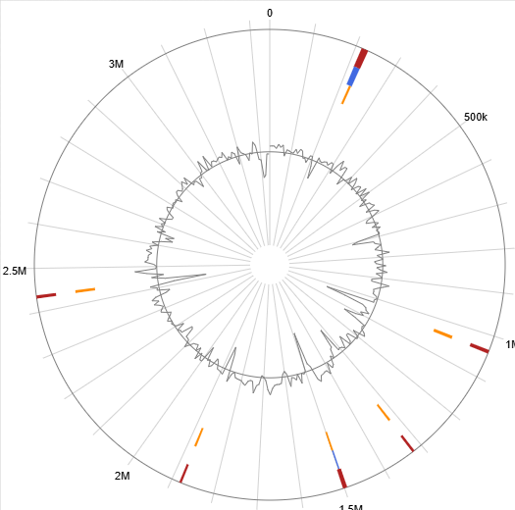
Figure S4. Genomic island distribution across Bdellovibrio sp. Kdesi genome.
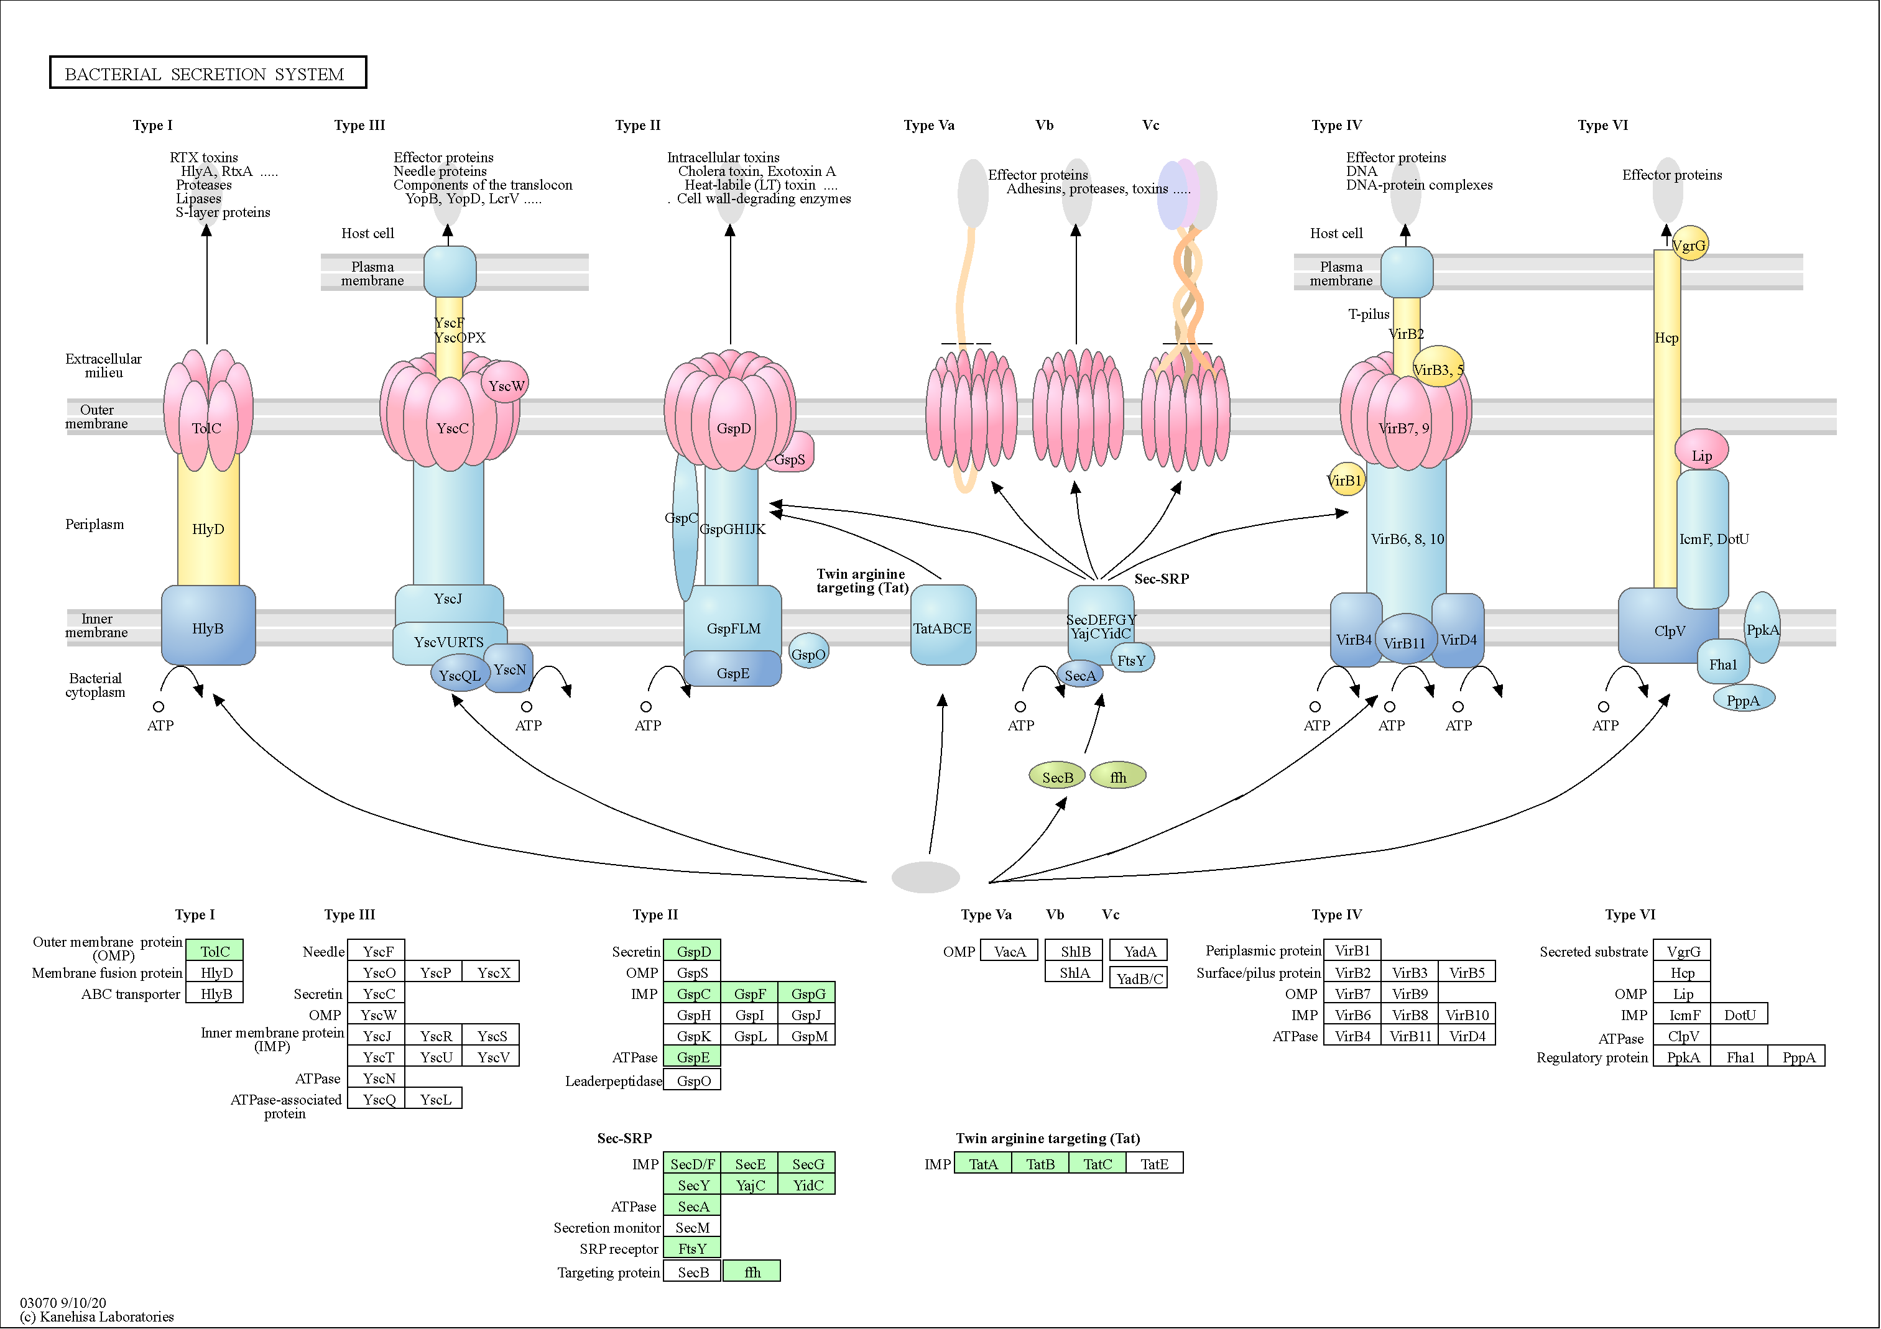

Figure S5. This figure showed the absence of SecB in the Sec secretion system across Bdellovibrio strains using the Sec system from Bdellovibrio sp kdesi identified with the KEGG GhosttKoala and pathway mapping. Image was generated from KEGG pathway mapping (Kanehisa et al., 2025).

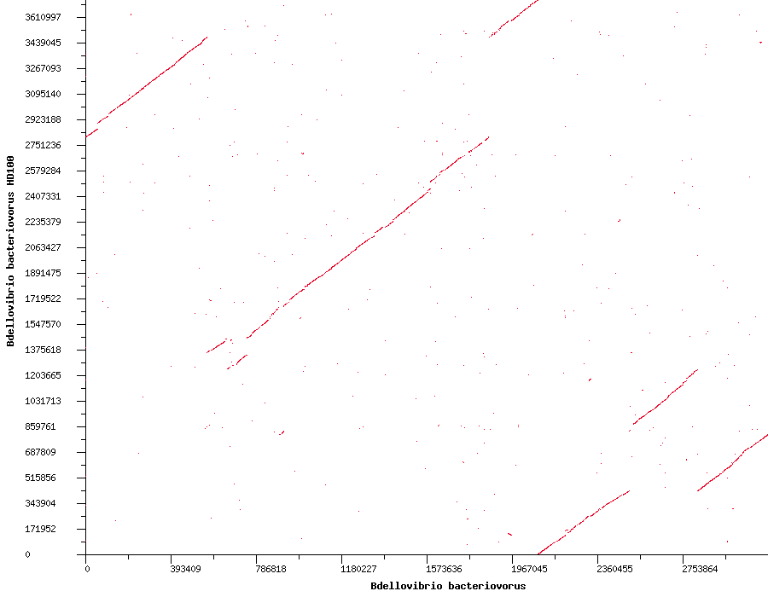
Kdesi
A

Figure S6a. Whole-genome synteny comparison between *Bdellovibrio sp. Kdesi and B. bacteriovorus* HD100.
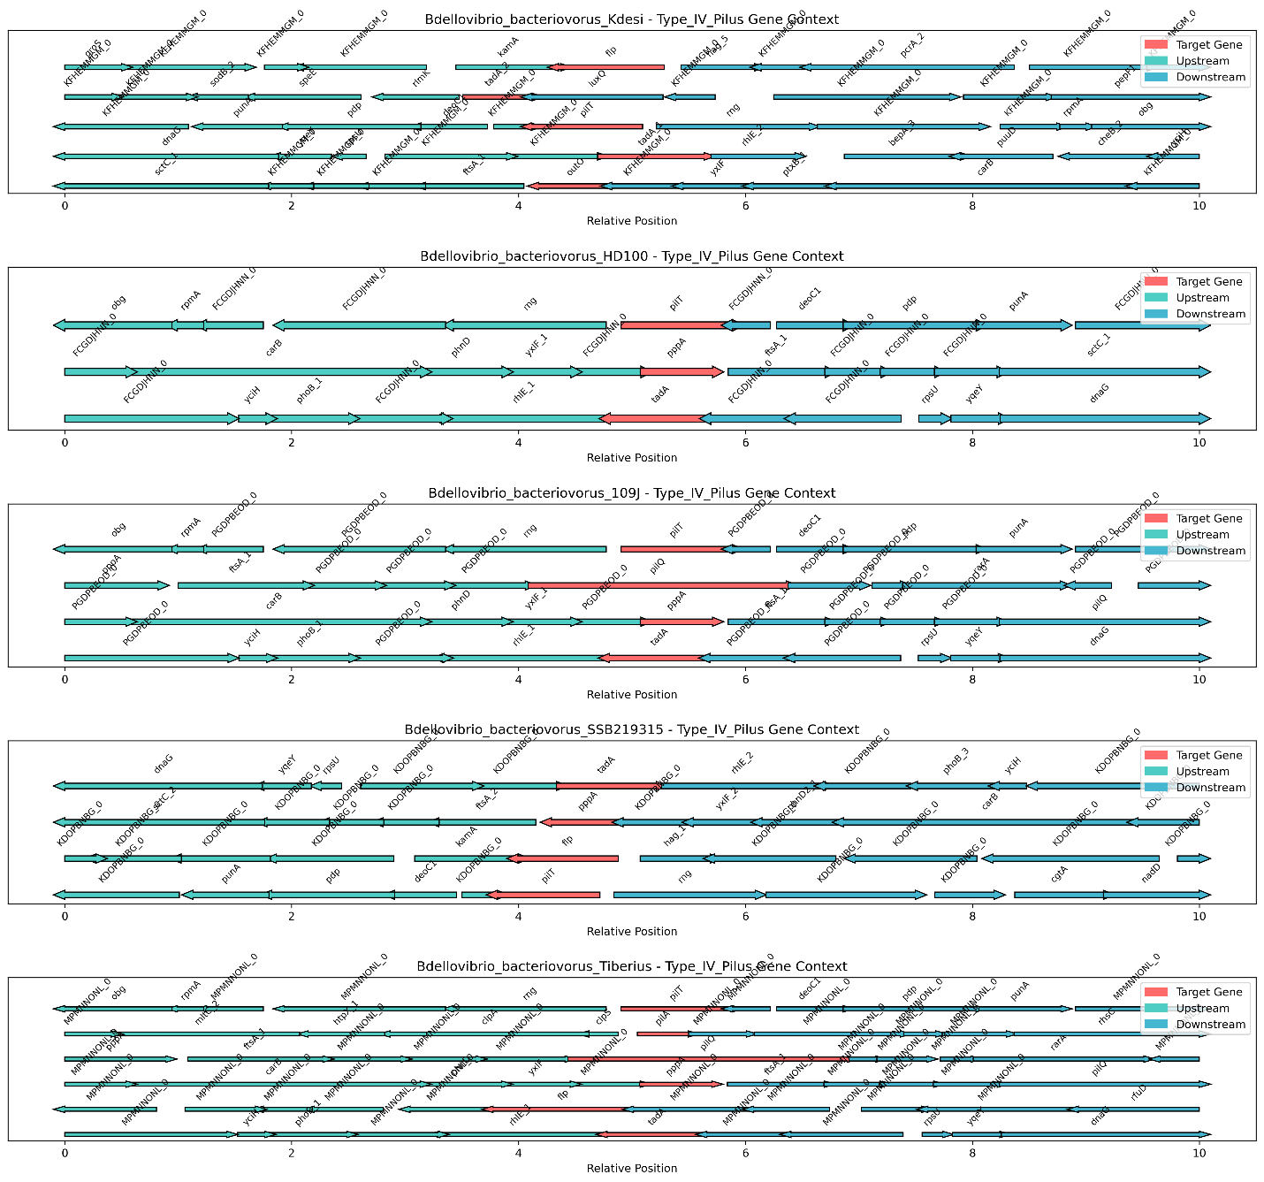
Figure S7. Synteny of Type IV pilus (T4P) gene cluster across representative Bdellovibrio strains.

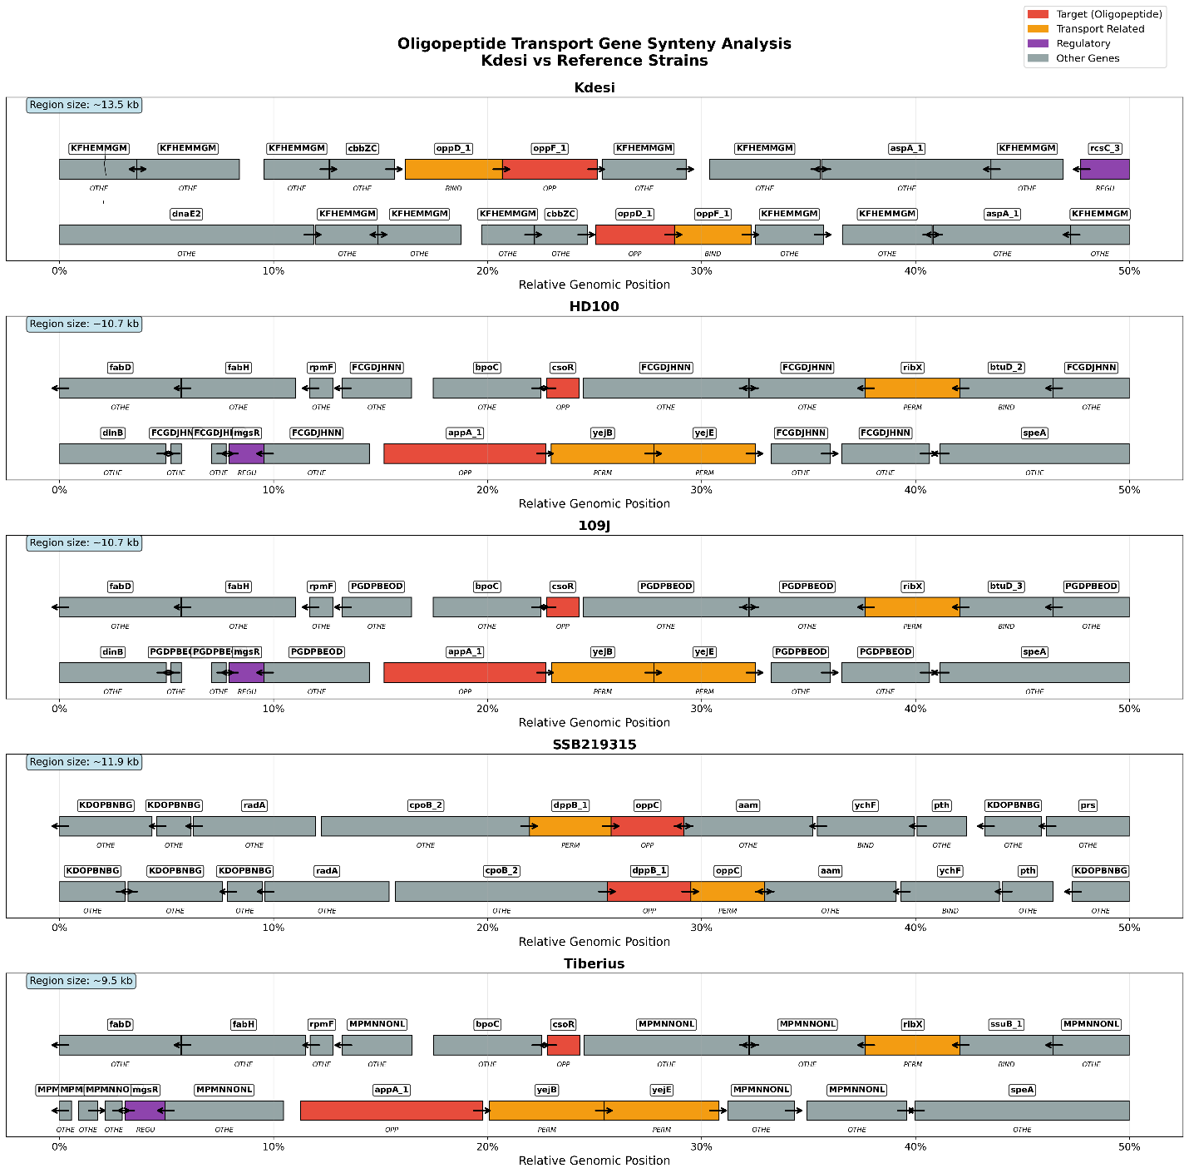
Oligopeptide synteny.

