Brain connectivity fingerprinting as a predictive biomarker of art therapy outcomes in Parkinson’s disease

Augusto Ielo^{1,§,*}, Danilo Genovese^{2,3,§}, Joan Falcó-Roget⁴, Enrico Amico^{5,6}, Alessandro Di Rocco⁷, Monica Norcini⁸, Angelo Quartarone¹, Maria Felice Ghilardi⁹, Alberto Cacciola^{10,11,*}

¹IRCCS Centro Neurolesi "Bonino Pulejo", 98124 Messina, Italy
²Institute of Neurology, Fondazione Policlinico Universitario A. Gemelli IRCCS, Rome, Italy
³Department of Neuroscience, Università Cattolica del Sacro Cuore, Rome, Italy
⁴Computational Neuroscience Group, Sano Centre for Computational Medicine, Kraków, Poland
⁵School of Mathematics, University of Birmingham, Birmingham, UK
⁶Centre for Human Brain Health, University of Birmingham, Birmingham, UK
⁷Department of Neurology, Donald and Barbara Zucker School of Medicine at Hofstra/Northwell, Lenox Hill Hospital, New York, NY
⁸NYU Langone Health, Department of Neurology, New York, NY 10016, USA
⁹Department of Molecular, Cellular & Biomedical Sciences, CUNY School of Medicine, New York, NY 10031, USA
¹⁰Department of Biomedical Sciences, Humanitas University, Via Rita Levi Montalcini 4, Pieve Emanuele, 20072 Milan, Italy
¹¹IRCCS Humanitas Research Hospital, Via Alessandro Manzoni 56, Rozzano, 20089 Milan, Italy
§Shared co-first authorship

*Correspondence
Augusto Ielo
IRCCS Centro Neurolesi "Bonino Pulejo", 98124 Messina, Italy.
augusto.ielo@irccsme.it

Alberto Cacciola, MD
Department of Biomedical Sciences, Humanitas University, Pieve Emanuele, Milan, Italy
IRCCS Humanitas Research Hospital, Rozzano, Milan, Italy
alberto.cacciola@hunimed.eu

Supplementary material

Supplementary Table 1. Characteristics of responders and non-responders to art therapy
 | Responders (n=13) | Non-Responders (n=10) | p-value | Cohen's d
Females (N, %) | 9, 69.2% | 6, 60.0% | 0.985
Age (years) | 67.3 ± 4.6 [64.5 70.1] | 70.1 ± 7.2 [65.0 75.2] | 0.301
Education (years) | 17.7 ± 3.3 [15.7 19.7] | 16.9 ± 2.1 [15.4 18.4] | 0.492
Right Handedness (N, %) | 12, 92.3% | 10, 100.0% | 1.000
MoCA | 26.1 ± 2.2 [24.8 27.4] | 26.1 ± 1.9 [24.8 27.4] | 0.978
PD duration [years] | 5.2 ± 3.1 [3.3 7.1] | 5.7 ± 5.1 [2.0 9.3] | 0.822 | -0.10
Hoehn & Yahr, BL | 2.2 ± 0.4 [2.0 2.5] | 2.5 ± 0.5 [2.1 2.9] | 0.209 | -0.56
UPDRS I, BL | 15.5 ± 6.5 [11.6 19.5] | 12.6 ± 7.9 [6.9 18.3] | 0.356 | 0.41
UPDRS II, BL | 13.8 ± 4.6 [11.1 16.6] | 11.5 ± 7.8 [5.9 17.1] | 0.414 | 0.38
UPDRS III, BL | 35.3 ± 8.8 [30.0 40.6] | 41.0 ± 13.3 [31.5 50.5] | 0.259 | -0.52
UPDRS IV, BL | 3.5 ± 3.6 [1.4 5.7] | 3.9 ± 5.3 [0.1 7.7] | 0.854 | -0.08
UPDRS total, BL | 68.2 ± 13.2 [60.2 76.2] | 69.0 ± 22.9 [52.6 85.4] | 0.926 | -0.04
LEDD [mg/day], BL | 592 ± 342 [385 799] | 638± 523 [263 1012] | 0.812 | -0.11
Hoehn & Yahr, FU | 2.3 ± 0.5 [2.0 2.6] | 2.5 ± 0.5 [2.1 2.9] | 0.379 | -0.38
UPDRS I, FU | 13.3 ± 7.2 [8.9 17.7] | 11.6 ± 8.1 [5.8 17.4] | 0.606 | 0.22
UPDRS II, FU | 12.0 ± 5.8 [8.5 15.5] | 12.0 ± 8.9 [5.6 18.4] | 1.000 | 0.00
UPDRS III, FU | 25.4 ± 8.5 [20.2 30.6] | 41.7 ± 11.5 [33.5 49.9] | 0.002 | -1.64
UPDRS IV, FU | 4.3 ± 4.0 [1.9 6.7] | 3.0 ± 4.2 [0.0 6.0] | 0.458 | 0.32
UPDRS total, FU | 55.0 ± 16.8 [44.8 65.2] | 68.3 ± 23.3 [51.7 84.9] | 0.147 | -0.67
ΔUPDRS III %  FU vs. BL | -29.2 ± 11.4 [-36.1 -22.3] | 3.9 ± 14.7 [-6.6 14.5] | <0.001 | -2.56
ΔUPDRS Tot %  FU vs. BL | -20.5 ± 13.5 [-28.7 -12.4] | 0.3 ± 16.1 [-11.2 11.8] | 0.004 | -1.42
LEDD [mg/day], FU | 599 ± 295 [421 778] | 594 ± 452 [271 918] | 0.975 | 0.01

Demographic and clinical characteristics of the responder and non-responder PD groups. Mean ± SD and 95% confidence interval [CI, in parenthesis] are reported for continuous variables. Results of group comparisons are reported with p-values from Welch’s t-test and Cohen’s d [continuous variables] or chi-square test for categorical variables. Significant group differences are in bold. BL = baseline; FU = follow-up; MoCA = Montreal Cognitive Assessment; UPDRS = Unified Parkinson’s Disease Rating Scale; LEDD = levodopa equivalent daily dose; ΔUPDRS III (%) and ΔUPDRS Total (%) = [(FU − BL) / BL] × 100, negative values indicate improvement.

Supplementary Figure 1. Functional connectivity-based subject identifiability before and after residualization
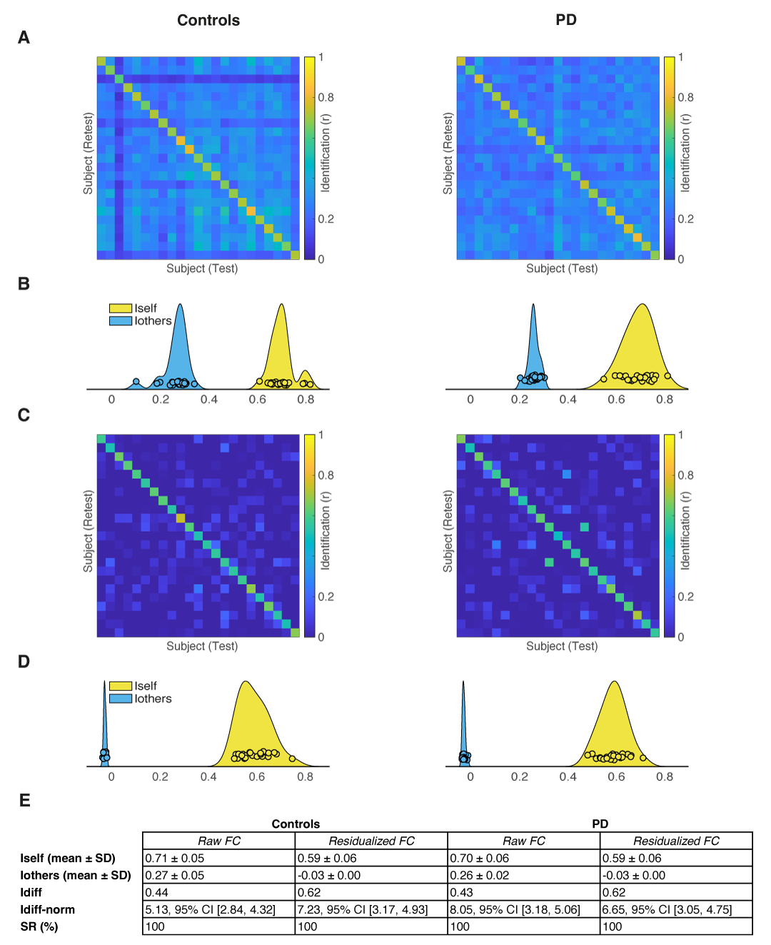
The distributions of I_{self} and I_{others} are summarized using kernel density estimates of with overlaid individual subject values. A) Identifiability matrices for Controls and PD computed from raw functional connectivity (FC) data. The color scale represents the identification score between test-retest FC pairs for each subject. Alongside each matrix, the mean ± SD values of I_{self} (within-subject similarity) and I_{others} (between-subject similarity) are reported, together with the normalized identifiability difference (I_{diff-norm}) and its 95% confidence interval (CI), and the identification success rate (SR). B) Distributions of I_{self} (yellow) and I_{others} (blue) for each group in the raw data. C) Identifiability matrices for the same groups after residualization of FC to remove the effects of age, sex, years of education, disease duration, and age at PD onset (with the latter two set to zero for HC). D) Distributions of I_{self} and I_{others} after residualization. Residualization markedly reduced the between-subject similarity distribution (I_{others}) to values near zero, while SR remained at 100% in all conditions and an increase in differential identifiability metrics was observed. E) Summary metrics including mean I_{self}, mean Iothers, I_{diff-norm}, and SR obtained before and after residualization are showed for each condition.
Supplementary Figure 2. Network-aggregated magnitudes of significant ΔICC (Controls vs PD)
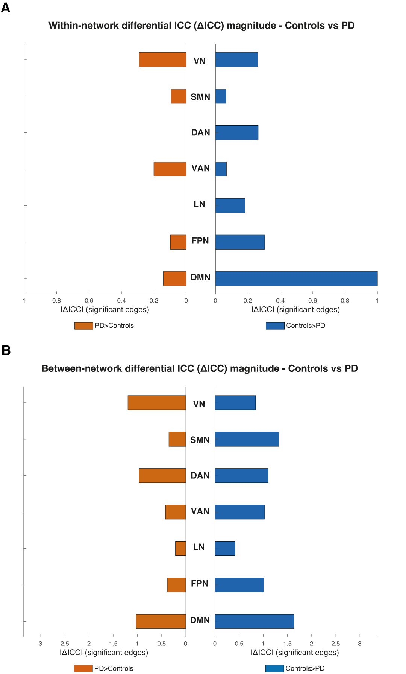
Horizontal bar plots summarize, by Yeo network, the magnitude of significant differential ICC (Controls > PD on the right and PD > HC on the left). A) Within-network edges. B) Between-network edges (totals for all cross-network edges incident to each network). Bar length reflects the summed absolute differential ICC for edges that survived permutation testing with FDR correction. Colours: PD>HC = orange; HC > PD = blue.

