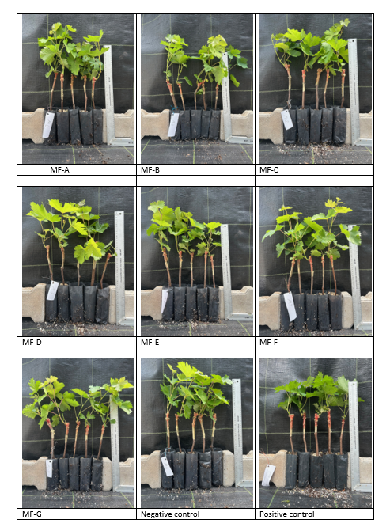
Supplementary Figure S1. Effect of microbial fertilizer applications on grapevine seedling growth

