Supporting Information

Enhanced oxygen evolution reaction by stacking single-crystalline freestanding SrRuO₃
Qixiang Wang^{1,2,#}, Huan Liu^{2,3,#}, Bin He^{1,}*, Ji Qi^{2,3}, Di Wang¹, Hang Xu^{2,3}, Nana Zhang¹, Jie Wang^{1,2} ,Yanan Chen¹, Zhihong Wang⁴, Zhengjia Wang², Limei Zheng^{5,}*, Ming Feng³, Weiming Lü^{1,2,}*, and Shishen Yan^{1,5,}*

1, Spintronics Institute, School of Physics and Technology, University of Jinan, Jinan 250022, China.
2, Condensed Matter Science and Technology Institute, School of Instrumentation Science and Engineering, Harbin Institute of Technology, Harbin 150080, China.
3, Key Laboratory of Functional Materials Physics and Chemistry of the Ministry of Education, Jilin Normal University, Changchun 130103, China.
4, School of Physics, Harbin Institute of Technology, Harbin 150001, China.
5, School of Physics, Shandong University, Jinan 250100, China.

# These authors contributed equally to this work.

The surface topography and thickness of single SRO layer grown on the SrTiO₃ substrate were probed by atomic force microscope (AFM, Shimadzu Corporation, SPM-9700HT) and low-angle X-ray reflectivity (XRR, Rigaku, Smartlab3KW). The rigid SRO film maintains a discernable terrace-like flat surface with the small root mean square (rms) roughness around 0.2 nm, as shown in Figure S1a. Figure S1b shows representative XRR measurement data and fitted curve of SRO films. The calculated thickness from the best fitted curve is nicely match the designed value of 16 nm. Figure S1c shows the resistance vs temperature curve and its differentiation of rigid SRO film, which presents the resistive transition from Fermi-liquid to ‘bad-metal’.

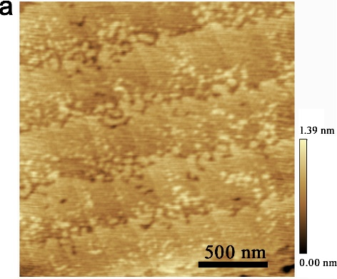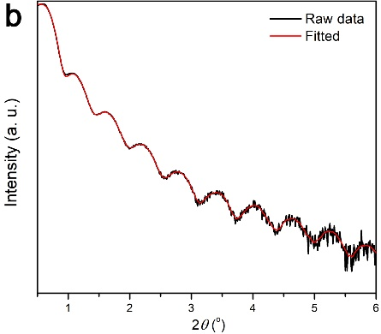

Figure S1 a AFM surface topography and b low-angle X-ray reflectivity of rigid SRO film grown on a (100)-oriented STO substrate. c Resistance and its differentiation as a function of the temperature of rigid SRO film.
During the OER measurement, the C-SROs can be easily removed by electrolyte as shown in Figure S2a. This instability can be improved by annealing the sample at 400 ºC to achieve a stronger adhesion as shown in Figure S2b.
Figure S2. The optical images of as-growth (a) and annealing (b) C-SRO before and after the OER measurements.
The electrochemical double-layer capacitances (C_{dl}) were analyzed by cyclic voltammetry measurements at different scan rates to realize the C-SRO coverage effort from the view of electrochemically active surface area. The capacitive current density was determined as a function of the scan rate (10 to 80 mV/s) for rigid SRO and C-SRO (n=3 and 10) in a small potential region of 100 mV (0.924 to1.024 V), as shown in Figure S3. By plotting the ΔJ/2 at 0.974 V against the scan rate, the linear slope is C_{dl}, which is proportional to the electrochemically active surface area. Thus, the electrochemically active surface area of rigid SRO and C-SRO (n=3 and 10) can be compared according to C_{dl} values.
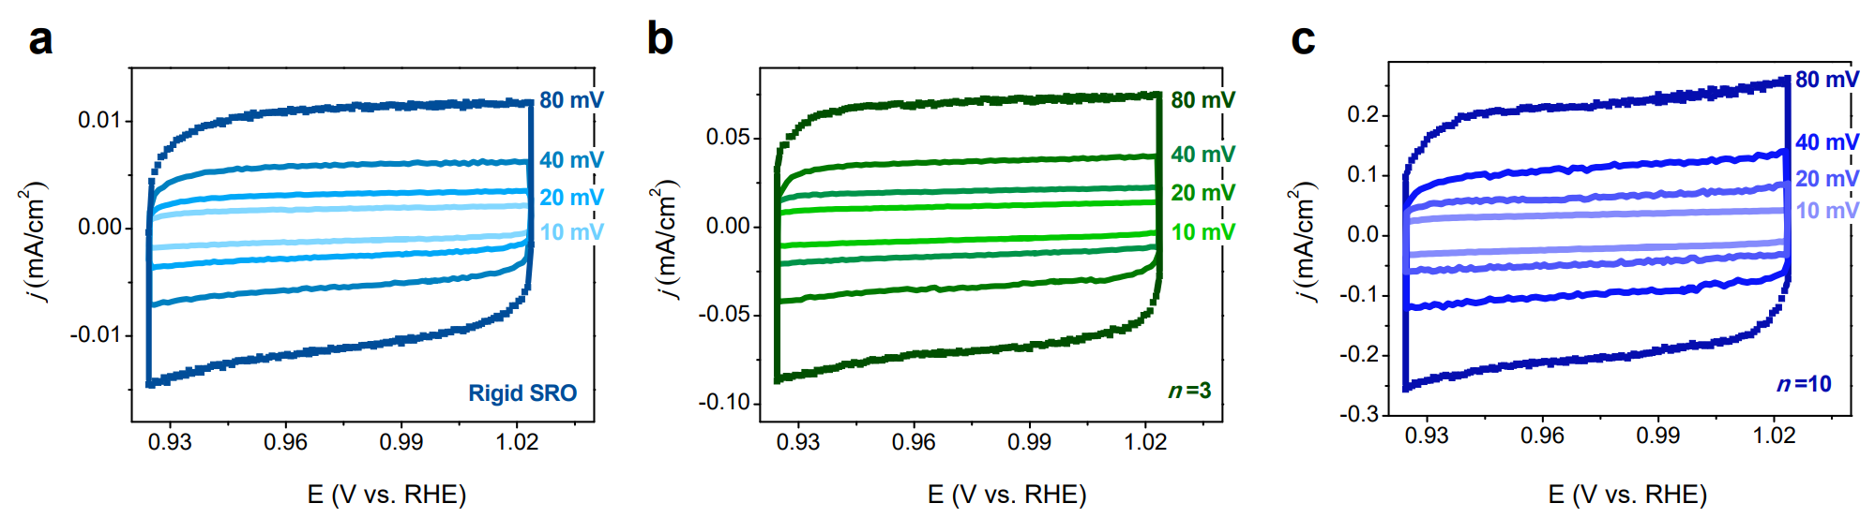
Figure S3, a and b The CV curves of rigid SRO and C-SRO (n=3 and10) under different scan rates of 10, 20, 40, and 80 mV/s.

