Drivers of sex differences in Mycobacterium tuberculosis immunoreactivity among adolescents and adults in Blantyre, Malawi
Authors
Mphatso D Phiri^{1,2,3,4} *, Hannah M Rickman^{1,5}, Hannah Mbale¹, Helena RA Feasey⁶, Marriott Nliwasa^{7,8}, Alvaro Schwalb^{9,10,11}, Tisungane E Mwenyenkulu¹², Kuzani N Mbendera¹², Henry C Mwandumba^{1,2,3}, Elizabeth L Corbett⁵, S Bertel Squire^{2,3}, Marc YR Henrion^{1,2,3}, Katherine C Horton^{9,10}, Peter MacPherson¹³
* Correspondence: Mphatso D Phiri (mdphiri@mlw.mw)

Supporting information includes:
- Appendix A: Conceptual framework of individual-, household- and community-level risk factors for Mycobacterium tuberculosis (Mtb) exposure and infection
- Appendix B: Model specification
- Appendix C: Participant recruitment
- Appendix D: Table S1: Predicted Mycobacterium tuberculosis (Mtb) immunoreactivity probabilities, by age and sex, male-to-female (M:F) ratios comparing predicted probabilities between males and females, and the posterior probability that M:F ratios exceeded 1 at each age.
- Appendix E: Posterior probability of excess male risk in Mycobacterium tuberculosis immunoreactivity, comparing male-to-female (M:F) predicted probability ratios
- Appendix F: Posterior sensitivity to weaker and stronger priors and likelihood
- Appendix G: Model comparison, goodness of fit, regression coefficients and for models reported in the main text.

Appendix A: Conceptual framework of individual-, household- and community-level risk factors for Mycobacterium tuberculosis (Mtb) exposure and infection
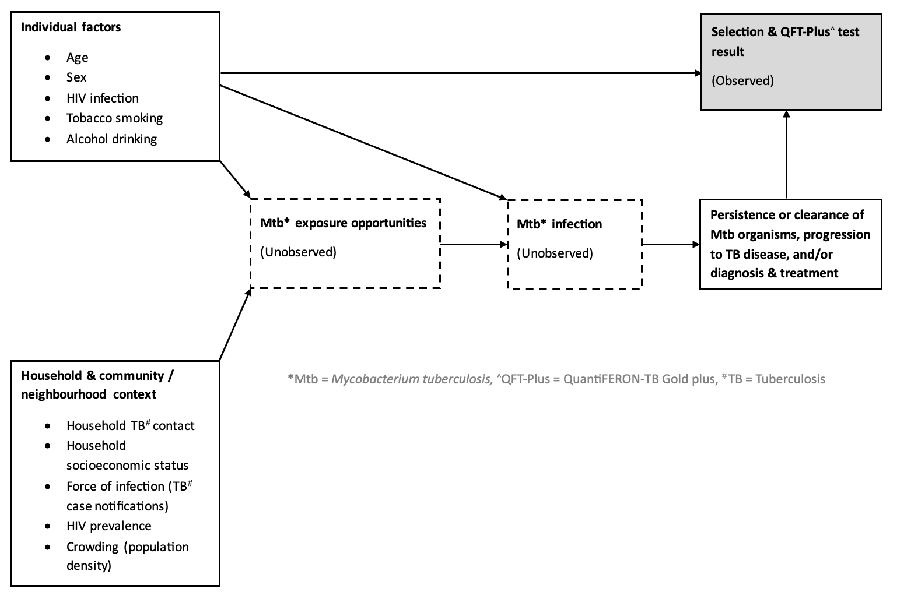
Figure S1: Conceptual framework of risk factors for Mycobacterium tuberculosis exposure and infection
Figure S1: Individual-, household- and community-level risk factors for Mycobacterium tuberculosis (Mtb) exposure and infection.

Appendix B: Model specification

“Base” model
Outcome: Mycobacterium tuberculosis (Mtb) immunoreactivity, defined as a positive QuantiFERON-TB Gold Plus test result. Mtb immunoreactivity probability $Pr\left(Y_{i}=1\right){= p}_{i}$ for participant $i=1,…,n$ nested in neighbourhood $j=i\left(j\right)$ was modelled as a Bernoulli outcome. The likelihood and link were:
$$Y_{i}∼Bernoulli\left(p_{i}\right), logit\left(p_{i}\right) = η_{i}.$$
The linear predictor comprises a sex-specific smooth of age and a neighbourhood-level random intercept.
$$η_{i} = α + f_{\text{age}×\text{sex}}​\left({age}_{i},{sex}_{i}\right) + b_{j\left[i\right]}, b_{j}∼N\left(0,σ_{b}^{2}\right), j=1,…,J.$$
The smooth function term for age and sex is specific as a spline basis of dimension $K$, allowing different age curves by sex:
$$f_{\text{age}×\text{sex}}​\left(age,sex\right)=\sum_{k=1}^{K}{γ_{k}} B_{k}\left(age\right) + 1\left\{sex=\text{male}\right\}\sum_{k=1}^{K}{δ_{k}} B_{k}\left(age\right),$$
where $B_{k}\left(⋅\right)$ are basis functions (thin-plate regression splines in implementation), $γ_{k}$ the baseline smooth coefficients and $δ_{k}$ the male-specific deviations. $K$ values were compared via leave-one-out cross-validation to identify an adequate spline basis dimension.

“Full” model (adding individual & neighbourhood-level covariates)
We let $x_{i}$ represent individual-level covariates (HIV status, previous TB treatment, household TB contact, smoking, alcohol); membership in the poorest poverty quartile of households; all specified as binary variables, and neighbourhood -level covariates (2020 TB case notification rate (mean-centred), 2019 adult HIV prevalence, population density (mean-centred)), with corresponding coefficients $β$. The full model extended the linear predictor as:
$$η_{i} = α + f_{\text{age}×\text{sex}}​\left({age}_{i},{sex}_{i}\right) + x_{i}^{​⊤}β + b_{j\left[i\right]}.$$

Priors
Priors were weakly informative, specified as below, visualised via prior predictive checks to inspect their implied probabilities, and prior–data conflict and sensitivity were examined using the priorsense package v1.1.0:
- Intercept (logit scale) centred on a baseline prevalence of 20% in females:
$$α∼N​\left(logit\left(0.2\right), 1^{2}\right) \text{with} logit\left(0.2\right)=log​\frac{0.2}{0.8}≈-1.386$$
- Population-level coefficients:
$$β_{m}∼N\left(0,1^{2}\right) \text{for each }m,$$
- Neighbourhood-level random-intercept standard deviation:
$$σ_{b}∼Exponential\left(1\right).$$
- Smooth (spline) standard deviations (brms class = sds, lower bounded at 0):
$$σ_{f}∼Half\text{-}Student\text{-}t\left(ν=2, 0, 2\right).$$
where $σ_{b}$ is the SD of the neighbourhood random intercepts, and $σ_{f}$ is the SD parameter governing the spline penalties. In brms, priors on SD parameters are constrained to be non-negative; thus the Student-$t$ prior on $σ_{f}$ is implicitly half-$t$.

Estimation
Models were fitted in a Bayesian framework using Hamiltonian Monte Carlo via the brms (v2.22.0) interface to Stan in the R environment for statistical computing (v4.3.3). We run 4 chains with 2,000 iterations per chain (1,000 warm-up), yielding 4,000 post-warm-up draws. Convergence and mixing were assessed using $\hat{R}$, effective sample sizes, and visual inspection of trace plots. We set a conservative target acceptance probability (e.g., adapt_delta = 0.999) to avoid divergent transitions. Models were fitted in R v4.3.3 using the brms package v2.22.0, an interface to Stan v0.7.1 implementing Hamiltonian Monte Carlo.

Posterior summaries and predictions
Posterior estimates are reported as posterior means and 95% credible intervals (CrIs; central 95% posterior percentiles). For age- and sex-specific inferences we calculated predictions, excluding neighbourhood-level random effects by setting $b_{j}=0$ (population-level predictions).

Annual risk of Mtb immunoreactivity conversion (ARC)
Let $p\left(a,s\right)$ denote the predicted probability of immunoreactivity at age $a$ and sex $s$. The annual risk of conversion (ARC) at age $a$ was defined as:
$$ARC\left(a,s\right) = \frac{p\left(a​+​1,s\right)-p\left(a,s\right)}{1-p\left(a,s\right)}×100\%.$$
To quantify sex differences we computed male-to-female (M:F) ratios of predicted probabilities
and ARCs at each age:
$${M:F}_{p}\left(a\right) = \frac{p\left(a,\text{male}\right)}{p\left(a,\text{female}\right)}, {M:F}_{ARC}\left(a\right) = \frac{ARC\left(a,\text{male}\right)}{ARC\left(a,\text{female}\right)}.$$
The posterior probability of excess male risk was reported as $Pr\{{M:F}_{p}\left(a\right)>1∣\text{data}\}$, computed as the proportion of posterior draws where the ratio exceeded 1 (with Monte Carlo standard error).

Interpretation
We exponentiated logit scale fixed-effect coefficients to obtain odds ratios. Nonlinear age effects are obtained from probabilities obtained via the logit-inverse function to the odds; uncertainty in both the smooth and random effects is propagated through all posterior summaries.

Appendix C: Participant recruitment
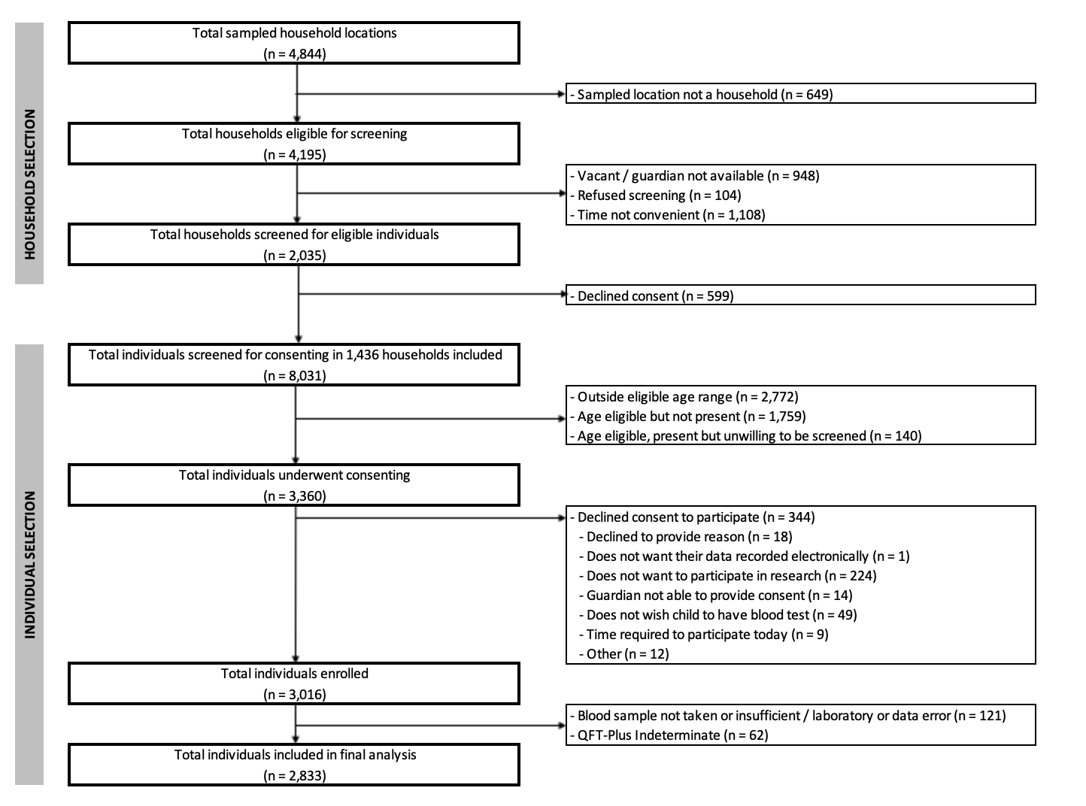
Figure S2: Participant recruitment

Appendix D: Mycobacterium tuberculosis immunoreactivity probabilities and male-to-female ratios
Table S1: Predicted Mycobacterium tuberculosis (Mtb) immunoreactivity probabilities, by age and sex, male-to-female (M:F) ratios comparing predicted probabilities between males and females, and the posterior probability that M:F ratios exceeded 1 at each age.
Age (years) | Predicted probability of Mtb immunoreactivity¹ (%) |  | M:F² probability ratio  (95% CrI) | Posterior probability³ that M:F ratio exceeded 1 | MCSE⁴ of posterior probability M:F > 1
 | Male | Female
10 | 6.2% (3.9%-9.1%) | 8.5% (5.7%-11.8%) | 0.74 (0.44-1.18) | 9.9% | 0.0052
11 | 6.9% (4.6%-9.6%) | 9.1% (6.4%-12.2%) | 0.77 (0.49-1.14) | 9.3% | 0.0049
12 | 7.6% (5.4%-10.2%) | 9.8% (7.2%-12.6%) | 0.79 (0.55-1.11) | 8.6% | 0.0046
13 | 8.5% (6.3%-10.9%) | 10.5% (8.1%-13.1%) | 0.82 (0.60-1.09) | 7.8% | 0.0044
14 | 9.4% (7.4%-11.7%) | 11.2% (9.0%-13.6%) | 0.85 (0.67-1.06) | 7.2% | 0.0043
15 | 10.4% (8.5%-12.5%) | 11.9% (9.9%-14.2%) | 0.88 (0.73-1.05) | 7.1% | 0.0045
16 | 11.5% (9.8%-13.5%) | 12.7% (10.9%-14.8%) | 0.91 (0.79-1.04) | 7.8% | 0.0050
17 | 12.7% (11.0%-14.6%) | 13.6% (11.8%-15.5%) | 0.94 (0.83-1.05) | 12.6% | 0.0061
18 | 13.9% (12.2%-15.9%) | 14.4% (12.7%-16.3%) | 0.97 (0.87-1.08) | 26.2% | 0.0074
19 | 15.2% (13.2%-17.4%) | 15.3% (13.5%-17.2%) | 0.99 (0.88-1.12) | 45.8% | 0.0083
20 | 16.5% (14.2%-19.0%) | 16.2% (14.3%-18.3%) | 1.02 (0.89-1.17) | 60.2% | 0.0087
21 | 17.8% (15.1%-20.7%) | 17.1% (15.0%-19.4%) | 1.05 (0.89-1.22) | 68.8% | 0.0091
22 | 19.1% (16.1%-22.4%) | 17.9% (15.7%-20.5%) | 1.07 (0.89-1.27) | 74.4% | 0.0091
23 | 20.4% (17.1%-24.1%) | 18.8% (16.4%-21.5%) | 1.09 (0.89-1.31) | 78.8% | 0.0087
24 | 21.6% (18.0%-25.7%) | 19.6% (17.1%-22.6%) | 1.11 (0.90-1.34) | 81.8% | 0.0079
25 | 22.8% (18.9%-27.1%) | 20.4% (17.7%-23.6%) | 1.12 (0.90-1.36) | 83.9% | 0.0072
26 | 23.9% (19.9%-28.4%) | 21.2% (18.4%-24.5%) | 1.13 (0.91-1.38) | 86.2% | 0.0066
27 | 24.9% (20.8%-29.5%) | 22.0% (19.1%-25.2%) | 1.14 (0.92-1.38) | 87.8% | 0.0062
28 | 25.8% (21.8%-30.4%) | 22.7% (19.8%-25.9%) | 1.14 (0.93-1.38) | 89.9% | 0.0053
29 | 26.6% (22.6%-31.2%) | 23.3% (20.4%-26.6%) | 1.15 (0.94-1.37) | 91.6% | 0.0045
30 | 27.4% (23.3%-31.9%) | 23.9% (21.0%-27.2%) | 1.15 (0.95-1.37) | 92.8% | 0.0043
31 | 28.0% (23.8%-32.6%) | 24.5% (21.6%-27.6%) | 1.15 (0.96-1.36) | 92.8% | 0.0045
32 | 28.6% (24.2%-33.4%) | 25.0% (22.1%-28.1%) | 1.14 (0.95-1.36) | 92.2% | 0.0050
33 | 29.0% (24.3%-34.3%) | 25.5% (22.5%-28.8%) | 1.14 (0.93-1.37) | 90.1% | 0.0055
34 | 29.5% (24.1%-35.3%) | 26.0% (22.7%-29.5%) | 1.14 (0.91-1.39) | 86.8% | 0.0061
35 | 29.8% (23.8%-36.3%) | 26.5% (22.8%-30.3%) | 1.13 (0.88-1.42) | 82.7% | 0.0068
36 | 30.1% (23.3%-37.5%) | 26.9% (22.7%-31.2%) | 1.13 (0.84-1.45) | 78.4% | 0.0070
37 | 30.4% (22.7%-38.9%) | 27.3% (22.6%-32.3%) | 1.12 (0.80-1.49) | 74.0% | 0.0073
38 | 30.7% (21.9%-40.2%) | 27.7% (22.4%-33.4%) | 1.12 (0.76-1.54) | 70.0% | 0.0076
39 | 30.9% (21.1%-41.9%) | 28.2% (22.1%-34.6%) | 1.11 (0.72-1.59) | 66.8% | 0.0078
40 | 31.2% (20.4%-43.4%) | 28.6% (21.8%-35.8%) | 1.11 (0.68-1.65) | 63.6% | 0.0078
- Mtb: Mycobacterium tuberculosis (Mtb) immunoreactivity probability predicted from a model adjusted for age and sex, with age specified via a thin-plate regression spline function, separately for each sex. Mtb immunoreactivity was defined as a positive QFT-Plus test.
- M:F: ratio comparing predicted Mtb immunoreactivity probability between males and females
- The proportion of M:F ratios that exceeded 1 across 4,000 posterior draws, expressed as a percentage. M:F exceeding 1 denotes excess male risk, and excess female risk below 1.
- Monte Carlo standard error of the proportion of posterior M:F ratios exceeding 1.

Appendix E: Posterior probability of excess male risk in Mycobacterium tuberculosis immunoreactivity, comparing male-to-female (M:F) predicted probability ratios
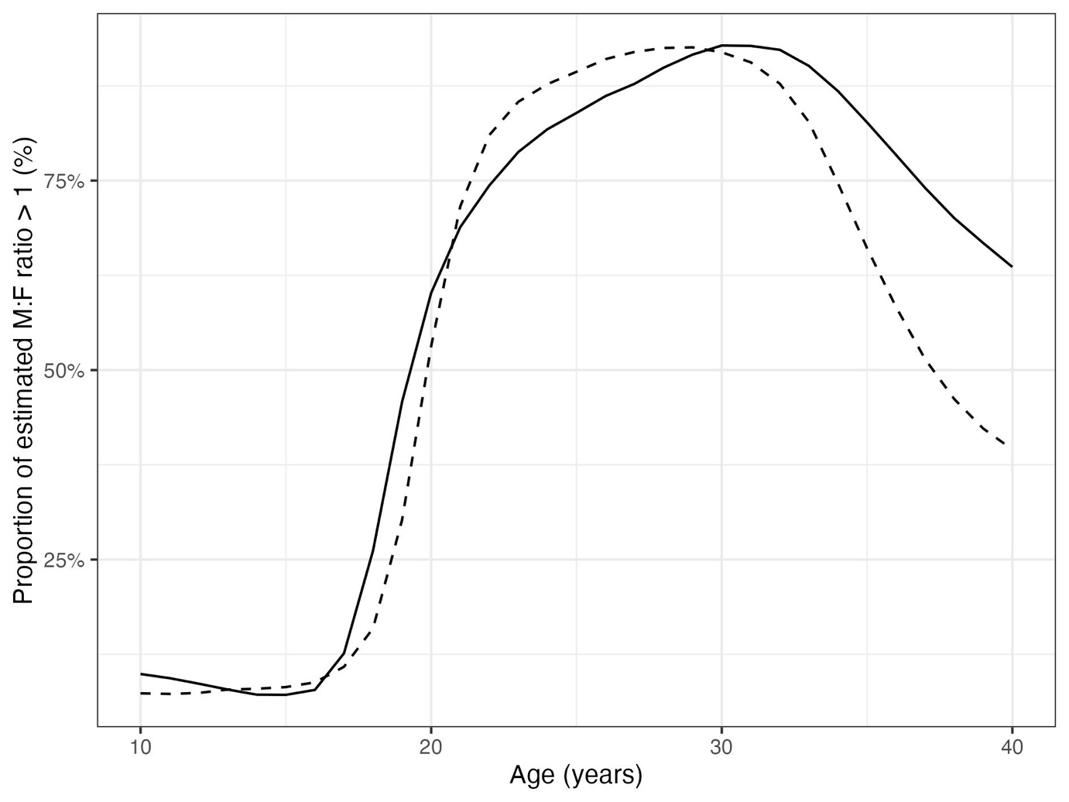
Figure S3: Posterior probability that male-to-female (M:F) ratio of Mtb immunoreactivity probability exceed 1 across age. Probabilities were predicted from a Bayesian logistical regression model of Mtb immunoreactivity additionally adjusted for age, sex and a neighbourhood level random effect, but predictions excluded random effects. M:F ratios were calculated at each posterior draw. Mtb immunoreactivity was defined as a positive QFT-Plus test. Posterior probability is the proportion of M:F ratios exceeding 1 across 4,000 draws. Solid lines are predictions from a model fitted to both HIV negative and HIV positive participants. Dashes lines are predictions from a model fitted to HIV negative participants only.

Appendix F: Posterior sensitivity to weaker and stronger priors and likelihood
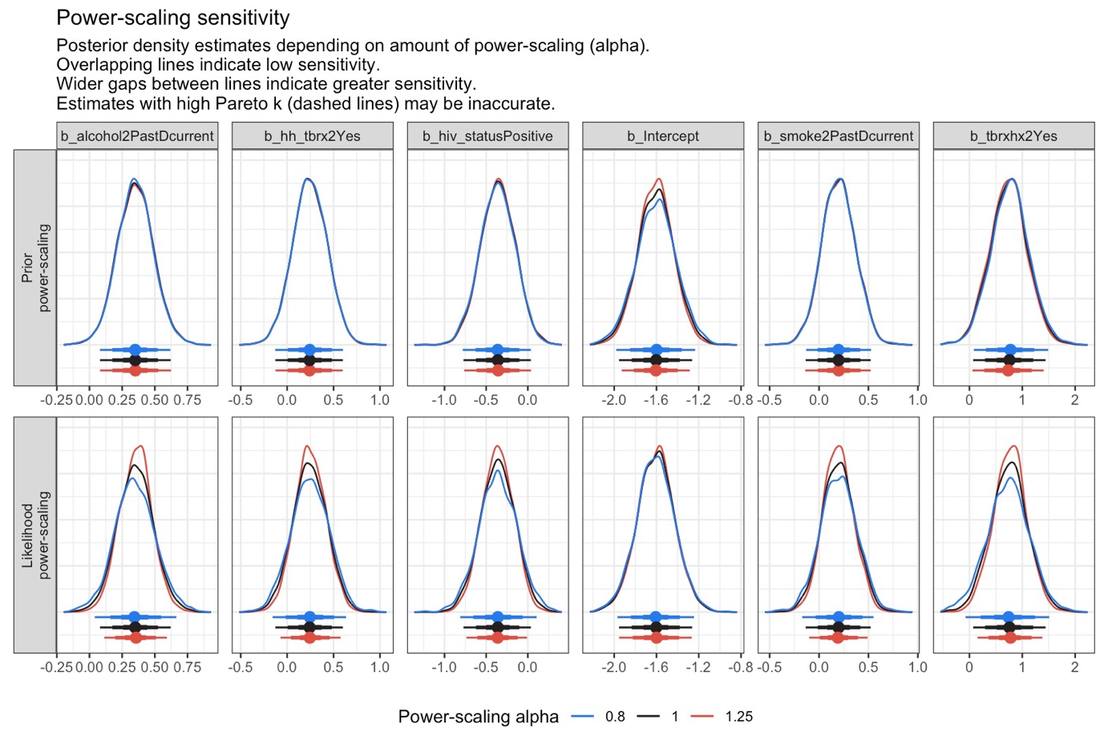
Figure S4: Density plots showing model posterior sensitivity to weaker and stronger priors and likelihood for fixed model effects. Plots are outputs from the priorsense R package.

Appendix G: Model comparison, goodness of fit, regression coefficients and for models reported in the main text.

Models and covariates
Several multilevel Bayesian logistic regression models were fitted to estimate the odds of Mtb immunoreactivity. Covariates included individual variables: age (integer years); sex (male/female); HIV status (positive/negative), previous TB treatment, household TB contact, (as indicator variables: (yes/no); and any lifetime smoking, and any lifetime alcohol drinking (as indicator variables: (“past or current”/never); household variables: membership in the poorest quartile of households (yes/no); and neighbourhood variables: 2019 neighbourhood adult HIV prevalence, 2020 neighbourhood TB case notification rates (mean scaled), and neighbourhood population density (mean scaled). Age was specified via a thin-plate regression spline function, for each sex. Αll models included a neighbourhood random effect to account for the cluster household sampling.

Spline specification for age variable
Models with age specified as a continuous, 5- or 10-year group variable (age_5y or age_10_y), or as an integer via a thin-plate spline function (spline_k3, …, spline_k6), were compared via leave-one-out cross-validation.
model | elpd_diff | se_diff | elpd_loo | se_elpd_loo | p_loo | se_p_loo | looic | se_looic
spline_k3 | 0.00 | 0.00 | -1277.59 | 31.2 | 8.95 | 0.3 | 2555.18 | 62.4
age_10y | -9.38 | 3.98 | -1286.97 | 31.3 | 8.8 | 0.28 | 2573.94 | 62.6
age_5y | -6.00 | 2.27 | -1283.58 | 31.18 | 11.97 | 0.38 | 2567.17 | 62.36
continuous | -4.75 | 3.07 | -1282.34 | 31.21 | 7.74 | 0.25 | 2564.68 | 62.43
spline_k5 | -1.49 | 1.29 | -1279.08 | 31.11 | 9.47 | 0.31 | 2558.16 | 62.21
spline_k4 | -1.43 | 1.26 | -1279.01 | 31.09 | 9.07 | 0.3 | 2558.03 | 62.17
spline_k6 | -0.79 | 0.79 | -1278.38 | 31.18 | 9.92 | 0.33 | 2556.76 | 62.36

Covariate selection and model comparison
Models were adjusted for age and sex a priori, and included different sets of variables, as follows:
- m0_age_sex : age (integer years) and sex (male/female).
- m1_full: m0_age_sex additionally adjusted for HIV status (positive/negative), previous TB treatment, household TB contact, (as indicator variables: (yes/no); and any lifetime smoking, and any lifetime alcohol drinking (as indicator variables: (“past or current”/never)
- m1_full_popdens: m1_full additionally adjusted for neighbourhood population density
- m1_full_cluster_pov: m1_full additionally adjusted for membership in the poorest quartile of households.
- m1_full_cnr: m1_full additional adjusted for neighbourhood TB case notification rates
- m1_full_cluster_hiv: m1_full additionally adjusted for neighbourhood adult HIV prevalence.
- m2_full: m1_full additionally adjusted for neighbourhood adult HIV prevalence, neighbourhood TB case notification rates, and neighbourhood population density.

Model comparison
Table below shows model comparison statistics for fitted models.
model | looic | looic_se | p_loo | se_p_loo | elpd_diff | se_diff
m1_full_popdens | 1960.7 | 50.5 | 14.4 | 0.6 | 0.0 | 0.0
m1_full_cnr | 1964.9 | 50.5 | 15.6 | 0.6 | -2.1 | 2.1
m2_full | 1965.3 | 50.7 | 17.6 | 0.7 | -2.3 | 0.9
m1_full_cluster_hiv | 1965.4 | 50.3 | 15.3 | 0.6 | -2.3 | 2.4
m1_full | 1966 | 50.3 | 15.4 | 0.6 | -2.6 | 2.4
m1_full_pov | 1967.4 | 50.4 | 16.3 | 0.6 | -3.3 | 2.5

Full model regression coefficients (log scale) are presented below. For each model, mean, sd, q2.5 and q97.54 are presented up to 4 decimal points, and ess_bulk and ess_tail are rounded to whole number.
model | variable | mean | sd | q2.5 | q97.5 | rhat | ess_bulk | ess_tail
m0_age_sex | b_Intercept | -1.6041 | 0.0579 | -1.7196 | -1.4901 | 1.0011 | 3905 | 2797
m0_age_sex | bs_sage:sexFemale_1 | 0.3990 | 0.0630 | 0.2749 | 0.5226 | 0.9995 | 4485 | 3203
m0_age_sex | bs_sage:sexMale_1 | 0.5279 | 0.0866 | 0.3565 | 0.6995 | 1.0014 | 5303 | 2646
m0_age_sex | sd_cluster__Intercept | 0.1032 | 0.0703 | 0.0045 | 0.2532 | 1.0052 | 1288 | 1923
m0_age_sex | sds_sagesexFemale_1 | 2.1744 | 1.9882 | 0.1309 | 7.1894 | 1.0011 | 2020 | 1713
m0_age_sex | sds_sagesexMale_1 | 3.0920 | 2.6811 | 0.4043 | 9.8916 | 1.0004 | 2015 | 1533
m0_age_sex | Intercept | -1.6041 | 0.0579 | -1.7196 | -1.4901 | 1.0011 | 3905 | 2797
m0_age_sex | s_sagesexFemale_1[1] | 1.2993 | 0.9586 | -0.2292 | 3.2481 | 1.0023 | 2585 | 2131
m0_age_sex | s_sagesexMale_1[1] | 2.4370 | 1.3038 | 0.0295 | 4.9491 | 1.0005 | 2570 | 1432
m1_full | b_Intercept | -1.6050 | 0.0846 | -1.7744 | -1.4436 | 1.0006 | 4745 | 3078
m1_full | b_hiv_statusPositive | -0.3604 | 0.2091 | -0.7787 | 0.0404 | 1.0007 | 5626 | 3088
m1_full | b_smoke2PastDcurrent | 0.2148 | 0.1744 | -0.1324 | 0.5409 | 1.0029 | 5848 | 3105
m1_full | b_alcohol2PastDcurrent | 0.3381 | 0.1361 | 0.0775 | 0.6036 | 1.0019 | 4691 | 3109
m1_full | b_tbrxhx2Yes | 0.7749 | 0.3579 | 0.0824 | 1.4710 | 1.0010 | 6615 | 3440
m1_full | b_hh_tbrx2Yes | 0.2572 | 0.1851 | -0.1151 | 0.6126 | 1.0006 | 5810 | 3383
m1_full | bs_sage:sexFemale_1 | 0.3899 | 0.0828 | 0.2296 | 0.5582 | 1.0017 | 5283 | 3185
m1_full | bs_sage:sexMale_1 | 0.4168 | 0.1070 | 0.2054 | 0.6267 | 1.0014 | 5877 | 2800
m1_full | sd_cluster__Intercept | 0.1326 | 0.0868 | 0.0056 | 0.3235 | 1.0013 | 1315 | 2015
m1_full | sds_sagesexFemale_1 | 1.8971 | 1.9514 | 0.0757 | 6.9557 | 1.0008 | 2492 | 2065
m1_full | sds_sagesexMale_1 | 2.6811 | 2.3896 | 0.1552 | 9.4623 | 1.0030 | 2020 | 1294
m1_full | Intercept | -1.4515 | 0.0682 | -1.5865 | -1.3189 | 1.0002 | 4365 | 2783
m1_full | s_sagesexFemale_1[1] | 0.9474 | 0.9605 | -0.498 | 3.1063 | 1.0001 | 2862 | 2991
m1_full | s_sagesexMale_1[1] | 1.9540 | 1.4361 | -0.3232 | 4.9086 | 1.0031 | 2474 | 2457
m1_full_popdens | b_Intercept | -1.6127 | 0.0820 | -1.7760 | -1.4538 | 1.0020 | 4458 | 3244
m1_full_popdens | b_hiv_statusPositive | -0.3433 | 0.2116 | -0.7679 | 0.0562 | 1.0006 | 5189 | 2954
m1_full_popdens | b_smoke2PastDcurrent | 0.2068 | 0.1727 | -0.1407 | 0.5419 | 1.0007 | 3885 | 2875
m1_full_popdens | b_alcohol2PastDcurrent | 0.3461 | 0.1390 | 0.0689 | 0.6129 | 1.0008 | 3730 | 2879
m1_full_popdens | b_tbrxhx2Yes | 0.7455 | 0.3658 | 0.0299 | 1.4771 | 1.0006 | 4071 | 2838
m1_full_popdens | b_hh_tbrx2Yes | 0.2492 | 0.1877 | -0.1310 | 0.6116 | 1.0000 | 4163 | 2955
m1_full_popdens | b_pop_dens_km2_std | 0.1626 | 0.0611 | 0.0448 | 0.2849 | 1.0002 | 4481 | 3210
m1_full_popdens | bs_sage:sexFemale_1 | 0.3932 | 0.0852 | 0.2276 | 0.5676 | 1.0015 | 3801 | 3061
m1_full_popdens | bs_sage:sexMale_1 | 0.4253 | 0.1071 | 0.2249 | 0.6420 | 1.0008 | 4211 | 2579
m1_full_popdens | sd_cluster__Intercept | 0.1035 | 0.0726 | 0.0049 | 0.2699 | 1.0027 | 1408 | 1924
m1_full_popdens | sds_sagesexFemale_1 | 1.9643 | 2.0563 | 0.0622 | 6.9846 | 1.0031 | 1737 | 1210
m1_full_popdens | sds_sagesexMale_1 | 2.7011 | 2.5854 | 0.1195 | 9.1112 | 1.0002 | 1681 | 1077
m1_full_popdens | Intercept | -1.4591 | 0.0638 | -1.5846 | -1.3336 | 1.0015 | 3979 | 3255
m1_full_popdens | s_sagesexFemale_1[1] | 1.0144 | 0.9732 | -0.5286 | 3.1745 | 1.0016 | 2501 | 3367
m1_full_popdens | s_sagesexMale_1[1] | 1.8888 | 1.3845 | -0.2665 | 4.7994 | 1.0009 | 1868 | 2684
m2_full | b_Intercept | -1.6051 | 0.1760 | -1.9543 | -1.2619 | 1.0019 | 5594 | 3009
m2_full | b_hiv_statusPositive | -0.3605 | 0.2062 | -0.7733 | 0.0363 | 1.0019 | 5891 | 3127
m2_full | b_smoke2PastDcurrent | 0.1984 | 0.1686 | -0.1353 | 0.5234 | 1.0008 | 3775 | 3314
m2_full | b_alcohol2PastDcurrent | 0.3509 | 0.1380 | 0.0800 | 0.6217 | 1.0005 | 3736 | 2880
m2_full | b_tbrxhx2Yes | 0.7524 | 0.3537 | 0.0699 | 1.4414 | 1.0019 | 5205 | 3202
m2_full | b_hh_tbrx2Yes | 0.2447 | 0.1843 | -0.1271 | 0.6008 | 1.0015 | 4804 | 3229
m2_full | b_poorest_quartileYes | 0.0625 | 0.1270 | -0.1790 | 0.3136 | 1.0008 | 5659 | 3262
m2_full | b_cnr_std | 0.0237 | 0.0699 | -0.1092 | 0.1592 | 1.0005 | 3565 | 3239
m2_full | b_cluster_hiv_prev | -0.1692 | 0.9549 | -2.0243 | 1.7531 | 1.0035 | 5981 | 2921
m2_full | b_pop_dens_km2_std | 0.1492 | 0.0728 | 0.0089 | 0.2885 | 1.0008 | 3244 | 3083
m2_full | bs_sage:sexFemale_1 | 0.4005 | 0.0822 | 0.2413 | 0.5603 | 1.0004 | 4170 | 3062
m2_full | bs_sage:sexMale_1 | 0.4270 | 0.1059 | 0.2203 | 0.6338 | 1.0017 | 5033 | 3268
m2_full | sd_cluster__Intercept | 0.1071 | 0.0762 | 0.0040 | 0.2846 | 1.0025 | 1433 | 1694
m2_full | sds_sagesexFemale_1 | 1.9847 | 2.1157 | 0.0734 | 6.8834 | 1.0010 | 1843 | 2082
m2_full | sds_sagesexMale_1 | 2.6714 | 2.6620 | 0.1556 | 9.4086 | 1.0001 | 1866 | 1329
m2_full | Intercept | -1.4624 | 0.0654 | -1.5902 | -1.3317 | 1.0010 | 4266 | 2959
m2_full | s_sagesexFemale_1[1] | 1.0090 | 0.9746 | -0.5042 | 3.1408 | 1.0000 | 2308 | 3470
m2_full | s_sagesexMale_1[1] | 1.8858 | 1.4114 | -0.3362 | 4.8188 | 1.0002 | 2015 | 2130

