Glucose coating tunes the catalytic reactivity of FeO@Fe₃O₄ for biomedical applications: safety assessment using a 3D hepatic in vitro model.

Marco A. Morales Ovalle^{a,b,c,d,e#}, Iza Rozman^{f,g#}, Elin L. Winkler^{a,b,c}, Enio Lima Jr.^{a,b}, Alja Štern^{f,g}, Katja Kološa^{f}, Bojana Žegura^{f,g}, and Gerardo F. Goya^{d,e}*

ª Departamento de Magnetismo y Materiales Magnéticos, Gerencia de Física, Centro Atómico Bariloche, S. C. de Bariloche, 8400, Argentina
^{b} Instituto de Nanociencia y Nanotecnología, CNEA/CONICET, Centro Atómico Bariloche, S. C. Bariloche, 8400, Argentina
^{c} Instituto Balseiro, UNCuyo/CNEA, Centro Atómico Bariloche, S. C. Bariloche, 8400, Argentina
^{d} Departamento de Materia Condensada, Universidad de Zaragoza, Zaragoza, Spain
^{e} Instituto de Nanociencia y Materiales de Aragón, CSIC-Universidad de Zaragoza, Zaragoza, Spain
^{f} National Institute of Biology, Department of Genetic Toxicology and Cancer Biology, Ljubljana, Slovenia.
^{g} Biotechnical Faculty, University of Ljubljana, Ljubljana, Slovenia

*Correspondence: goya@unizar.es
# These authors contributed equally to this work.

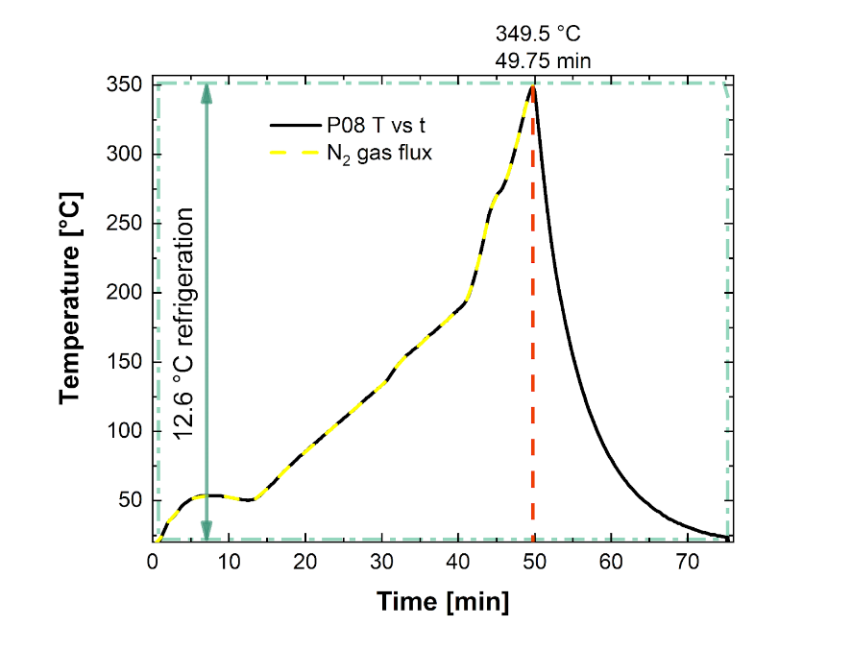
Figure S1. Temperature profile of the reaction mixture during nanoparticle synthesis (black line). The mixture was heated from room temperature to 200 °C at ∼5 °C/min and then from 200 °C to 350 °C at 18(6) °C/min under a stream of nitrogen (N2​ gas flux, yellow dashed line). Water at 12 °C was continuously circulated through an Allihn-condenser (cyan dashed line) throughout the process. Immediately after reaching 349.5 °C (at 49.75 min), the heating mantle was removed, allowing the product to cool to room temperature.

Table S1. Rietveld refinement results for FeO@Fe₃O₄ nanoparticles under different fitting models. Refinement 1 represents a model without microdeformation, where phase coupling is inferred from the lattice parameter. Refinement 2 incorporates a coupled Gaussian microdeformation for both phases.$a$= lattice parameter; $<d>:$ average crystallite size; $ε$: microstrain.

 |  | Refinement 1 | Refinement 2
FeO | $$a$$ | 4.2079 Å | 4.2114 Å
FeO | $$<d>$$ | 6.861 nm | 8.599 nm
FeO | $$ε$$ | -- | 0.25 %
FeO | Vol% | 27.1 % | 31.2 %
Fe₃O₄ | $$a$$ | 8.4040 Å | 8.4133 Å
Fe₃O₄ | $$<d>$$ | 2.354 nm | 3.290 nm
Fe₃O₄ | $$ε$$ | -- | 0.25 %
Fe₃O₄ | Vol% | 72.9 % | 68.8 %

Figure S2: Small-angle X-ray scattering (SAXS) profile (log-log scale) of glucose-coated FeO@Fe₃​O₄​ nanoparticles. The black line with error bars represents the experimental data, and the red line shows the best fit obtained from a combined sphere form factor and square-well structure factor model.

Table S2: Small-angle X-ray scattering (SAXS) fitting parameters for glucose-coated FeO@Fe₃O₄ nanoparticles after fitting with sphere form factor only (Fit #1) and the full fit with sphere form+square wellfactors (Fit #2):<d>=mean radius; σ/R=.ditribution of radii; EI_{R}=effective interaction radius; V%=volume fraction; W_{D}=well depth and W_{W}=well width.
 | <d>  (nm) | σ/R | EI_{R}  (nm) | V% | W_{D}  kT | W_{W}  (diameters)
Fit #1 | 5.957(4) | 0.0794(9) | - | - | - | -
Fit #2 | 6.031(3) | 0.0794 | 6.0509 | 0.0373(5) | 1.500(9) | 1.586(3)

Table S3. Comet assay conditions.
Phase | Buffer composition | Conditions
Cell lysis | 0.1 M EDTA, 2.5 M NaOH,  0.01 M Tris, 1% Triton X-100 | pH 10, 4 °C, 60 min
Unwinding | 300 mM NaOH, 1 mM EDTA | pH 13, 4 °C, 20 min
Electrophoresis | 300 mM NaOH, 1 mM EDTA | 25 V and 300 mA (0.5–1 V/cm),  4 °C, 20 min
Neutralization | 0.4 M Tris | pH 7.5, 4 °C, 15 min

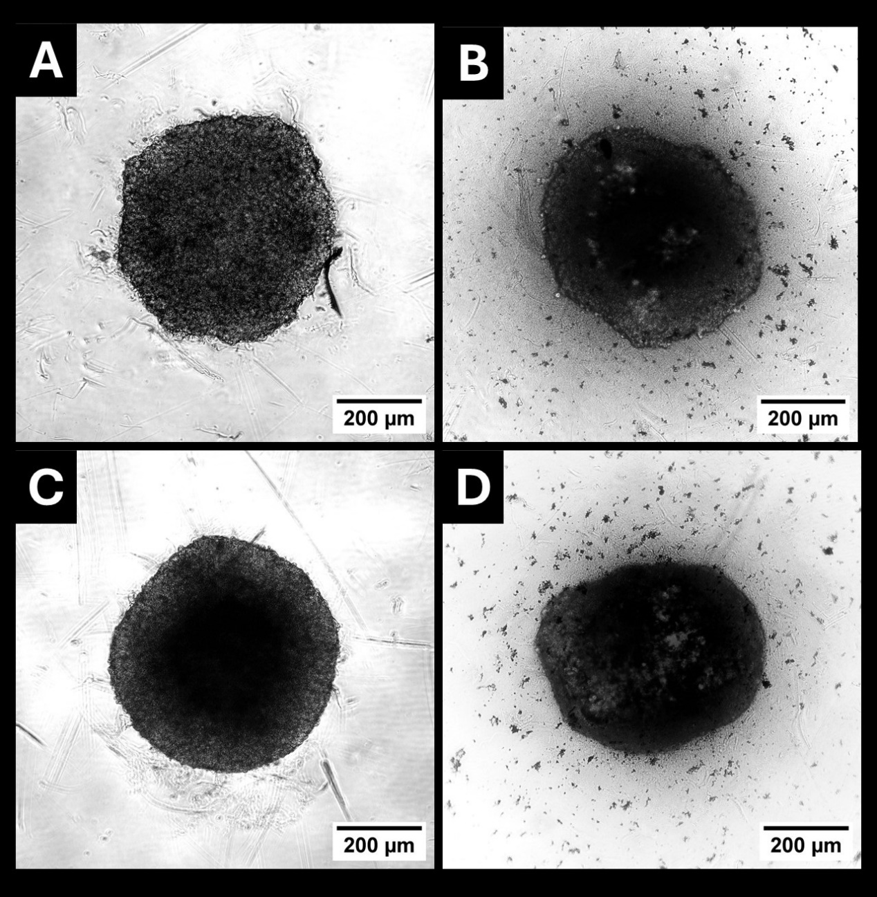
Figure S3. Representative images of HepG2 spheroids cultured in the presence and absence of nanoparticles (NPs). Images (A) and (C) show HepG2 spheroids maintained in standard cell culture medium without the addition of nanoparticles, imaged after 24 hours (A) and 96 hours (C) of incubation. Images (B) and (D) depict HepG2 spheroids exposed to nanoparticles at a concentration of 10 μg/cm², imaged after 24 hours (B) and 96 hours (D) of exposure. All images were taken with Nikon TI Eclipse microscope, at 4X magnification.

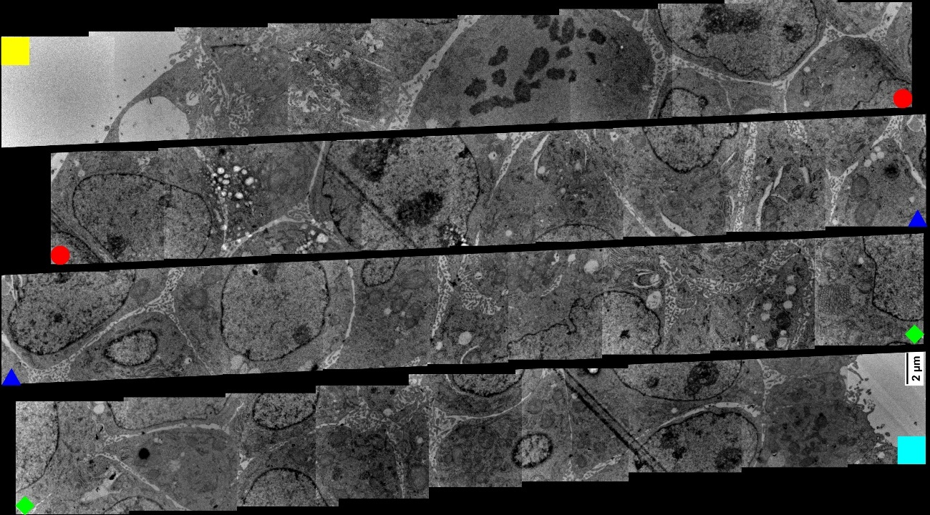
Figure S4. Transmission electron microscopy (TEM) image of a control HepG2 spheroid (4 days old), free of nanoparticles. Reconstruction panoramic view from a series of higher-magnification TEM micrographs, representing a cross-sectional "line" through the spheroid. The yellow square marks the starting border of the spheroid, and the cyan square indicates the ending border. For display clarity, the continuous "line" of micrographs has been split into four rows, with the red circle, blue triangle, and green diamond marking the points where the line was split.

