Supplementary material for:

Integrating pathway knowledge with deep neural networks to reduce the dimensionality in single-cell RNA-Seq data

Peling Gundogdu, Carlos Loucera, Inmaculada Alamo, Joaquin Dopazo and Isabel Nepomuceno

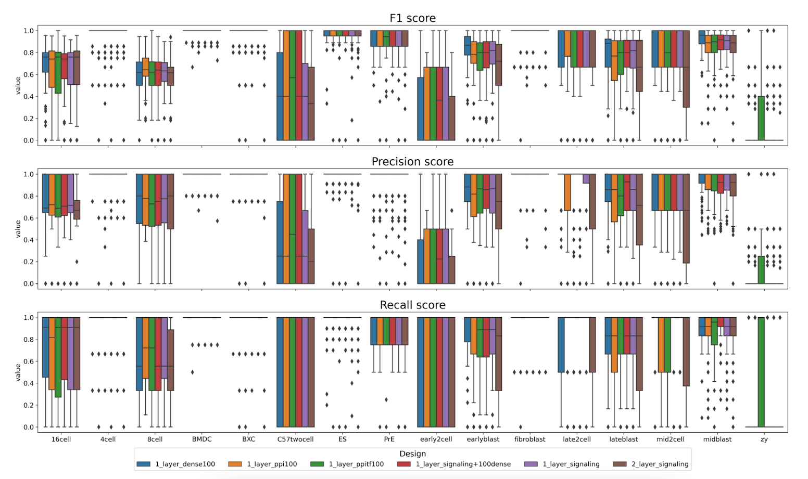

Supplementary Figure 1. Per-class metric distributions

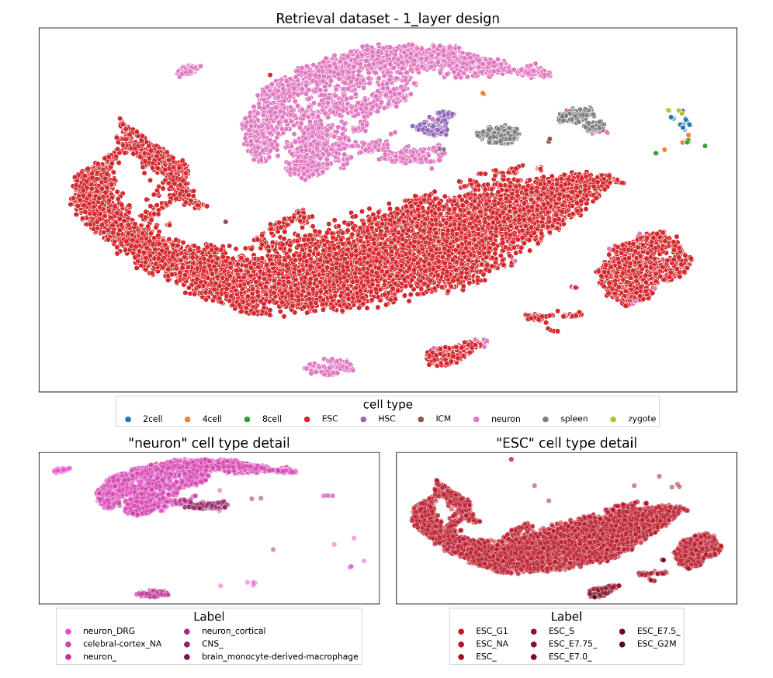
Supplementary Figure 2. Encoding information of the network with mouse cells

Supplementary Table 1. Accession number of each experiment

Num | doi | Accession number | Experiment | Dataset | Cell type
1 | 10.1016/j.cell.2018.09.006 | GSE115978 | Melanoma | Training & testing | B.cell, T.CD4, T.CD8, Macrophage, NK, CAF, Endothelial cells, Maligant, T.cell
2 | 10.1038/nature12172 | GSE41265 | Mouse | learning | BMDC
3 | 10.1186/gb-2013-14-4-r31 | GSE42268 | Mouse | learning | ESC
4 | 10.1126/science.1245316 | GSE45719 | Mouse | learning | Embryonic cells
6 | 10.1038/nbt.3102 | E-MTAB-2805 | Mouse | retrieval | ESC
7 | 10.1186/s13059-016-0950-z | GSE76483 | Mouse | retrieval | DRG
8 | 10.1073/pnas.1402030111 | GSE47835 | Mouse | retrieval | ESC MEF
9 | 10.1038/nature13173 | GSE52583 | Mouse | retrieval | distal lung epithelium
10 | 10.1016/j.stem.2014.11.005 | GSE55291 | Mouse | retrieval | iPS TTF ESC
11 | 10.1101/gr.177725.114 | GSE57249 | Mouse | retrieval | embryonic cells
12 | 10.1101/gr.171645.113 | GSE60297 | Mouse | retrieval | thymus TEC
13 | 10.1126/science.aaa1934 | GSE60361 | Mouse | retrieval | celebral-cortex
14 | 10.15252/msb.20156198 | GSE60768 | Mouse | retrieval | ESC NSC
15 | 10.1038/nbt.3154 | GSE61470 | Mouse | retrieval | ESC PS NP HF
16 | 10.1038/cr.2015.149 | GSE63576 | Mouse | retrieval | DRG
17 | 10.1016/j.cub.2015.01.034 | GSE64960 | Mouse | retrieval | granulosa
18 | 10.1016/j.cell.2015.04.044. | GSE65525 | Mouse | retrieval | ESC
19 | 10.1016/j.devcel.2015.09.009. | GSE66202 | Mouse | retrieval | kidney
20 | 10.1038/nbt.3443 | GSE70844 | Mouse | retrieval | neuron
21 | 10.1016/j.cell.2015.11.009 | GSE75107 | Mouse | retrieval | CNS/Th17
22 | 10.1016/j.cell.2015.11.009 | GSE75108 | Mouse | retrieval | LN/Th17
23 | 10.1016/j.cell.2015.11.009 | GSE75109 | Mouse | retrieval | spleen LN/Th17
24 | 10.1016/j.cell.2015.11.009 | GSE75110 | Mouse | retrieval | spleen LN/Th17
25 | 10.1016/j.cell.2015.11.009 | GSE75111 | Mouse | retrieval | spleen LN/Th17
26 | 10.1038/ncomms10220 | GSE74923 | Mouse | retrieval | cancer
27 | 10.1038/nature17997 | GSE67120 | Mouse | retrieval | HSC
28 | 10.1186/s12974-016-0581-z | GSE79510 | Mouse | retrieval | brain
29 | 10.1038/celldisc.2016.10 | GSE70605 | Mouse | retrieval | embryonic cells
30 | 10.1182/blood-2016-05-716480 | GSE81682 | Mouse | retrieval | HSC
31 | 10.1172/JCI77378 | GSE66578 | Mouse | retrieval | lung
32 | 10.1038/ni.3437 | GSE74596 | Mouse | retrieval | thymus
33 | 10.1038/ni.3412 | GSE77029 | Mouse | retrieval | bone marrow
34 | 10.1016/j.devcel.2016.02.020 | GSE65924 | Mouse | retrieval | embryonic cells
35 | 10.1038/ncomms11075 | GSE70657 | Mouse | retrieval | HSC

Supplementary Table 2: Parameter values

Parameter name | Experiment | Parameter value
epochs | Human & Mouse | 100
batch_size | Human & Mouse | 10
kernel_initializer | Human & Mouse | glorot_uniform
bias_initializer | Human & Mouse | zeros
activation | Mouse | tanh (hidden layer) / softmax (last layer)
optimizer | Mouse | SGD
activation | Human | relu (hidden layer) / softmax (last layer)
optimizer | Human | Adam

Supplementary Table 3: Cell type and number of samples detail of mouse datasets

 | Number of samples
cell type | learning dataset | retrieval dataset
16cell | 54 | -
4cell | 14 | 55
8cell | 47 | 53
BMDC | 18 | -
BXC | 13 | -
C57twocell | 8 | -
ES | 49 | -
PrE | 22 | -
early2cell | 8 | -
earlyblast | 43 | -
fibroblast | 10 | -
late2cell | 10 | -
lateblast | 30 | -
mid2cell | 12 | -
midblast | 60 | -
zy | 4 | -
2cell | - | 85
ESC | - | 9123
HSC | - | 202
ICM | - | 22
neuron | - | 3667
spleen | - | 420
zygote | - | 18

Supplementary Table 4: Clustering performance, Homo: Homogeneity, Comp: Completeness, V-m: V-measure, ARI: Adjusted Rand Index, AMI: Adjusted Mutual Information, FM: Fowlkes-Mallows, Avg.: the mean of all metrics

P-Groups-Out | Architecture | # of nodes (Layer2) | Homo | Comp | V-m | ARI | AMI | FM | Avg.
2 cell types | Dense | X | 0.909 | 0.895 | 0.900 | 0.906 | 0.897 | 0.961 | 0.911
2 cell types | Dense with signaling pathways | X | 0.959 | 0.955 | 0.957 | 0.965 | 0.955 | 0.983 | 0.962
2 cell types | Dense with PPI | X | 0.925 | 0.912 | 0.917 | 0.922 | 0.915 | 0.969 | 0.927
2 cell types | Dense with PPI/TF | X | 0.925 | 0.912 | 0.917 | 0.922 | 0.915 | 0.969 | 0.927
2 cell types | Signaling pathways | X | 0.945 | 0.936 | 0.940 | 0.953 | 0.939 | 0.979 | 0.949
2 cell types | Signaling pathways | 100 | 0.946 | 0.939 | 0.943 | 0.953 | 0.941 | 0.978 | 0.950
4 cell types | Dense | X | 0.801 | 0.799 | 0.798 | 0.725 | 0.786 | 0.814 | 0.787
4 cell types | Dense with signaling pathways | X | 0.804 | 0.797 | 0.798 | 0.718 | 0.786 | 0.811 | 0.786
4 cell types | Dense with PPI | X | 0.811 | 0.804 | 0.805 | 0.728 | 0.794 | 0.817 | 0.793
4 cell types | Dense with PPI/TF | X | 0.820 | 0.808 | 0.812 | 0.746 | 0.802 | 0.827 | 0.802
4 cell types | Signaling pathways | X | 0.797 | 0.788 | 0.790 | 0.716 | 0.778 | 0.809 | 0.780
4 cell types | Signaling pathways | 100 | 0.775 | 0.803 | 0.786 | 0.729 | 0.774 | 0.820 | 0.781
6 cell types | Dense | X | 0.796 | 0.743 | 0.768 | 0.612 | 0.753 | 0.707 | 0.730
6 cell types | Dense with signaling pathways | X | 0.784 | 0.733 | 0.756 | 0.604 | 0.741 | 0.701 | 0.720
6 cell types | Dense with PPI | X | 0.796 | 0.747 | 0.769 | 0.631 | 0.755 | 0.720 | 0.737
6 cell types | Dense with PPI/TF | X | 0.800 | 0.743 | 0.769 | 0.613 | 0.755 | 0.708 | 0.732
6 cell types | Signaling pathways | X | 0.770 | 0.723 | 0.744 | 0.603 | 0.729 | 0.699 | 0.711
6 cell types | Signaling pathways | 100 | 0.750 | 0.699 | 0.723 | 0.573 | 0.705 | 0.677 | 0.688
8 cell types | Dense | X | 0.806 | 0.757 | 0.780 | 0.605 | 0.763 | 0.677 | 0.731
8 cell types | Dense with signaling pathways | X | 0.798 | 0.761 | 0.778 | 0.610 | 0.761 | 0.683 | 0.732
8 cell types | Dense with PPI | X | 0.793 | 0.759 | 0.775 | 0.596 | 0.757 | 0.673 | 0.725
8 cell types | Dense with PPI/TF | X | 0.804 | 0.768 | 0.784 | 0.611 | 0.768 | 0.686 | 0.737
8 cell types | Signaling pathways | X | 0.766 | 0.742 | 0.752 | 0.572 | 0.733 | 0.653 | 0.703
8 cell types | Signaling pathways | 100 | 0.744 | 0.718 | 0.729 | 0.549 | 0.708 | 0.635 | 0.681

Supplementary Table 5: Cell type and number of samples detail of melanoma datasets

 | Number of samples
cell type | training dataset | testing dataset
B.cell | 245 | 573
Macrophage | 126 | 294
NK | 28 | 64
Neg.cell | - | 2228
T.CD4 | 257 | 599
T.CD8 | 528 | 1231

Supplementary Table 6. Top 10 most highly weighted pathways for NK

Cell type | Pathway ID | Pathway name
NK | hsa04664 | Fc epsilon RI signaling pathway
NK | hsa04742 | Taste transduction
NK | hsa05100 | Bacterial invasion of epithelial cells
NK | hsa04726 | Serotonergic synapse
NK | hsa04022 | cGMP-PKG signaling pathway
NK | hsa03320 | PPAR signaling pathway
NK | hsa04066 | HIF-1 signaling pathway
NK | hsa04914 | Progesterone-mediated oocyte maturation
NK | hsa04150 | mTOR signaling pathway
NK | hsa04713 | Circadian entrainment
TCD8 | hsa05100 | Bacterial invasion of epithelial cells
TCD8 | hsa04664 | Fc epsilon RI signaling pathway
TCD8 | hsa04742 | Taste transduction
TCD8 | hsa04022 | cGMP-PKG signaling pathway
TCD8 | hsa04150 | mTOR signaling pathway
TCD8 | hsa04915 | Estrogen signaling pathway
TCD8 | hsa04713 | Circadian entrainment
TCD8 | hsa04914 | Progesterone-mediated oocyte maturation
TCD8 | hsa04012 | ErbB signaling pathway
TCD8 | hsa04670 | Leukocyte transendothelial migration
TCD4 | hsa04664 | Fc epsilon RI signaling pathway
TCD4 | hsa05100 | Bacterial invasion of epithelial cells
TCD4 | hsa04742 | Taste transduction
TCD4 | hsa04726 | Serotonergic synapse
TCD4 | hsa04973 | Carbohydrate digestion and absorption
TCD4 | hsa04650 | Natural killer cell mediated cytotoxicity
TCD4 | hsa04919 | Thyroid hormone signaling pathway
TCD4 | hsa04012 | ErbB signaling pathway
TCD4 | hsa04670 | Leukocyte transendothelial migration
TCD4 | hsa04666 | Fc gamma R-mediated phagocytosis
BCell | hsa04150 | mTOR signaling pathway
BCell | hsa04022 | cGMP-PKG signaling pathway
BCell | hsa04726 | Serotonergic synapse
BCell | hsa04915 | Estrogen signaling pathway
BCell | hsa04650 | Natural killer cell mediated cytotoxicity
BCell | hsa04960 | Aldosterone-regulated sodium reabsorption
BCell | hsa04972 | Pancreatic secretion
BCell | hsa04914 | Progesterone-mediated oocyte maturation
BCell | hsa04610 | Complement and coagulation cascades
BCell | hsa04913 | Ovarian steroidogenesis
Macrophage | hsa05100 | Bacterial invasion of epithelial cells
Macrophage | hsa04664 | Fc epsilon RI signaling pathway
Macrophage | hsa04742 | Taste transduction
Macrophage | hsa04022 | cGMP-PKG signaling pathway
Macrophage | hsa04726 | Serotonergic synapse
Macrophage | hsa04915 | Estrogen signaling pathway
Macrophage | hsa04151 | PI3K-Akt signaling pathway
Macrophage | hsa04380 | Osteoclast differentiation
Macrophage | hsa04973 | Carbohydrate digestion and absorption
Macrophage | hsa04650 | Natural killer cell mediated cytotoxicity

