Supplementary material

The association of temperature variability with blood pressure
in southern China

Figure of Contents
Figure S1. Density distribution of blood pressure for populations with different hypertension status.
Figure S2. Estimated effects of Temperature Variability with different exposure days on BP by sex.
Figure S3. Estimated effects of Temperature Variability with different exposure days on BP by age
Figure S4. GCV scores obtained by model fitting for temperature variability with different exposure days

Figure1. Density distribution of blood pressure for populations with different hypertension status.
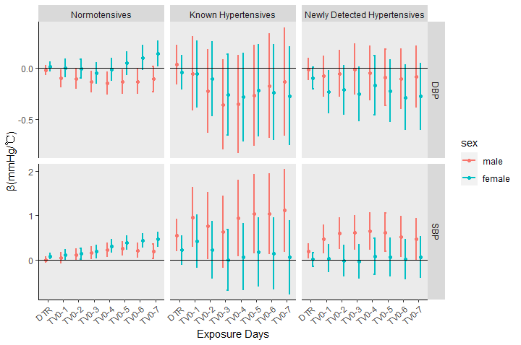
Figure 2 Estimated effects of Temperature Variability with different exposure days on BP by sex

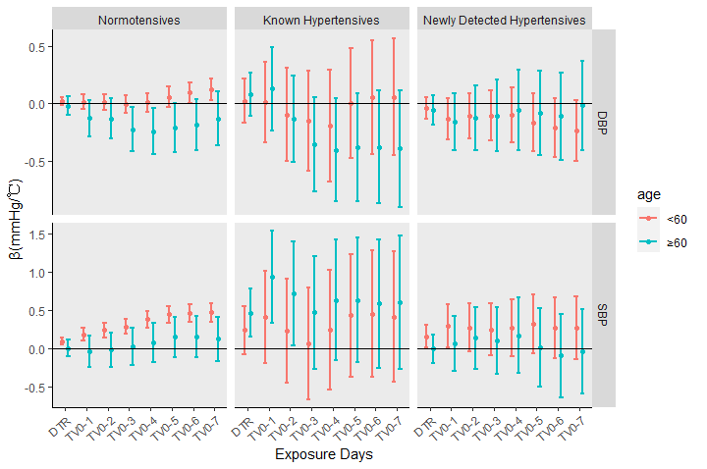
Figure3 Estimated effects of Temperature Variability with different exposure days on BP by age

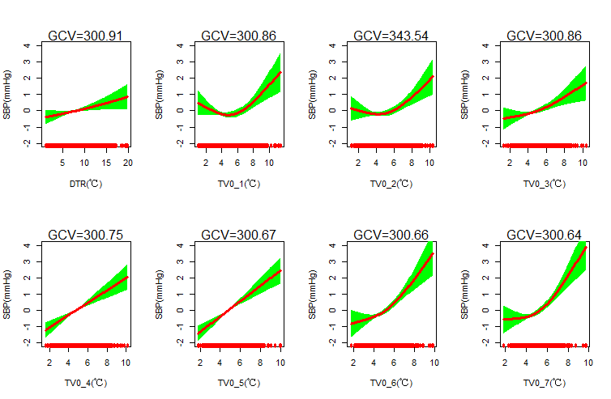
Figure4 GCV scores obtained by model fitting for temperature variability with different exposure days

