Impacts of Diwali fireworks on aerosol levels, composition, chemistry, and toxicity: Insights from a combined indoor-outdoor study
(Supplementary)
Debayan Mandal, Abhishek Chakraborty, Vidit Parkar

- Minimum detection limit for OC and EC:
Table SI 1 Minimum detection limit of OC and EC used in the DRI TOA analyzer (DRI 2015) . Units of μg/filter were obtained using a deposit area of 3.53 cm², typical of 25 mm quartz fiber filters
 | µg/cm² | µg/filter
Total OC | 0.43 | 1.53
Total EC | 0.12 | 0.44
TC | 0.49 | 1.72
2. Quality assurance quality control for Ion Chromatography:
First and foremost, the correlation coefficient of the individual ions should be at least 0.995; otherwise, the calibrations will be repeated. Quality check standards are analyzed initially and after every 10 analytical runs. The results are compared with known QC; it should not exceed 3% of the known value.

3.Minimum detection limit (DL) of elements in EDXRF
Table SI 2 Minimum detection limit (MDL) of elements in EDXRF in ng/cm² for 45mins of runtime for each sample
Element | MDL | Element | MDL
Na | 4.7 | Cu | 0.3
Mg | 2.8 | Zn | 0.3
Al | 3.5 | Ga | 0.5
Si | 2.3 | As | 0.8
P | 0.5 | Se | 0.3
S | 0.7 | Br | 0.5
Cl | 0.9 | Sr | 0.3
K | 1 | Zr | 0.7
Ca | 0.7 | Mo | 0.5
Sc | 0.3 | Cd | 8.3
Ti | 0.3 | Sn | 27
V | 0.3 | Sb | 13
Cr | 0.7 | Te | 1
Mn | 0.5 | I | 1
Fe | 0.7 | Cs | 1
Co | 0.7 | Ba | 1.7
Ni | 0.5 | Hg | 0.3
Pb | 0.4

3. Data inputs for PSC equivalent calculation from Elemental Carbon
Table SI 3 Risk estimates for ETS (Environmental Tobacco Smoke) exposure (compared to no ETS exposure) in relation to health outcomes, adopted from van der Zee et al. (2016)
Outcome | Description | Risk estimate (95% CI)
Lung cancer (LC) | Incidence (> 15yrs) | 1.21 (1.13–1.30)
Cardiovascular mortality (CM) | Ischaemic heart disease (IHD) mortality > 15 yrs | 1.27 (1.19–1.36)

Table SI 4 Risk estimates (95% CI) for equivalent Black Carbon (EBC) concentration and the established health outcomes, adopted from Pani et al. (2020). Used as the Risk estimate of Elemental carbon in the Manuscript

Outcome | EC (per 1 µg m⁻³) | References
Lung cancer (LC) | 1.05 (0.02–1.08) | van der Zee et al., 2016
Cardiovascular mortality (CM) | 1.13 (1.09–1.18) | Smith and Peel 2010

4. W statistics of the PM_{2.5} concentration in the study locations during different periods
Table SI 5 W statistics and p values of the PM_{2.5} concentration in the study locations
Set | W statistic | p-value
PrD Indoor | 0.85 | 0.19
PrD Outdoor | 0.87 | 0.25
Di Indoor | 0.92 | 0.52
Di Outdoor | 0.79 | 0.07
PoD Indoor | 0.82 | 0.12
PoD Outdoor | 0.83 | 0.14

5. Ionic Composition in the indoor outdoor location
Figure SI 1 Water-soluble inorganic ions in the study locations

6.Van-krevelen (V-K) diagram
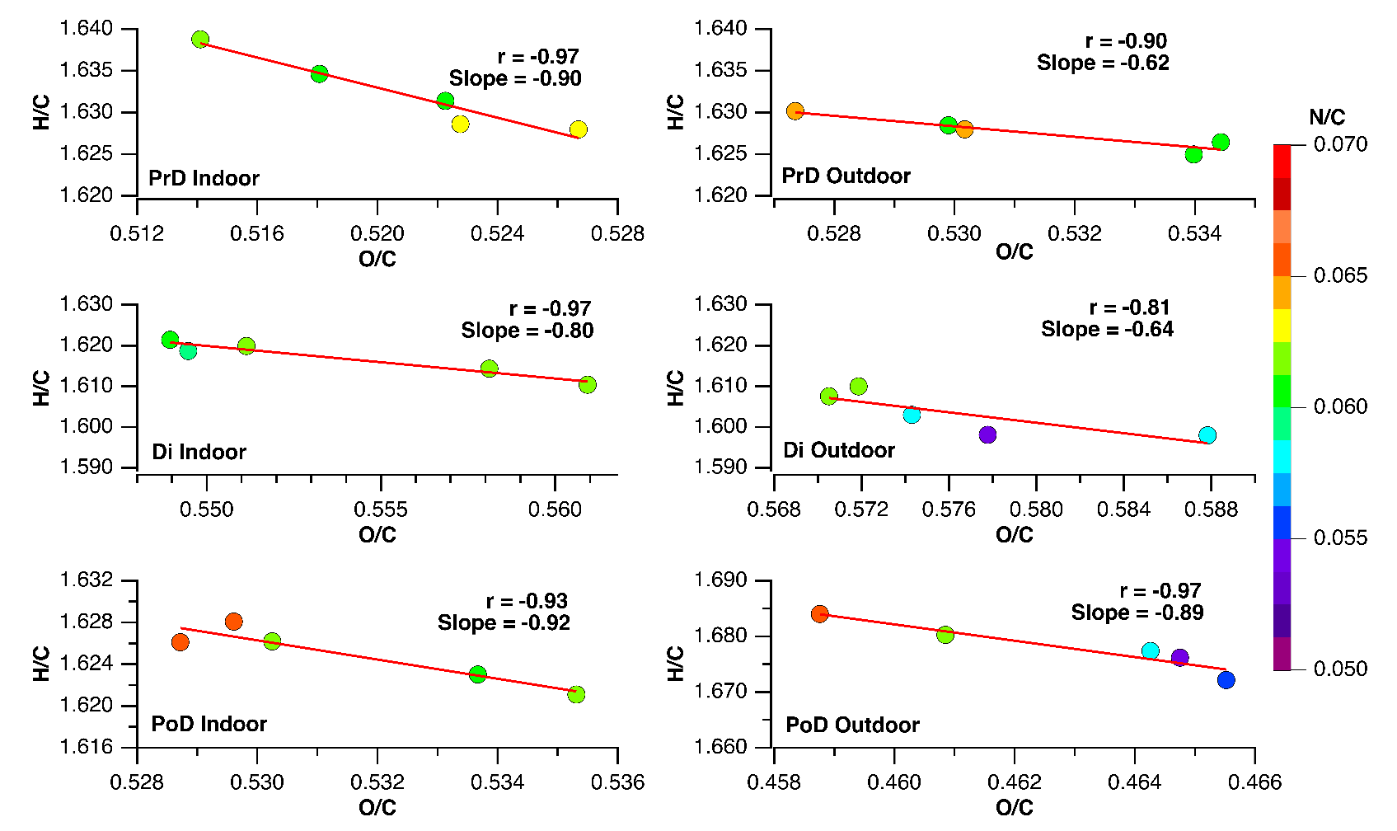
Figure SI 2 V-K diagram in the study locations
6.The fCO₂⁺ and fC₂H₃O⁺ relationship

Figure SI 3 fC₃H₃O⁺ and fCO₂⁺ relationship in the indoor and outdoor locations during the study period

7. Elemental levels in PM_{2.5}
Table SI 6 Average Elemental concentration levels in PM_{2.5} (ng/m³) in the study locations.
 | PrD |  |  | Di |  |  | PoD
 | I | O |  | I | O |  | I | O
Na | 776.4 | 851.9 |  | 2324.7 | 2555.2 |  | 904.0 | 948.5
Mg | 461.4 | 525.6 |  | 828.1 | 920.1 |  | 626.0 | 646.4
Al | 255.4 | 285.8 |  | 2321.6 | 2591.3 |  | 198.0 | 213.3
Si | 273.0 | 300.4 |  | 252.2 | 278.6 |  | 169.9 | 285.7
P | 7.0 | 7.7 |  | 7.8 | 8.7 |  | 8.0 | 8.8
S | 3164.6 | 3550.8 |  | 10160.6 | 11248.6 |  | 5031.3 | 5529.8
Cl | 708.8 | 798.9 |  | 2828.3 | 3141.1 |  | 937.9 | 1042.1
K | 724.5 | 816.5 |  | 6219.5 | 6910.5 |  | 924.0 | 1035.3
Ca | 158.9 | 173.9 |  | 201.6 | 224.5 |  | 111.2 | 122.6
Ti | 5.4 | 11.9 |  | 15.4 | 32.9 |  | 8.5 | 11.5
Cr | 2.4 | 4.0 |  | 13.4 | 23.3 |  | 6.1 | 3.8
Mn | 13.9 | 15.4 |  | 35.9 | 39.8 |  | 16.1 | 18.5
Fe | 195.4 | 219.4 |  | 336.3 | 376.2 |  | 147.3 | 162.7
Co | 2.3 | 2.6 |  | 2.3 | 2.6 |  | 2.4 | 1.7
Ni | 4.1 | 4.8 |  | 4.7 | 5.4 |  | 3.1 | 3.6
Cu | 2.7 | 2.6 |  | 37.6 | 41.8 |  | 7.9 | 8.7
Zn | 327.0 | 360.0 |  | 500.0 | 543.1 |  | 386.2 | 429.1
Ga | 1.0 | 1.2 |  | 4.1 | 4.6 |  | 0.8 | 1.7
Se | 0.7 | 1.0 |  | 0.9 | 1.1 |  | 0.6 | 0.7
Br | 6.7 | 7.4 |  | 16.0 | 18.7 |  | 10.0 | 11.5
Sr | 1.7 | 2.1 |  | 842.9 | 963.0 |  | 12.1 | 13.9
Mo | 2.9 | 3.3 |  | 2.9 | 3.1 |  | 2.7 | 3.0
Cd | 2.8 | 3.2 |  | 5.8 | 6.3 |  | 9.2 | 9.7
Sn | 32.7 | 35.6 |  | 43.6 | 50.0 |  | 42.7 | 47.4
Sb | 24.1 | 26.5 |  | 31.3 | 34.6 |  | 25.3 | 28.5
Ba | 7.4 | 8.2 |  | 1031.8 | 1154.2 |  | 47.1 | 52.3
Hg | 1.2 | 1.3 |  | 1.2 | 1.5 |  | 1.8 | 1.3
Pb | 83.9 | 93.6 |  | 215.2 | 234.5 |  | 57.5 | 69.4

8. Indoor-outdoor(I/O) ratio of enrichment factor(EF)

Table SI 7 I/O ratio of EF
Element | PrD | Di | PoD
Na | 1.00 | 1.01 | 1.57
Mg | 0.97 | 0.99 | 1.61
Al | 0.98 | 0.99 | 1.34
Si | 1.00 | 1.00 | 1.00
P | 1.00 | 0.99 | 1.55
S | 0.98 | 1.00 | 1.55
Cl | 0.98 | 0.99 | 1.53
K | 0.98 | 0.99 | 1.52
Ca | 1.01 | 0.99 | 1.51
Ti | 0.50 | 0.52 | 1.25
Cr | 0.65 | 0.64 | 1.63
Mn | 0.99 | 1.00 | 1.53
Fe | 0.98 | 0.99 | 1.52
Co | 0.98 | 1.00 | 1.61
Ni | 0.93 | 0.97 | 1.50
Cu | 1.13 | 0.99 | 1.53
Zn | 1.00 | 1.02 | 1.53
Ga | 0.98 | 0.99 | 1.05
Se | 0.76 | 0.93 | 1.52
Br | 0.99 | 0.94 | 1.53
Sr | 0.90 | 0.97 | 1.56
Mo | 0.98 | 1.05 | 1.51
Cd | 0.99 | 1.01 | 1.58
Sn | 1.01 | 0.96 | 1.53
Sb | 1.00 | 1.00 | 1.52
Ba | 0.99 | 0.99 | 1.56
Hg | 1.00 | 0.86 | 1.80
Pb | 0.99 | 1.01 | 1.49

9.Oxidative Potential (OP^{DTTv}) has been reported in different studies worldwide
Table SI 8 OP^{DTTv} in different studies
Location | OP | Location/activity | References
Lahore (Pakistan) | 8.9±3.8 | Urban | (Ahmad et al. 2021)
Peshawar (Pakistan) | 9.3±3.9 | Urban | (Ahmad et al. 2021)
Rohtak (India) | 1.72±1.07 | Urban Background | (Dubey et al. 2024)
Terni (Italy) | 0.05±0.02 | Urban | (Massimi et al. 2020)
Atlanta (USA) | 0.18 | Urban | (Verma et al. 2012)

9. Association between OP^{DTTv} and measured chemical parameters
Table SI 9 Pearson correlation coefficient (r values ) between elements and OP^{DTTv}. The Green numbers are significant at p<0.05
Element | r_indoor | r_outdoor
P | 0.25 | 0.33
Si | 0.011 | -0.45
Al | 0.79 | 0.81
Mg | 0.79 | 0.82
Ti | 0.82 | 0.85
Cr | 0.67 | 0.81
Mn | 0.83 | 0.86
Fe | 0.71 | 0.77
Co | 0.065 | 0.079
Ni | 0.39 | 0.36
Cu | 0.78 | 0.76
Zn | 0.7 | 0.81
Ga | 0.75 | 0.76
Se | 0.47 | 0.36
Br | 0.85 | 0.81
Sr | 0.73 | 0.71
Mo | 0.14 | 0.12
Cd | 0.26 | 0.2
Sn | 0.47 | 0.44
Ba | 0.84 | 0.82
Hg | 0.11 | -0.09
Pb | 0.77 | 0.78
EC | 0.93 | 0.91
OC | 0.8 | 0.68
Ca²⁺ | 0.71 | 0.56
K⁺ | 0.8 | 0.88
NH4+ | 0.66 | 0.21
Na⁺ | -0.3 | 0.57
SO₄²⁻ | 0.83 | 0.89
NO₃⁻ | 0.011 | 0.85
Cl⁻ | 0.72 | 0.69

10. Mass normalized oxidative potential (OP^{DTTm})
Figure SI 4 OP^{DTTm} in the study locations

Comparison of OP^{DTTm} values with other studies

Table SI 10 OP^{DTTm} values in different study locations
Region/City | OPDTTm (pmol DTT min⁻¹ μg⁻¹) | Season/Context | Citations
New Delhi, India | 61 ± 29 | Summer | (Verma et al. 2024)
Delhi, India | 29–78 | Diwali/Burning Events | (Patel et al. 2021b; Puthussery et al. 2022)
Ahmedabad, India | 21–25 | Annual | (Patel et al. 2021a)
Mount Abu, India | 10–23 | Seasonal | (Patel and Rastogi 2018)
Hangzhou, China | 2–23 | Annual | (Wang et al. 2019)
Wuhan, China | 18–53 | Annual | (Liu et al. 2020)
Midwestern USA | 5–28 | Annual | (Yu et al. 2021)
Room (indoor) | 34.82±13.32 | Pre Diwali (PrD) | This study
Room (indoor) | 64.83±10.75 | Diwali(Di) | This study
Room (indoor) | 64.46±7.02 | Post Diwali (PoD) | This study
Terrace (outdoor) | 40.88±7.30 | Pre Diwali (PrD) | This study
Terrace (outdoor) | 61.26±9.75 | Diwali(Di) | This study
Terrace (outdoor) | 57.89±4.61 | Post Diwali (PoD) | This study

Reference
DRI Model 2015 Multiwavelength Thermal / Optical Carbon Analyzer. Desert Research Institute, Nevada System of Higher Education
Ahmad M, Yu Q, Chen J, et al (2021) Chemical characteristics, oxidative potential, and sources of PM2.5 in wintertime in Lahore and Peshawar, Pakistan. J Environ Sci (China) 102:148–158. https://doi.org/10.1016/j.jes.2020.09.014
Dubey S, Manwani P, SumanYadav, Phuleria HC (2024) Variation in oxidative potential of fine particulate matter and its association with chemical constituents at a regional site in India. Sci Total Environ 954:176159. https://doi.org/10.1016/j.scitotenv.2024.176159
Liu Q, Lu Z, Xiong Y, et al (2020) Oxidative potential of ambient PM2.5 in Wuhan and its comparisons with eight areas of China. Sci Total Environ 701:134844. https://doi.org/10.1016/j.scitotenv.2019.134844
Massimi L, Ristorini M, Simonetti G, et al (2020) Spatial mapping and size distribution of oxidative potential of particulate matter released by spatially disaggregated sources. Environ Pollut 266:. https://doi.org/10.1016/j.envpol.2020.115271
Patel A, Rastogi N (2018) Seasonal variability in chemical composition and oxidative potential of ambient aerosol over a high altitude site in western India. Sci Total Environ 644:1268–1276. https://doi.org/10.1016/j.scitotenv.2018.07.030
Patel A, Rastogi N, Gandhi U, Khatri N (2021a) Oxidative potential of atmospheric PM10 at five different sites of Ahmedabad, a big city in Western India. Environ Pollut 268:115909. https://doi.org/10.1016/j.envpol.2020.115909
Patel A, Satish R, Rastogi N (2021b) Remarkably High Oxidative Potential of Atmospheric PM2.5Coming from a Large-Scale Paddy-Residue Burning over the Northwestern Indo-Gangetic Plain. ACS Earth Sp Chem 5:2442–2452. https://doi.org/10.1021/acsearthspacechem.1c00125
Puthussery J V., Dave J, Shukla A, et al (2022) Effect of Biomass Burning, Diwali Fireworks, and Polluted Fog Events on the Oxidative Potential of Fine Ambient Particulate Matter in Delhi, India. Environ Sci Technol 56:14605–14616. https://doi.org/10.1021/acs.est.2c02730
Smith KR, Peel JL (2010) Mind the gap. Environ Health Perspect 118:1643–1645. https://doi.org/10.1289/ehp.1002517
Verma PK, Devaprasad M, Dave J, et al (2024) Summertime oxidative potential of atmospheric PM2.5 over New Delhi: Effect of aerosol ageing. Sci Total Environ 920:170984. https://doi.org/10.1016/j.scitotenv.2024.170984
Verma V, Rico-Martinez R, Kotra N, et al (2012) Contribution of water-soluble and insoluble components and their hydrophobic/hydrophilic subfractions to the reactive oxygen species-generating potential of fine ambient aerosols. Environ Sci Technol 46:11384–11392. https://doi.org/10.1021/es302484r
Wang J, Lin X, Lu L, et al (2019) Temporal variation of oxidative potential of water soluble components of ambient PM2.5 measured by dithiothreitol (DTT) assay. Sci Total Environ 649:969–978. https://doi.org/10.1016/j.scitotenv.2018.08.375
Yu H, Puthussery JV, Wang Y, Verma V (2021) Spatiotemporal variability in the oxidative potential of ambient fine particulate matter in the Midwestern United States. Atmos Chem Phys 21:16363–16386. https://doi.org/10.5194/acp-21-16363-2021

