Supporting Information
Biodegradable Mesoporous Manganese Carbonate Nanocomposites for LED Light-Driven Cancer Therapy via Enhancing Photodynamic Therapy and Attenuating Survivin Expression
Lihua Li^{1*}, Lingling Chen², Ling Huang¹, Xiangling Ye³, Zefeng Lin², Xiaoming Wei¹, Xianfeng Yang¹*, and Zhongmin Yang¹*
1. The State Key Laboratory of Luminescent Materials and Devices; Guangdong Provincial Key Laboratory of Fiber Laser Materials and Applied Techniques; Analytical and Testing Center, South China University of Technology, Guangzhou, Guangdong, 510640, China

2. Guangdong Key Lab of Orthopedic Technology and Implant, General Hospital of Southern Theater Command of PLA, The First School of Clinical Medicine, Southern Medical University, Guangzhou, 510515, China.

3. The Fifth Clinical Medical College, Guangzhou University of Chinese Medicine, Guangzhou, 510095, China.

Fig. S1. Degeneration of PEI-MnCO₃ under simulated TME solution. (a) Schematic illustration of PEI-MnCO₃ degradation in TME; (b) TEM images of PEI-MnCO₃ NCs under TME at different time intervals.

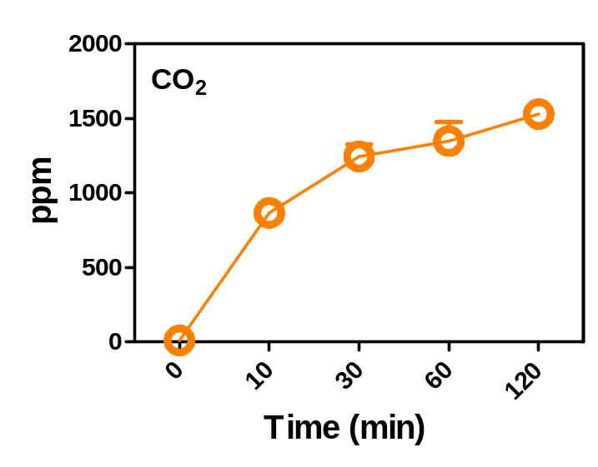
Fig. S2. CO₂ generation ability of PEI-MnCO₃ NCs in simulated TME (2 mM H₂O_{2,} pH=5.5) solution.

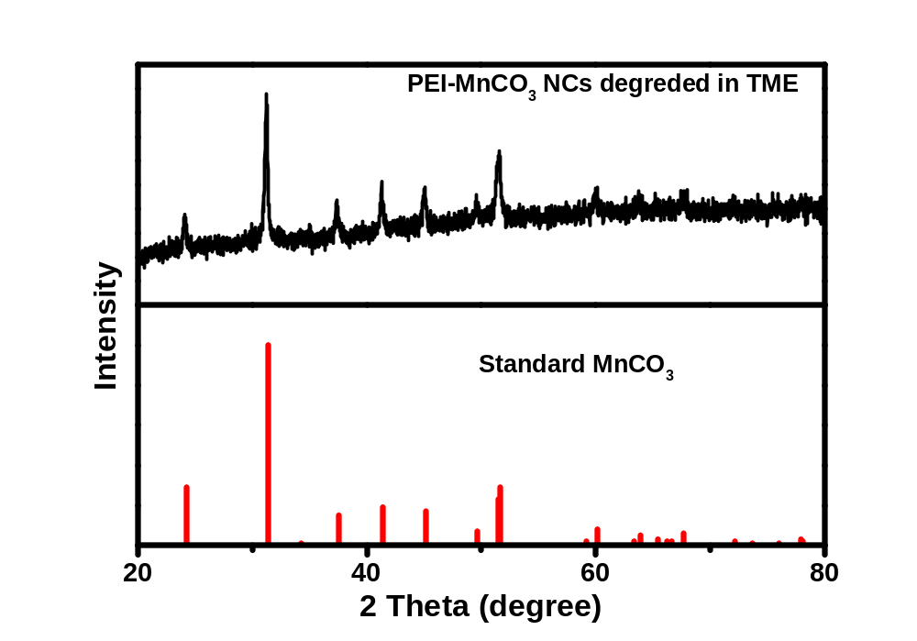
Fig. S3. XRD spectra of PEI-MnCO₃ degradation in simulated TME solution.

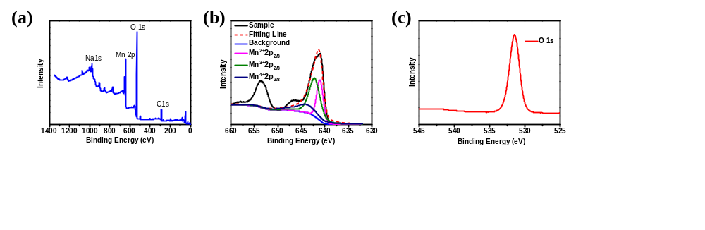
Fig. S4. XPS spectra of PEI-MnCO₃ NCs after incubated in simulated TME (2 mM H₂O_{2,} pH=5.5) solution for 2 h. (a) Full XPS spectrum of PEI-MnCO₃ NCs. XPS spectra of (b) Mn and (c) O.

