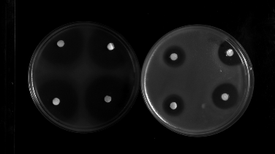
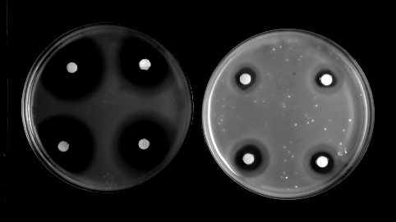
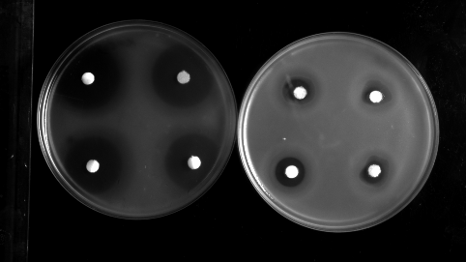
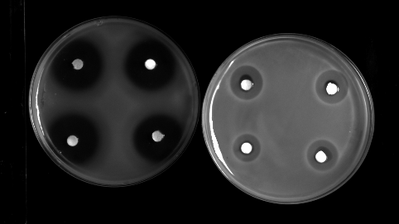
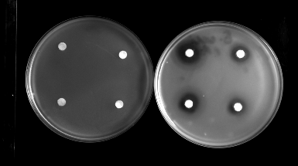
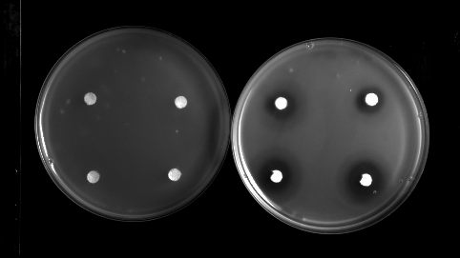
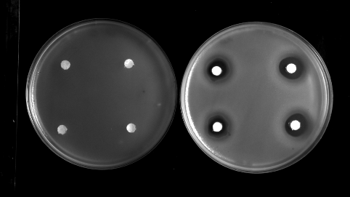
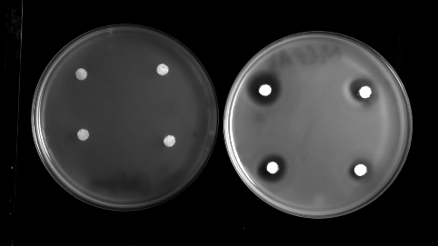
Supplementary files
B
A

E. coli
E. cloacae
K. pneumoniae
E. coli
S. Typhimurium
E. cloacae
K. pneumoniae

S. Typhimurium

Supplementary file 1. Antibacterial activity of preservatives (Nipagin/Propionic Acid) present in fly food against E. coli, S. Typhimurium, S. marcescens, K. pneumoniae and E. cloacae using agar overlay method. (A) Nipagin (left petri plate: control - 5 µL methanol on each disc; right petri plate: 5 µL Nipagin on each disc) (B) Propionic Acid (left petri plate: control - 50 µg chloramphenicol; right petri plate: 5 µL of Propionic acid on each disc).

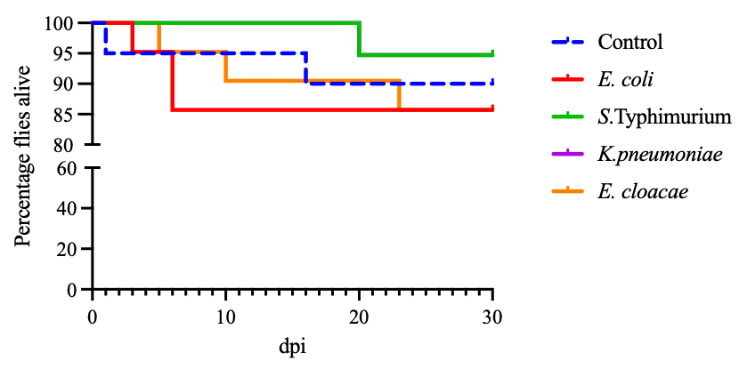
Supplementary file 2. Kaplan–Meier survival curve depicting the percentage survival of infected flies over time. The y-axis represents survival probability after infection, while the x-axis indicates days post-infection (dpi), with survival assessed upto 30 dpi. Each curve corresponds to flies infected with a specific bacterial strain.

Sample/infection group | Mean | Standard Deviation (SD)
Control | 97.6 | ±5.103
E. coli | 90.82 | ±6.642
S. Typhimurium | 91.07 | ±1.84
K. pneumoniae | 101.56 | ±6.796
E. cloacae | 100.07 | ±9.771
Supplementary file 3. No significant difference in survival was observed between Duox RNAi flies and their respective control, Actin-gfp flies. Data represent the survival relative to the actin-gfp flies.

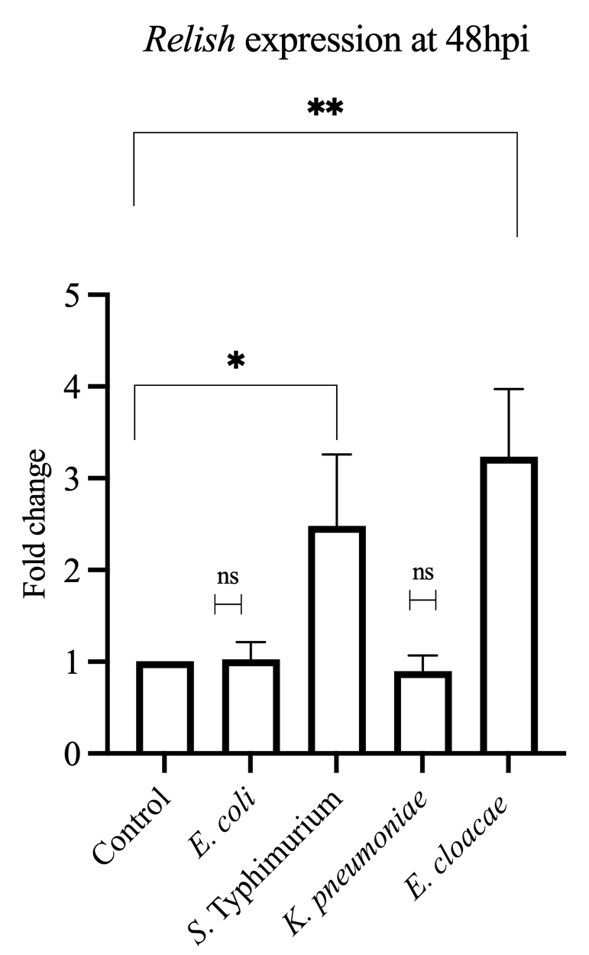
Supplementary file 4. Pathogen-Specific induction of Relish in Drosophila following infection. mRNA transcript levels of Relish at 48 hours post-infection (hpi). Relative expression was calculated against control gut samples. Each biological replicate consisted of 15 adult flies. Data is represented as the mean ± SD from three independent biological replicates. Significance levels are denoted as follows *, p < 0.05; **, p < 0.01 and ns, not significant.

Control
S. Typhimurium
E. cloacae

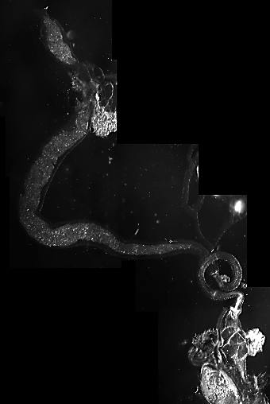
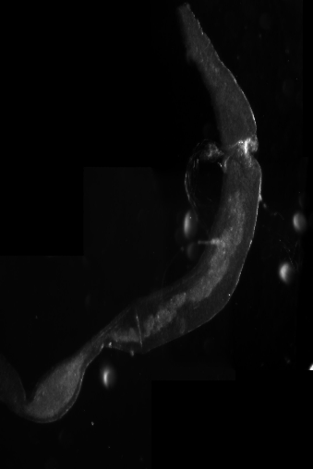
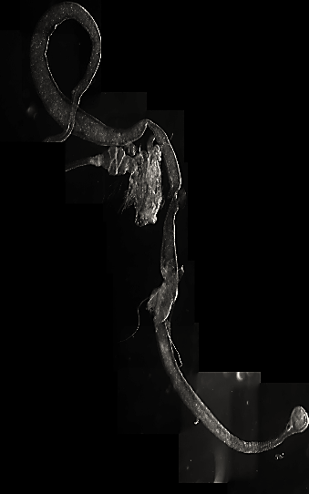
Control
S. Typhimurium
E. cloacae

Supplementary file 5. Representative DIC images of S. Typhimurium- and E. cloacae-infected fly guts at 24 hpi showing narrowing of the gut lumen.

Supplementary file 6. Primer pairs used for gene expression analysis, listed with their sequences.
Gene name | Primer | Primer sequence (5′–3′)
RP49 | Reverse | GCGGGTGCGCTTGTTCGATCC
RP49 | Forward | CCAAGGACTTCATCCGCCACC
Cecropin | Reverse | GCTTCCGATTGTCCAATGCT
Cecropin | Forward | CAGTCGCTCAGTTTCCACAG
Defensin | Reverse | GCAGTAGCCGCCTTTGAACC
Defensin | Forward | CGCATAGAAGCGAGCCACATG
Relish | Reverse | TGCCATGTGGAGTGATTAT
Relish | Forward | TCCTTAATGGAGTGCCAACC
TRPA1 | Reverse | AATATCCTGAAGGGGCTGTCA
TRPA1 | Forward | GGGTCCCAAGCGGATTGAAAT`
Duox | Reverse | CGCTGTTTCTCGGTCTGACT
Duox | Forward | AGCCCTGCTGCTTCTACTGA
Nox | Reverse | GTCTTCTTGATGCTGCGTATGC
Nox | Forward | GCCGCAAACTGATTTCCTG

