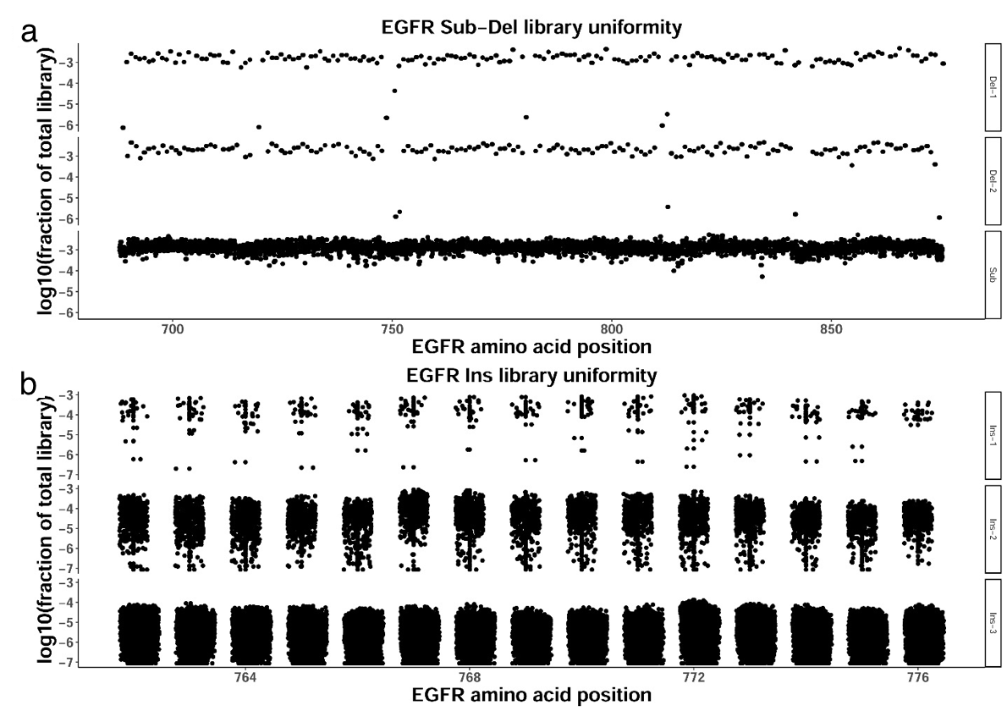
Figure S2. EGFR variant libraries showed good uniformity. The mutation regions of the final Sub-Del library variants and Ins library variants were amplified and subjected to next-generation sequencing. The proportion of each variant was defined as the ratio of detected reads of the related variant to total valid reads. (a) EGFR Sub-Del library variants uniformity results. Del-1, Del-2, and Sub indicate the variants with single amino acid deletion, double amino acid deletion, and substitution mutations, respectively. (b) EGFR Ins library variants uniformity results. Ins-1, Ins-2, and Ins-3 indicate variants with mutations of single, double, and triple amino acid insertion mutations, respectively.

