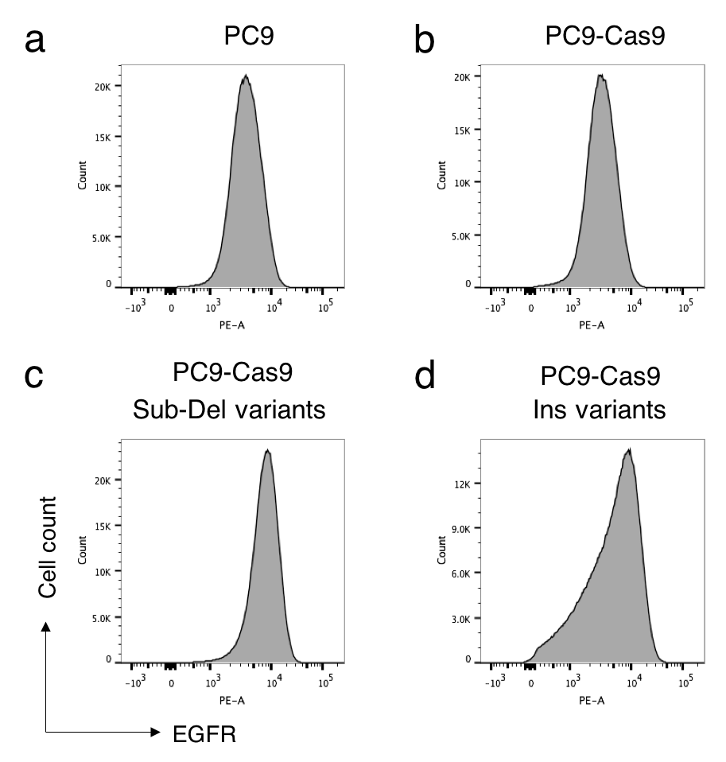

Figure S6. Comparison of endogenous and exogenous EGFR expression. a. Endogenous EGFR expression level in PC9 cell line. b. Endogenous EGFR expression level in PC9-Cas9 cell line. c. Sub-Del variants expression level in PC9-Cas9 cell line. d. Ins variants expression level in PC9-Cas9 cell line.

