Amino acid position-762
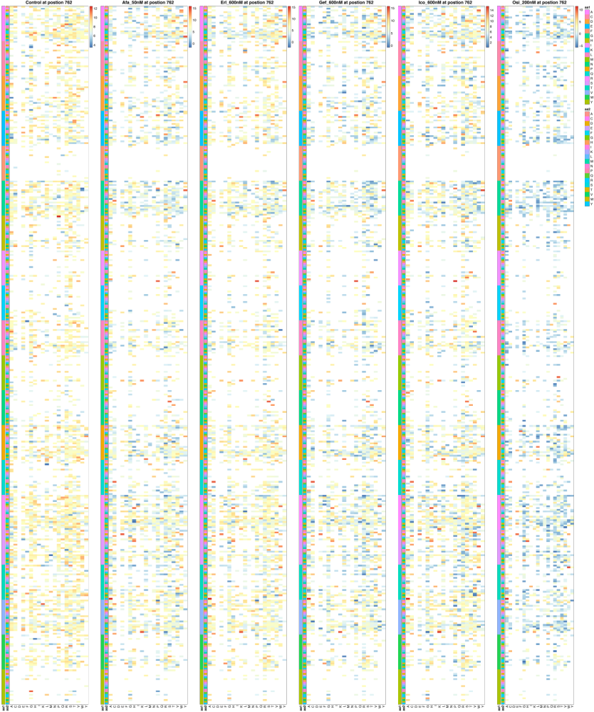

Amino acid position-763

Amino acid position-764

Amino acid position-765

Amino acid position-766

Amino acid position-767

Amino acid position-768
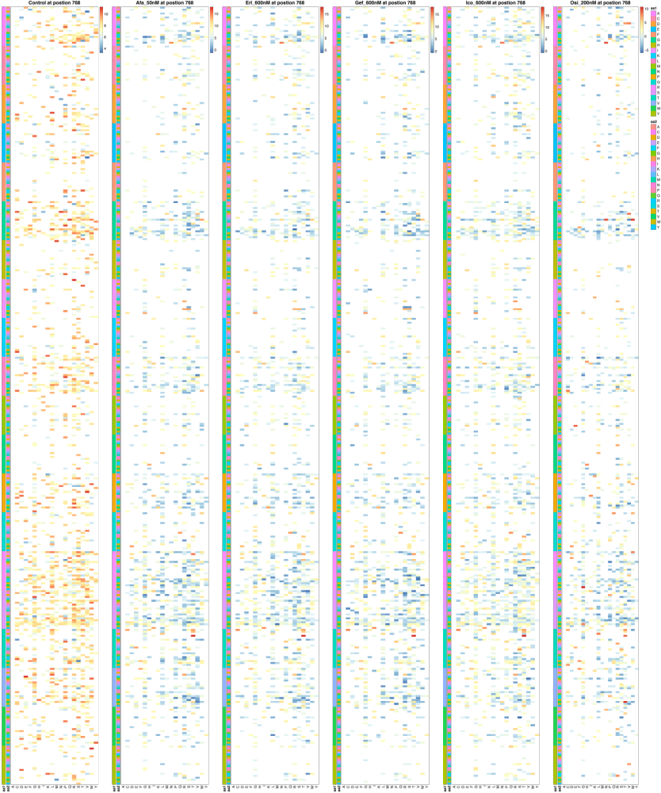

Amino acid position-769
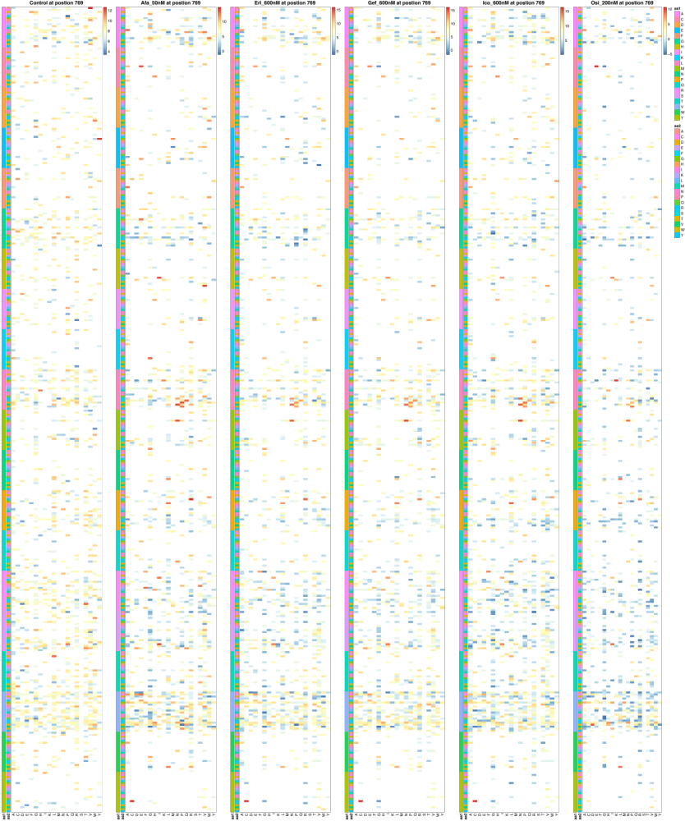

Amino acid position-770
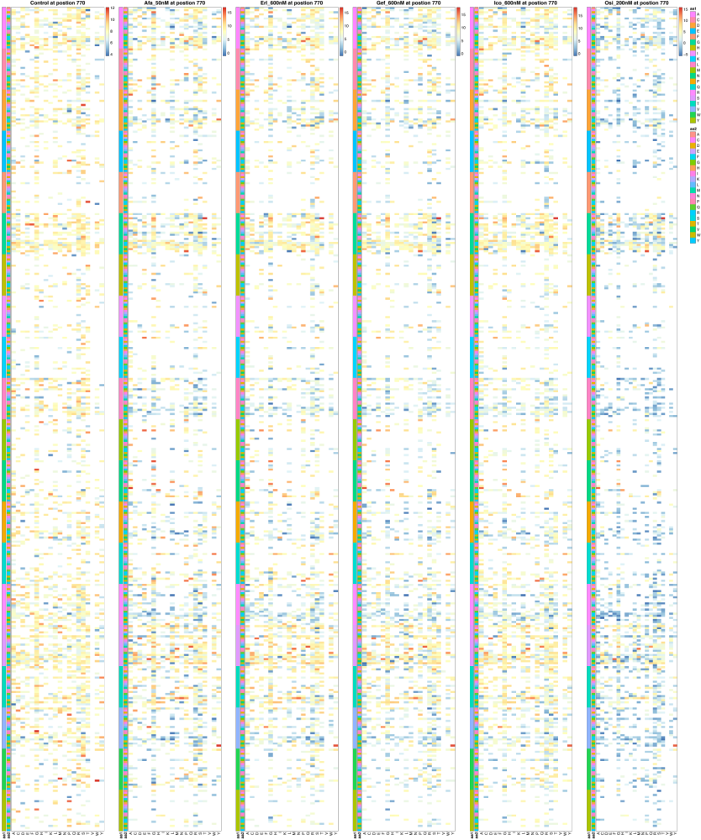

Amino acid position-771
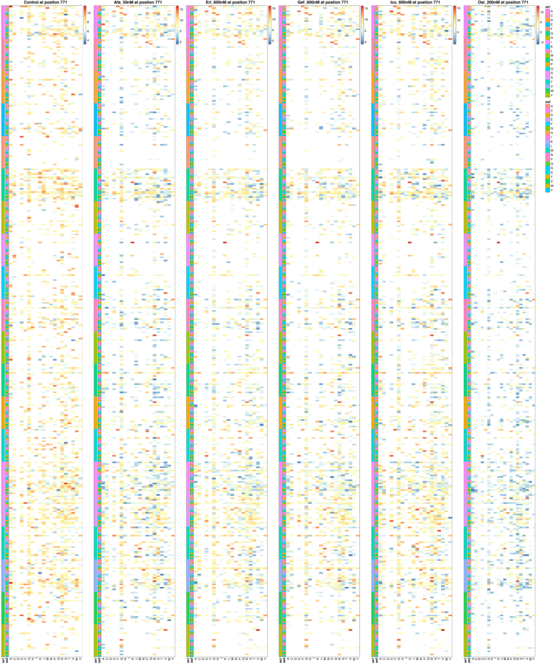

Amino acid position-772
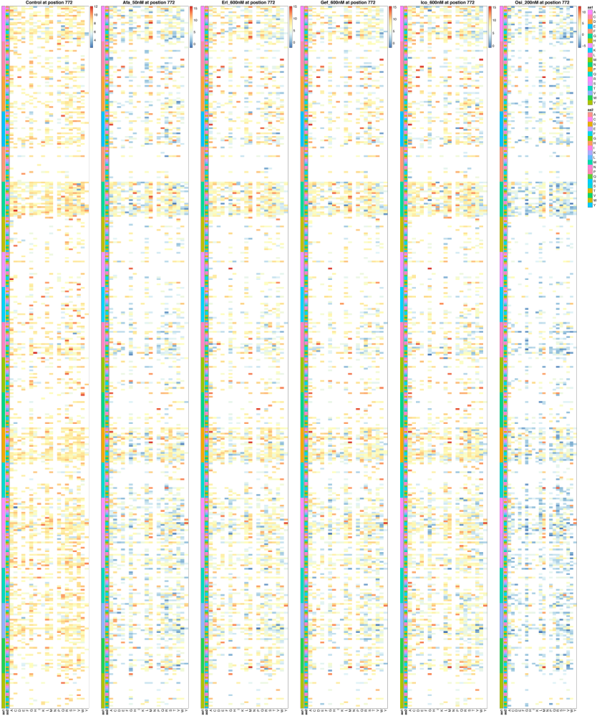

Amino acid position-773
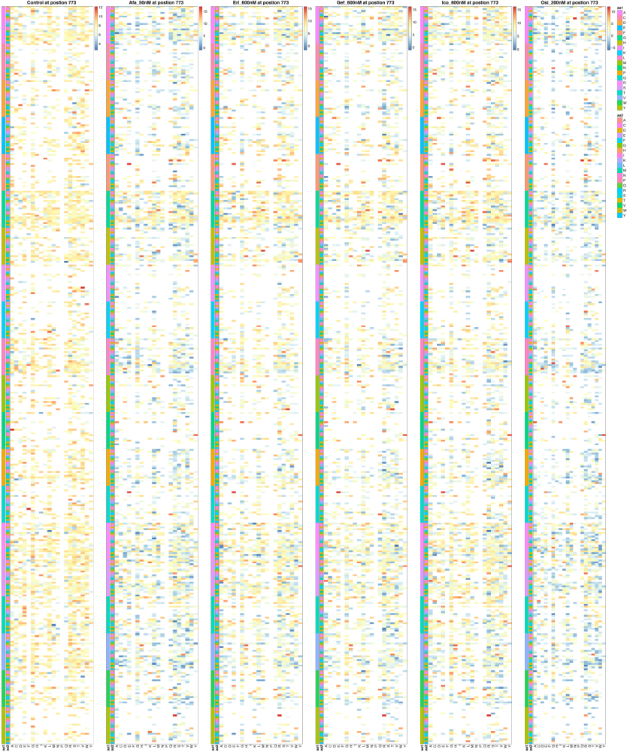

Amino acid position-774
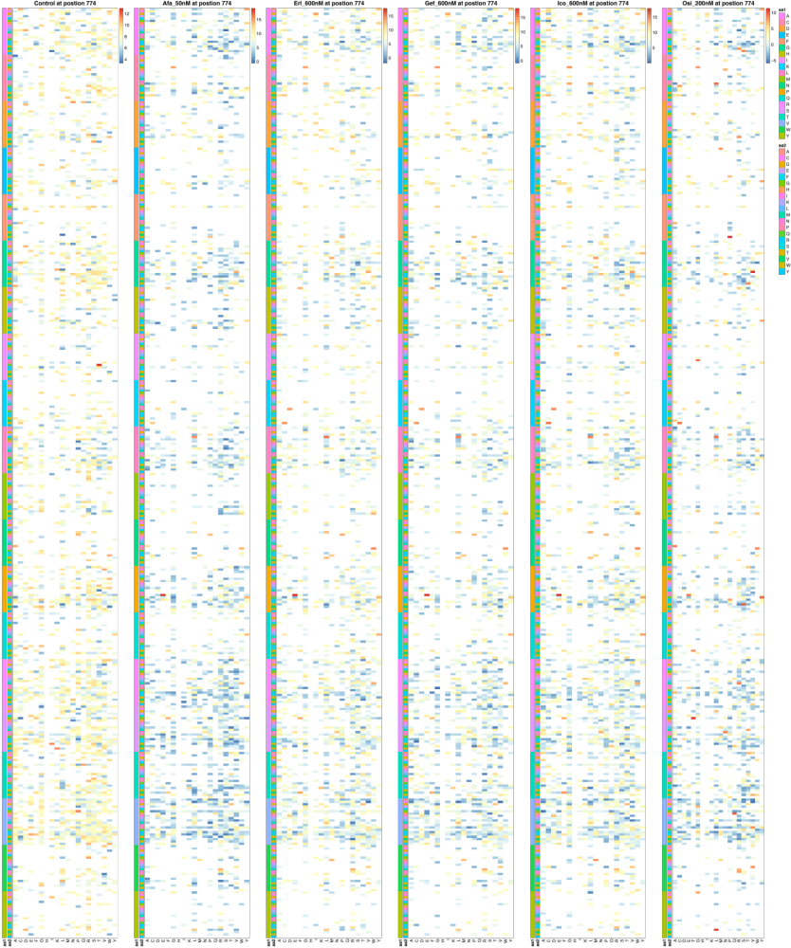

Amino acid position-775
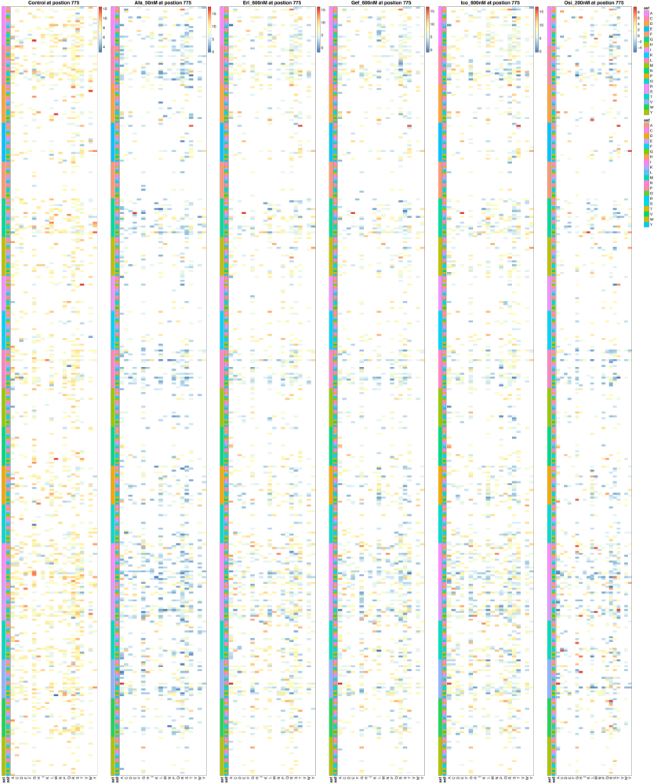

Amino acid position-776
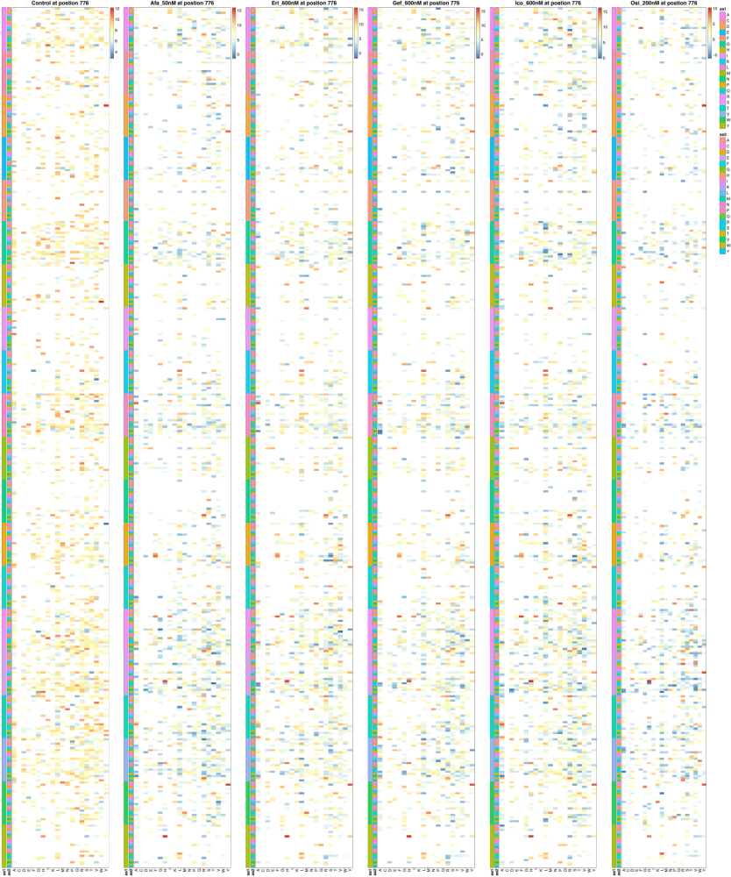

Figure S9. Heatmaps depicting enrichment results of EGFR Ins-3 variants on five TKIs cytotoxicity listed by amino acid position. The enrichment scores are shown as the ratio (log2) of the cell number post-TKI treatment to that pre-TKI treatment. Each amino acid position in EGFR protein was filled with six 20×20×20 (AA1, AA2, AA3) matrixes. The rows (400) and columns (20) of the matrix in each assay represent different amino acids, respectively. Each element in the matrix indicates a triple amino acid insertion. Red to blue represent high and low variants abundance, respectively. Variants that were not covered are colored in white. Cells were treated with DMSO (control), 50 nM of afatinib, 600 nM of erlotinib, 600 nM of gefitinib, 600 nM of icotinib, or 200 nM of osimertinib, respectively.

