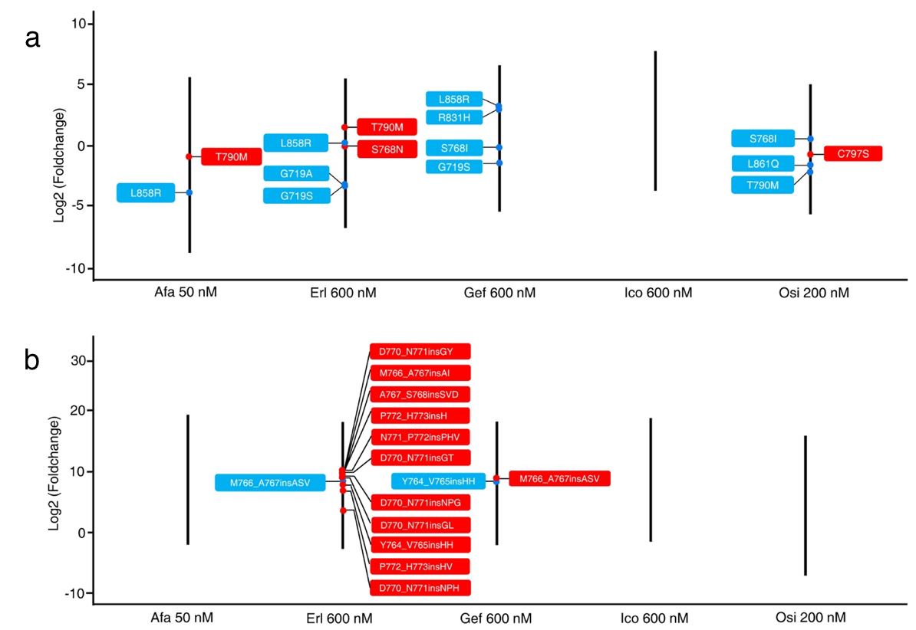
Figure S7. TKI screening results were consistent with known annotations from the CIViC knowledgebase. The relative order of selected high-level evidence Sub-Del (a) and Ins (b) variants in each TKI screening assay. The black bar indicates the range of all variants’ enrichment scores (log2) in each assay. Variants in blue and red boxes are annotated to be drug-sensitive and drug-resistant, respectively.

