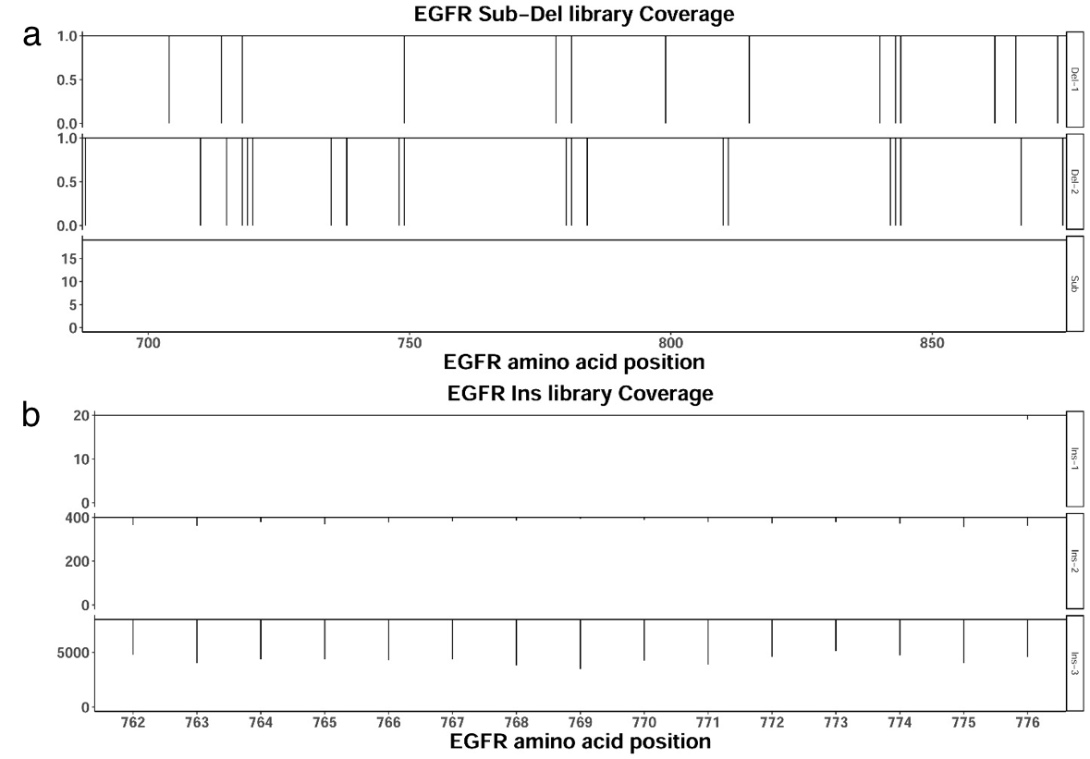
Figure S3. EGFR variant completeness of Sub-Del and Ins libraries. (a) EGFR Sub-Del library detected 99.3 % designed variants. Del-1, Del-2, and Sub indicate the variants with single amino acid deletion, double amino acid deletion, and substitution mutations, respectively. These three types of mutations separately have 100 % (Sub), 92.6 % (Del-1), and 92.3 % (Del-2) of designed variants detected. (b) EGFR Ins library detected 55.8 % designed variants. Ins-1, Ins-2, and Ins-3 indicate variants with mutations of single, double, and triple amino acid insertion mutations, respectively. These three types of mutations separately have 99.7 %, 93.6 %, and 53.8 % of variants detected.

