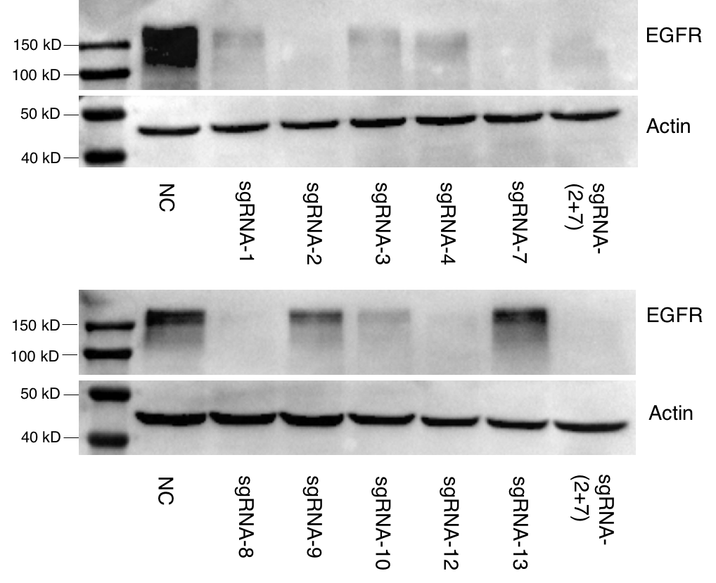
Figure S5. Deletion of endogenous EGFR were further determined by immunoblotting. The sgRNA lentiviruses were separately introduced into A549 cells and then selected with puromycin. Cells were harvested and subject to immunoblotting. NC stands for negative control.

