Supplementary Materials
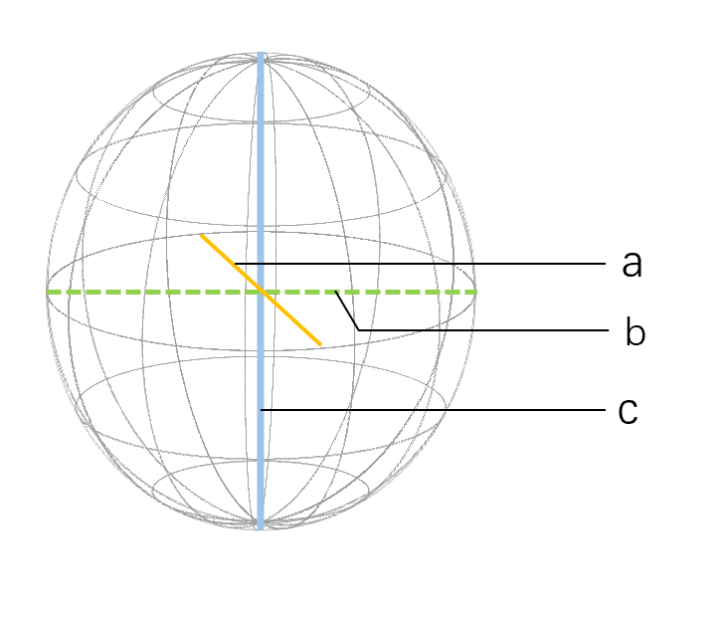
Figure S1 Sphericity measurement diagram,the lymph node is approximated as an ellipsoid, c is the longest diameter of the lymph node, a is the shortest diameter passing through the midpoint of c and perpendicular to c, and b is the longest diameter of the plane

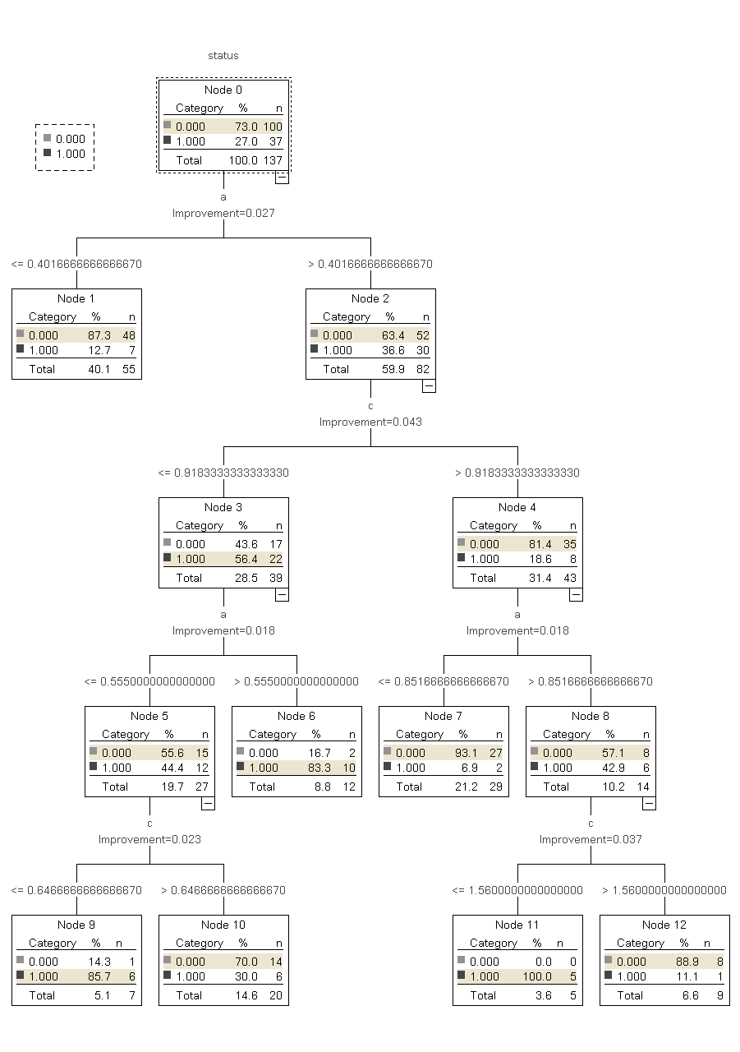
Figure S2. Decision tree model.Dividing the sample by nodes according to the value of the independent variable, the sample size of all terminals was equal to the root knot sample size. 0 indicates no lymph node metastasis, and 1 indicates lymph node metastasis.

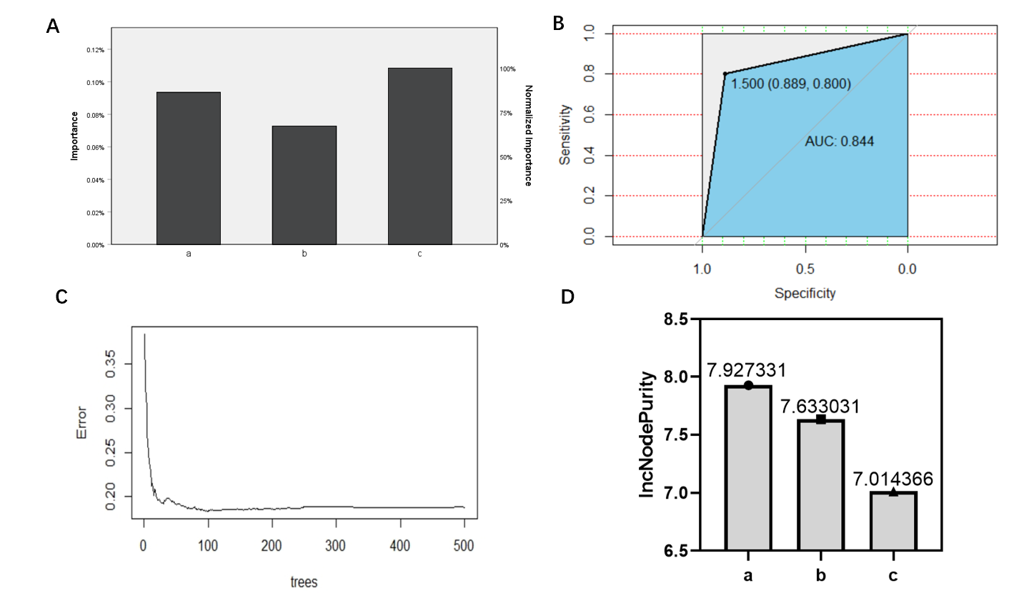
Figure S3. Importance of variables in decision tree models and performance evaluation of random forest models

Table S1 Evaluation Index of assessment methods for diagnosis of lymph node metastasis by 3D Reconstruction system and traditional imaging
 | Sensitivity | Specificity | False positive rate | False negative rate
2D formula | 75.5% | 46.3% | 53.7% | 25.5%
Sphericity formula | 91.9% | 52.0% | 48.0% | 8.1%
Decision tree model | 68.0% | 96.6% | 3.4% | 32.0%
Random forest model | 88.9% | 80.0% | 20.0% | 11.1%
B-ultrasound | 25.0% | 72.7% | 27.3% | 75.0%
CT | 35.5% | 83.3% | 16.7% | 64.5%
Sphericity formula combined with ultrasound | 96.4% | 81.8% | 18.2% | 3.6%
Sphericity formula combined with CT | 93.5% | 83.3% | 16.7% | 6.5%

Table S2 Evaluation of the validity of the assessment methods
 |  | Pathological examination results
 |  | Metastasis | Non-metastasis | Total | Correct classification rate
2D formula | Metastasis | 24 | 6 | 30 | 69.8%
2D formula | Non-metastasis | 7 | 6 | 13 | 69.8%
2D formula | Total | 31 | 12 | 43 | 69.8%
Sphericity formula | Metastasis | 28 | 3 | 31 | 86.0%
Sphericity formula | Non-metastasis | 3 | 9 | 12 | 86.0%
Sphericity formula | Total | 31 | 12 | 43 | 86.0%
Decision tree model | Metastasis | 28 | 2 | 30 | 88.4%
Decision tree model | Non-metastasis | 3 | 10 | 13 | 88.4%
Decision tree model | Total | 31 | 12 | 43 | 88.4%
Random forest model | Metastasis | 29 | 2 | 31 | 90.7%
Random forest model | Non-metastasis | 2 | 10 | 12 | 90.7%
Random forest model | Total | 31 | 12 | 43 | 90.7%
 | Metastasis | 7 | 3 | 10 | 38.5%
B-ultrasound | Non-metastasis | 21 | 8 | 29 | 38.5%
 | Total | 28 | 11 | 39 | 38.5%
CT | Metastasis | 11 | 2 | 13 | 48.8%
CT | Non-metastasis | 20 | 10 | 30 | 48.8%
CT | Total | 31 | 12 | 43 | 48.8%
Sphericity formula combined with ultrasound | Metastasis | 27 | 2 | 29 | 92.3%
Sphericity formula combined with ultrasound | Non-metastasis | 1 | 9 | 10 | 92.3%
Sphericity formula combined with ultrasound | Total | 28 | 11 | 39 | 92.3%
Sphericity formula combined with CT | Metastasis | 29 | 2 | 31 | 90.7%
Sphericity formula combined with CT | Non-metastasis | 2 | 10 | 12 | 90.7%
Sphericity formula combined with CT | Total | 31 | 12 | 43 | 90.7%

Table S3 Statistical variability analysis for each of the two methods in the validation cohort
 | 2D formula | Sphericity formula | Decision tree model | Random forest model | B-ultrasound | CT | Sphericity formula combined with ultrasound | Sphericity formula combined with CT
2D formula | - | 0.059 | 0.031 | 0.014 | 0.004 | 0.039 | 0.01 | 0.014
Sphericity formula | 0.059 | - | 0.5 | 0.369 | 0.000 | 0.000 | 0.293 | 0.369
Decision tree model | 0.031 | 0.5 | - | 0.5 | 0.000 | 0.000 | 0.413 | 0.5
Random forest model | 0.014 | 0.369 | 0.5 | - | 0.000 | 0.000 | 0.555 | 0.644
B-ultrasound | 0.004 | 0.000 | 0.000 | 0.000 | - | 0.235 | 0.000 | 0.000
CT | 0.039 | 0.000 | 0.000 | 0.000 | 0.235 | - | 0.000 | 0.000
Sphericity formula combined with ultrasound | 0.01 | 0.293 | 0.413 | 0.555 | 0.000 | 0.000 | - | 0.555
Sphericity formula combined with CT | 0.014 | 0.369 | 0.5 | 0.644 | 0.000 | 0.000 | 0.555 | -
A p value<0.05 was determined to be statistically significant.

Table S4 Evaluation of the validity of lymph node assessment methods in post-neoadjuvant patients
 |  | Pathological examination results
 |  | Metastasis | Non-metastasis | Total | Correct classification rate
2D formula | Metastasis | 3 | 3 | 6 | 54.5%
2D formula | Non-metastasis | 2 | 3 | 5 | 54.5%
2D formula | Total | 5 | 6 | 11 | 54.5%
Sphericity formula | Metastasis | 4 | 3 | 7 | 63.6%
Sphericity formula | Non-metastasis | 1 | 3 | 4 | 63.6%
Sphericity formula | Total | 5 | 6 | 11 | 63.6%
Decision tree model | Metastasis | 3 | 1 | 8 | 72.7%
Decision tree model | Non-metastasis | 2 | 5 | 3 | 72.7%
Decision tree model | Total | 5 | 6 | 11 | 72.7%
Random forest model | Metastasis | 4 | 2 | 6 | 72.7%
Random forest model | Non-metastasis | 1 | 4 | 5 | 72.7%
Random forest model | Total | 5 | 6 | 11 | 72.7%
 | Metastasis | 2 | 3 | 5 | 45.5%
B-ultrasound | Non-metastasis | 3 | 3 | 6 | 45.5%
 | Total | 5 | 6 | 11 | 45.5%
CT | Metastasis | 2 | 2 | 4 | 54.5%
CT | Non-metastasis | 3 | 4 | 7 | 54.5%
CT | Total | 5 | 6 | 11 | 54.5%
Sphericity formula combined with ultrasound | Metastasis | 4 | 2 | 6 | 72.7%
Sphericity formula combined with ultrasound | Non-metastasis | 1 | 4 | 5 | 72.7%
Sphericity formula combined with ultrasound | Total | 5 | 6 | 11 | 72.7%
Sphericity formula combined with CT | Metastasis | 4 | 2 | 6 | 72.7%
Sphericity formula combined with CT | Non-metastasis | 1 | 4 | 5 | 72.7%
Sphericity formula combined with CT | Total | 5 | 6 | 11 | 72.7%

Table S5 Statistical variability analysis for each of the two methods in post-neoadjuvant patients
 | 2D formula | Sphericity formula | Decision tree model | Random forest model | B-ultrasound | CT | Sphericity formula combined with ultrasound | Sphericity formula combined with CT
2D formula | - | 0.5 | 0.33 | 0.33 | 0.5 | 0.665 | 0.33 | 0.33
Sphericity formula | 0.5 | - | 0.5 | 0.5 | 0.335 | 0.5 | 0.5 | 0.5
Decision tree model | 0.33 | 0.5 | - | 0.682 | 0.193 | 0.33 | 0.682 | 0.682
Random forest model | 0.33 | 0.5 | 0.682 | - | 0.193 | 0.33 | 0.682 | 0.682
B-ultrasound | 0.5 | 0.335 | 0.193 | 0.193 | - | 0.5 | 0.193 | 0.193
CT | 0.665 | 0.5 | 0.33 | 0.33 | 0.5 | - | 0.33 | 0.33
Sphericity formula combined with ultrasound | 0.33 | 0.5 | 0.682 | 0.682 | 0.193 | 0.33 | - | 0.682
Sphericity formula combined with CT | 0.33 | 0.5 | 0.644 | 0.682 | 0.193 | 0.33 | 0.682 | -
A p value<0.05 was determined to be statistically significant.

