Supporting Information
Oligoquinane Hydrocarbons Display Dual Fluorescence & Phosphorescence Anti-Kasha Emissions
Marcos Díaz-Fernández^{1#}, Chang Wang^{2#}, Alicia Omist^{3,4#}, José M. Marín-Beloqui¹*, David Casanova^{3,5}*, Junzhi Liu^{2,6,7}*, Juan Casado¹*

¹ Department of Physical Chemistry, Faculty of Science, University of Malaga, Campus de Teatinos s/n, 29071, Malaga, Spain.
² Department of Chemistry, The University of Hong Kong, Pokfulam Road, Hong Kong 999077, China.
³ Donostia International Physics Center (DIPC), 20018, Donostia, Euskadi, Spain.
⁴ Polimero eta Material Aurreratuak: Fisika, Kimika eta Teknologia Saila, Kimika Fakultatea, Euskal Herriko Unibertsitatea (EHU), PK 1072, 20080 Donostia, Euskadi, Spain.
⁵ IKERBASQUE, Basque Foundation for Science, 48009 Bilbao, Euskadi, Spain.
⁶ State Key Laboratory of Synthetic Chemistry, HKU-CAS Joint Laboratory on New Materials and Shanghai-Hong Kong Joint Laboratory on Chemical Synthesis, The University of Hong Kong, Pokfulam Road, Hong Kong 999077, China.
⁷ Materials Innovation Institute for Life Sciences and Energy (MILES), HKU-SIRI, Shenzhen 518048, China.

# These authors contributed equally to this work.
*Email: jm.marinbeloqui@uma.es; david.casanova @dipc.org; juliu@hku.hk; casado@uma.es

Experimental Section
Absorbance spectroscopy was performed using a Varian Cary 5000 UV-Vis-NIR Spectrophotometer. Emission and excitation spectra were obtained using an Edinburgh Instruments FLS920 Fluorimeter. Emission lifetimes were acquired using the Fluorimeter with pulsed xenon flash-lamp, Xe900, of 400 mW for the delayed emission characterization and Picoquant PLS-λ nanosecond LED diodes for the nanosecond timescale. Solutions temperatures were varied from room temperature to 80 K using an Optistat DN Oxford Instrument cryostat. Femtosecond transient absorption spectra were obtained using a Helios system from Ultrafast Systems. This setup includes an amplified femtosecond Spectra-Physics Solstice-100F laser, featuring a 128 fs pulse width and a 1 kHz repetition rate, coupled with a Spectra-Physics TOPAS Prime F optical parametric amplifier, covering a range of 195-22000 nm. Samples were studied in degassed 2-methyl-tetrahydrofuran (2-Me-THF, Sigma-Aldrich/Merck, Anhydrous, ≥99%) ca. 10⁻³ M solutions.
Dichloromethane (DCM), tetrahydrofuran (THF) and dimethylacetamide (DMF) were used from solvent purification system (Inert). All other reagents were purchased without any further purification. azu-Cl, NB0A1, 1, 2 and 3 was synthesized according to our previous work.^{[1]}
Preparative thin layer chromatography (P02015, Analtech Brand Silica Gel GF TLC Plates 2000 µm 20x20 cm) was bought form Miles Scientific company and used as received. High resolution mass spectra were obtained on a Bruker Q-Tof Maxis II mass spectrometer and a DFS high resolution magnetic sector mass spectrometer. Accurate masses from high-resolution mass spectra were reported for the molecular ion [M]+, [M+H]+, [M+Na]+ or [M+K]+. ¹H-NMR and ¹³C-NMR spectra were obtained on a Bruker 400, 500 or 600 spectrometers (400/500/600 MHz for ¹H, 101/126/151 MHz for ¹³C). Chemical shifts are reported as parts per million (ppm) with residual solvent signals as internal standard (dichloromethane-d2 (CD₂Cl₂), δ =5.32 ppm for ¹H-NMR, δ =54.00 ppm for ¹³C-NMR) and (tetrahydrofuran-d8 (THF-d8), δ =3.58 ppm for ¹H-NMR, δ =67.57 ppm for ¹³C-NMR).^{[2]} Data for ¹H-NMR were presented as following: chemical shifts (δ, ppm), multiplicity (s = singlet, d = doublet, t = triplet, q = quartet, dd = doublet of doublets, tt = triplet of triplets, td = triplet of doublets, m = multiples), coupling constant (Hz), and integration.

Synthesis of 9-(azulen-2-yl)-3,6-di-tert-butyl-9H-carbazole (NB0A1):
The compound was synthesized according to our previous work.^{[1]} To a Schlenk flask (100 mL) was added 3,6-di-tert-butyl-9H-carbazole (1.12 g, 4.00 mmol), azu-Cl (500 mg, 3.07 mmol), S-Phos (189 mg, 0.46 mmol) and ^{t}BuONa (443 mg, 4.61 mmol). The flask was moved into the glovebox. Pd₂(dba)₃ (282 mg, 0.31 mmol) and toluene (40 mL) was added. The resulting mixture was stirred at 110 ºC under N₂ for 24 h. Then then flask was cooled to room temperature and extracted with EtOAc (30 mL). The organic layer was dried over anhydrous Na₂SO₄ and evaporated. The residue was purified by column chromatography (hexane/DCM = 40/1) to give 9-(azulen-2-yl)-3,6-di-tert-butyl-9H-carbazole (NB0A1) 1.03 g (yield: 83 %) as dark green solid.
¹H-NMR (400 MHz, CD₂Cl₂) δ 8.38 (d, J=9.5 Hz, 2H), 8.17 (d, J=1.5 Hz, 2H), 7.96 (d, J=8.5 Hz, 2H), 7.69 (s, 2H), 7.61 (t, J=9.5 Hz, 1H), 7.55 (dd, J=8.5, 1.5 Hz, 2H), 7.33 (t, J=9.5 Hz, 2H), 1.48 (s, 18H).
¹³C-NMR (101 MHz, CD₂Cl₂) δ 146.53, 144.73, 140.44, 139.05, 135.83, 135.34, 125.10, 124.87, 124.56, 116.90, 111.00, 110.69, 35.25, 32.25.

Synthesis of 3,6-di-tert-butyl-9-(1,3-diiodoazulen-2-yl)-9H-carbazole (1):
The compound was synthesized according to our previous work.^{[1]} To a 100 mL bottle was added NB0A1 (1.2 g, 2.96 mmol) and DCM (100 mL) at 0 ºC. NIS (1.33 g, 5.92 mmol) was added at same temperature, and the resulting mixture was stirred for 1 h. The reaction was quenched by Na₂SO₃ and extracted with DCM. The organic layer was dried over anhydrous Na₂SO₄ and evaporated. The residue was purified by column chromatography (hexane/DCM = 10/1) to give 3,6-di-tert-butyl-9-(1,3-diiodoazulen-2-yl)-9H-carbazole (1) 1.8 g (yield: 93 %) as dark green solid.
¹H-NMR (400 MHz, CD₂Cl₂) δ 8.42 (d, J=9.5 Hz, 2H), 8.22 (s, 2H), 7.87 (t, J=9.5 Hz, 1H), 7.54 (t, J=9.5 Hz, 2H), 7.45 (d, J=8.5 Hz, 2H), 6.92 (d, J=7.0 Hz, 2H), 1.48 (s, 18H).
¹³C-NMR (101 MHz, CD₂Cl₂) δ 149.66, 143.88, 142.02, 140.38, 140.21, 139.34, 126.85, 124.23, 124.02, 117.15, 110.89, 76.42, 35.26, 32.33.

Synthesis of 9-(1,3-bis(2-bromophenyl)azulen-2-yl)-3,6-di-tert-butyl-9H-carbazole (2):
The synthetic route to this compound was modified based on our previous work.^{[1]} To a Schlenk flask (100 mL) was added 1 (200 mg, 0.30 mmol), (2-bromophenyl) boronic acid (367 mg, 1.83 mmol), K₂CO₃ (168 mg, 1.22 mmol), THF (10 mL) and H₂O (2 mL). The resulting mixture was bubbled with N₂ for 0.5 h. Then Pd(dppf)Cl₂ (22 mg, 0.030 mmol) was added. The resulting mixture was stirred at 40 ºC under N₂ for 36 h. The resulting mixture was cooled to room temperature and extracted with EtOAc (30 mL). The organic layer was dried over anhydrous Na₂SO₄ and evaporated. The residue was purified by column chromatography (hexane/DCM = 15/1) to give 9-(1,3-bis(2-bromophenyl)azulen-2-yl)-3,6-di-tert-butyl-9H-carbazole (2) 91 mg (yield: 42 %) as dark green solid.
¹H-NMR (400 MHz, CD₂Cl₂) δ 8.22 (d, J=9.5 Hz, 2H), 7.94 (s, 2H), 7.79 (t, J=9.5 Hz, 1H), 7.59 (d, J=6.5 Hz, 2H), 7.40 (t, J=9.5 Hz, 2H), 7.25 (d, J=8.5 Hz, 2H), 7.17 (d, J=8.5 Hz, 2H), 7.05–6.97 (m, 6H), 1.37 (s, 18H).
¹³C-NMR (126 MHz, CD₂Cl₂) δ 143.24, 142.46, 140.18, 139.00, 137.33, 136.39, 136.06, 133.58, 133.55, 129.35, 127.56, 125.70, 125.46, 125.36, 123.68, 116.36, 110.65, 35.06, 32.22.

Synthesis of compound NB2A1:
To a Schlenk tube (100 mL) was added 2 (200 mg, 0.280 mmol) and DBU (393 mg, 2.52 mmol). Then, the tube was moved into the glovebox. Pd(PCy₃)Cl₂ (51 mg, 0.112 mmol) and DMF (20 mL) was added. The resulting mixture was stirred at 130 ºC under N₂ for 24 h. The resulting mixture was cooled to room temperature and extracted with EtOAc (200 mL). The organic layer was dried over anhydrous Na₂SO₄ and evaporated. The residue was purified by column chromatography (hexane/DCM = 5/1) to give crude product. The crude product was further purified by GPC to obtain NB2A1 62 mg (yield: 40 %) as orange solid.
¹H-NMR (500 MHz, CD₂Cl₂) δ 8.30-8.28 (m, 2H), 8.23-8.19 (m, 3H), 7.73 (t, J=8.0 Hz, 4H), 7.57 (dd, J= 8.5, 2.0 Hz, 2H), 7.03 (td, J=7.5, 1.5 Hz, 2H), 6.95 (td, J=7.5, 1.5 Hz, 2H), 6.48 (d, J=7.5 Hz, 2H), 1.50 (s, 18H).
¹³C-NMR (126 MHz, CD₂Cl₂) δ 145.99, 143.25, 143.16, 141.58, 141.14, 138.39, 134.63, 130.48, 127.75, 125.69, 125.51, 124.67, 124.10, 123.56, 123.02, 117.03, 112.71, 35.40, 32.25.
HRMS(ESI) for NB2A1: calcd. for C₄₂H₃₅N ([M+H]+): 554.2842, found: 554.2825.

Synthesis of 9-([2,1':3',2''-terazulen]-2'-yl)-3,6-di-tert-butyl-9H-carbazole (3):
The synthetic route to this compound was modified based on our previous work.^{[1]} To a Schlenk tube (100 mL) was added 1 (200 mg, 0.30 mmol), 2-(4,4,5,5-tetramethyl-1,3,2-dioxa-borolanyl)azulene (378 mg, 1.37 mmol), K₂CO₃ (253 mg, 1.83 mmol), THF (10 mL) and H₂O (2 mL). The resulting mixture was bubbled with N₂ for 0.5 h. Then Pd(dppf)Cl₂ (22 mg, 0.030 mmol) was added. The resulting mixture was stirred at 40 ºC under N₂ for 36 h. The reaction was cooled to room temperature and extracted with EtOAc (30 mL). The organic layer was dried over anhydrous Na₂SO₄ and evaporated. The residue was purified by column chromatography (hexane/DCM = 10/1) to give 9-([2,1':3',2''-terazulen]-2'-yl)-3,6-di-tert-butyl-9H-carbazole (3) 91 mg (yield: 43 %) as dark green solid.
¹H-NMR (500 MHz, CD₂Cl₂) δ 9.05 (d, J=9.5 Hz, 2H), 8.11 (d, J=2.0 Hz, 2H), 8.00 (d, J=9.5 Hz, 4H), 7.78 (t, J=9.5 Hz, 1H), 7.41 (td, J=9.5, 2.5 Hz, 4H), 7.14–7.09 (m, 6H), 7.03 (t, J=9.5 Hz, 4H), 6.82 (d, J=8.5 Hz, 2H), 1.34 (s, 18H).
¹³C-NMR (101 MHz, CD₂Cl₂) δ 143.71, 143.01, 142.72, 140.92, 140.56, 140.27, 138.32, 137.74, 136.44, 135.68, 126.71, 124.53, 124.04, 123.81, 118.21, 116.68, 110.19, 35.07, 32.21.

Synthesis of 3,6-di-tert-butyl-9-(1,1''-dichloro-[2,1':3',2''-terazulen]-2'-yl)-9H-carbazole (4)
To a 200 mL bottle was added 3 (200 mg, 0.304 mmol) and DCM (30 mL) at 0 ºC. N-Chlorosuccinimide (NCS, 82 mg, 0.608 mmol) in DCM (10 mL) was added dropwise at 0 ºC, and the resulting mixture was stirred at same temperature for 1 h. The reaction was quenched by Na₂SO₃ and extracted with DCM. The organic layer was dried over anhydrous Na₂SO₄ and evaporated. The residue was purified by column chromatography (hexane/DCM = 5/1) to 3,6-di-tert-butyl-9-(1,1''-dichloro-[2,1':3',2''-terazulen]-2'-yl)-9H-carbazole (4) 148 mg (yield: 67 %) as dark green solid.
¹H-NMR (500 MHz, THF-d8) δ 8.52 (d, J=9.5 Hz, 2H), 8.24 (d, J=9.5 Hz, 2H), 7.93-7.89 (m, 4H), 7.80 (t, J=9.5 Hz, 1H), 7.50-7.42 (m, 4H), 7.14 (t, J=9.5 Hz, 2H), 7.00 (t, J=9.5 Hz, 2H), 6.94-6.90 (m, 6H), 1.20 (s, 18H).
¹³C-NMR (126 MHz, THF-d8) δ 144.96, 143.13, 142.26, 140.52, 139.60, 139.53, 138.94, 138.66, 137.81, 137.61, 135.69, 134.18, 127.05, 125.11, 124.65, 124.22, 123.41, 120.96, 118.41, 116.44, 110.99, 35.24, 32.30.
HRMS(ESI) for 4: calcd. for C₅₀H₄₁Cl₂N ([M+H]+): 726.2689, found: 726.2678.

Synthesis of compound NB0A3
To a Schlenk tube (100 mL) was added 4 (200 mg, 0.275 mmol) and DBU (377 mg, 2.48 mmol). Then, the tube was moved into the glovebox. Pd(PCy₃)Cl₂ (50 mg, 0.110 mmol) and DMF (20 mL) was added. The resulting mixture was stirred at 125 ºC under N₂ for 24 h. The reaction was cooled to room temperature and extracted with EtOAc (200 mL). The organic layer was dried over anhydrous Na₂SO₄ and evaporated. The residue was purified by column chromatography (hexane/DCM = 5/1) to give crude product. The crude product was further purified by GPC to give NB0A3 32 mg (yield: 18 %) as dark brown solid.
¹H-NMR (600 MHz, THF-d8) δ 8.29 (d, J=2.0 Hz, 2H), 8.20-8.16 (m, 4H), 8.08-8.02 (m, 1H), 7.73 (d, J=8.5 Hz, 2H), 7.65 (dd, J=8.5, 2.0 Hz, 2H), 7.58 (d, J=9.5 Hz, 2H), 7.04 (t, J=9.6 Hz, 2H), 6.98 (t, J=9.5 Hz, 2H), 6.90 (t, J=9.5 Hz, 2H), 6.21 (s, 2H), 1.51 (s, 18H).
¹³C-NMR (151 MHz, THF-d8) δ 156.18, 154.67, 151.56, 145.78, 141.59, 138.81, 138.16, 137.22, 136.88, 136.46, 134.44, 133.85, 131.07, 130.70, 130.68, 129.30, 128.53, 126.33, 125.23, 124.68, 123.89, 117.47, 114.03, 112.63, 35.73, 32.50.
HRMS(ESI) for NB0A3: calcd. for C₅₀H₃₉N ([M+H]+): 654.3155, found: 654.3125.

X-ray crystallography
The X-ray crystallographic coordinates for structures reported in this article have been collected at Cambridge Crystallographic Data Centre (CCDC), under collecting number, CCDC 2414487 for NB2A1, CCDC 2414489 for NB0A3. These data can be obtained free of charge from CCDC via https://www.ccdc.cam.ac.uk/structures/. Crystal data and structure refinement are summarized in Table S1.

Table S1. Crystallographic data and details of the structural refinements of NB2A1 and NB0A3.
 | NB2A1 | NB0A3
Formula | C₄₂H₃₅N | C₅₀H₃₉N
Sum formula | C₄₂H₃₅N | C₅₀H₃₉N
fw | 553.71 | 653.82
T (K) | 100 | 100
Crystal system | Trigonal | Monoclinic
Space group | R-3 | P21/c
A/ Å | 37.7998(8) | 21.9021(9)
B/ Å | 37.7998(8) | 13.6459(6)
C/ Å | 11.7297(2) | 11.8955(5)
α/ º | 90 | 90
β/ º | 90 | 100.068(3)
γ/ º | 120 | 90
Volume/ Å³ | 14514.3(7) | 3500.5(3)
Z | 18 | 4
Dcalc, (g / cm³) | 1.140 | 1.241
µ (mm⁻¹) | 0.493 | 0.536
F(000) | 5292.0 | 1384.0

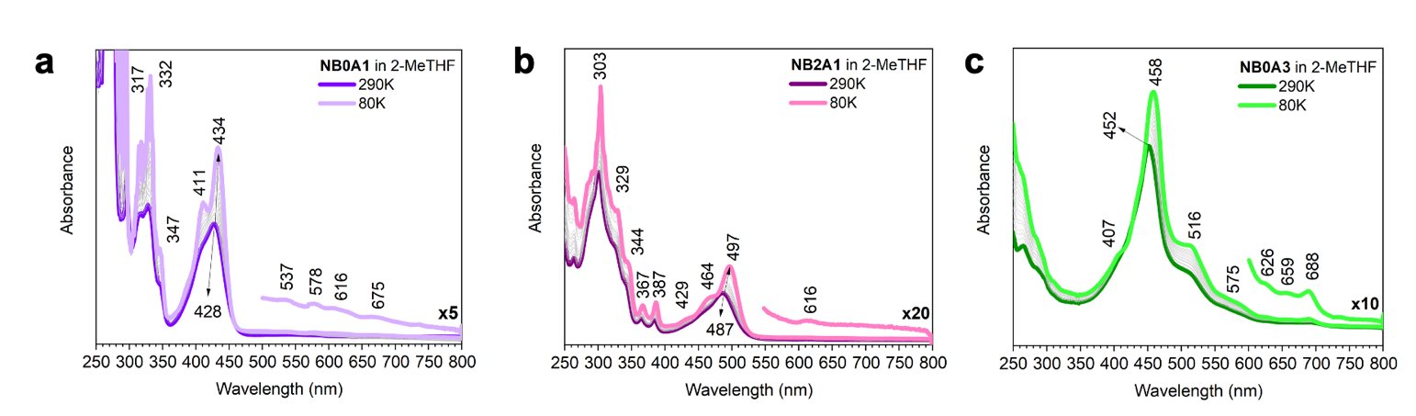
Ground State Absorbance

Figure S1. Absorption spectra in 2-MeTHF of (a) NB0A1 (b) NB2A1 and (c) NB0A3 and their evolution with the temperature.

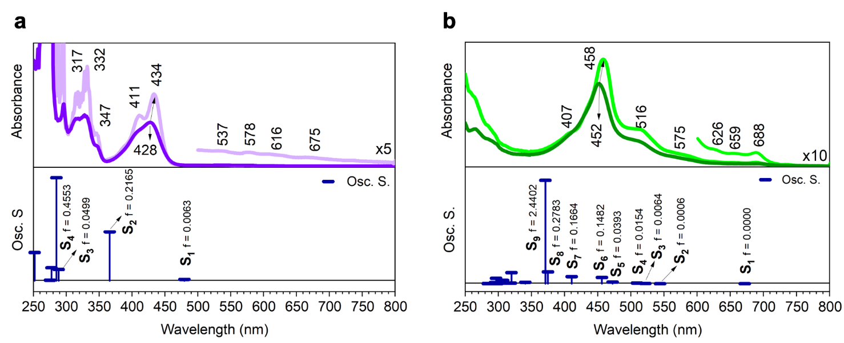
Figure S2. (a) Top: NB0A1 absorption spectra at room T (violet) and 80 K (light violet) in 2-MeTHF. Bottom: computed singlet transitions (blue vertical bars) together with the oscillator strengths values (f) (vertical bars are proportional to f). (b) Top: NB0A3 absorption spectra at room T (green) and 80 K (light green) in 2-MeTHF. Bottom: computed singlet transitions (blue vertical bars) together with the oscillator strengths values (f) (vertical bars are proportional to f). Both molecules, NB0A1 and NB0A3, have been computed at the CAM-B3LYP/6-31G(d) level of theory.

Orbital Topology

LUMO + 5 | LUMO + 4 | LUMO + 3
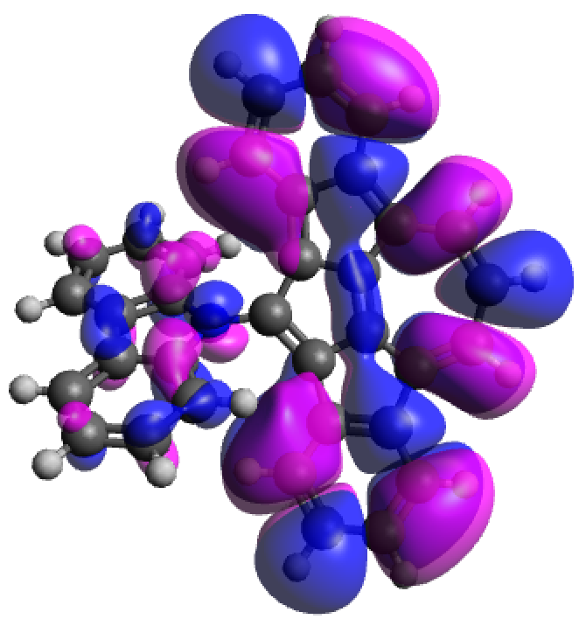 | 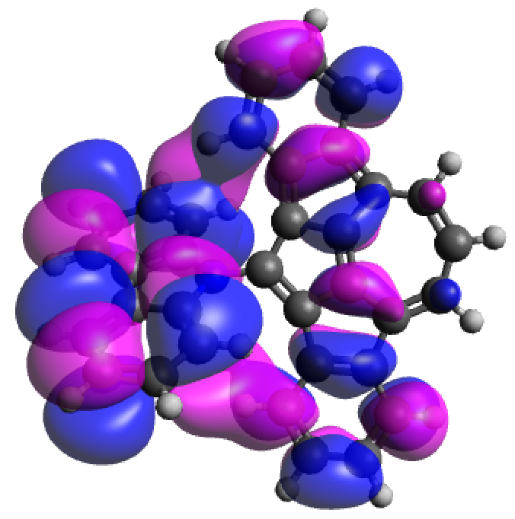 | 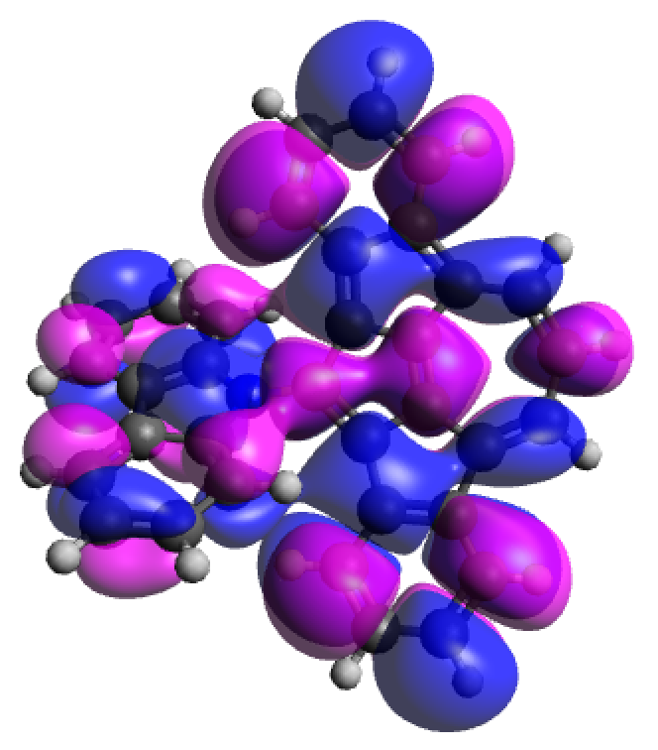
LUMO + 2 | LUMO + 1 | LUMO
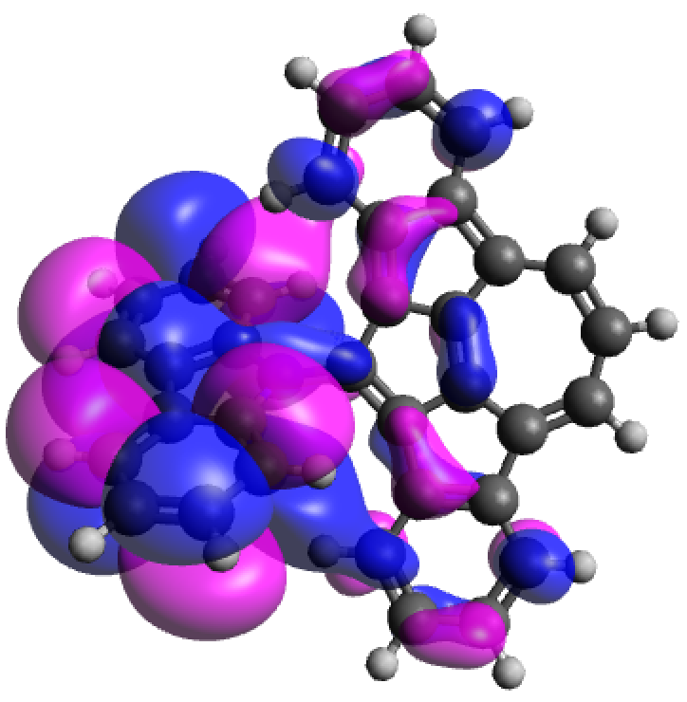 | 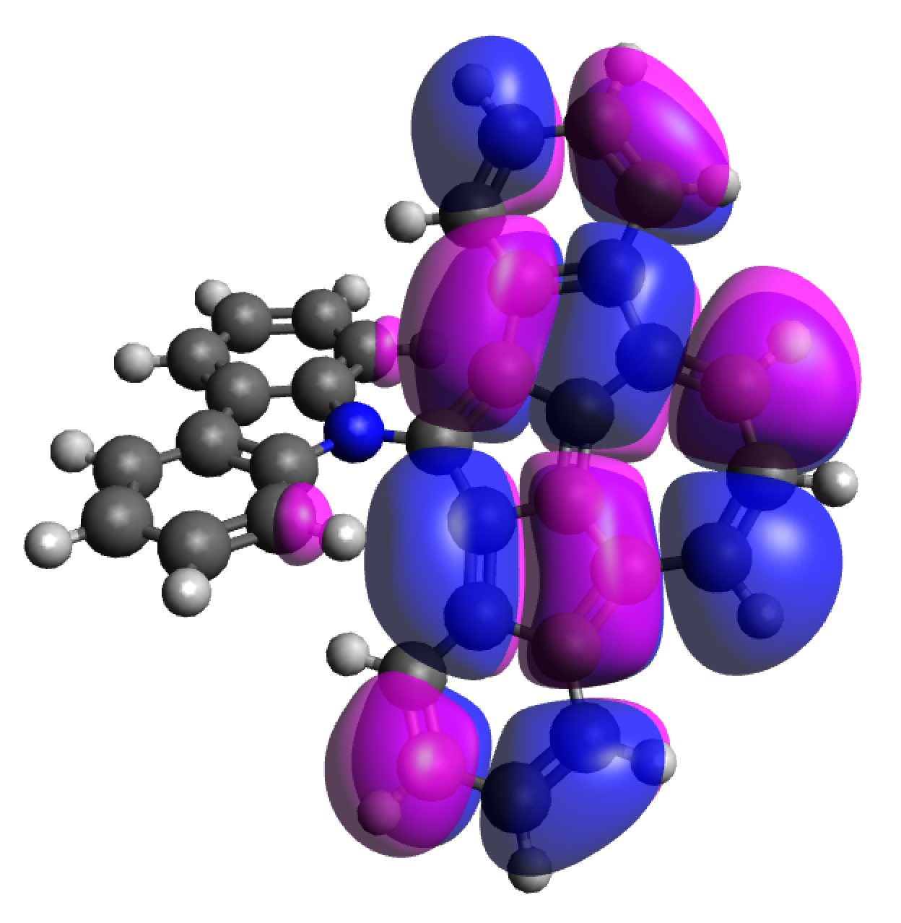 | 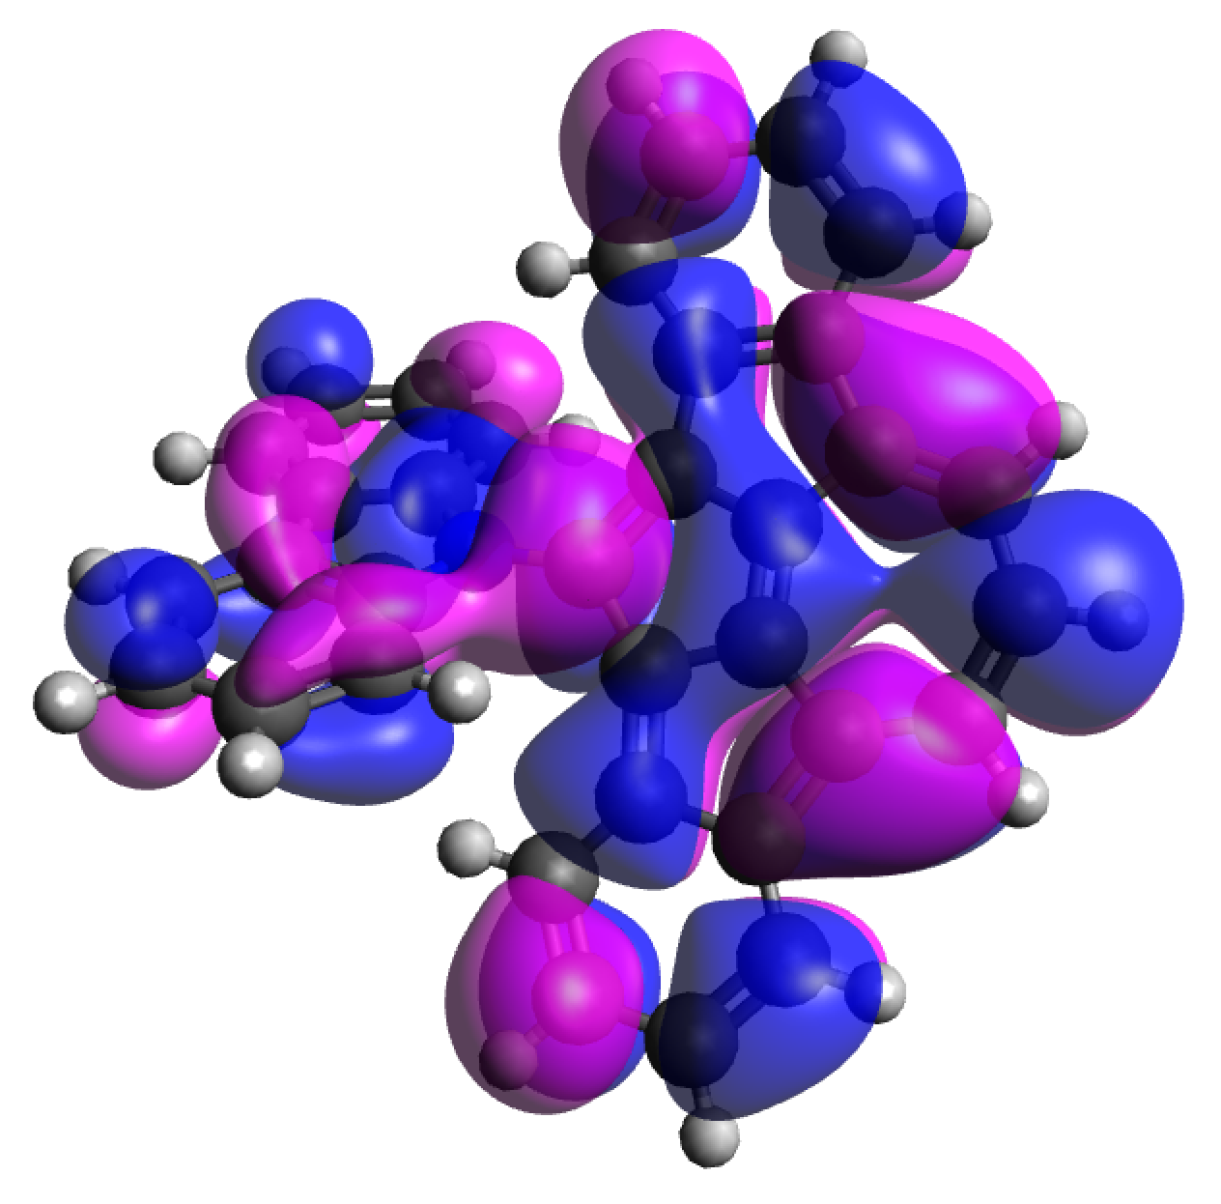
HOMO | HOMO - 1 | HOMO - 2
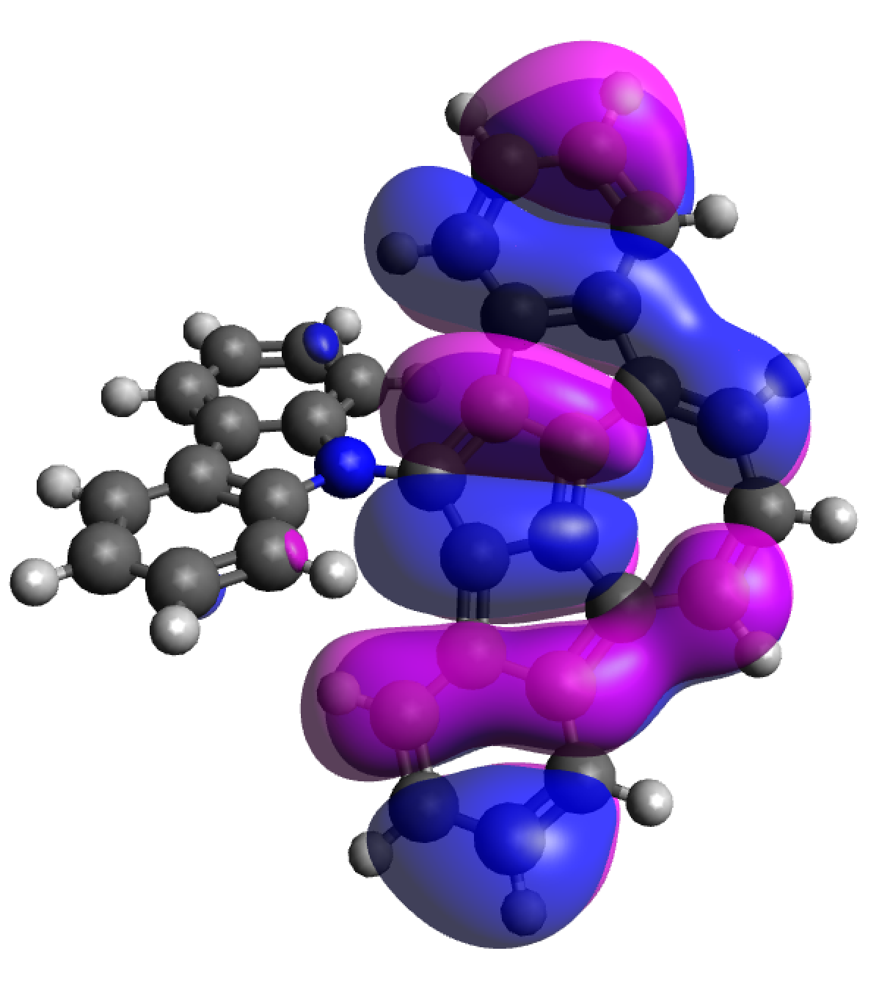 | 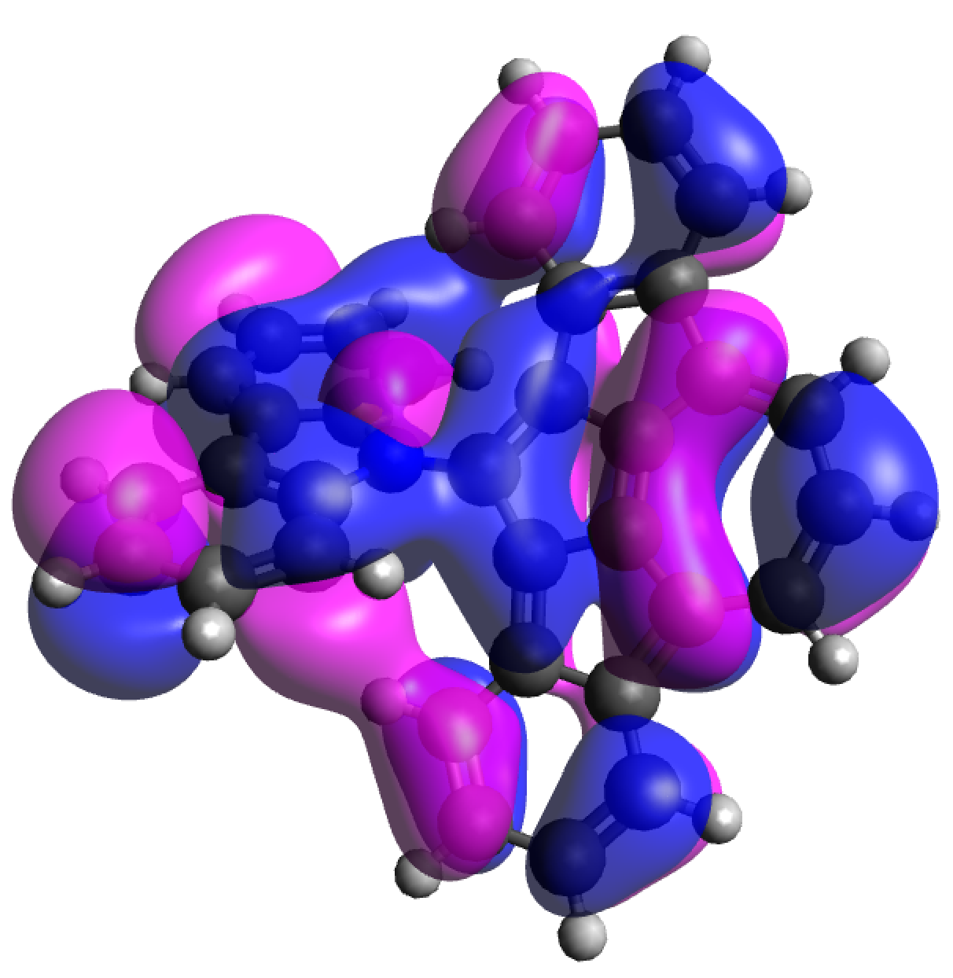 | 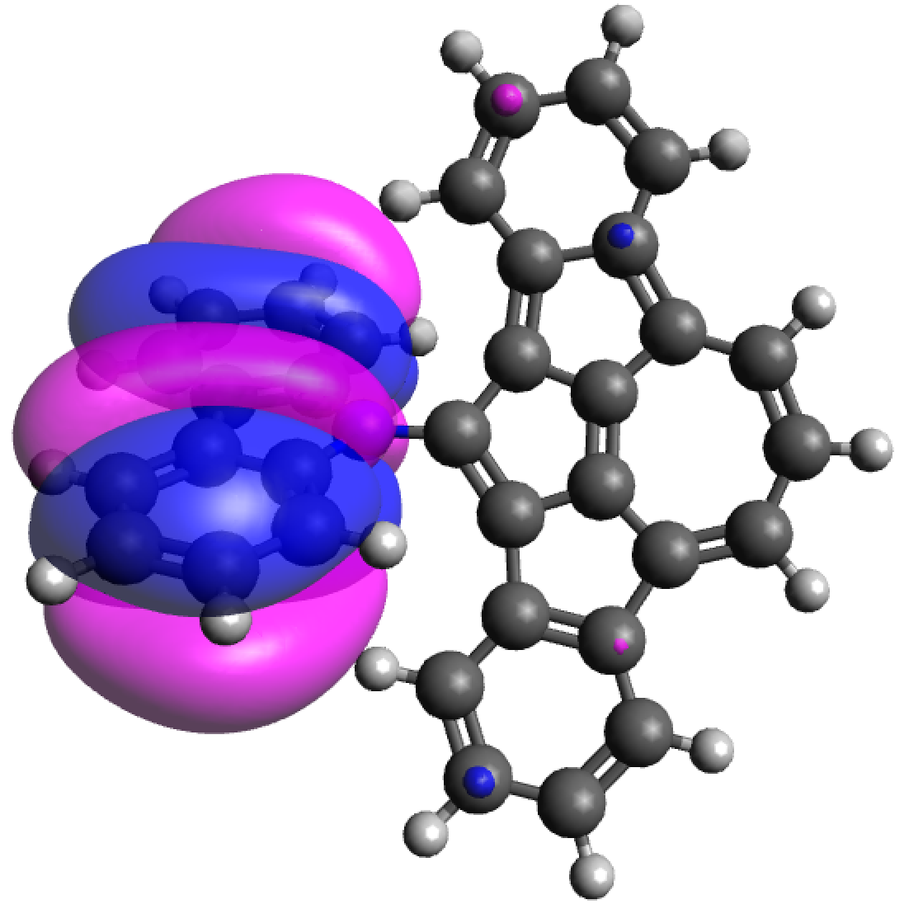
HOMO - 3 | HOMO - 4 | HOMO - 5
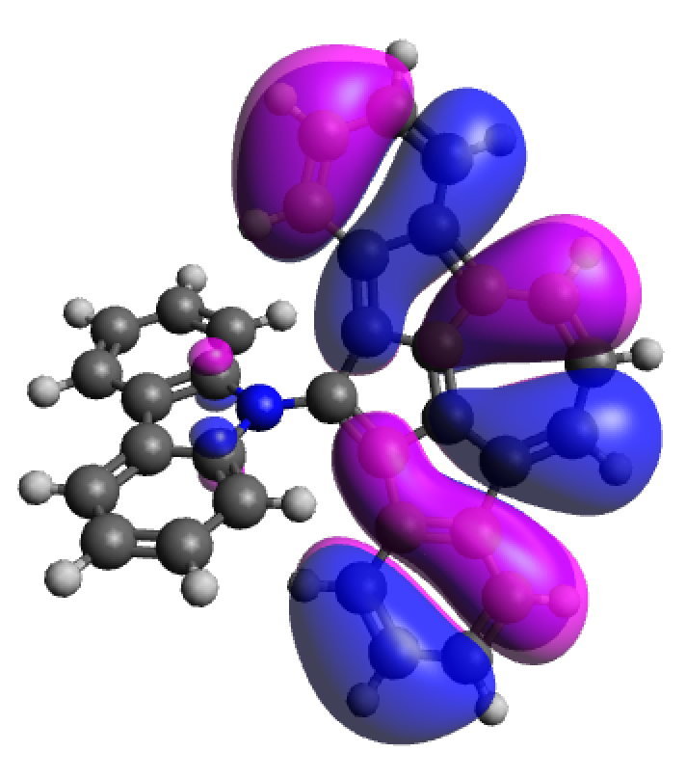 | 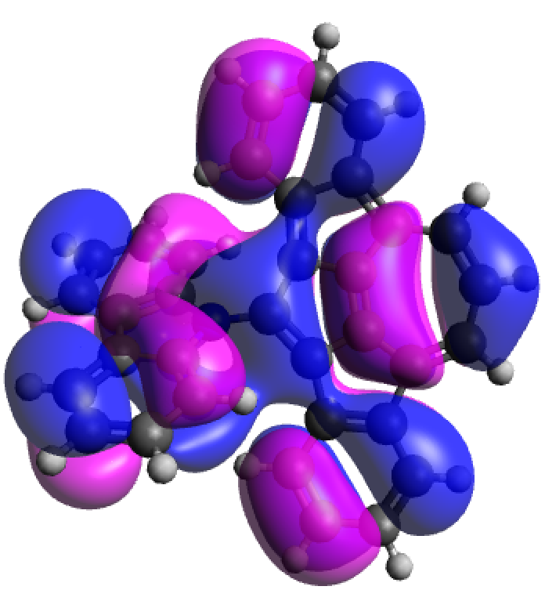 | 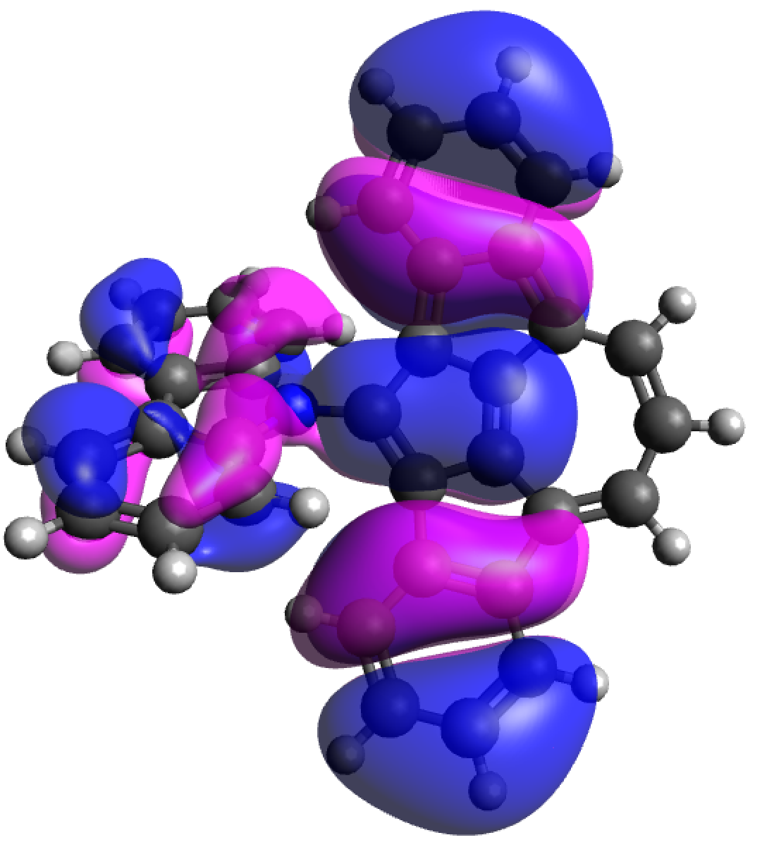

Figure S3. Orbital topology of NB2A1 computed at the CAM-B3LYP/6-31G(d) level of theory.

LUMO + 5 | LUMO + 4 | LUMO + 3
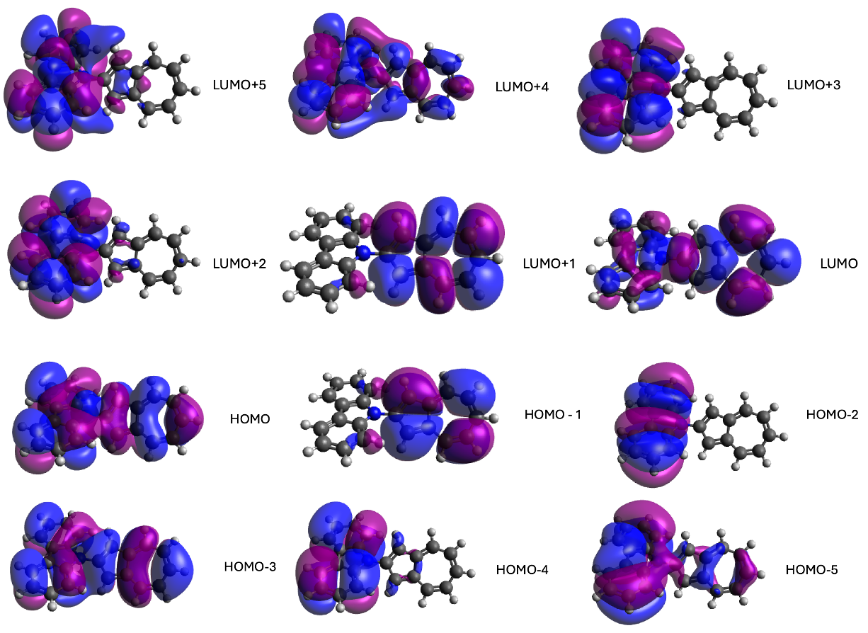
LUMO + 2 | LUMO + 1 | LUMO
HOMO | HOMO - 1 | HOMO - 2
HOMO - 3 | HOMO - 4 | HOMO - 5

Figure S4. Orbital topology of NB0A1 computed at the CAM-B3LYP/6-31G(d) level of theory.

LUMO + 5 | LUMO + 4 | LUMO + 3
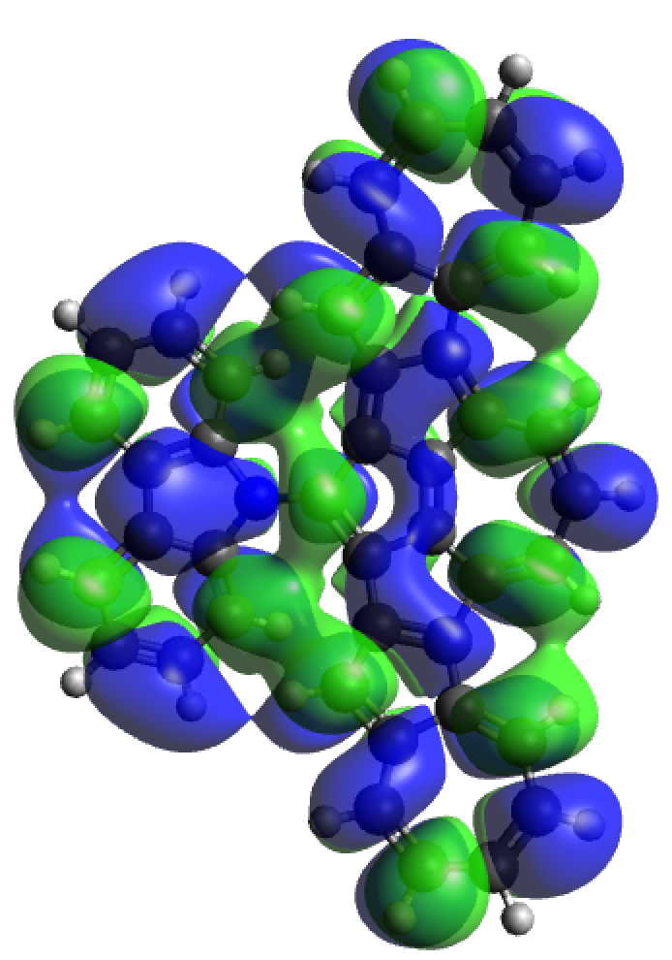 | 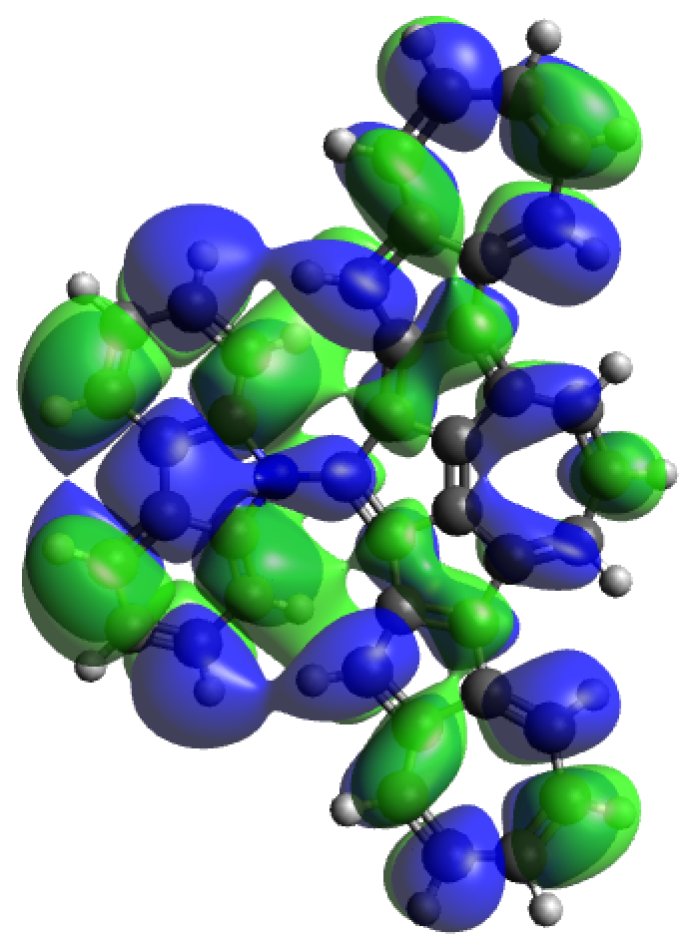 | 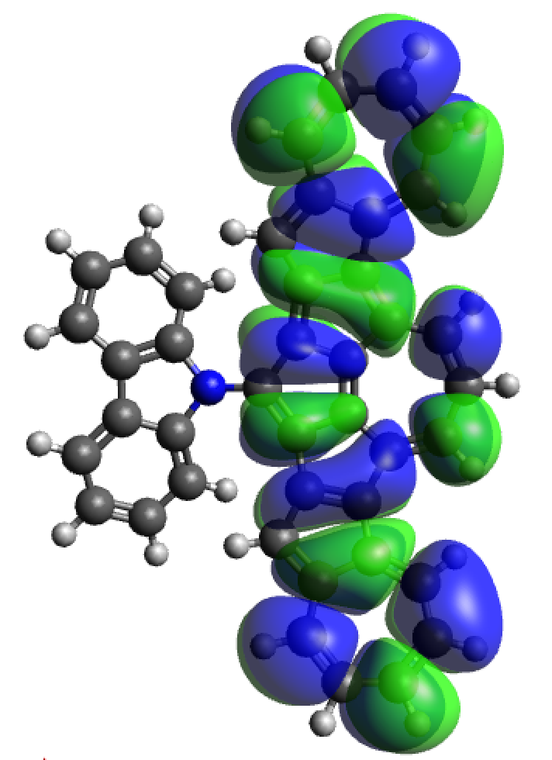
LUMO + 2 | LUMO + 1 | LUMO
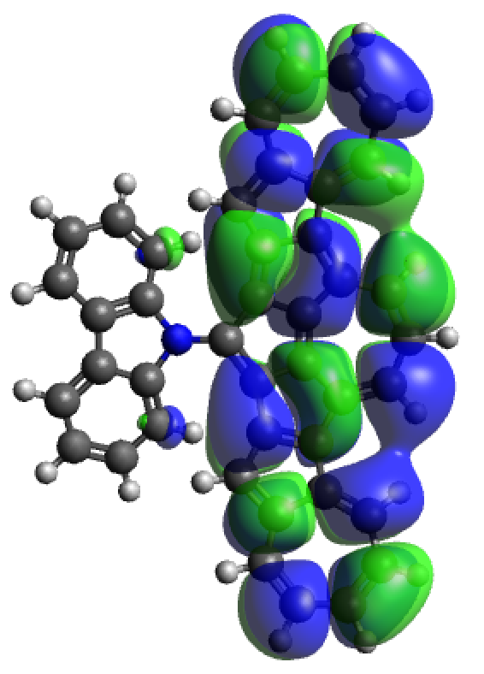 | 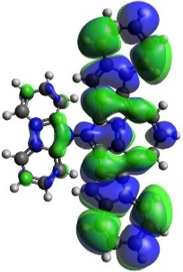 | 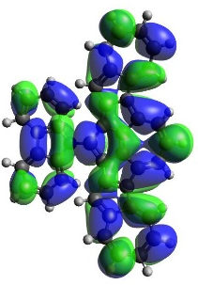
HOMO | HOMO - 1 | HOMO - 2
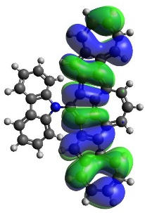 | 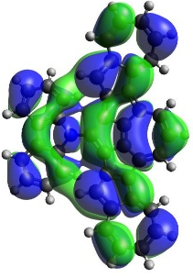 | 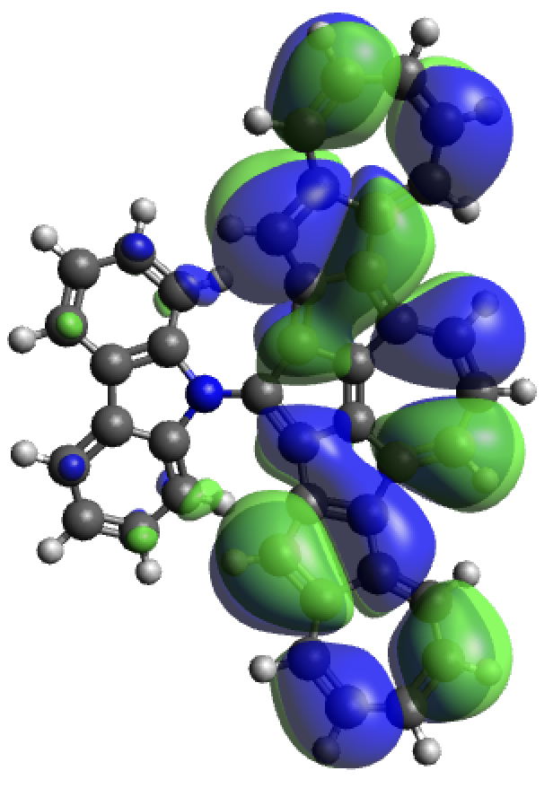
HOMO - 3 | HOMO - 4 | HOMO - 5
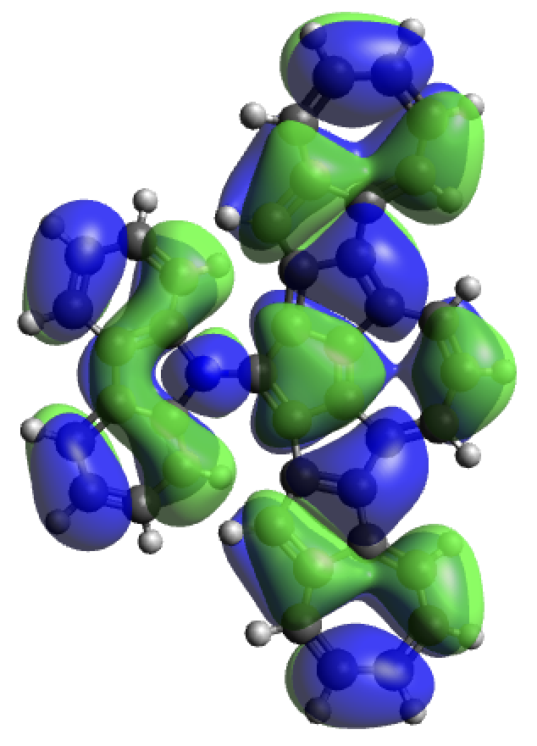 | 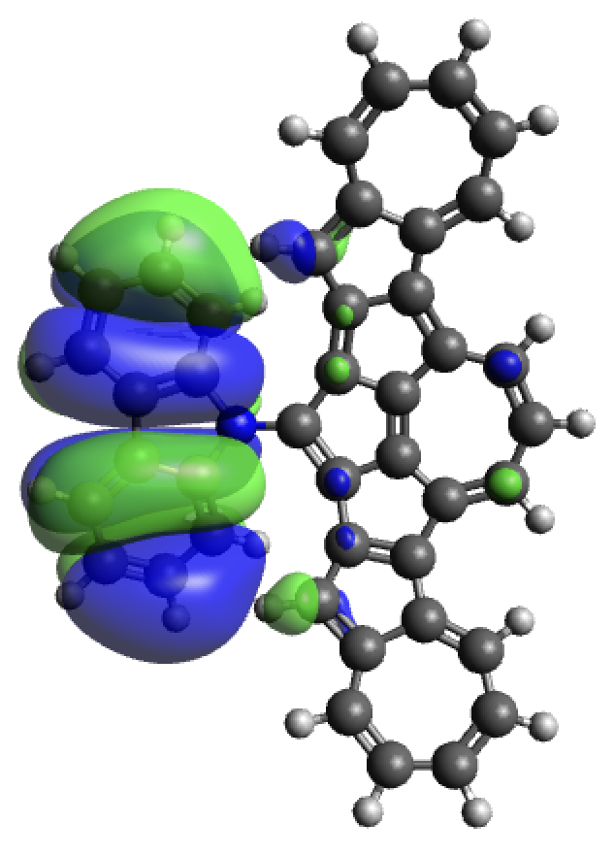 | 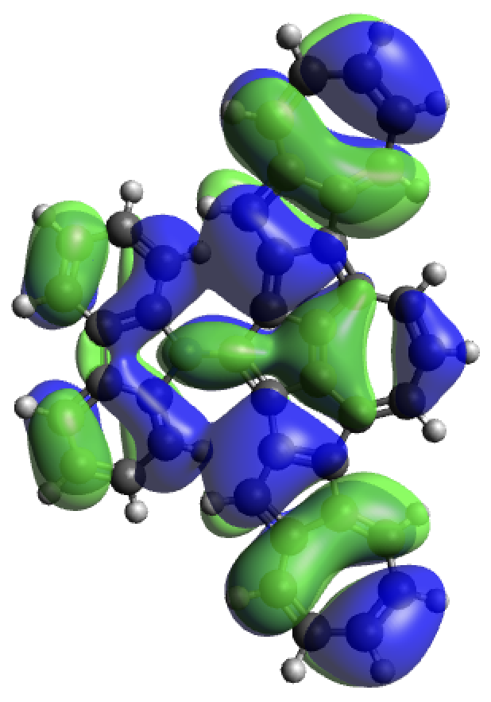

Figure S5. Orbital topology of NB0A3 computed at the CAM-B3LYP/6-31G(d) level of theory.

Exchange-correlation functional benchmark
Motivated by the size of the studied compounds and the complexity of calculations to be performed: vertical electronic transitions, excited state optimizations, singlet-triplet spin-orbit couplings (SOCs), and excited state properties in general, our calculations will rely on the TDDFT methodology within the Tamm-Dancoff approximation (TDA), which provides an optimal compromise between accuracy and feasibility. Moreover, given the nature of the studied compounds, constituted by two conjugated fragments (carbazole and an oligoazulene), we employ the CAM-B3LYP functional, as it includes long-range exact exchange designed to properly describe extended π-conjugated systems and charge-transfer (CT) excitations potentially involved in the low-energy excited states of NB0A1, NB2A1 and NB0A3 molecules.
In order to evaluate the performance and suitability of the method, we compare excitation energies of NB2A1 computed within the TDA and with full TDDFT (RPA). We also compare CAM-B3LYP energies with those obtained with the B3LYP functional (Table S2) and with post-Hartree-Fock wavefunction methods (Table S3).

Table S2. Vertical excitation energies (ΔE in eV, λ in nm), oscillator strengths (f) and orbital composition to the S₁-S₃ states of NB2A1 computed with full TDDFT (RPA) and with TDA with the CAM-B3LYP and B3LYP functionals and the 6-31G(d) basis set.
ΔE λ f composition ΔE λ f composition
Table S3. Vertical excitation energies (ΔE in eV, λ in nm), oscillator strengths (f) and orbital composition to the S₁-S₃ states of NB2A1 computed with post-Hartree-Fock wavefunction methods and the def2-svp basis set.
ΔE λ f comp. ΔE λ f comp. ΔE λ f comp.

The obtained results show that all methods consistently characterize the vertical excitations to S₁-S₃ states with the same orbital transitions. It is worth noticing that CAM-B3LYP (TDA) systematically overestimate excitation energies with respect accurate results, e.g., STEOM-DLPNO-CCSD, but the nature of the transition, state ordering, and relative energies between excited states is well preserved. These results justify the use of the selected methodology for the computational study of NB0A1, NB2A1 and NB0A3 compounds: TDA/CAM-B3LYP/6-31G(d).

Table S4. Vertical excitation energies (ΔE in eV, λ in nm), and oscillator strengths (f) to singlet and triplet excited states of NB2A1 computed with TDDFT (TDA) with the CAM-B3LYP and the 6-31G(d) basis set.
ΔE λ f

TDDFT transitions at the ground state
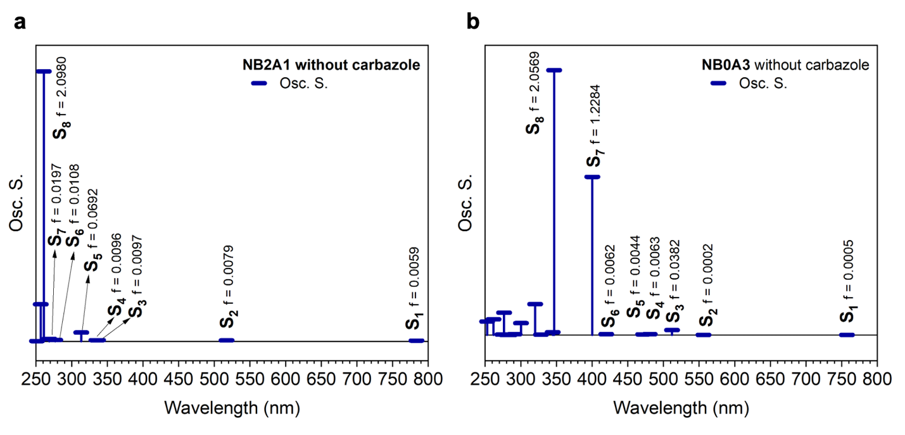
Figure S6. (a) Computed singlet transitions (blue vertical bars) together with the oscillator strengths values (f) (vertical bars are proportional to f) of truncated NB2A1 (without carbazole). (b) Computed singlet transitions (blue vertical bars) together with the oscillator strengths values (f) (vertical bars are proportional to f) of truncated NB0A3 (without carbazole).

The role of the carbazole unit can be observed comparing the predicted transitions in NB2A1 (Figure 2) and in truncated NB2A1, this is, without the carbazole moiety (see S3). Both molecules have been computed at the CAM-B3LYP/6-31G(d) level of theory.
In NB2A1 an electronic transition at 391 nm appears which correspond to the S₀ S₃ transition. This transition is correlated with the bands 464 and 497 nm in the experimental spectrum. The orbital composition of this transition is H-1 L, and both orbitals are extended through both, the azulene part and the carbazole. In contrast, in the modified molecular system there are no transitions in the 350-500 nm region. Only the typical azulene derivatives transitions are observed in the 300 nm region. This clearly demonstrates the critical role of the carbazole in the NB2A1 497 nm band.
An experimental intense absorption band observed at ~300 nm is attributed to the theoretical S₀- S₅ transition computed at 312 nm (f=0.138). It is composed by H-3 L and H L+3 orbitals, with major carbazole-based character. In the truncated system, there are no significant absorption transitions in the 350 nm region, highlighting the essential contribution of this unit at the 300 nm experimental band.

Comparing the NB0A3 transitions and the truncated NB0A3 transitions there are no big differences, and the absorption profile does not change. The carbazole has hardly any influence. These results confirm the azulenic nature of the NB0A3 absorption spectrum.

Emission Spectroscopy
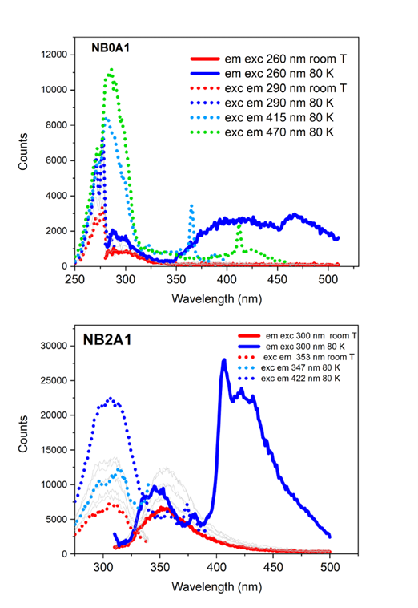
b
a

Figure S7. Temperature dependence of the emission/excitation spectra of (a) NB0A1 and (b) NB2A1.

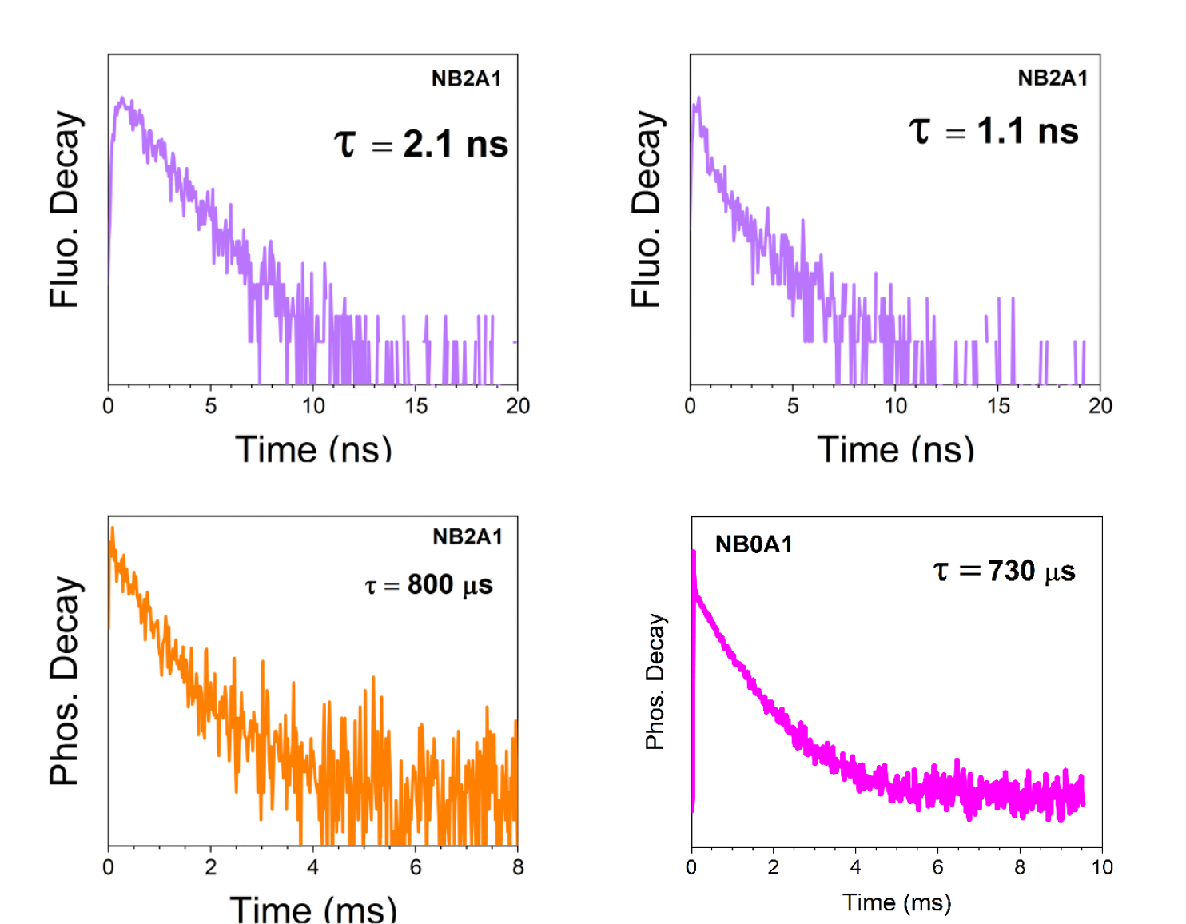
b
d
c
c
a
Figure S8. Emission decay of (a) NB2A1 at room temperature. NB2A1 emission decay at b) short and c) longer timescales at 80 K. NB0A1 emission decay at d) longer timescales at 80 K. The NB0A1 emission decay at shorter wavelength has not been included since there was not a pulse LED suitable for 260 nm excitation.

Excited State Calculations
The computed S₅ optimized state keeping a considerable oscillator strength, is consistent with the to the most intense absorption band observed experimentally at 303 nm (Fig. S7b), attributed to the anti-Kasha fluorescence transition (353 nm). Photoexcitation at 300 nm is proposed to populate S₅, followed by rapid IC and relaxation among the S₄–S₆ states, enabling the formation of the experimentally observed triplet manifold.
ISC is predicted to occur from the minima of these relaxed states, identifying the S₅ T₁₀ and S₆ T₈ transitions as the most efficient ISC channels, owing to their small energy separations and SOCCs. Consequently, ISC from the anti-Kasha S₅ state initially populates high-lying triplets within the T₆–T₁₂ manifold, enabling rapid sequential IC.
The IC is predicted to slow at T₄, which presents a considerable energy gap with T₃. Optimization of T₄ yields a vertical de-excitation energy of 2.67 eV (464 nm), in good agreement with the long-lived phosphorescence observed experimentally at 421 nm (80 K) (Fig. S7b). These results support assigning the anti-Kasha phosphorescence to emission from T_{4.}

Table S5. Singlet-triplet vertical excitation energies (ΔE = E(S_{n}) – E(T_{m}) in meV) and SOCCs (in cm⁻¹) between excited singlet and close-lying triplet states computed at respective excited singlet optimized geometries at the CAM-B3LYP/6-31G(d) level.
singlet triplet ΔE SOCC
S₄ T₆ 176 0.016
T₇ -173 0.026
T₈ -198 0.003
S₅ T₁₀ 41 1.011
T₁₁ 22 0.148
T₁₂ 12 0.005
S₆ T₈ 88 0.759
T₉ 20 0.049
T₁₀ -79 0.122
Note. The labels S₅ and S₆ correspond to the energy ordering computed at the ground-state geometry. Upon optimization of the excited-state geometries, the S₆ state becomes lower in energy than S₅.

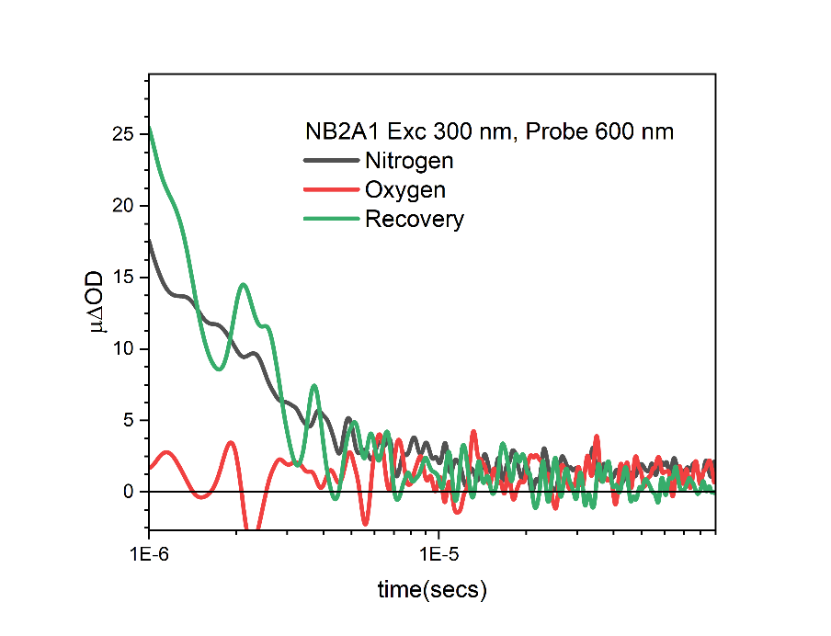
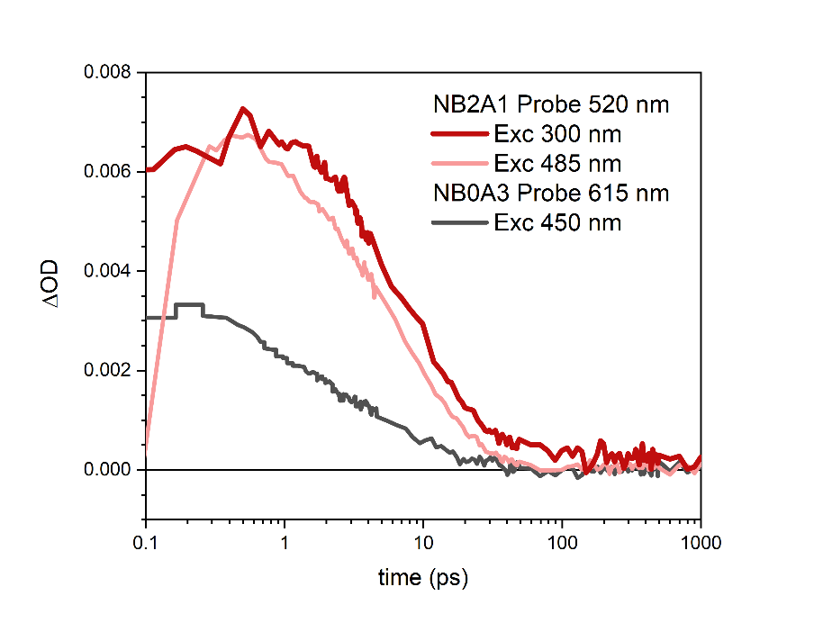
Transient Absorption Spectroscopy
Figure S10. Microsecond transient absorption decay of NB2A1 solution in 2Me-THF under nitrogen atmosphere (black), oxygen (red) and flushed back to nitrogen (green). Decays were obtained exciting at 300 and probed at 600 nm with an excitation density of 80 μJ cm⁻².

Figure S9. Femtosecond transient absorption decays of NB2A1 and NB0A3 solutions in 2Me-THF. NB2A1 decays were obtained probing at 520 nm and exciting at 300 and 485 nm (dark and light red, respectively). NB0A3 decay was obtained probing at 615 nm and exciting at 450 nm (black). Decays were obtained exciting at an excitation power of 0.25 mW.

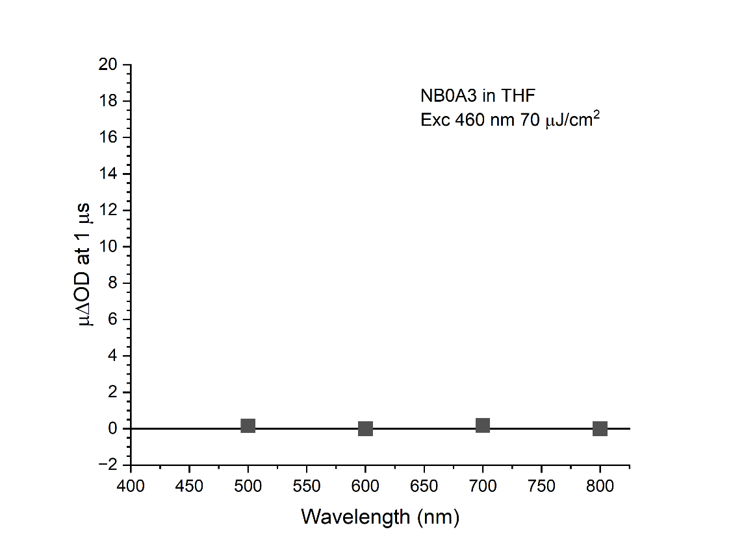
Figure S11. Microsecond transient absorption decay of NB0A3 solution in 2Me-THF exciting at 460 nm with an excitation density of 70 μJ cm⁻². The scale has been chosen to be the same used for the microsecond TA spectrum of NB2A1 in Figure 3.

NMR and Mass Spectrometry
Figure S12. ¹H-NMR spectrum of NB2A1 (500 MHz, CD₂Cl₂, rt).
Figure S13. ¹³C-NMR spectrum of NB2A1 (126 MHz, CD₂Cl₂, rt).
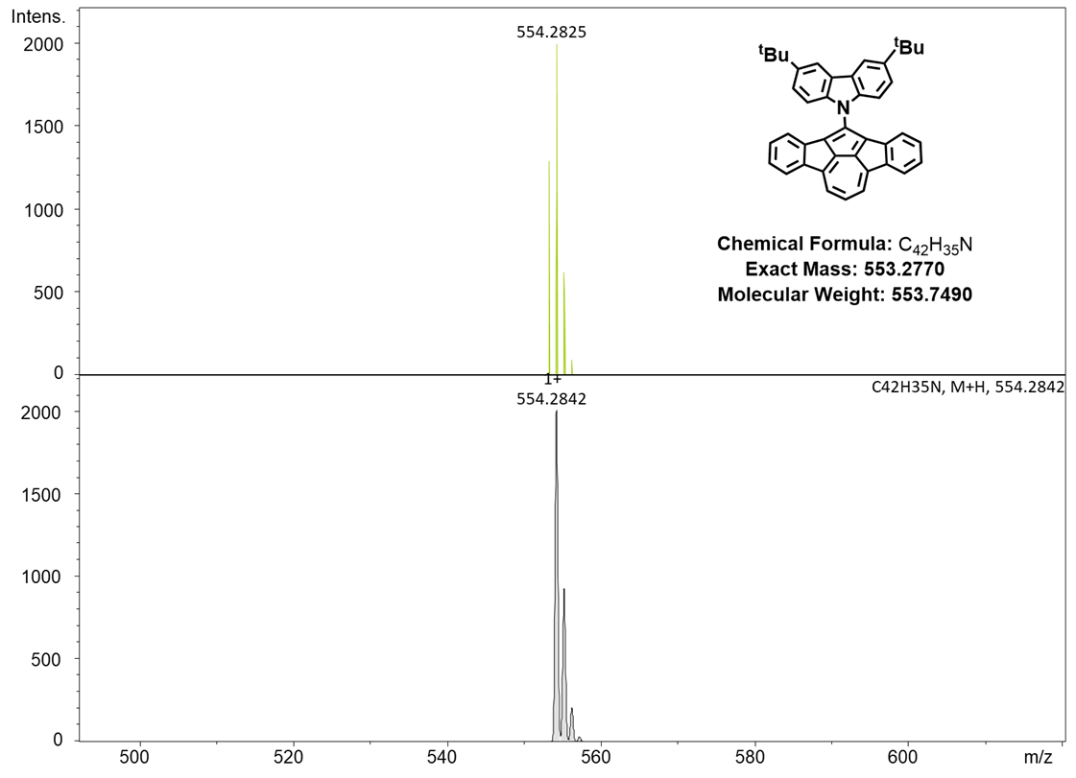
Figure S14. HR-MS (ESI) spectrum of NB2A1 (up: experimental; down: simulated).

Figure S15. ¹H-NMR spectrum of 4 (500 MHz, THF-d8, rt).
Figure S16. ¹³C-NMR spectrum of 4 (126 MHz, THF-d8, rt).
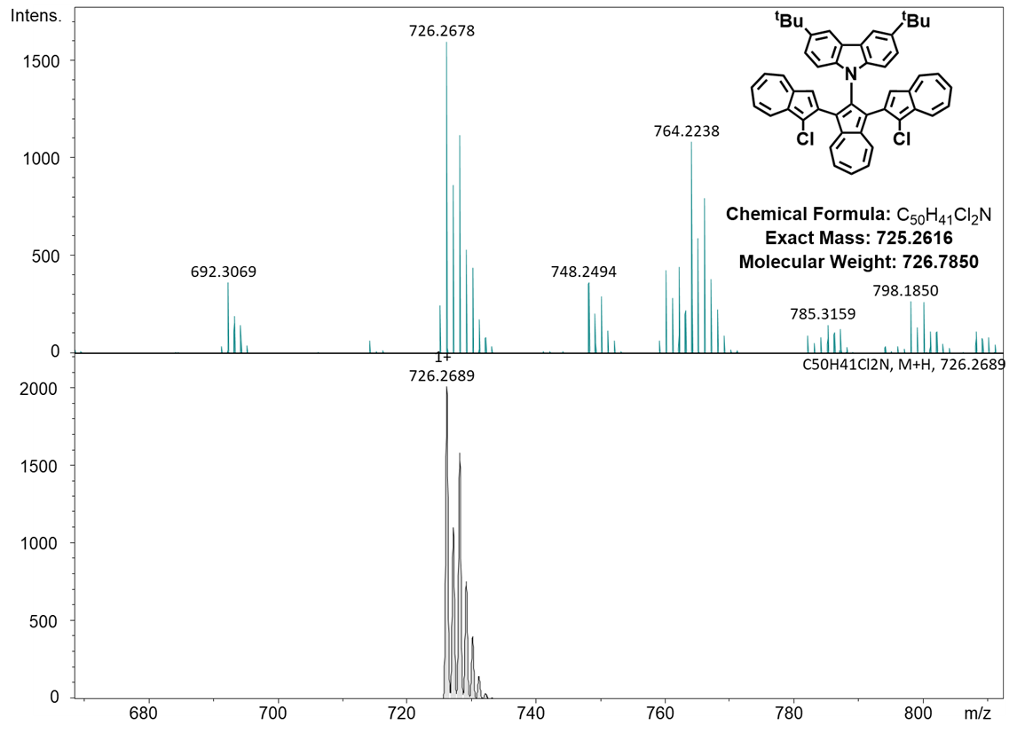
Figure S17. HR-MS (ESI) spectrum of 4 (up: experimental; down: simulated).

Figure S18. ¹H-NMR spectrum of NB0A3 (600 MHz, THF-d8, rt).
Figure S19. ¹³C-NMR spectrum of NB0A3 (151 MHz, THF-d8, rt).
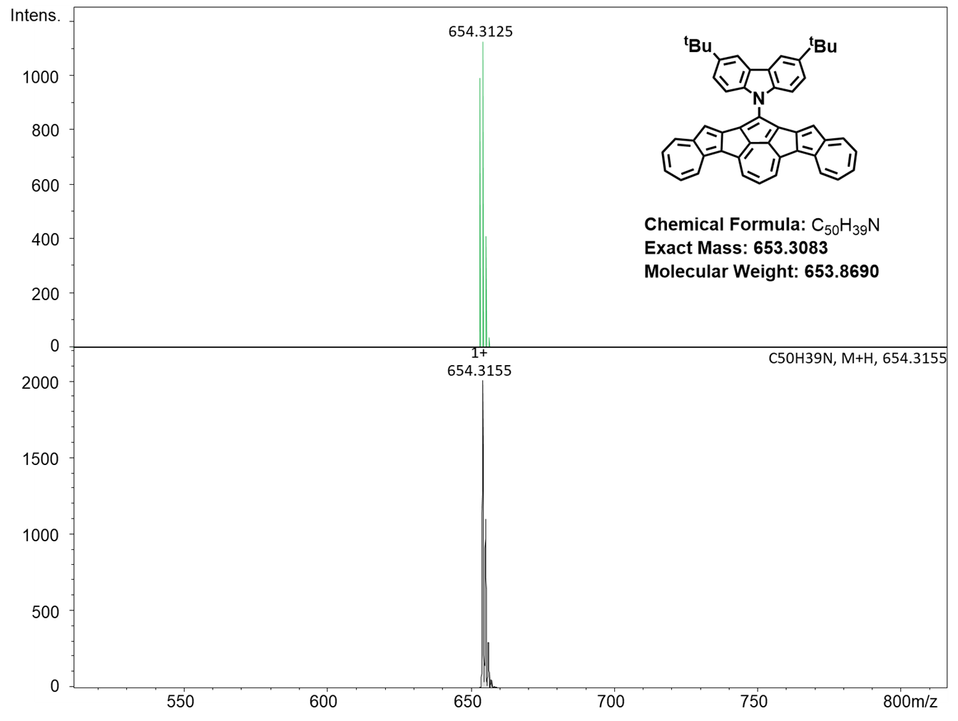
Figure S20. HR-MS (ESI) spectrum of NB0A3 (up: experimental; down: simulated).

References:
[1] C. Wang, Z. Deng, D. L. Phillips, J. Liu, Angew. Chem. Inter. Ed. 2023, 62, e202306890.
[2] S. Budavari, M.J. O'Neil, A. Smith, P. E. Heckelman, The Merck Index, an Encyclopedia of Chemicals, Drugs, and Biologicals-Eleventh Edition, Merck Co., Inc. Rahway, NJ, 1989.

