Supporting Information for

“Military expenditure associated with substantial material intensification of the global economy”

General Information

Global Military Expenditure 1988-2024
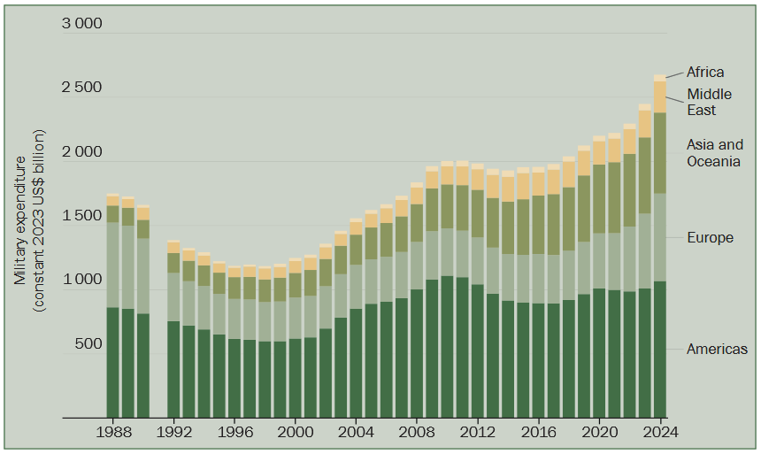
Figure 1: Military Expenditure 1988-2024
Source: (Liang et al., 2025)

Results

Association of MILEX ratio and non-biomass material intensity
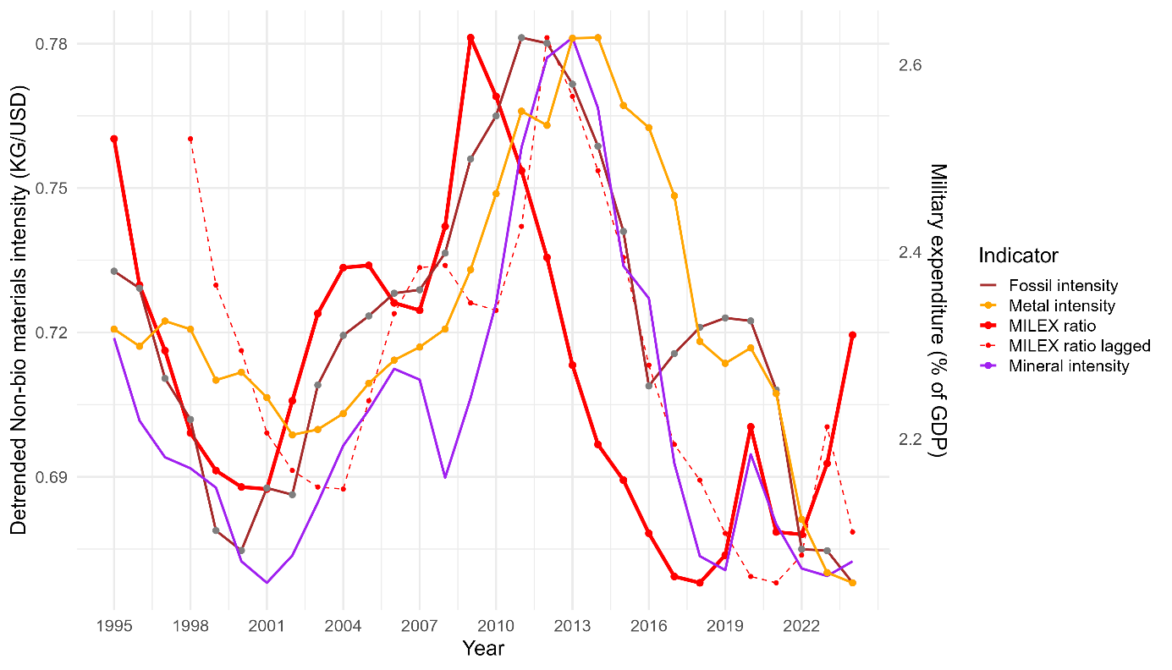
Figure 2: Association of MILEX Ratio and Non-biomass material intensity | Solid thick red: MILEX ratio; dashed thin red: 3-year lagged MILEX; solid brown line: fossil material intensity; non-metallic mineral intensity ; solid orange line: metal intensity (all intensities detrended and scaled on non-biomass intensity).

Regression Plot: MILEX ratio and Material Footprint
Although not an objective of this study which focusses on material intensity i.e. material per unit of the GDP measured in Kg/USD, as indicated in the manuscript, following plot shows a positive association between MILEX ratio and total material footprint (time series: 1995-2024)
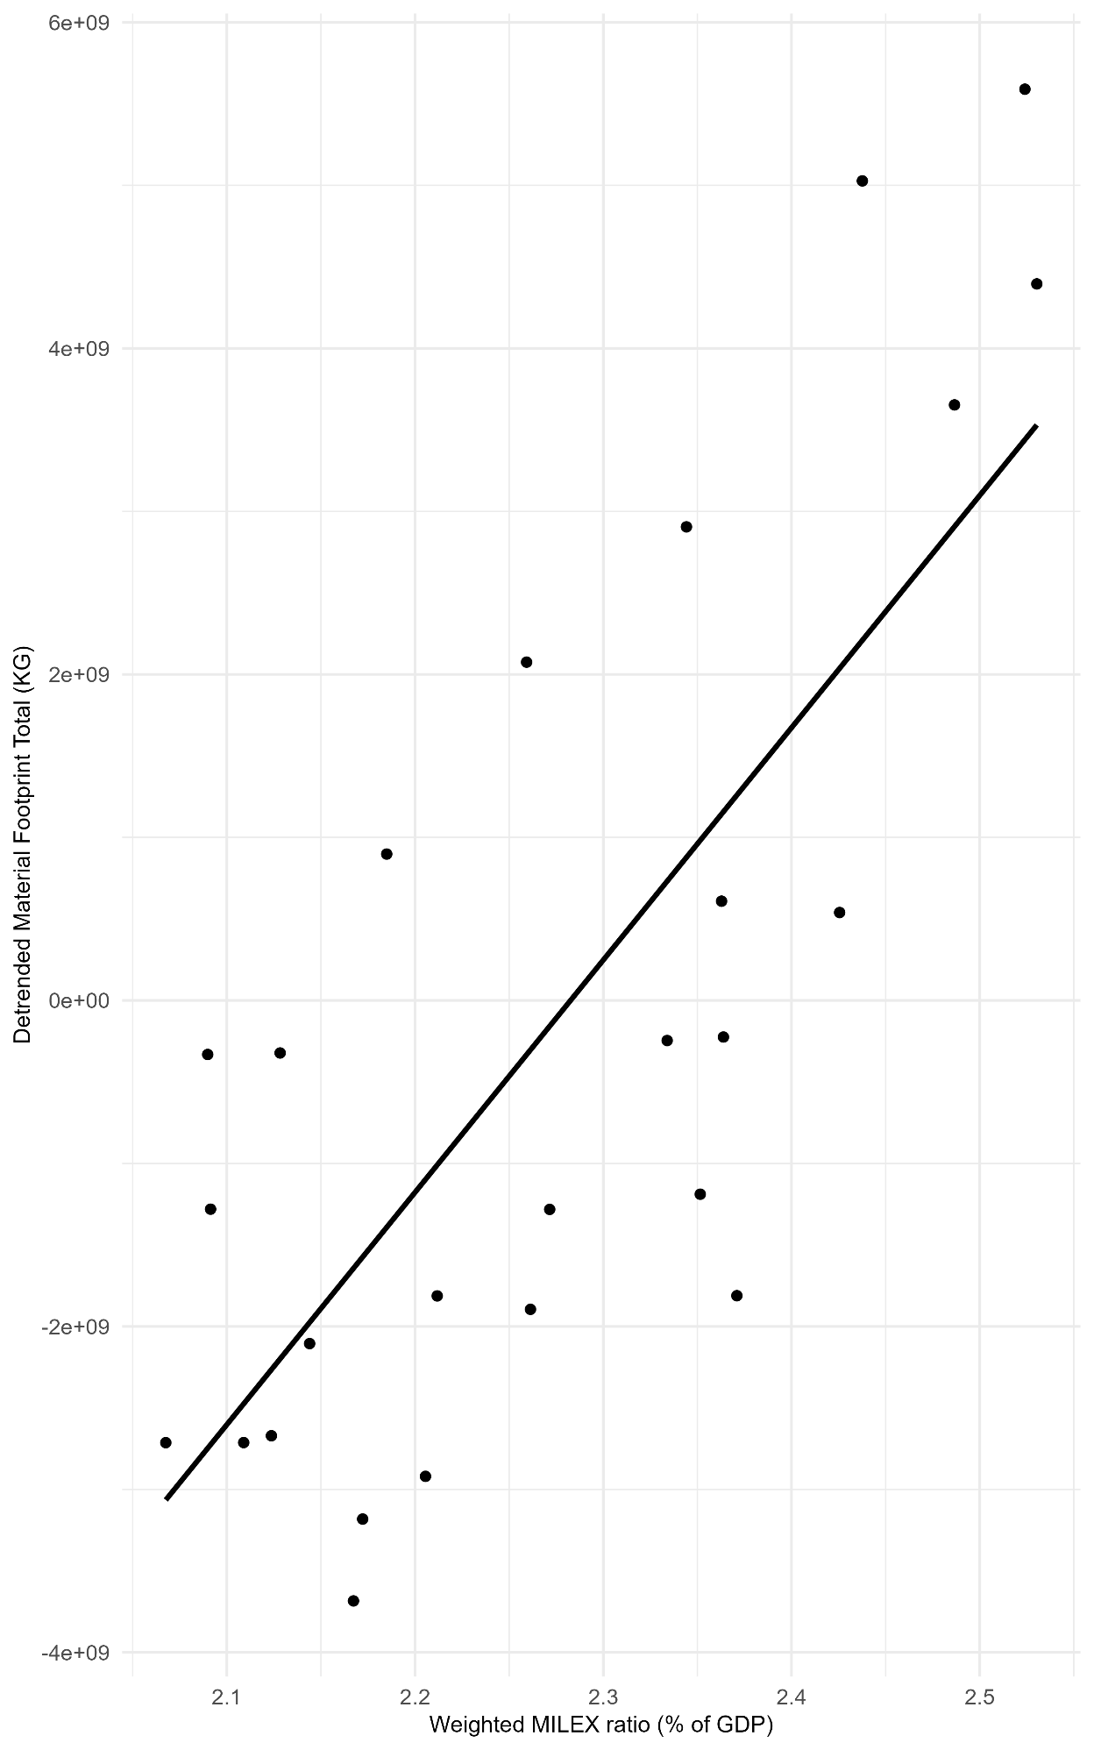
Figure 3: Regression Plot for Detrended Total Material Footprint

Methods

GDP Deflation
Not consequential for correlation and regression but results in different baseline values (e.g. MILEX ratio for 2024 is 2.77 % without deflation and 2.31% after adjusting for deflation). Therefore, for estimating projected values for 2035, GDP is deflated.
Although available at the individual country levels, it was not possible to find publicly available database of GDP deflator (R) for the time series 2015-2022 at the global level. Secondary data from Index mundi for 2015-2020 (Index Mundi, n.d.), projected till 2022, gives a value of 1.197824. This was cross-checked against value for the US (from the world bank database (World Bank, n.d.)).
Method 1(Global data from Index Mundi):
calculated as
$$R= \sum_{t=2015}^{2022}{1+{(Inflation_rate)}_{t}}$$
R = 1.19782365028093296111
Method 2(US data): WB database -> filter WB_WDI_NY_GDP_DEFL_ZS on country US - pick data from the column OBS_VALUE
calculated as
$$R= \frac{{Deflator}_{2022}}{{Deflator}_{2015}}$$
2015 Ratio for US: 97.3158875215682
2022 Ratio for US: 118.026303631687
R = 1.212816392447006563771
Method 1 used in the Analysis for hypothetical estimates

Robustness Checks

Goldfeld-Quandt test
Model | df1 | df2 | p-value
Aggregate intensity (Mat) | 11 | 11 | 0.30
Non-biomass intensity (NonBio) | 11 | 11 | 0.50
P-value is greater than 0.05. Therefore, no evidence of Heteroskedasticity for both models as confirmed graphically below.
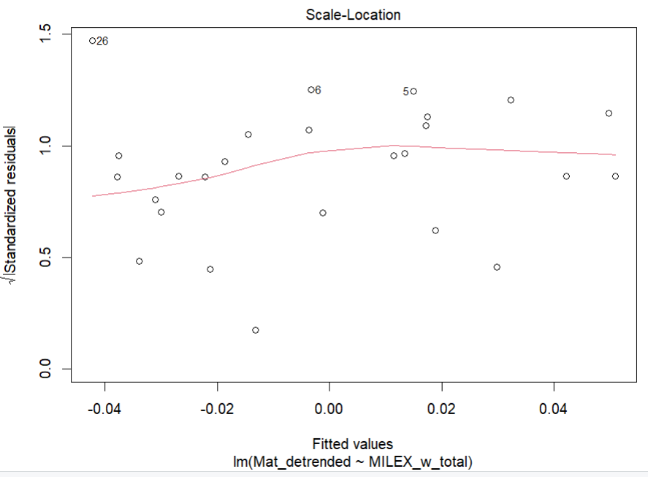
Figure 4: Plot of residual vs fitted values for Aggregate Material Intensity Model

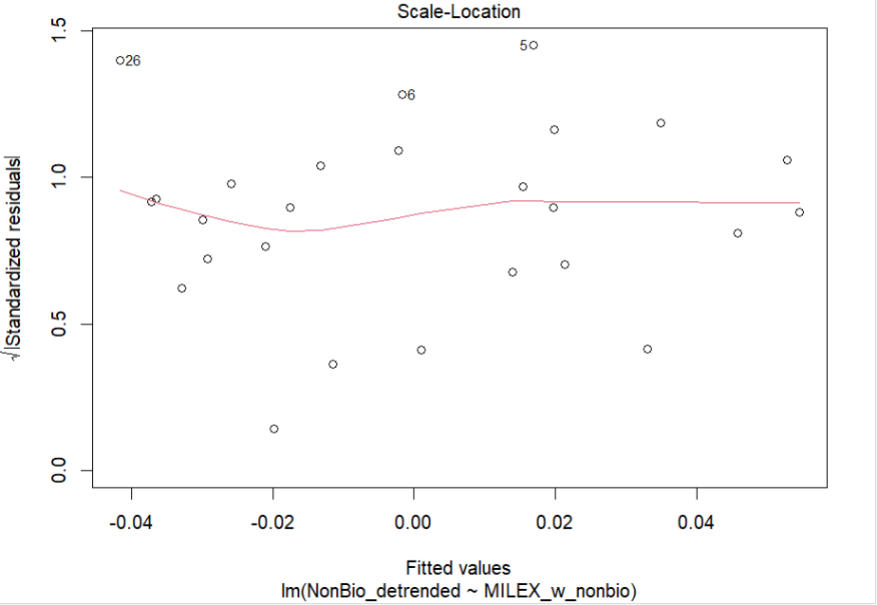
Figure 5: plot of residual vs fitted values for Non-bio material intensity model

References
Becker, J., Benson, S., Dunne, J. P., & Malesky, E. (2025). Disaggregated defense spending: Introduction to data. Journal of Peace Research, 62(3), 772–788. https://doi.org/10.1177/00223433231215785
Index Mundi. (n.d.). World—Inflation, GDP deflator (annual %) [Data set]. Retrieved 8 December 2025, from https://www.indexmundi.com/facts/world/indicator/NY.GDP.DEFL.KD.ZG
Liang, X., Tian, N., Diego Lopes da Silva, Scarazzato, L., Karim, Z. A., & Jade Guiberteau Ricard. (2025). Trends in World Military Expenditure, 2024. SIPRI. https://doi.org/10.55163/AVEC8366
World Bank. (n.d.). GDP deflator (base year varies by country) [Data set]. Retrieved 8 December 2025, from https://data360.worldbank.org/en/indicator/WB_WDI_NY_GDP_DEFL_ZS

