Supplemental Figure S1
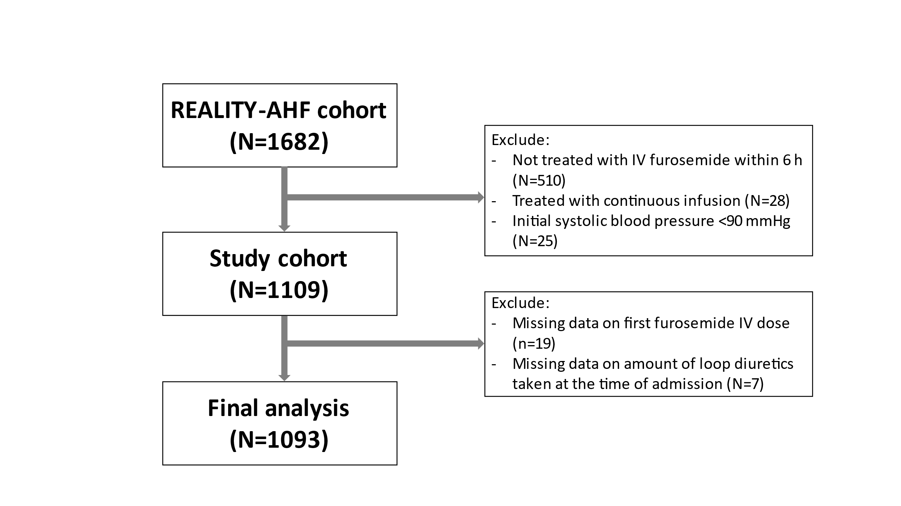

Supplemental Figure S1. A participant selection flow chart of the study

