Gradient Copolymerization towards High-performance Monocomponent Polymers for Energy and Charge Storages

Yuanwei Zhu¹, Wanlong Lu¹, Nan Qiao¹, Huize Cui¹, Zhipeng Hu^{1,3}, Zichao Shen¹, Jinde Yu¹, Bo Liu²*, Shuwen Zhang⁴, Yongjie Nie⁵, Guochang Li⁶, Shengtao Li¹*, Guanghao Lu¹*

Supplementary information

Table S1 | Copolymerization of ethylene and styrene catalyzed by complex 1 under various initial concentration of styrene.ª
copolymer | E  /atm | [St]₀  /mol·L^{–1} | Time  /min | Yield  /g | f_{St}  / mol%^{b} | M_{n}  ×10^{-4c} | PDI^{c}
PESt15 | 1 | 0.20 | 15 | 3.6 | 14.7 | 4.2 | 3.7
PESt37 | 1 | 0.40 | 15 | 4.3 | 36.7 | 32.2 | 1.3
PESt59 | 1 | 1.50 | 9 | 4.7 | 59.2 | 65.2 | 1.6
ª1: 20 μmol, 1:[Ph₃C][B(C₆F₅)₄]:Al^{i}Bu₃ = 1:1:2, toluene: 75 mL, temperature: 40 °C. ^{b} Determined by ¹H NMR spectrum in C₂D₂Cl₄ at 110 °C (f_{St} = 4A_{ar}/(5A_{al} + A_{ar})×100%, where A_{ar} = area of aromatic protons and A_{al} = area of aliphatic protons). ^{c} Determined by GPC in 1,2,4-trichlorobenzene at 150 °C against polystyrene standard.

Table S2 | Kinetic study of co-polymerization of ethylene and styrene catalyzed by 1.ª
Entry | Time  /min | Yield  /g | f_{St}  / mol%^{b} | M_{n}  ×10^{-4c} | PDI^{c}
1 | 2 | 0.60 | 59.7 | 25.1 | 2.6
2 | 5 | 0.89 | 58.0 | 51.2 | 1.6
3 | 15 | 1.71 | 50.3 | 56.8 | 1.7
6 | 40 | 2.08 | 40.8 | 60.5 | 1.7
ª1: 10 μmol, 1:[Ph₃C][B(C₆F₅)₄]:Al^{i}Bu₃ = 1:1:2, [St]₀ = 0.45 /mol·L^{–1}, toluene: 35 mL, ethylene: 1 atm, temperature: 40 °C. ^{b} Determined by ¹H NMR spectrum in C₂D₂Cl₄ at 110 °C (f_{St} = 4A_{ar}/(5A_{al} + A_{ar})×100%, where A_{ar} = area of aromatic protons and A_{al} = area of aliphatic protons). ^{c} Determined by GPC in 1,2,4-trichlorobenzene at 150 °C against polystyrene standard.

Table S3 | Performance of C12-BTBT/PS and C12-BTBT/PESt OFET on 10 devices
 | C12-BTBT/PS | C12-BTBT/ PESt15 | C12-BTBT/ PESt37 | C12-BTBT/ PESt59
μ_{max} | 12.3 | 9.8 | 11.8 | 14.2
μ_{average} | 11.2 | 8.7 | 10.1 | 12.8
I_{on}/I_{off} (average) | 3×10⁶ | 3×10⁵ | 5×10⁵ | 2×10⁶
V_{th-average} | -28 | -36 | -33 | -26

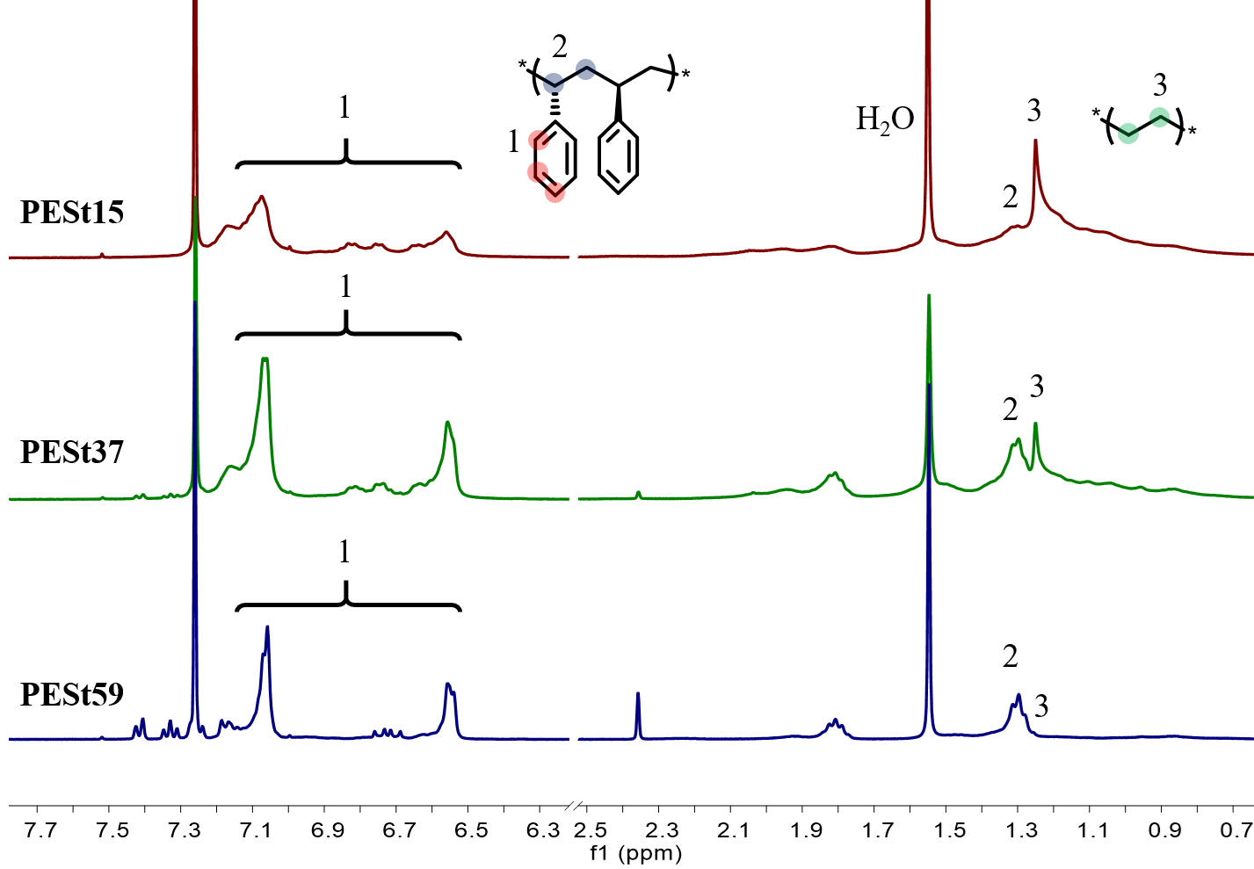
Figure S1 | The ¹H NMR spectra of PESt (PESt15, PESt37 and PESt59).

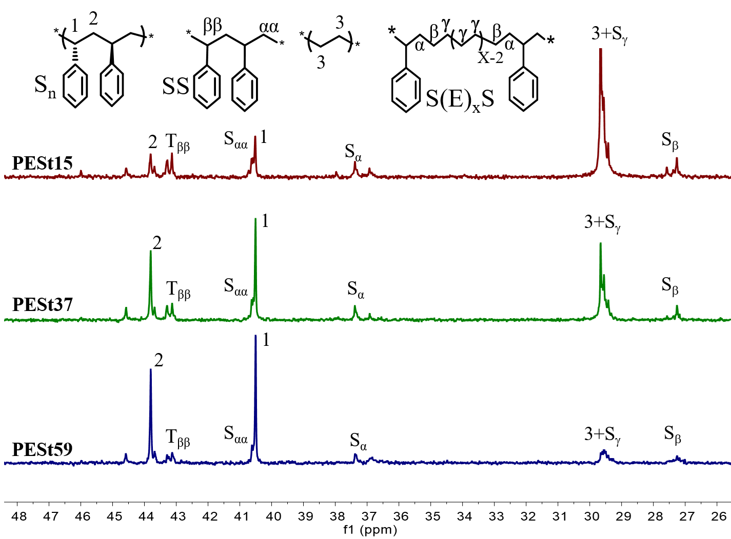
Figure S2 | The ¹³C NMR spectra of PESt (PESt15, PESt37 and PESt59).

b
a
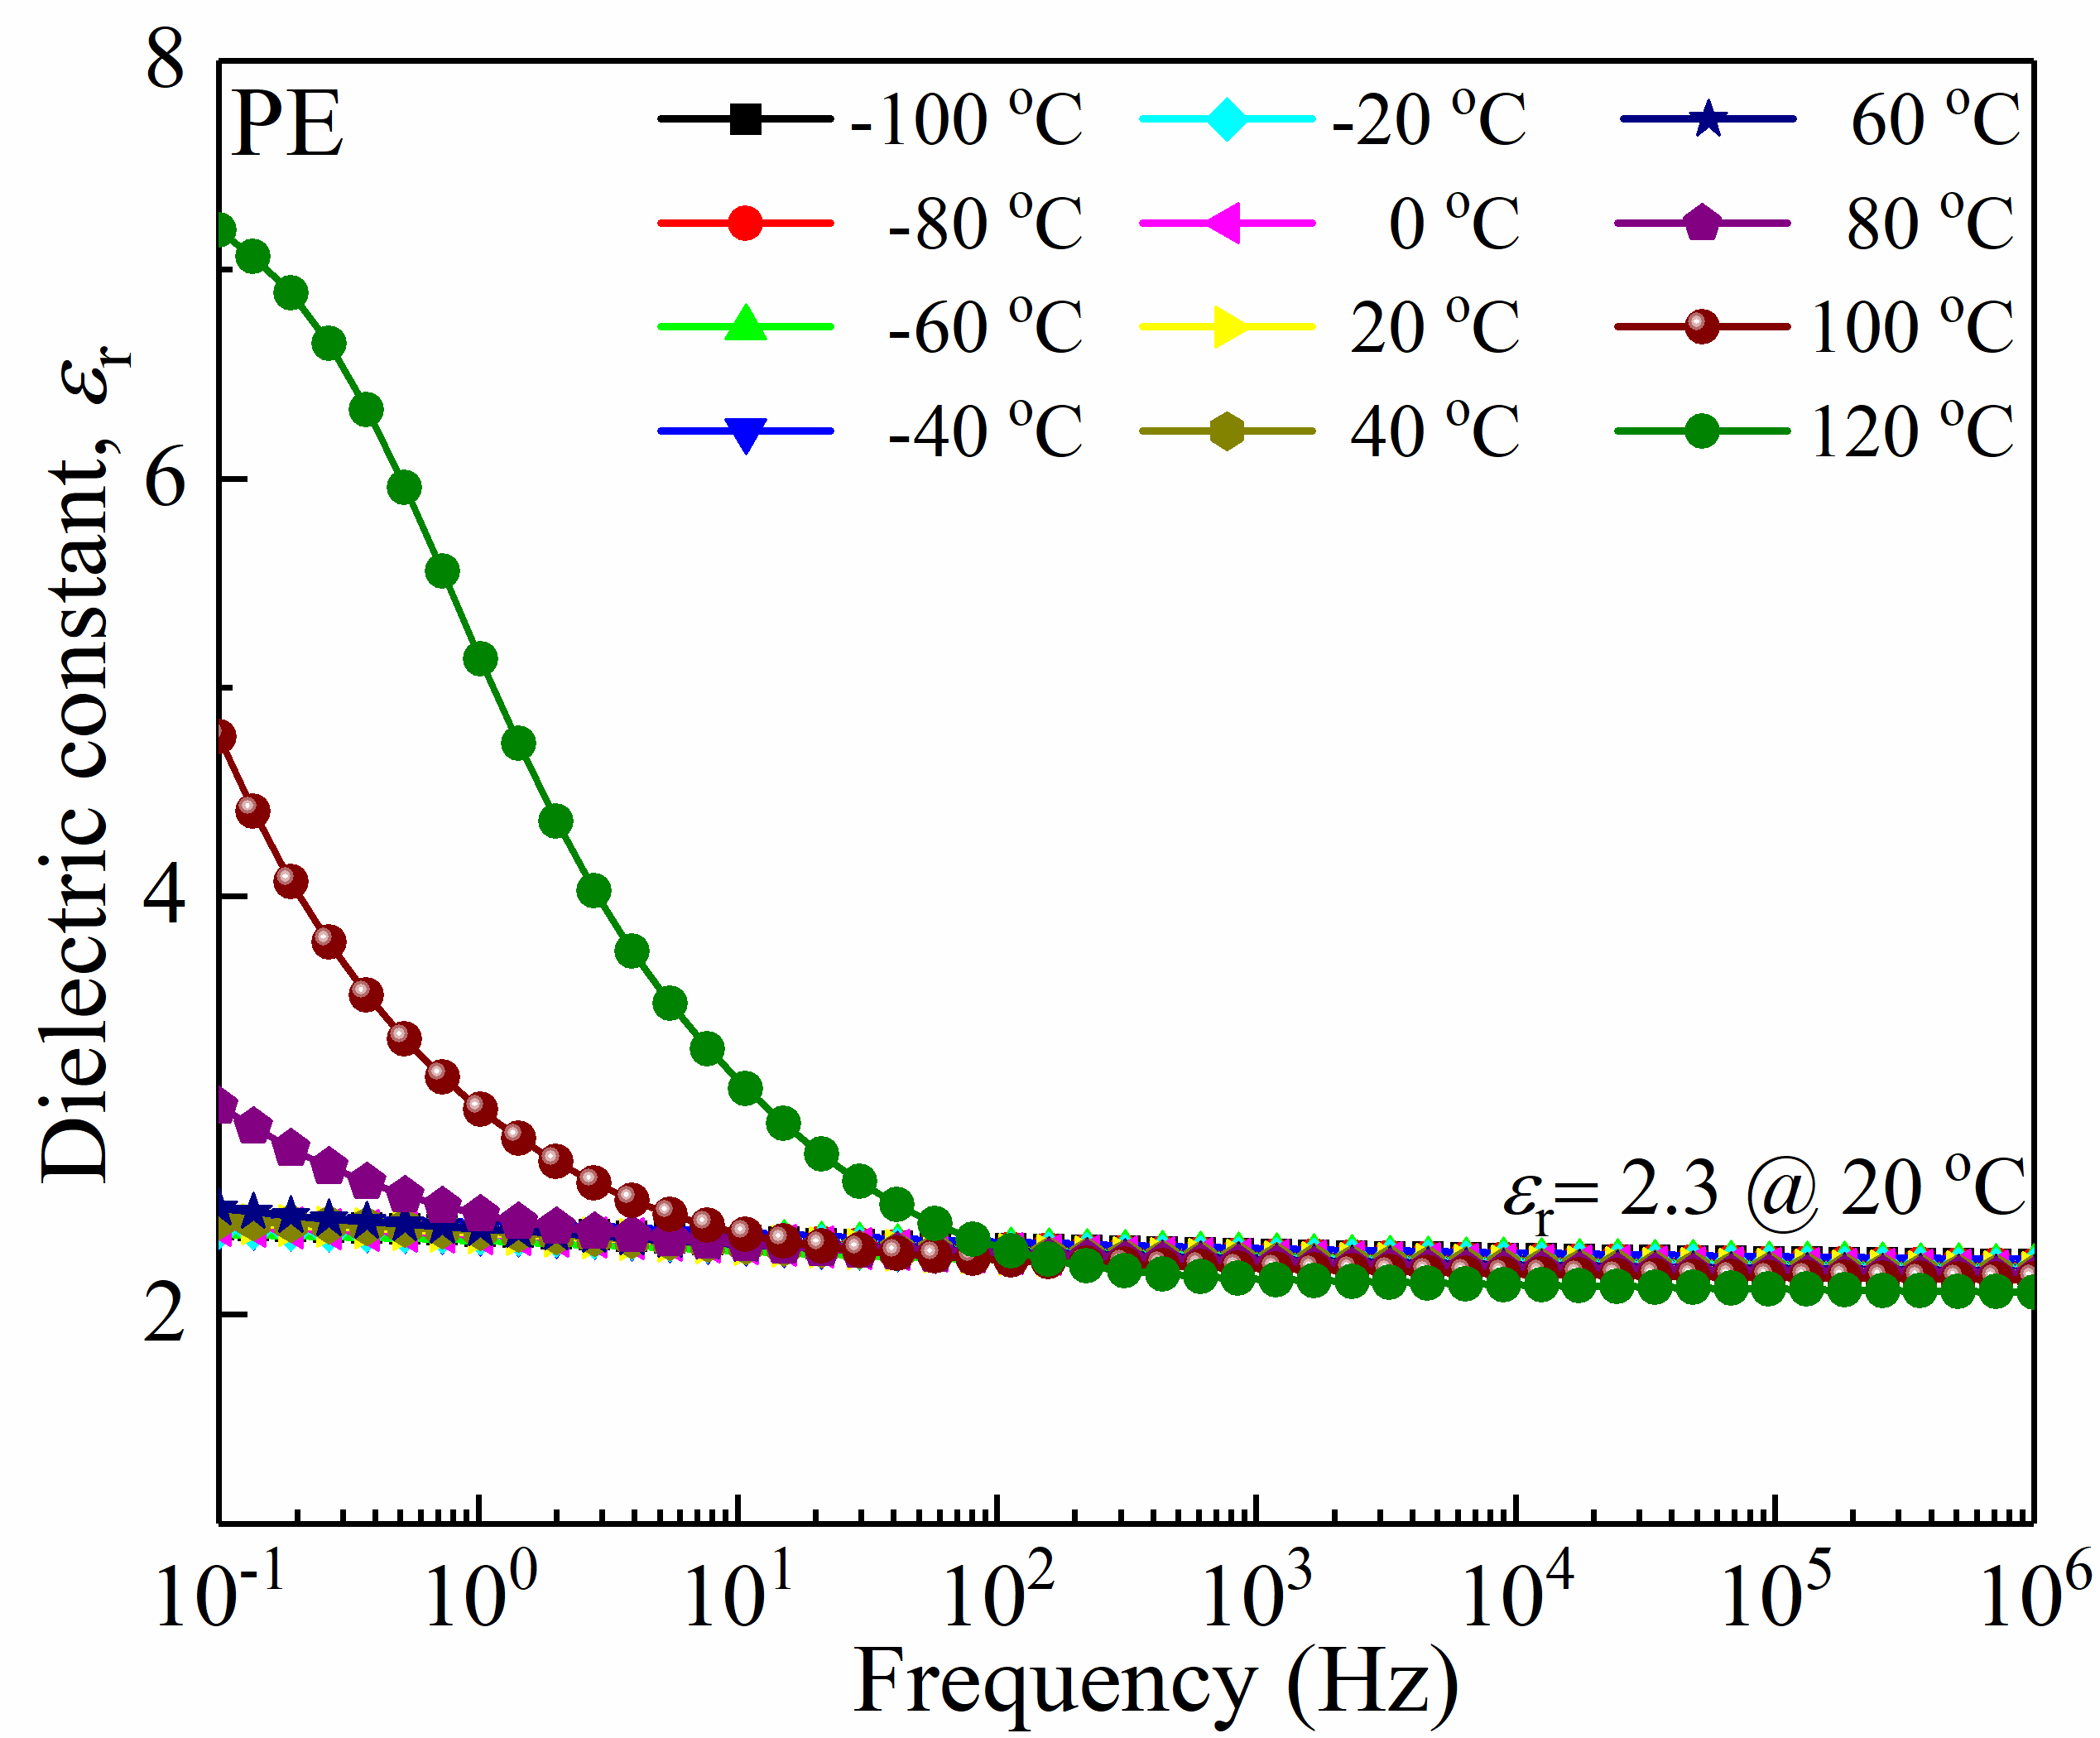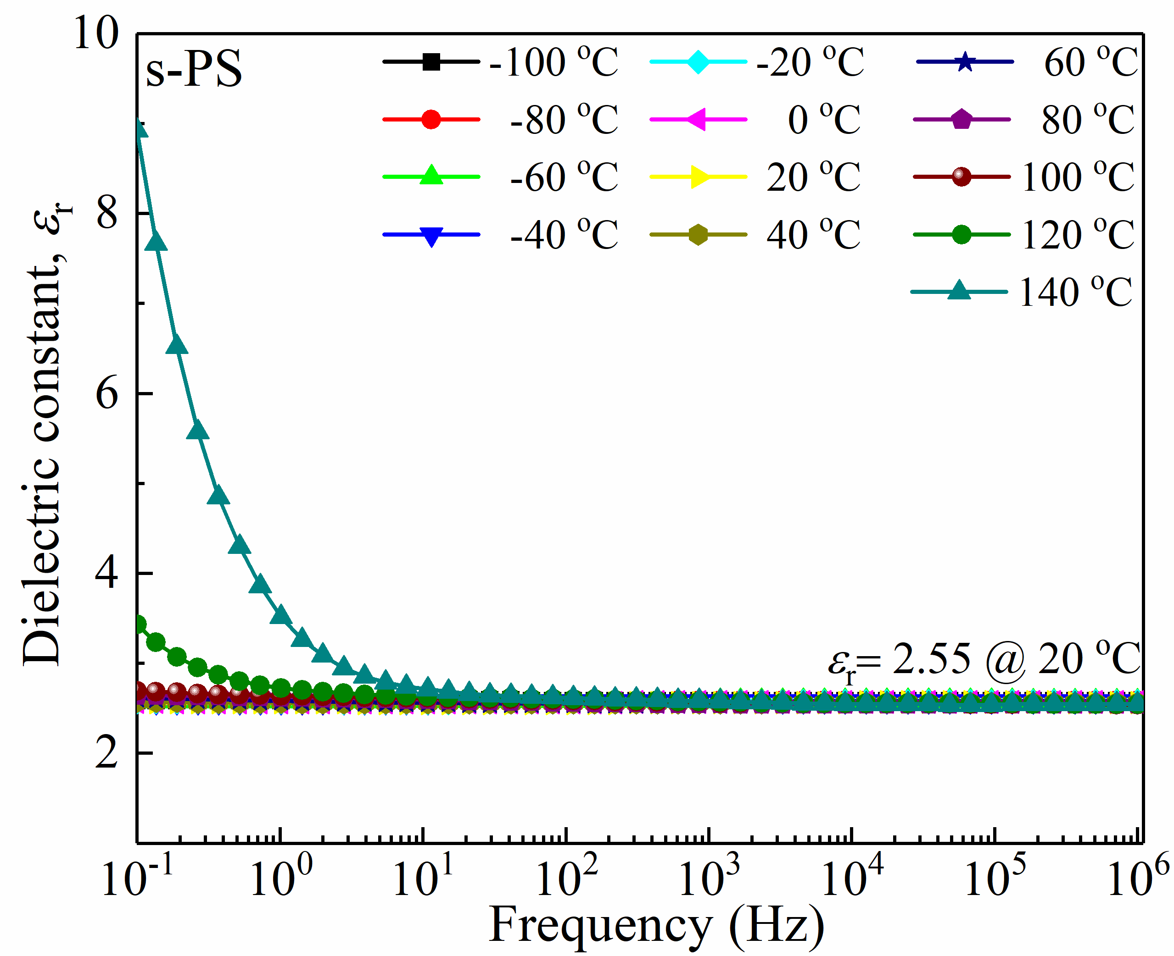
Figure S3 | Frequency dependent dielectric spectra of a) PE and b) s-PS.

a
c
b
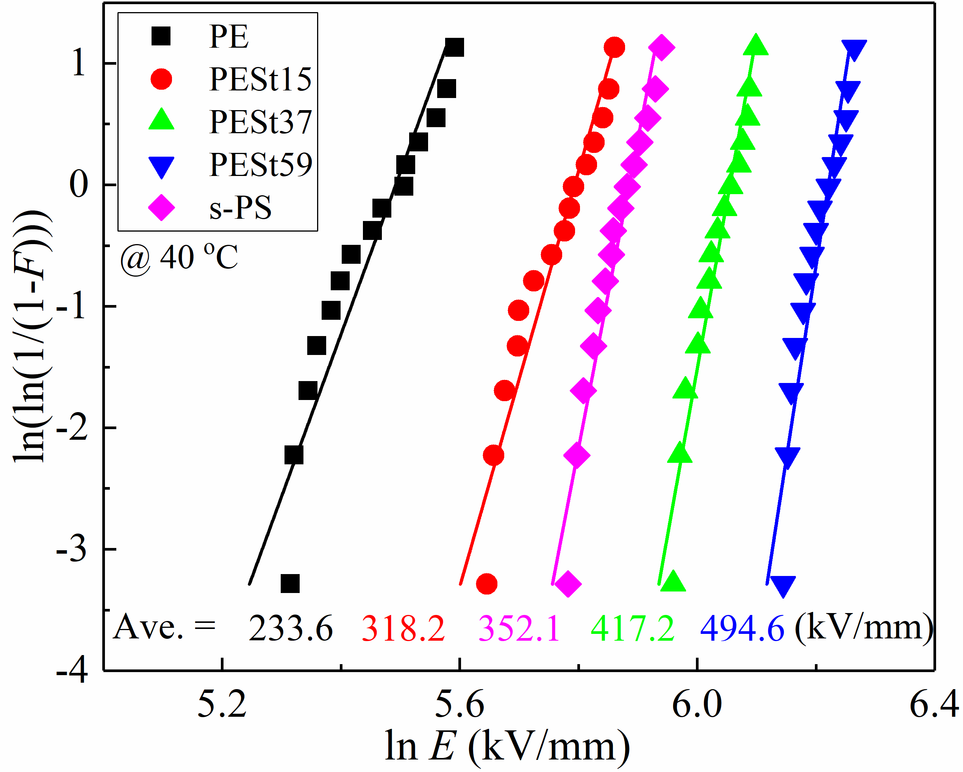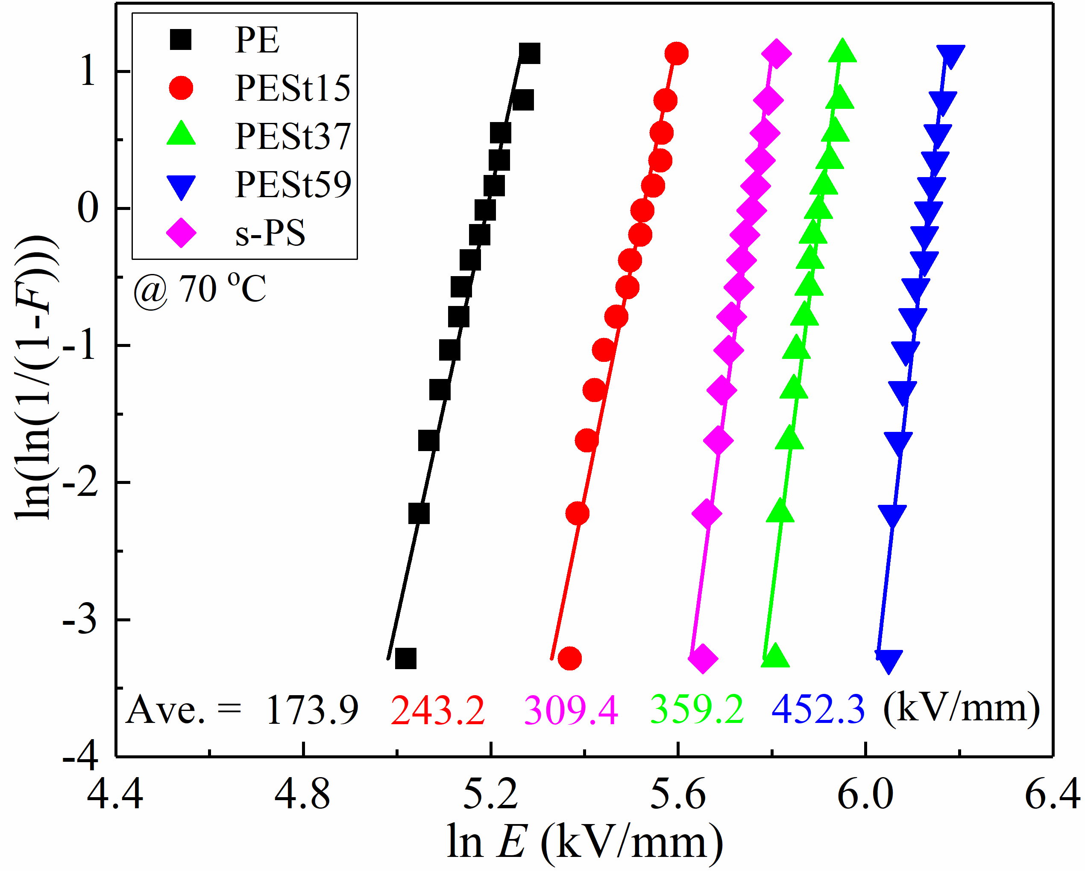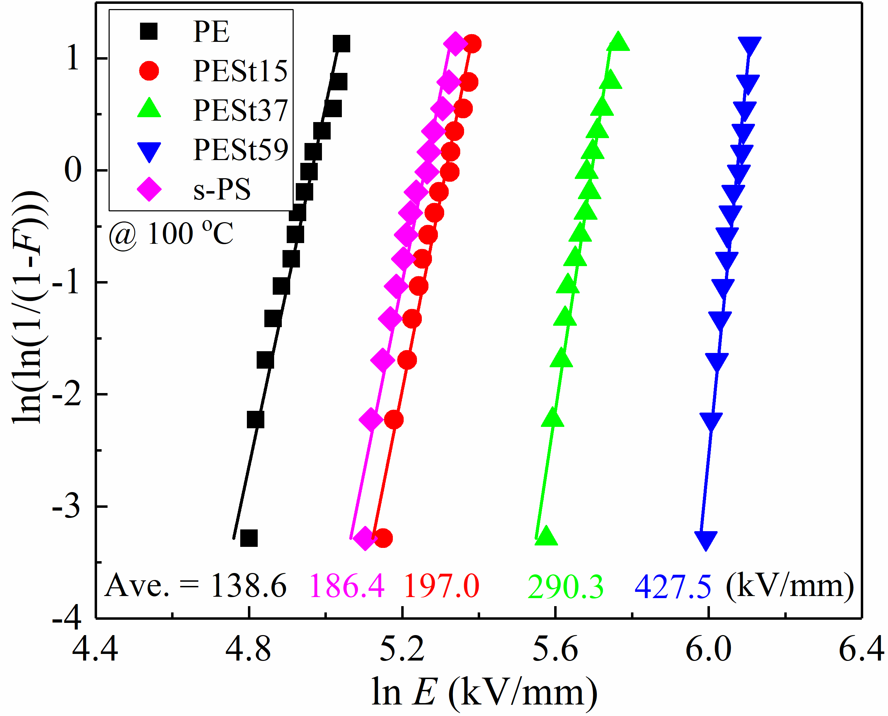
Figure S4 | Weibull distributions of DC breakdown strength of PE, PESt15, PESt37, PESt59 and s-PS at a) 40 ºC, b) 70 ºC c) 100 ºC on 15 samples.
a
b
c
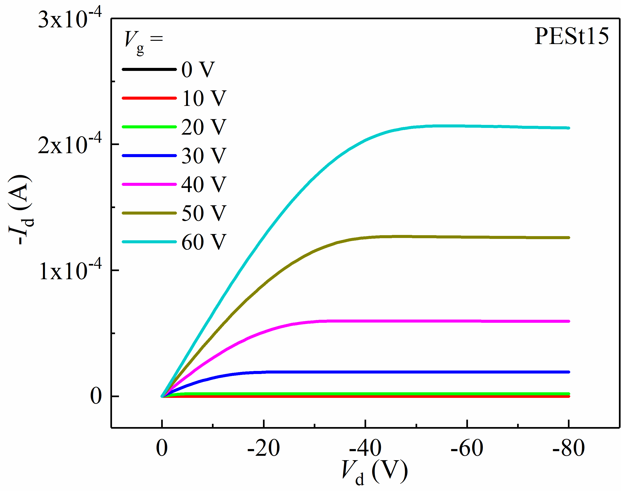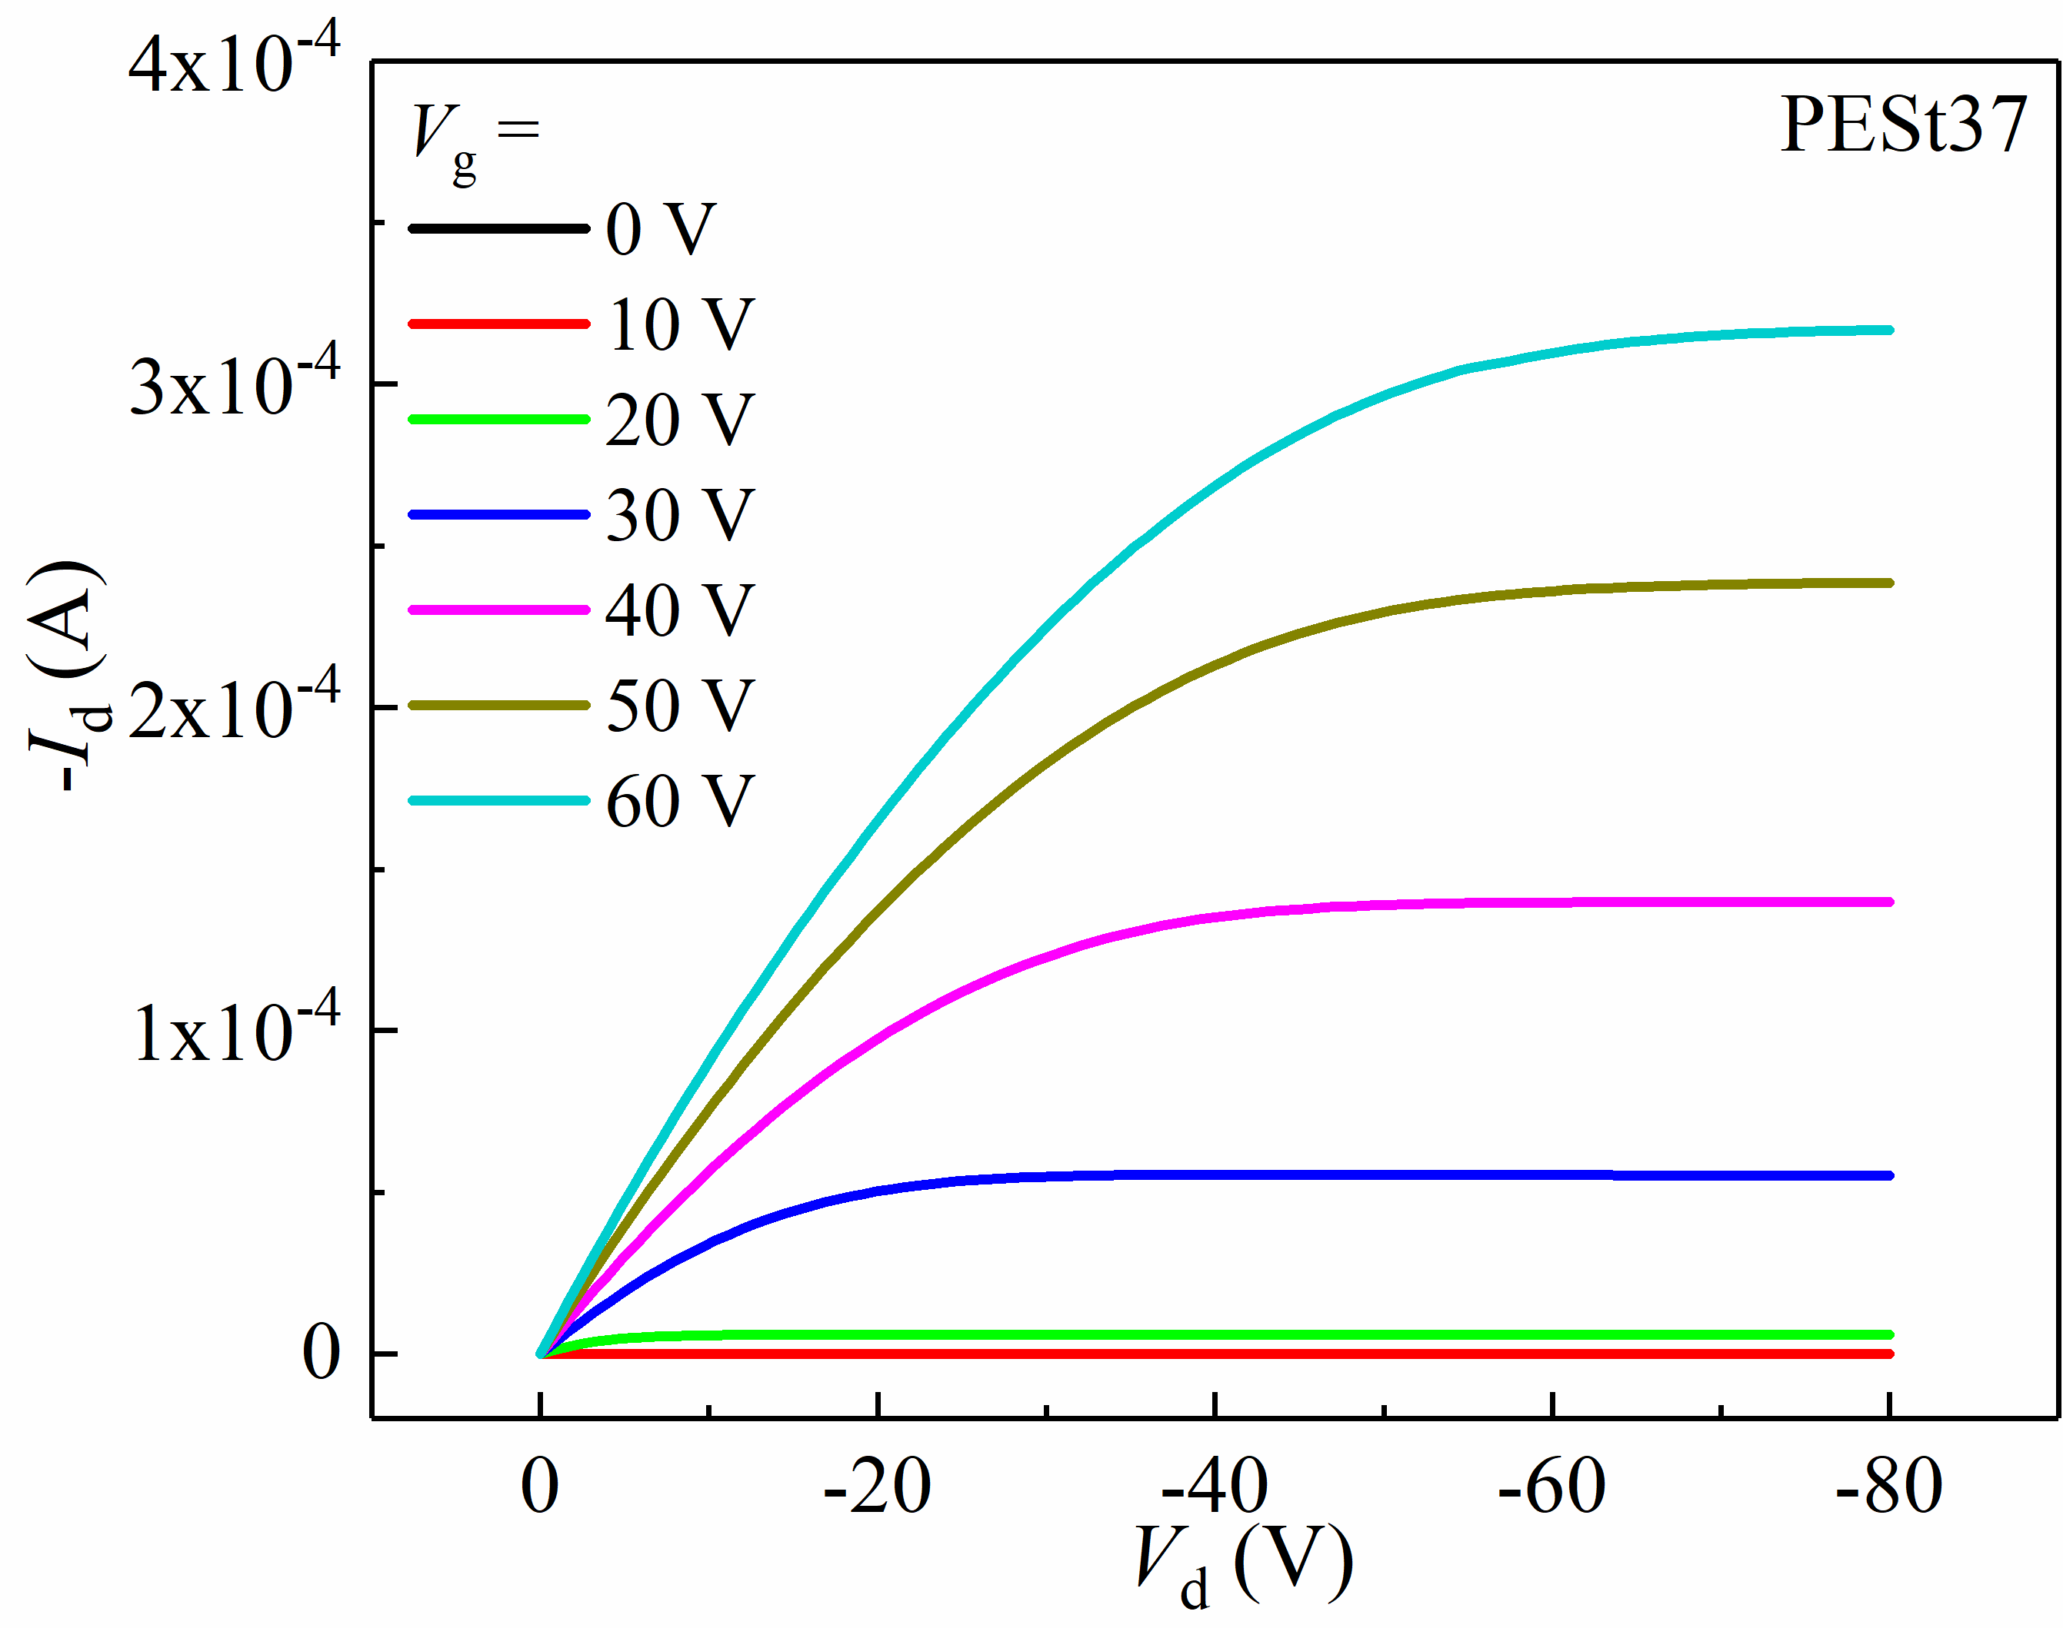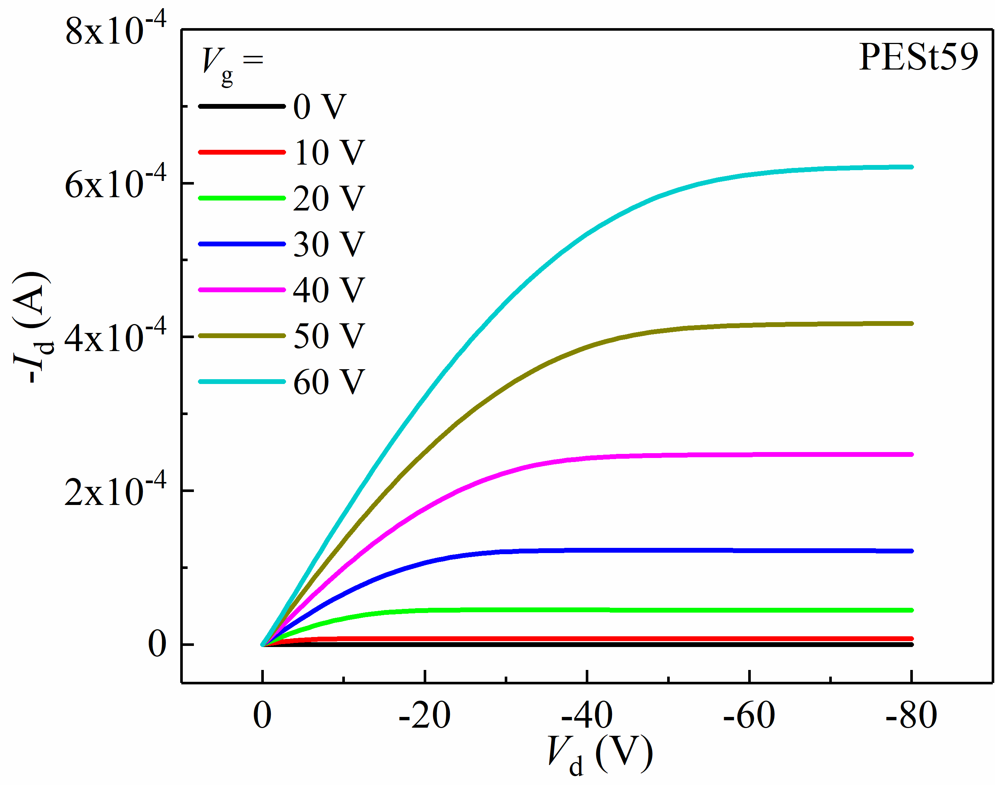
Figure S5 | Output characteristics of C12-BTBT OFETs with a) PESt15, b) PESt37 and c) PESt59 gate dielectrics.

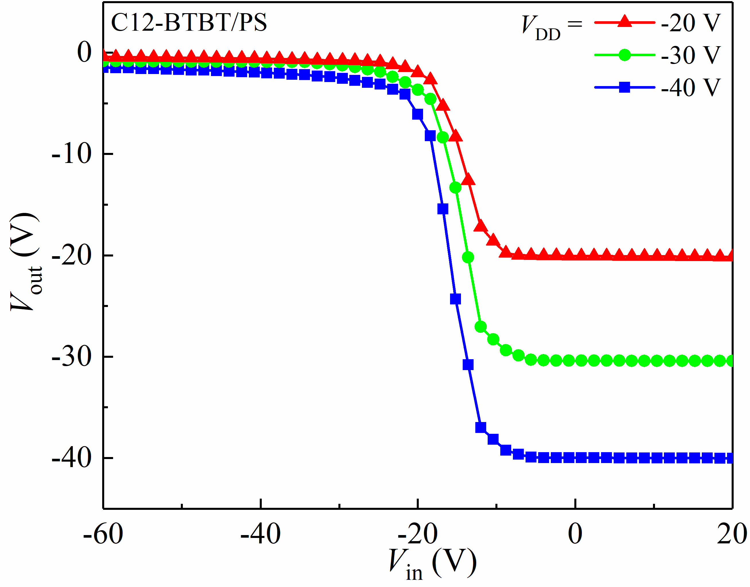
Figure S6 | Voltage transfer characteristics of the C12-BTBT/PS inverter.

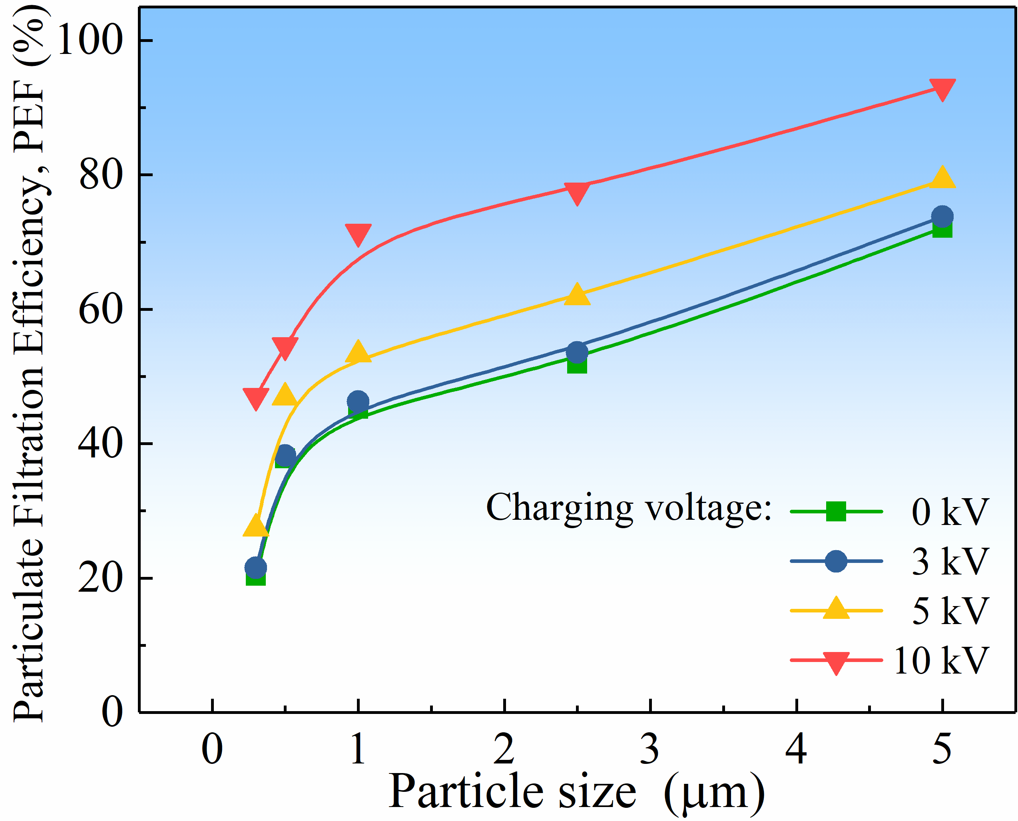
Figure S7 | Charging voltage dependent (0~10 kV) particulate filtration efficiency (PFE) of PESt coated nylon fiber membrane.

