Understanding cytotoxicity induction by plumbagin in pancreatic ductal adenocarcinoma using network pharmacology, bioinformatic and in-vitro study
(Running heading: Mechanistic role of Plumbagin in PDAC therapeutics)

JOURNAL- CYTOTECHNOLOGY
SUPPLEMENTARY FIGURES
Orcid IDs:
Shruti Gupta - 0000-0002-4934-4061
Khushhal Rathore- 0009-0007-7063-4075
Kiran Kumar Tejavath – 0000-0001-7876-421X

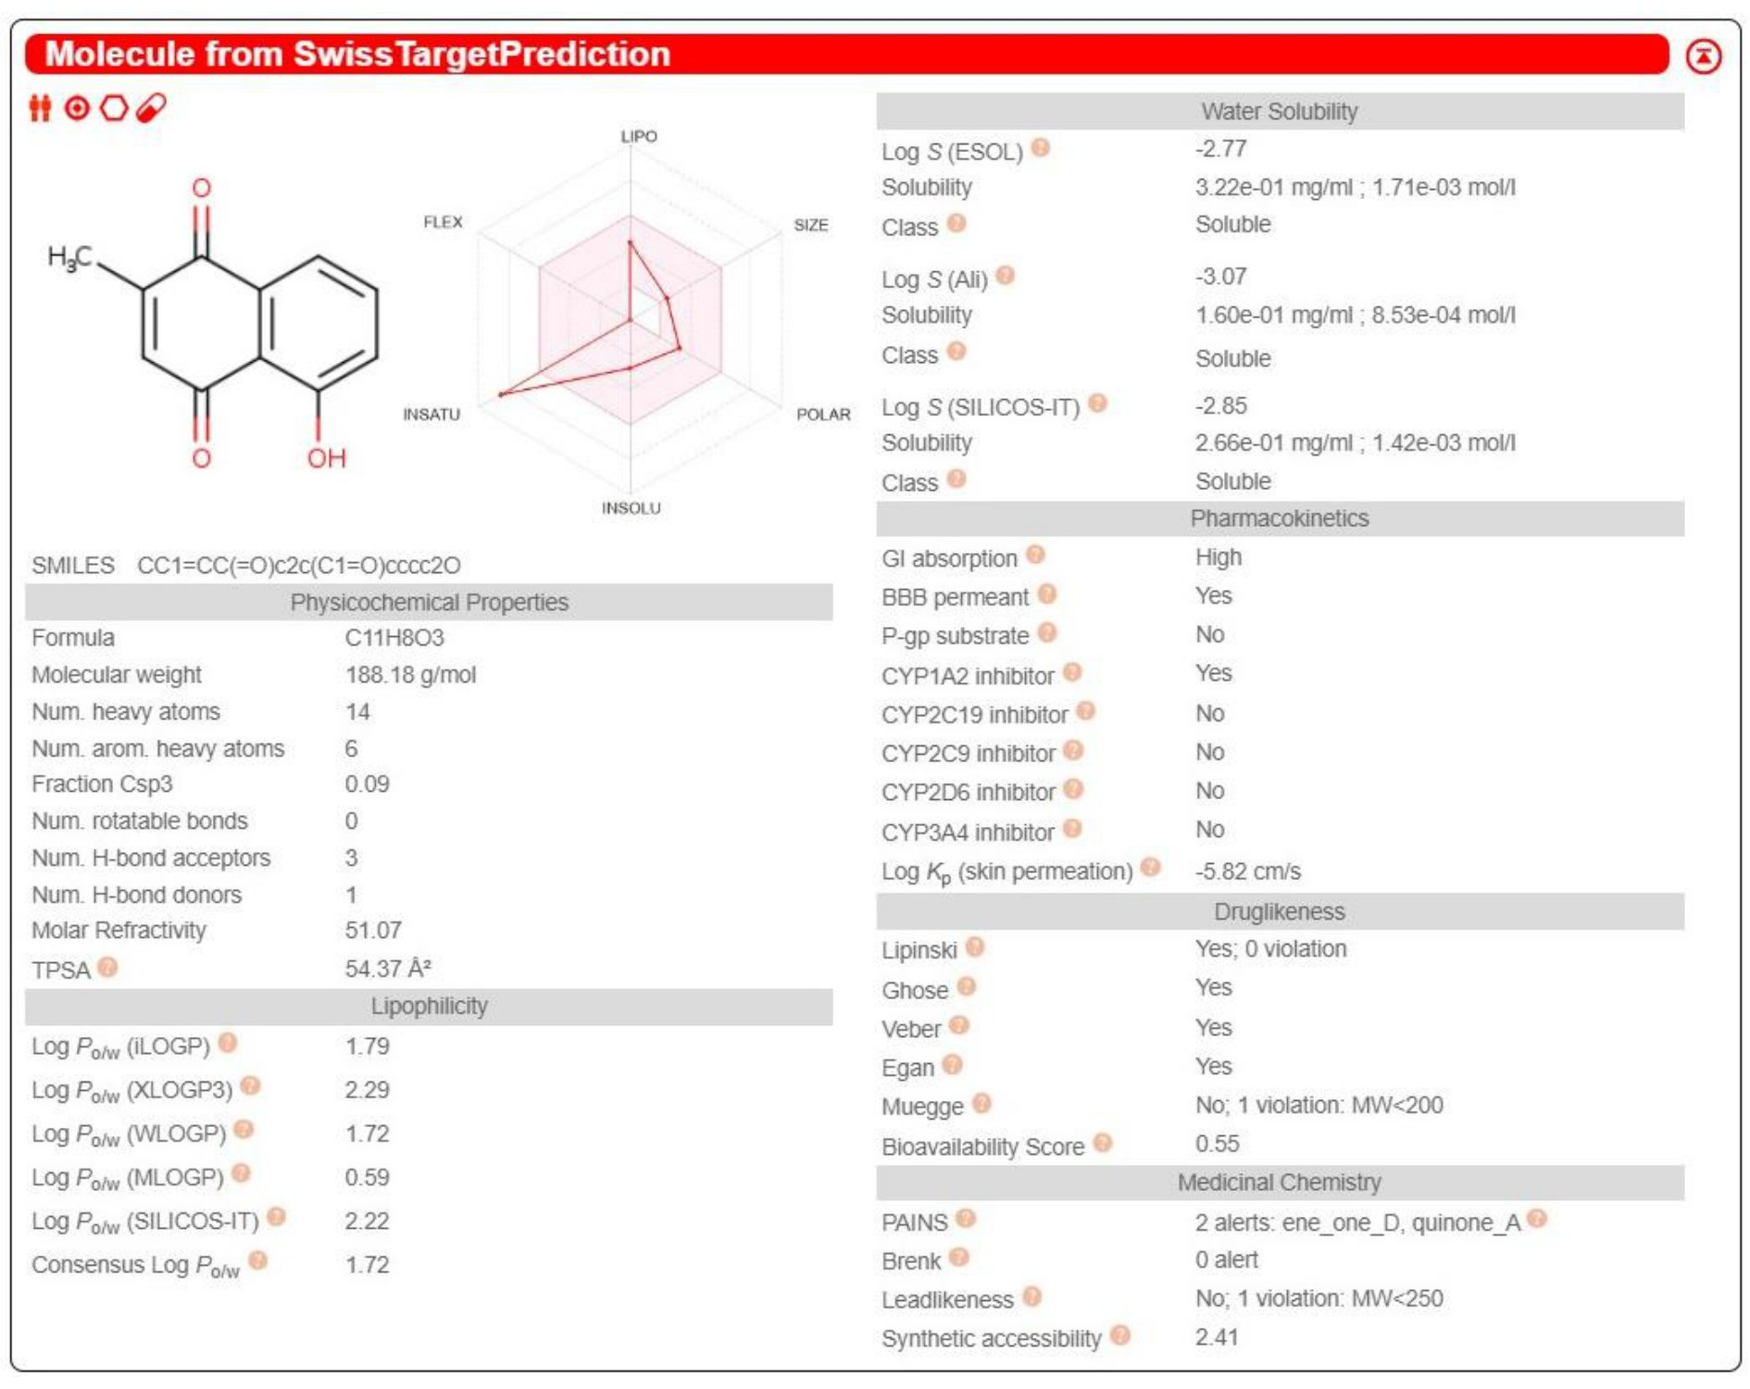
Fig. S1

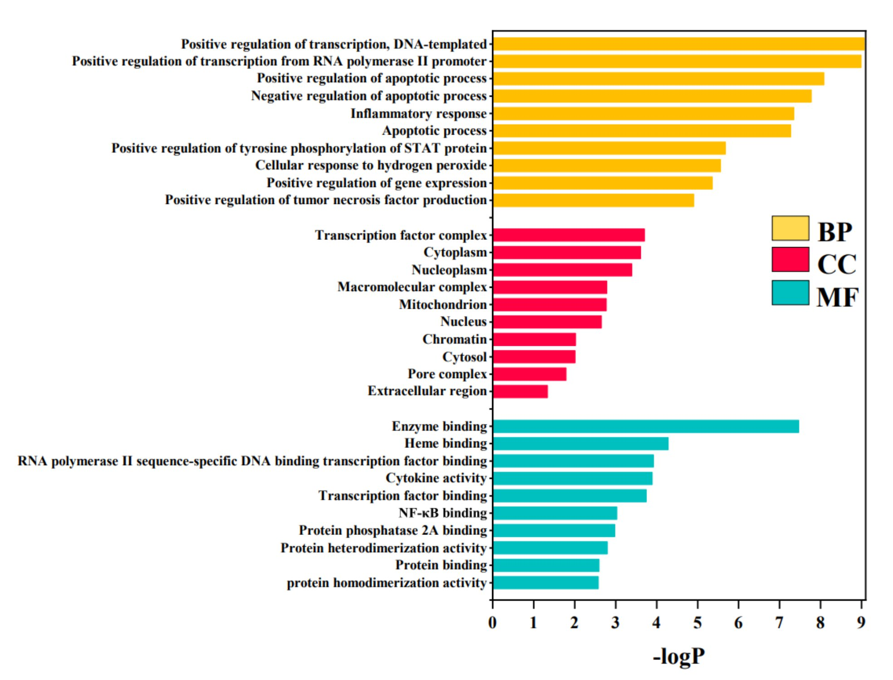
Fig. S2

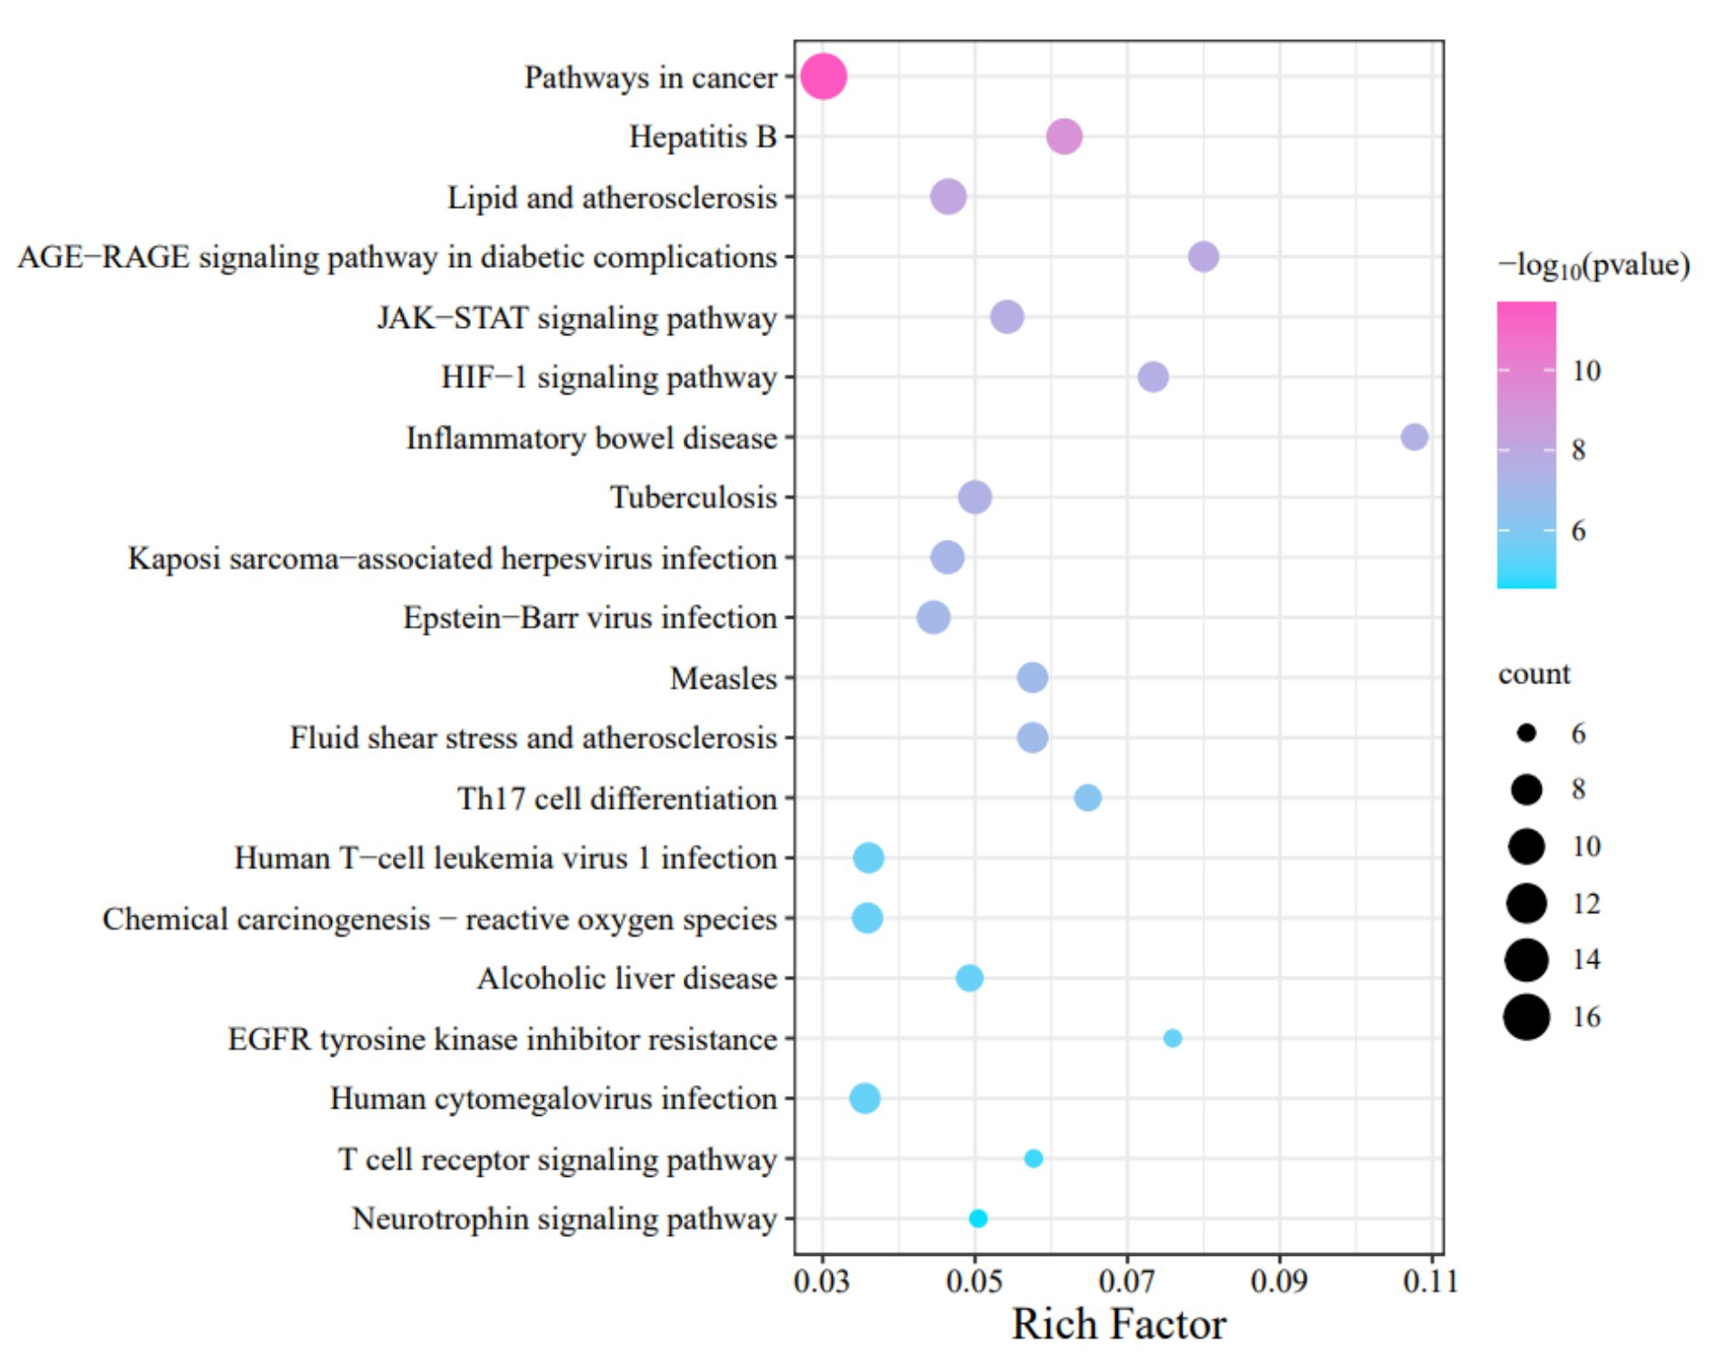
Fig. S3

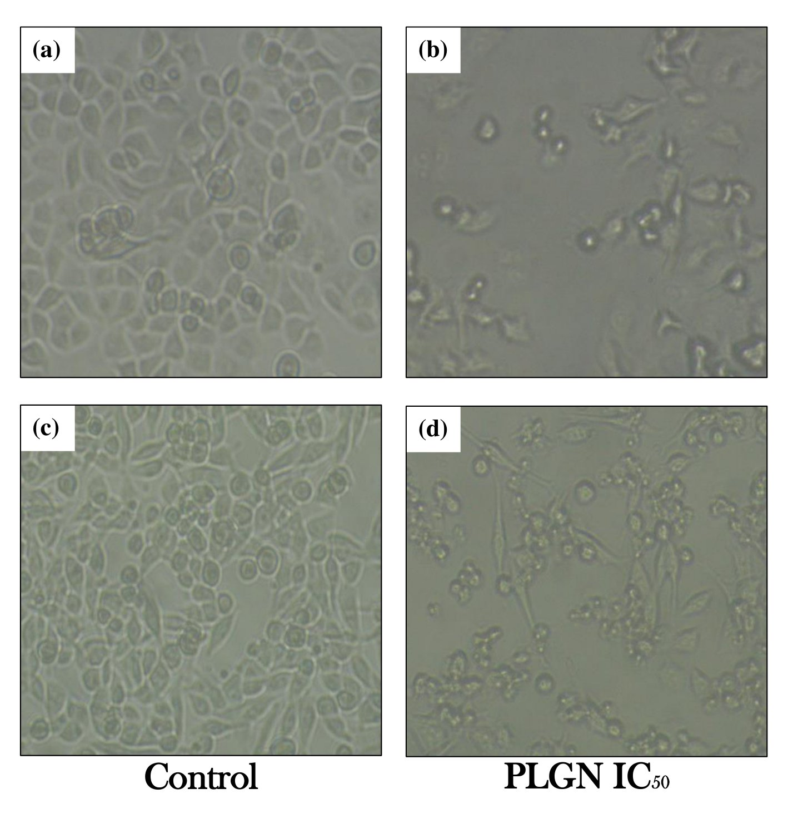
Fig. S4

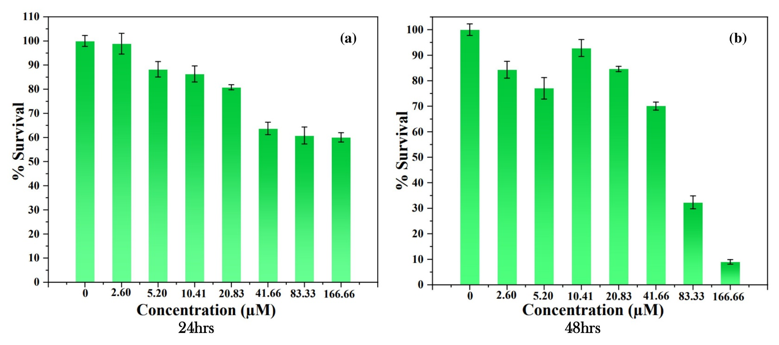
Fig. S5
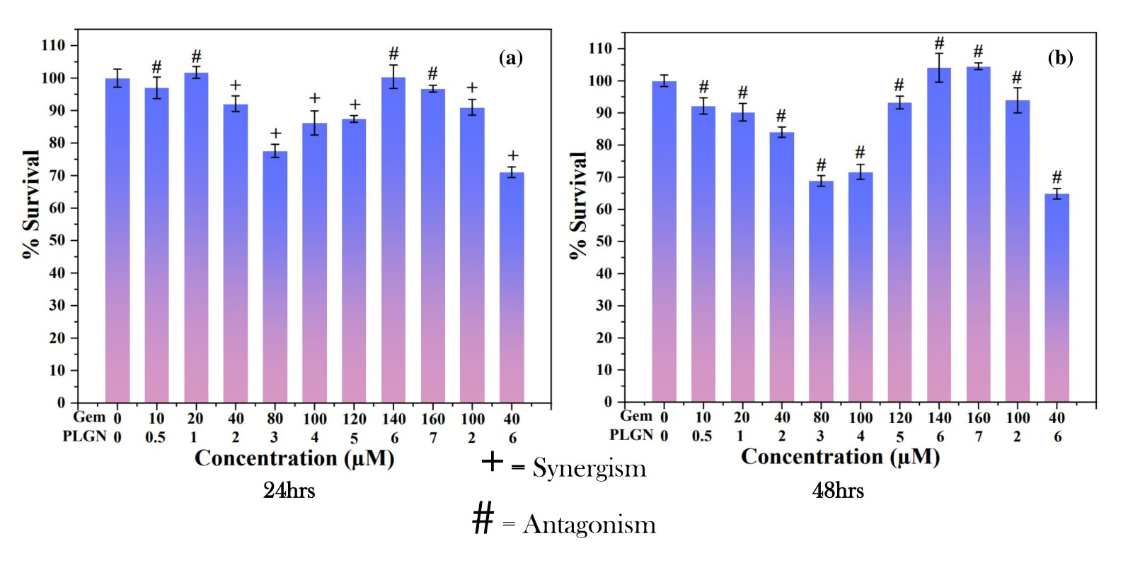
Fig. S6
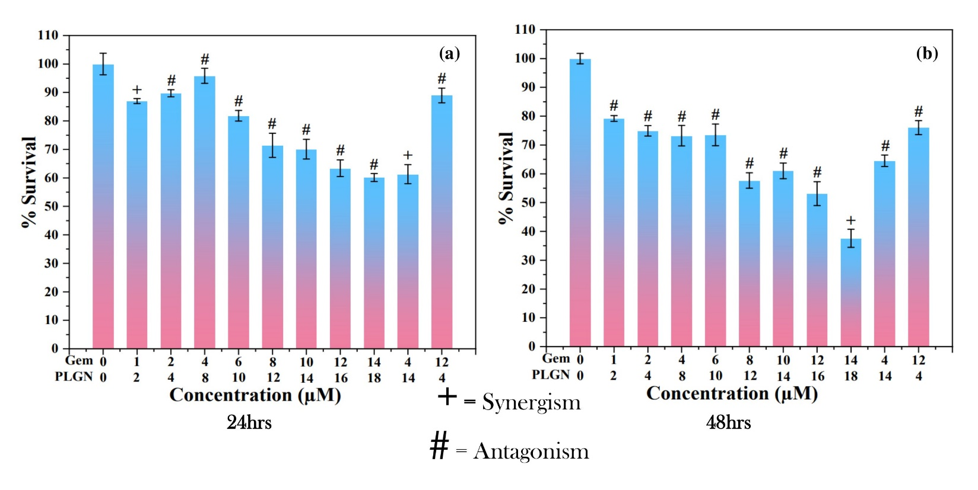
Fig. S7

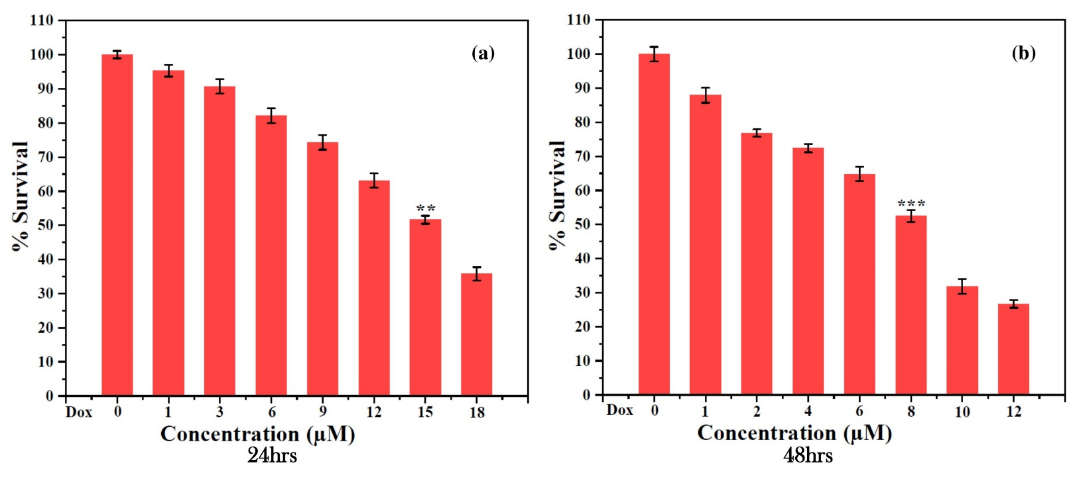
Fig. S8

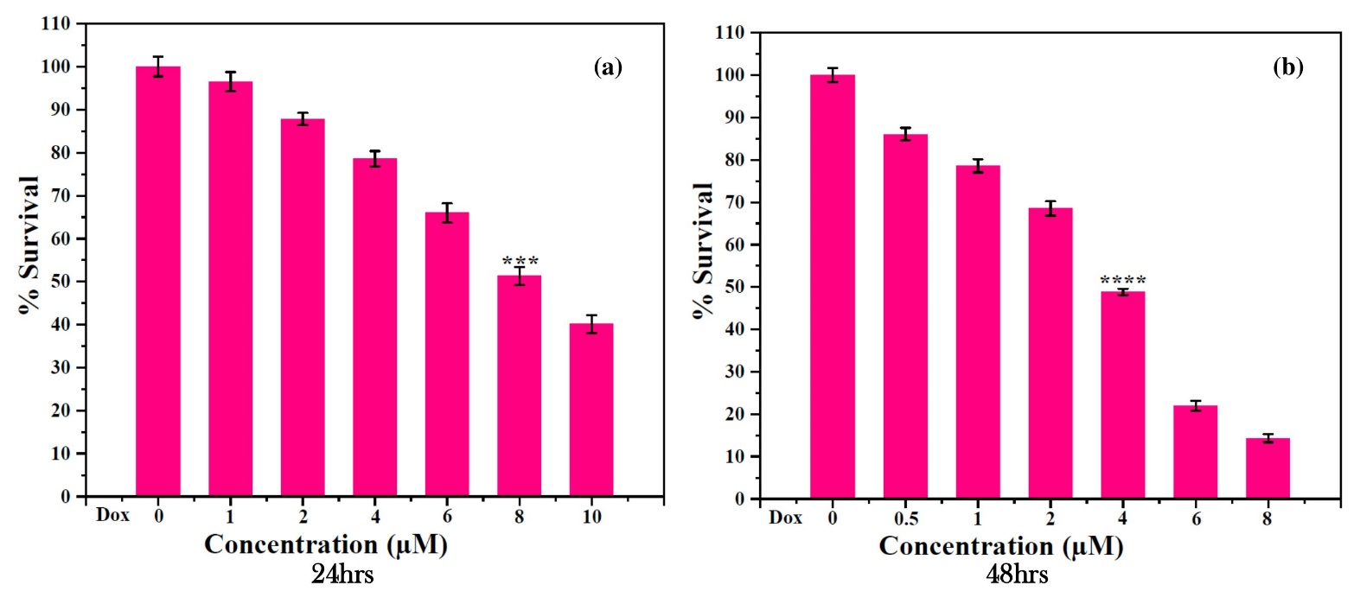
Fig. S9

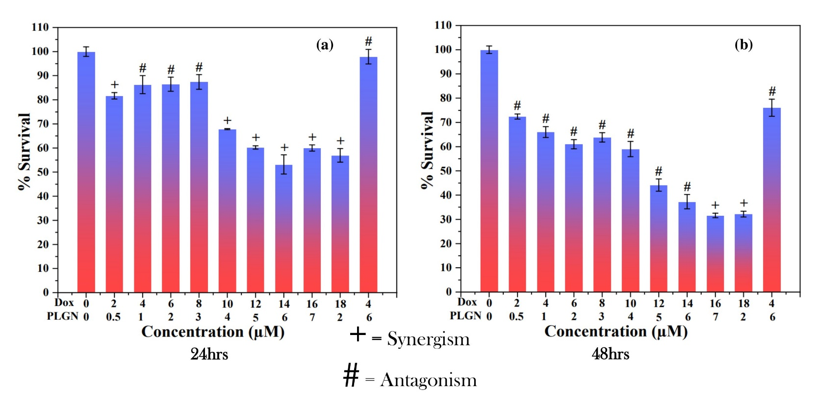
Fig. S10
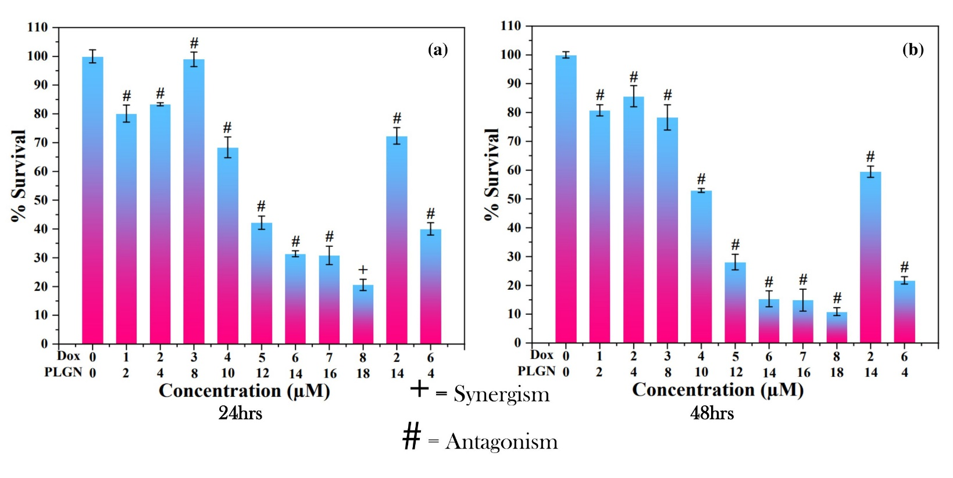
Fig. S11
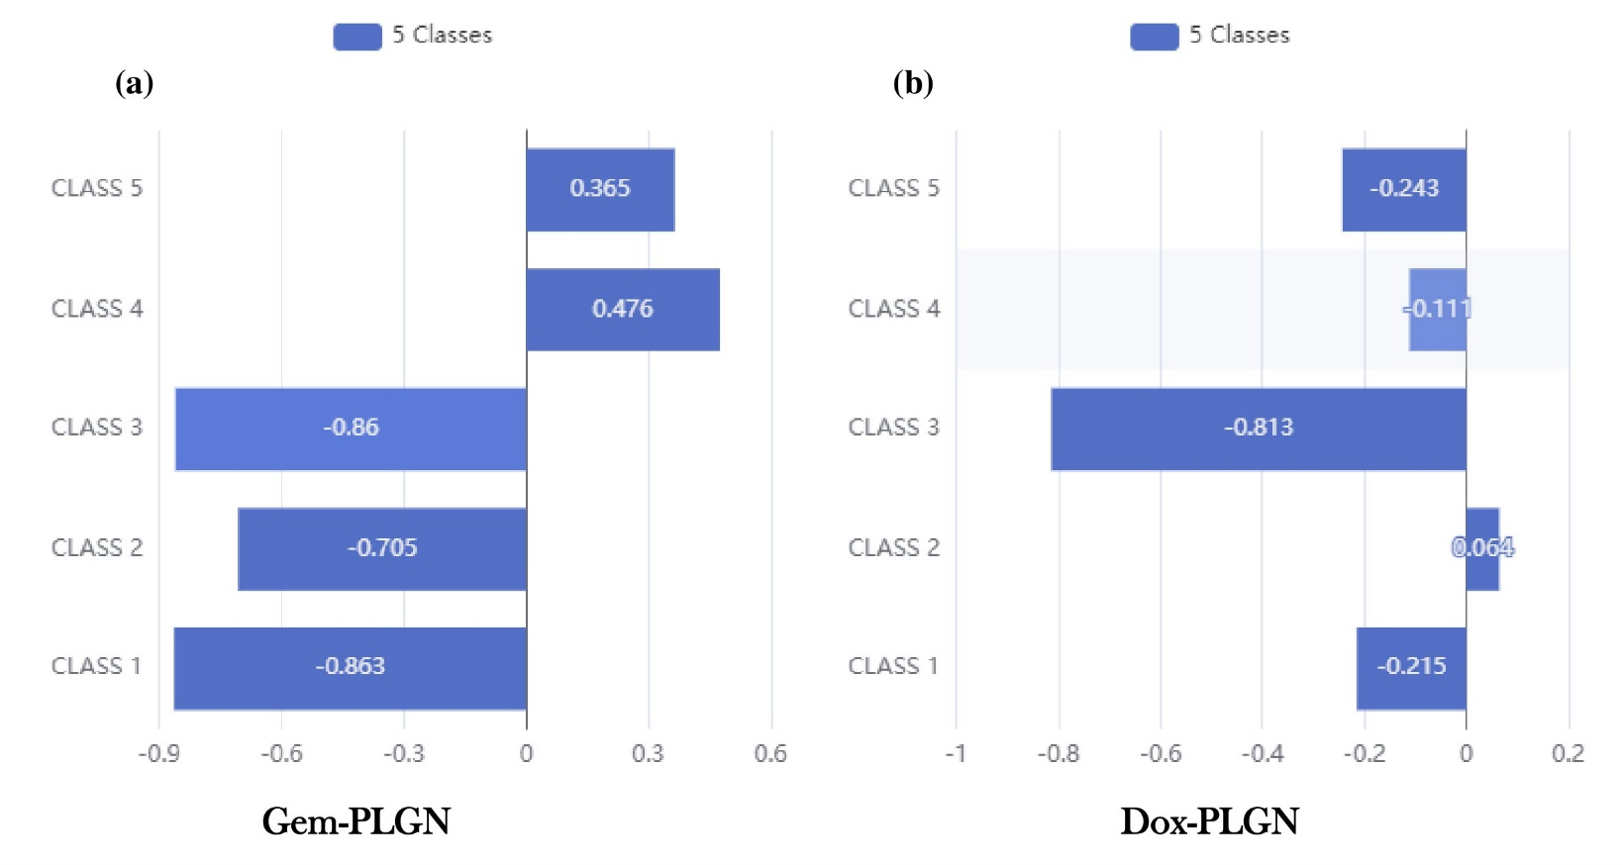
Fig. S12
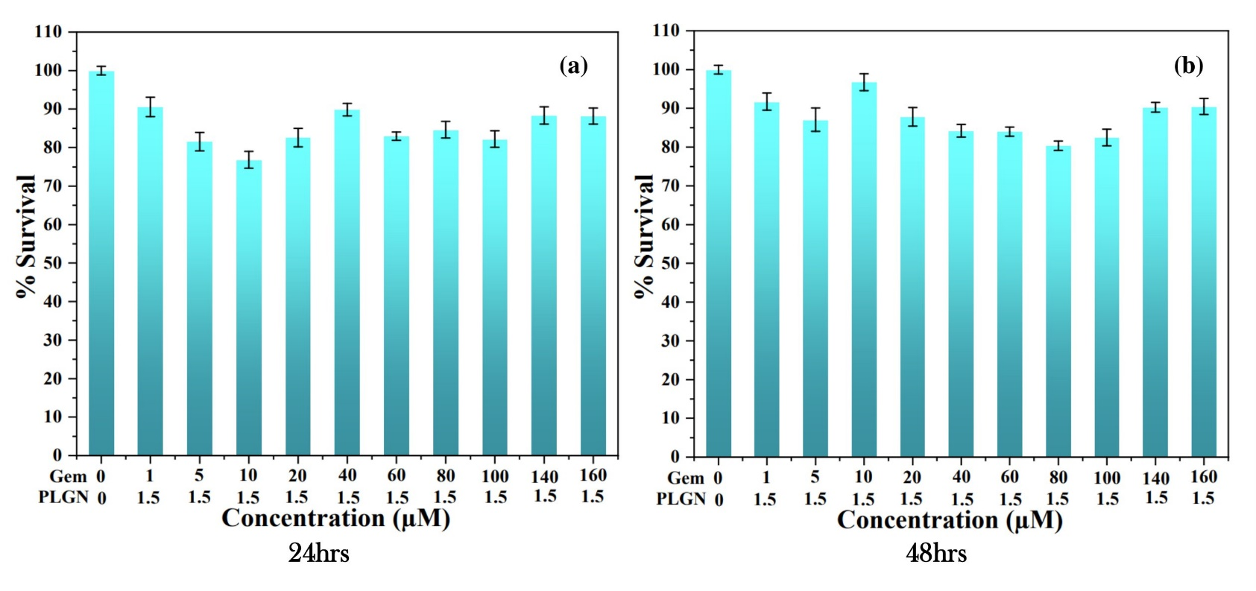
Fig. S13

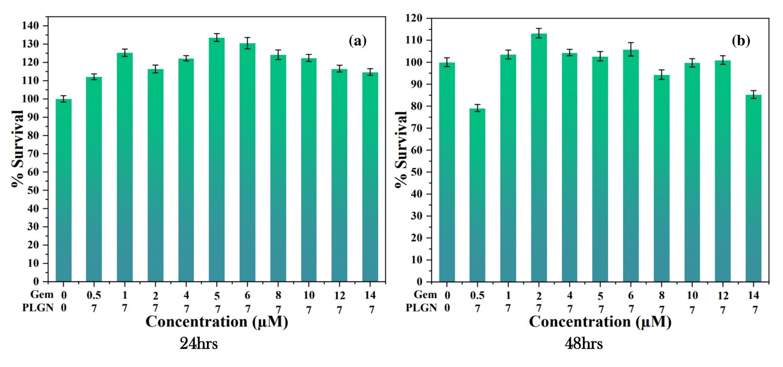
Fig. S14

