Suppl. Table 1. Agreement between subjective and UPSIT-defined hyposmia by diagnostic group

Variable | CS (20) | PD (20) | PSP-P (20) | PSP-RS (20)
Overall agreement (%) | 90.0 | 70.0 | 70.0 | 55.0
Expected agreement (%) | 81.5 | 67.5 | 52.5 | 47.0
Kappa (SE) | 0.46 (0.19) | 0.08 (0.21) | 0.37 (0.20) | 0.15 (0.20)
p-value | 0.007 | 0.359 | 0.035 | 0.222
True Positive (Both subjective & objective) | 1 | 13 | 10 | 5
False Negative (Objective only) | 2 | 4 | 5 | 7
False Positive (Subjective only) | 0 | 2 | 1 | 2
True Negative (Neither) | 17 | 1 | 4 | 6

In the PSP-P group, agreement between subjective and UPSIT-defined hyposmia was moderate, with 70.0% overall agreement (expected 52.5%) and a kappa of 0.37 (SE 0.20, p=0.035). Ten PSP-P patients had both subjective and UPSIT-defined hyposmia, five had UPSIT-defined hyposmia without subjective awareness, one reported hyposmia despite normal UPSIT, and four had normal olfactory function without complaint.
Among PSP-RS (n=20), agreement between subjective and UPSIT-defined hyposmia was low, with 55.0% overall agreement (expected 47.0%) and a kappa of 0.15 (SE 0.20, p=0.222). Five PSP-RS patients had both subjective and UPSIT-defined hyposmia, seven had UPSIT-defined hyposmia without subjective awareness, two reported hyposmia despite normal UPSIT, and six had normal olfactory function without complaint.
Among PD (n=20), agreement between subjective and UPSIT-defined hyposmia was low, with 70.0% overall agreement (expected 67.5%) and a very low kappa of 0.08 (SE 0.21, p=0.359). Thirteen PD patients had both subjective and UPSIT-defined hyposmia, four had UPSIT-defined hyposmia without subjective awareness, two reported hyposmia despite normal UPSIT, and one had normal olfactory function without complaint.
Among CS (n=20), agreement between subjective and UPSIT-defined hyposmia was high, with 90.0% overall agreement (expected 81.5%) and a moderate kappa of 0.46 (SE 0.19, p=0.007). Seventeen CS had normal olfactory function on the UPSIT and did not report hyposmia, one had both subjective and UPSIT-defined hyposmia, another reported hyposmia despite normal UPSIT and 2 had UPSIT-defined hyposmia without subjective awareness.

Suppl. Table 2. Univariate logistic regression models (PD vs. PSP all variants)
PSP vs. PD
Variable | OR | 95% CI OR | p | AUC | 95% CI AUC
Sex | 1.11 | 0.37 – 3.31 | 0.853 | 0.513 | 0.378 – 0.647
Age | 1.02 | 0.94 – 1.10 | 0.701 | 0.521 | 0.354 – 0.688
MoCA | 1.08 | 0.92 – 1.27 | 0.322 | 0.595 | 0.435 – 0.755
UPSIT | 0.91 | 0.84 – 0.99 | 0.032 | 0.300 | 0.157 – 0.443
UPSIT ≤15th % | 2.73 | 0.68 – 11.00 | 0.158 | 0.588 | 0.479 – 0.696
Orthostatism | 12.67 | 2.36 – 67.96 | 0.003 | 0.675 | 0.560 – 0.790
fRBD | 4.00 | 1.24 – 12.89 | 0.020 | 0.650 | 0.521 – 0.779
inRBD | 0.71 | 0.17 – 3.01 | 0.638 | 0.475 | 0.373 – 0.577
total RBD | 2.79 | 0.91 – 8.50 | 0.072 | 0.625 | 0.493 – 0.757
RBD probable premotor | 11.20 | 1.75 – 71.64 | 0.011 | 0.745 | 0.584 – 0.906
RBD probable postmotor | 0.09 | 0.014 – 0.57 | 0.011 | 0.255 | 0.094 – 0.416

CSF asyn-SAA: Cerebrospinal fluid α-synuclein analysed using a seed amplification assay; fRBD: full REM sleep behaviour disorder; inRBD: incomplete REM sleep behaviour disorder; MoCA: Montreal Cognitive Assessment; UPSIT: University of Pennsylvania Smell Identification Test.
Suppl. Table 3. Univariate logistic regression models (PD vs. PSP-P)

Variable | OR | 95% CI OR | p | AUC | 95% CI AUC
Sex | 1.23 | 0.35 – 4.31 | 0.749 | 0.525 | 0.368 – 0.682
Age | 1.04 | 0.95 – 1.13 | 0.398 | 0.546 | 0.360 – 0.732
MoCA | 0.96 | 0.80 – 1.17 | 0.699 | 0.505 | 0.321 – 0.689
UPSIT | 0.94 | 0.86 – 1.02 | 0.125 | 0.361 | 0.184 – 0.538
UPSIT ≤15th % | 1.89 | 0.38 – 9.27 | 0.433 | 0.550 | 0.424 – 0.676
Orthostatism | —* | — | — | 0.700 | 0.590 – 0.810
fRBD | 4.00 | 0.98 – 16.3 | 0.053 | 0.650 | 0.506 – 0.794
inRBD | 0.53 | 0.11 – 2.60 | 0.433 | 0.450 | 0.324 – 0.576
total RBD | 2.27 | 0.64 – 8.11 | 0.207 | 0.600 | 0.445 – 0.755
Premotor probable RBD | 12.8 | 1.21 – 135.6 | 0.034 | 0.752 | 0.578 – 0.928
Postmotor probable RBD | 0.08 | 0.007 – 0.83 | 0.034 | 0.248 | 0.072 – 0.423
CSF asyn-SAA | —* | — | —
CSF asyn-SAA: Cerebrospinal fluid α-synuclein analysed using a seed amplification assay; fRBD: full REM sleep behaviour disorder; inRBD: incomplete REM sleep behaviour disorder; MoCA: Montreal Cognitive Assessment; UPSIT: University of Pennsylvania Smell Identification Test.
* Orthostatism and CSF asyn-SAA dropped from regression due to perfect prediction.
Suppl. Table 4. Univariate logistic regression models (PSP-RS vs. PSP-P)
Variable | OR | 95% CI OR | p | AUC | 95% CI AUC
Sex | 1.23 | 0.35 – 4.31 | 0.749 | 0.525 | 0.368 – 0.682
Age | 1.06 | 0.96 – 1.17 | 0.251 | 0.609 | 0.423 – 0.794
MoCA | 0.76 | 0.61 – 0.95 | 0.016 | 0.269 | 0.109 – 0.428
UPSIT | 1.03 | 0.97 – 1.10 | 0.356 | 0.614 | 0.435 – 0.792
UPSIT ≤15th % | 0.50 | 0.13 – 1.93 | 0.315 | 0.425 | 0.278 – 0.572
Orthostatism | —* | — | —
fRBD | 1.00 | 0.21 – 4.71 | 1.000 | 0.500 | 0.373 – 0.627
inRBD | 0.53 | 0.11 – 2.60 | 0.433 | 0.450 | 0.324 – 0.576
totalRBD | 0.66 | 0.18 – 2.35 | 0.519 | 0.450 | 0.295 – 0.605
Premotor probable RBD | 1.33 | 0.07 – 25.9 | 0.849 | 0.516 | 0.339 – 0.693
Postmotor probable RBD | 0.75 | 0.04 – 14.6 | 0.849 | 0.484 | 0.307 – 0.661
CSF asyn-SAA | —* | — | — | — | —
CSF asyn-SAA: Cerebrospinal fluid α-synuclein analysed using a seed amplification assay; fRBD: full REM sleep behaviour disorder; inRBD: incomplete REM sleep behaviour disorder; MoCA: Montreal Cognitive Assessment; UPSIT: University of Pennsylvania Smell Identification Test.
* Orthostatism and CSF asyn-SAA dropped from regression due to perfect prediction.

Supplementary Figure 1. Epworth Sleepiness Scale scores by item
Median scores for each item of the Epworth Sleepiness Scale are shown for all study groups. There was less sleepiness in PSP-RS in one of the most passive situations (lying down to rest).
PD: Parkinson’s disease; PSP: progressive supranuclear palsy; PSP-P: PSP-parkinsonism; PSP-RS: PSP-Richardson’s syndrome.

Supplementary Figure 2. Comparison of PSQI components between groups
Comparison of the seven components of the Pittsburgh Sleep Quality Index (PSQI): A. Sleep quality, B. Sleep latency, C. Sleep duration, D. Sleep efficiency, E. Sleep disturbances, F. Use of sleep medication, and G. Daytime dysfunction—across groups using the Kruskal-Wallis test. p-values were adjusted by FDR.
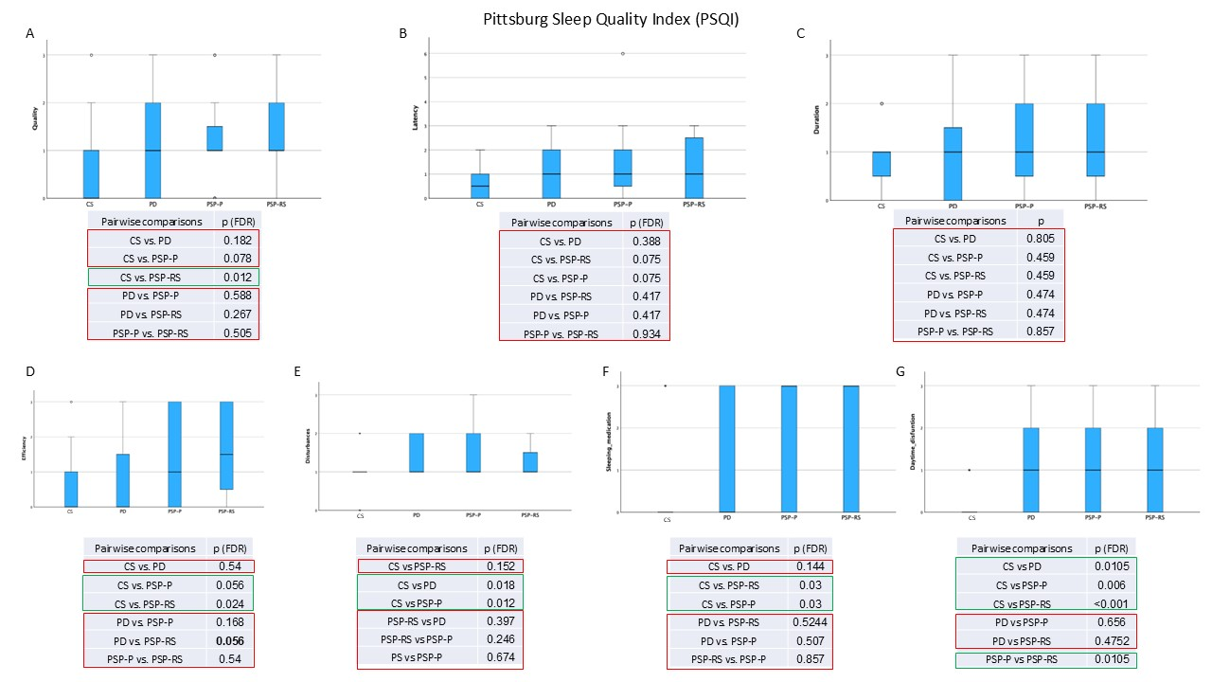

CS: control subjects; p-FDR: p-values adjusted for False Discovery Rate; PD: Parkinson’s disease; PSP: progressive supranuclear palsy; PSP-P: PSP-parkinsonism; PSP-RS: PSP-Richardson’s syndrome.

Supplementary Figure 3. Comparison of SCOPA-AUT domains between groups
Comparation of the domains of the Scale for Outcomes in Parkinson’s Disease - Autonomic (SCOPA-AUT): A. Gastrointestinal, B. Urinary, C. Cardiovascular, D. Pupillomotor, E. Thermoregulatory, and F. Sexual - across groups using the Kruskal–Wallis test. P-values were corrected by FDR.
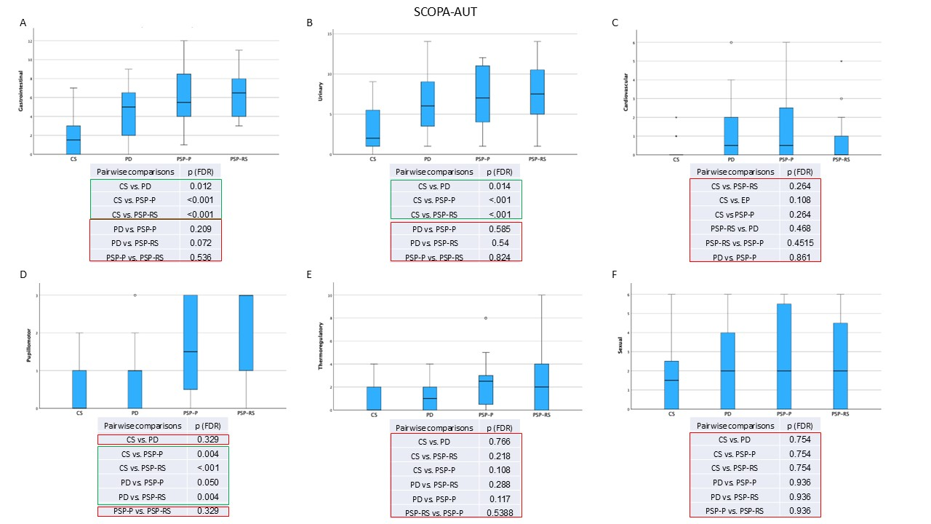

CS: control subjects; p-FDR: p-values adjusted for False Discovery Rate; PD: Parkinson’s disease; PSP: progressive supranuclear palsy; PSP-P: PSP-parkinsonism; PSP-RS: PSP-Richardson’s syndrome.

