Formaldehyde Hydroformylation over a Heterogeneous Catalyst Based on Functionalized Rh-biphosphine Unit: A Combined Experiment and Theoretical Study
Yuntao He,^{a,b} Wanting Xia,ª Luyang Qiao,ª Zongkai Wu,^{a,c} Xinyi Cao,ª Yong Gao,^{d} Jiankai Cheng,^{a,*} Zhangfeng Zhou,^{a,*} Yuangen Yaoª
[a] State Key Laboratory of Structural Chemistry, Fujian Institute of Research on the Structure of Matter, Chinese Academy of Sciences, Fuzhou 350002, China
[b] University of Chinese Academy of Sciences, Beijing 100049, China
[c] College of Chemistry and Materials Science, Fujian Normal University, Fuzhou 350007, China
[d] Shaanxi Key Laboratory of Low Metamorphic Coal Clean Utilization, School of Chemistry and Chemical Engineering, Yulin University, Yulin 719000, China
Corresponding authors:
Jiankai Cheng, Email: cjk@fjirsm.ac.cn
Zhangfeng Zhou, Email: zfzhou@fjirsm.ac.cn

Fig. S1. Mass fraction of P in PNP under different (a) PNP addition amounts and (b) reaction times.
Fig. S2. Mass spectra of the filtrate after loading rhodium species (a) Rh/PS-SG and (b) Rh/PS-N₂.
Fig. S3. XRD patterns of supports and catalysts.
Fig. S4. Differential thermogravimetric image of SiO₂, Cl-SiO₂ and PNP-SiO₂.
Fig. S5. N 1s XPS of PNP-SiO₂, Rh/PS-SG and Rh/PS-N₂.
Fig. S6. Recycling performance of Rh/PS-SG. Reaction condition: [Rh] = 0.8 mmol/L, V_{DMA} = 25 mL, n(FA): n(Rh) = 1200, T = 95 ℃, P = 12 MPa, n(CO): n(H₂) = 1; t = 3 h.
Fig. S7. HRTEM and mapping images of (a)(b) Rh/PS-SG-Used

Table S1. The deconvolution analysis results of Rh 3d XPS profiles of Rh/PS-SG and Rh/PS-N₂.
Catalyst | Rh⁺ (%) | Rh⁰ (%)
Rh/PS-SG | 54.9 | 45.1
Rh/PS-N₂ | 58.1 | 41.9

Table S2. The Rh content of Rh/PS-SG and Rh/PS-N₂ before and after reaction.
Catalyst | ªRh (wt%)
Rh/PS-SG-Fresh | 0.39
Rh/PS-SG-Used | 0.36
Rh/PS-N₂-Fresh | 0.31
Rh/PS-N₂-Used | 0.16
ª Measured by ICP-OES.

Table S3. The catalytic performance in hydroformylation of formaldehyde with different Rh-based solid catalysts.
Catalyst | Rh loading (%) | $m_{{PPh}_{3}}$ (g) | Conversion of FA (%) | Selectivity of GA (%) | TOF_{GA}  (h⁻¹) | Ref.
ªRh/PS-SG | 0.39 | - | 12.5 | 88.3 | 99.6 | This work
^{b}Rh/Na-Y | 2.91 | 0.785 | 60.1 | 86.6 | 40.3 | ¹
^{c}Rh@N-SiO₂ | 0.78 | 0.785 | 33.1 | 94.7 | 90.8 | ²
^{d}Rh@SiO₂ | 0.59 | 0.012 | 25.3 | 90.8 | 183.3 | ³
ª Reaction condition: 0.50 g catalyst, 0.64 g paraformaldehyde (CH₂O)_{n}, 25 mL DMA, P = 8 MPa (CO: H₂ = 1:1), T = 110 °C, reaction time = 3 h.
^{b} Reaction condition: 1.0 g catalyst, 1.97 g paraformaldehyde (CH₂O)_{n}, 25 mL DMA, P = 12 MPa (CO: H₂ = 1:1), T = 95 °C, reaction time = 3 h.
^{c} Reaction condition: 1.0 g catalyst, 1.97 g paraformaldehyde (CH₂O)_{n}, 25 mL DMA, P = 12 MPa (CO: H₂ = 1:1), T = 95 °C, reaction time = 3 h.
^{d} Reaction condition: 0.29 g catalyst, 0.60 g paraformaldehyde (CH₂O)_{n}, 20 mL acetonitrile, P = 8 MPa (CO: H₂ = 1:1), T = 110 °C, reaction time = 3 h.

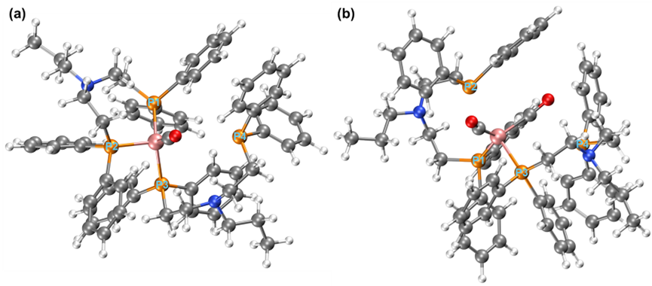
Fig. S8. (a) Rh/PS-N₂ with one CO coordinated; (b) Rh/PS-N₂ with two CO molecules coordinated.

Table S4. Rh-P bond lengths (in Å) in Rh/PS-N₂ during sequential CO coordination.
Structure | Rh-P1 | Rh-P2 | Rh-P3 | Rh-P4
Rh/PS-N₂ | 2.29 | 2.29 | 2.32 | 2.36
Rh/PS-N₂ + 1CO | 2.32 | 2.29 | 2.36 | 4.08
Rh/PS-N₂ + 2CO | 2.45 | 2.94 | 2.40 | 4.74
As shown in Fig. S7, upon binding one CO molecule, the Rh-P4 bond in Rh/PS-N₂ significantly elongates to 4.08 Å (Table S3), indicating local structural distortion induced by coordination. When a second CO molecule binds (Fig. S7b), the Rh-P4 bond further breaks up to 4.74 Å, while the Rh-P2 bond markedly extends from 2.29 Å to 2.94 Å. The concurrent weakening of these two Rh-P bonds clearly reveals the stepwise dissociation mechanism of Rh/PS-N₂ under multiple coordination stresses.

Reference
1. Guo, X. et al. Effect of NaY Zeolite at Different Calcination Temperatures on the Activity in Hydroformylation of Formaldehyde. ChemistrySelect 7, (2022).
2. Chen, J. et al. Promoted Hydroformylation of Formaldehyde By Electronic Metal–Support Interactions in N-Group Functionalized Silica Supported Rhodium Catalyst. Catal. Lett. 151, 3664–3674 (2021).
3. Yang, Q. et al. Unravelling structure sensitivity in heterogeneous hydroformylation of aldehyde over Rh. Chem. Eng. J. 481, 148529 (2024).

