Supporting information for
Ni-Fe phosphide deposited carbon felt as free-standing bifunctional catalyst electrode for urea electrolysis

Woo Hyun Yun, Gautam Das, Bohyeon Kim, Bang Ju park, Hyon Hee Yoon, and Young Soo Yoon

Fig. S1. SEM EDX spectra of (a) carbon felt, (b) Ni@CF (c) NiFe@CF and (d) P-NiFe@CF.
Fig. S2. EDS elemental mapping of (a) Ni@CF, (b) NiFe@CF (c) P-NiFe@CF obtained by SEM.
Fig. S3. EDS mapping of P-NiFe@CF obtained by HRTEM.

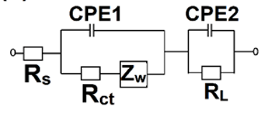
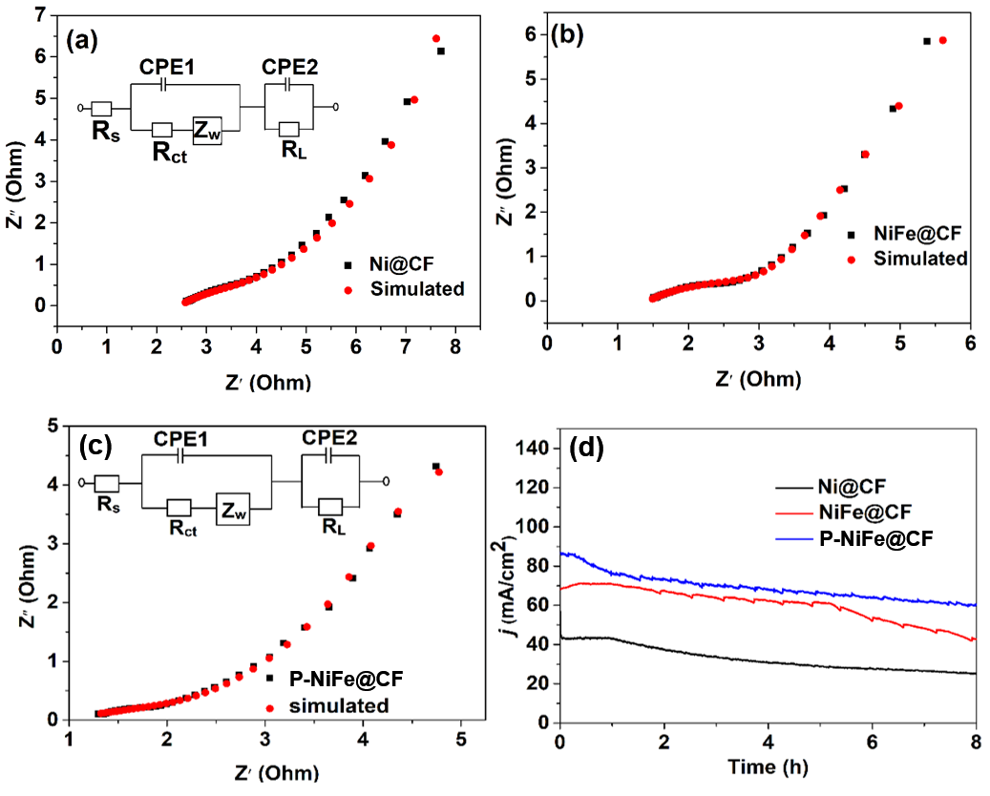
Fig. S4. Impedance plots of (a) Ni@CF, inset: equivalent circuit diagram, (b) NiFe@CF, and (c) P-NiFe@CF. (d) The stability test using 1 M KOH and 0.33 M urea as a electrolyte towards UOR.

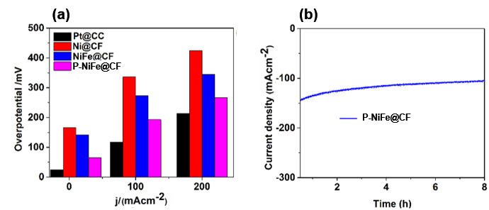
Fig. S5. (a) Bar graph illustrating overpotential vs current density plots of different catalysts determined from the LSV plot of HER in 0.33 M urea +1.0 M KOH and (b) the stability test using 1 M KOH and 0.33 M urea as a electrolyte towards HER.

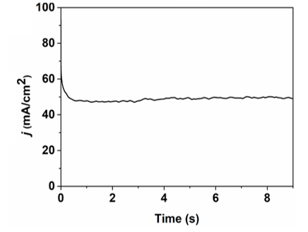
Fig. S6. The stability test in 1 M KOH and 0.33 M urea solution using P-NiFe@CF as anode and cathode at an applied potential corresponding to a current of 50 mA cm⁻².

Table S1. Performance comparison for urea electro-oxidation with different catalysts.
Catalyst | Potential at 10 mAcm⁻² (V vs RHE) | Electrolyte | Reference
NiO nanosheet array | 1.38 | 1 M KOH+ 0.33 M Urea | [1]
NiMoS | 1.38V | 1M KOH + 0.5M | [2]
Ni₃N/NF | 1.34 | 1 M KOH+ 0.5 M Urea | [3]
Ni₃N NA/CC | 1.35 | 1 M KOH+ 0.33 M Urea | [4]
Ni0-rich Ni/NiO | 1.33 | 1 M KOH+ 0.33 M Urea | [5]
Ni₂P/CFC | 1.34 | 1 M KOH+ 0.33 M Urea | [6]
CoS₂ NA/Ti | 1.40 | 1 M KOH+ 0.33 M Urea | [7]
MnO₂/MnCo₂O₄/Ni | 1.33 | 1 M KOH+ 0.5 M Urea | [8]
Ni(OH)₂ nanocube | 1.55 | 1 M KOH+ 0.33 M Urea | [9]
Graphene Ni(OH)₂ | 1.52 | 5 M KOH+ 0.5 M Urea | [10]
NiFe@CF | 1.47 | 1 M KOH+ 0.33 M Urea | This work
P-NiFe@CF | 1.33 | 1 M KOH+ 0.33 M Urea | This work

Table S2. Performances comparison for urea electrolysis in two electrode cell test with different catalysts.
Anode catalyst | Cathode catalyst | Cell Potential  at 10 mA cm⁻² | Electrolyte | Reference
HC-NiMoS/Ti | HC-NiMoS/Ti | 1.59 | 1M KOH + 0.5M urea | [2]
Ni₃N NA/CC | Ni₃N NA/CC | 1.44 | 1M KOH + 0.33M urea | [4]
NF@Acid-H₂ | NF@Acid-H₂ | 1.49 | 1M KOH + 0.5M urea | [5]
CoS₂ Na/Ti | CoS₂ Na/Ti | 1.59 | 1M KOH + 0.3M urea | [7]
MnO₂/MnCo₂O₄ | MnO₂/MnCo₂O₄ | 1.55 | 1M KOH + 0.5M urea | [8]
Fe_{11.1%}-Ni₃S₂/NF | Fe_{11.1%}-Ni₃S₂/NF | 1.46 | 1M KOH + 0.33M urea | [11]
MoS₂/Ni₃S₂ | MoS₂/Ni₃S₂ | 1.45 (@20) | 1M KOH + 0.33M urea | [12]
NiFe@CF | NiFe@CF | 1.614 | 1 M KOH+ 0.33 M Urea | This work
P-NiFe@CF | P-NiFe@CF | 1.424 | 1 M KOH+ 0.33 M Urea | This work
References
[1] Wu MS, Lin GW, Yang RS. Hydrothermal growth of vertically-aligned ordered mesoporous nickel oxide nanosheets on three-dimensional nickel framework for electrocatalytic oxidation of urea in alkaline medium. J Power Sources 2014;272:711–8. https://doi.org/10.1016/j.jpowsour.2014.09.009.
[2] Wang X, Wang J, Sun X, Wei S, Cui L, Yang W, et al. Hierarchical coral-like NiMOS nanohybrids as highly efficient bifunctional electrocatalysts for overall urea electrolysis. Nano Res 2018;11:988–96. https://doi.org/10.1007/s12274-017-1711-3.
[3] Hu S, Feng C, Wang S, Liu J, Wu H, Zhang L, et al. Ni 3 N/NF as Bifunctional Catalysts for Both Hydrogen Generation and Urea Decomposition. ACS Appl Mater Interfaces 2019;11:13168–75. https://doi.org/10.1021/acsami.8b19052.
[4] Liu Q, Xie L, Qu F, Liu Z, Du G, Asiri AM, et al. A porous Ni3N nanosheet array as a high-performance non-noble-metal catalyst for urea-assisted electrochemical hydrogen production. Inorg Chem Front 2017;4:1120–4. https://doi.org/10.1039/c7qi00185a.
[5] Zhang B, Wang S, Ma Z, Qiu Y. Ni0-rich Ni/NiO nanocrystals for efficient water-to‑hydrogen conversion via urea electro-oxidation. Appl Surf Sci 2019;496:143710. https://doi.org/10.1016/j.apsusc.2019.143710.
[6] Zhang X, Liu Y, Xiong Q, Liu G, Zhao C, Wang G, et al. Vapour-phase hydrothermal synthesis of Ni2P nanocrystallines on carbon fiber cloth for high-efficiency H2 production and simultaneous urea decomposition. Electrochim Acta 2017;254:44–9. https://doi.org/10.1016/j.electacta.2017.09.097.
[7] Wei S, Wang X, Wang J, Sun X, Cui L, Yang W, et al. CoS2 nanoneedle array on Ti mesh: A stable and efficient bifunctional electrocatalyst for urea-assisted electrolytic hydrogen production. Electrochim Acta 2017;246:776–82. https://doi.org/10.1016/j.electacta.2017.06.068.
[8] Xiao C, Li S, Zhang X, MacFarlane DR. MnO2/MnCo2O4/Ni heterostructure with quadruple hierarchy: A bifunctional electrode architecture for overall urea oxidation. J Mater Chem A 2017;5:7825–32. https://doi.org/10.1039/c7ta00980a.
[9] Wu MS, Ji RY, Zheng YR. Nickel hydroxide electrode with a monolayer of nanocup arrays as an effective electrocatalyst for enhanced electrolysis of urea. Electrochim Acta 2014;144:194–9. https://doi.org/10.1016/j.electacta.2014.08.098.
[10] Miller AT, Hassler BL, Botte GG. Rhodium electrodeposition on nickel electrodes used for urea electrolysis. J Appl Electrochem 2012;42:925–34. https://doi.org/10.1007/s10800-012-0478-1.
[11] Zhu W, Yue Z, Zhang W, Hu N, Luo Z, Ren M, et al. Wet-chemistry topotactic synthesis of bimetallic iron-nickel sulfide nanoarrays: An advanced and versatile catalyst for energy efficient overall water and urea electrolysis. J Mater Chem A 2018;6:4346–53. https://doi.org/10.1039/c7ta10584c.
[12] Li F, Chen J, Zhang D, Fu WF, Chen Y, Wen Z, et al. Heteroporous MoS2/Ni3S2 towards superior electrocatalytic overall urea splitting. Chem Commun 2018;54:5181–4. https://doi.org/10.1039/c8cc01404c.

