Supplementary Material

Supplementary Table 1: Autism Treatment Evaluation Checklist (ATEC) ¹, subscale 1: Speech/Language/Communication. The answers choices were: not true, somewhat true, very true.
1. Knows own name
2. Responds to ‘No’ or ‘Stop’
3. Can follow some commands
4. Can use one word at a time (No!, Eat, Water, etc.)
5. Can use 2 words at a time (Don't want, Go home)
6. Can use 3 words at a time (Want more milk)
7. Knows 10 or more words
8. Can use sentences with 4 or more words
9. Explains what he/she wants
10. Asks meaningful questions
11. Speech tends to be meaningful/relevant
12. Often uses several successive sentences
13. Carries on fairly good conversation
14. Has normal ability to communicate for his/her age

Supplementary Table 2: ATEC subscale 2: Sociability. The answers choices were: not true, somewhat true, very true.
1. Seems to be in a shell – you cannot reach him/her
2. Ignores other people
3. Pays little or no attention when addressed
4. Uncooperative and resistant
5. No eye contact
6. Prefers to be left alone
7. Shows no affection
8. Fails to greet parents
9. Avoids contact with others
10. Does not imitate
11. Dislikes being held/cuddled
12. Does not share or show
13. Does not wave ‘bye bye’
14. Disagreeable/not compliant
15. Temper tantrums
16. Lacks friends/companions
17. Rarely smiles
18. Insensitive to other's feelings
19. Indifferent to being liked
20. Indifferent if parent(s) leave

Supplementary Table 3: ATEC subscale 3: Sensory/Cognitive awareness. The answers choices were: not true, somewhat true, very true.
1. Responds to own name
2. Responds to praise
3. Looks at people and animals
4. Looks at pictures (and T.V.)
5. Does drawing, coloring, art
6. Plays with toys appropriately
7. Appropriate facial expression
8. Understands stories on T.V.
9. Understands explanations
10. Aware of environment
11. Aware of danger
12. Shows imagination
13. Initiates activities
14. Dresses self
15. Curious, interested
16. Venturesome - explores
17. “Tuned in” — Not spacey
18. Looks where others are looking

Supplementary Table 4: ATEC subscale 4: Health/Physical/Behavior. The answers choices were: not a problem, minor problem, moderate problem, and serious problem.
1. Bed-wetting
2. Wets pants/diapers
3. Soils pants/diapers
4. Diarrhea
5. Constipation
6. Sleep problems
7. Eats too much/too little
8. Extremely limited diet
9. Hyperactive
10. Lethargic
11. Hits or injures self
12. Hits or injures others
13. Destructive
14. Sound-sensitive
15. Anxious/fearful
16. Unhappy/crying
17. Seizures
18. Obsessive speech
19. Rigid routines
20. Shouts or screams
21. Demands sameness
22. Often agitated
23. Not sensitive to pain
24. “Hooked” or fixated on certain objects/topics
25. Repetitive movements (stimming, rocking, etc.)

Supplementary Table 5: Mental Synthesis Evaluation Checklist (MSEC) ². The answers choices were: not true, somewhat true, very true.
1. Understands simple stories that are read aloud
2. Understands elaborate fairy tales that are read aloud (i.e. stories describing FANTASY creatures)
3. Draws a VARIETY of RECOGNIZABLE images (objects, people, animals, etc.)
4. Can draw a NOVEL image following YOUR description (e.g. a three-headed horse)
5. Engages in a VARIETY of make-believe activities (such as: playing house, playing with toy soldiers, building forts and castles, etc.)
6. Understands some simple modifiers (i.e. green apple vs. red apple or big apple vs. small apple)
7. Understands several modifiers in a sentence (i.e. small green apple)
8. Understands size (can select the largest/smallest object out of a collection of objects)
9. Understands possessive pronouns (i.e. your apple vs. her apple)
10. Understands spatial prepositions (i.e. put the apple ON TOP of the box vs. INSIDE the box vs. BEHIND the box)
11. Understands verb tenses (i.e. I will eat an apple vs. I ate an apple)
12. Understands the change in meaning when the order of words is changed (i.e. understands the difference between 'a cat ate a mouse' vs. 'a mouse ate a cat')
13. Understands NUMBERS (i.e. two apples vs. three apples)
14. Can perform simple arithmetic: 2 + 3 = ?
15. Can add larger numbers: 7 + 6 = ?
16. Can perform simple subtraction: 3 – 2 = ?
17. Can subtract larger numbers: 15 – 7 = ?
18. Can perform simple multiplication: 2 × 2 = ?
19. Can multiply larger numbers: 6 × 7 = ?
20. Understands explanations about people, objects or situations beyond the immediate surroundings (e.g., “Mom is walking the dog,” “The snow has turned to water”)

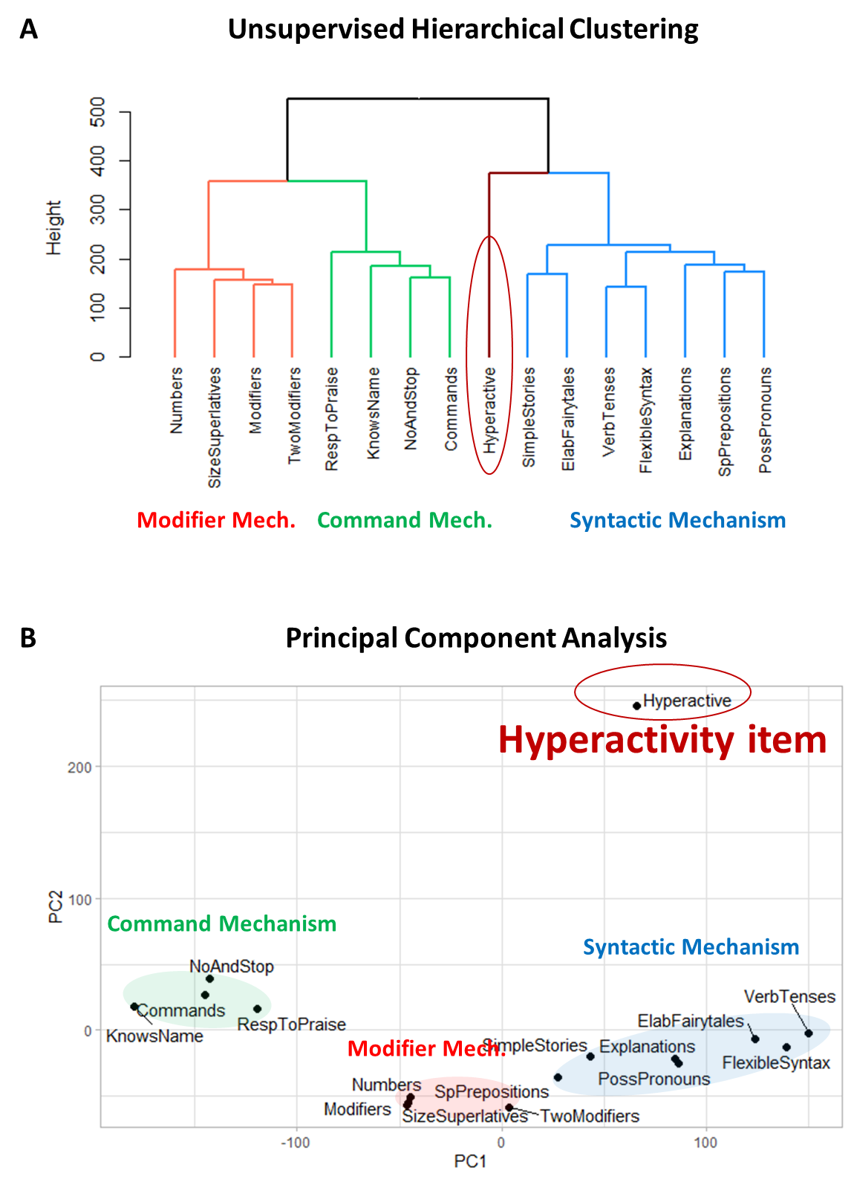
Supplementary Figure 1. Clustering analysis of 15 language comprehension items with the Hyperactivity item. (A) The dendrogram representing the unsupervised hierarchical clustering of language comprehension abilities. (B) Principal component analysis. Principal component 1 accounts for 36.8% of the variance in the data. Principal component 2 accounts for 16.7% of the variance in the data.
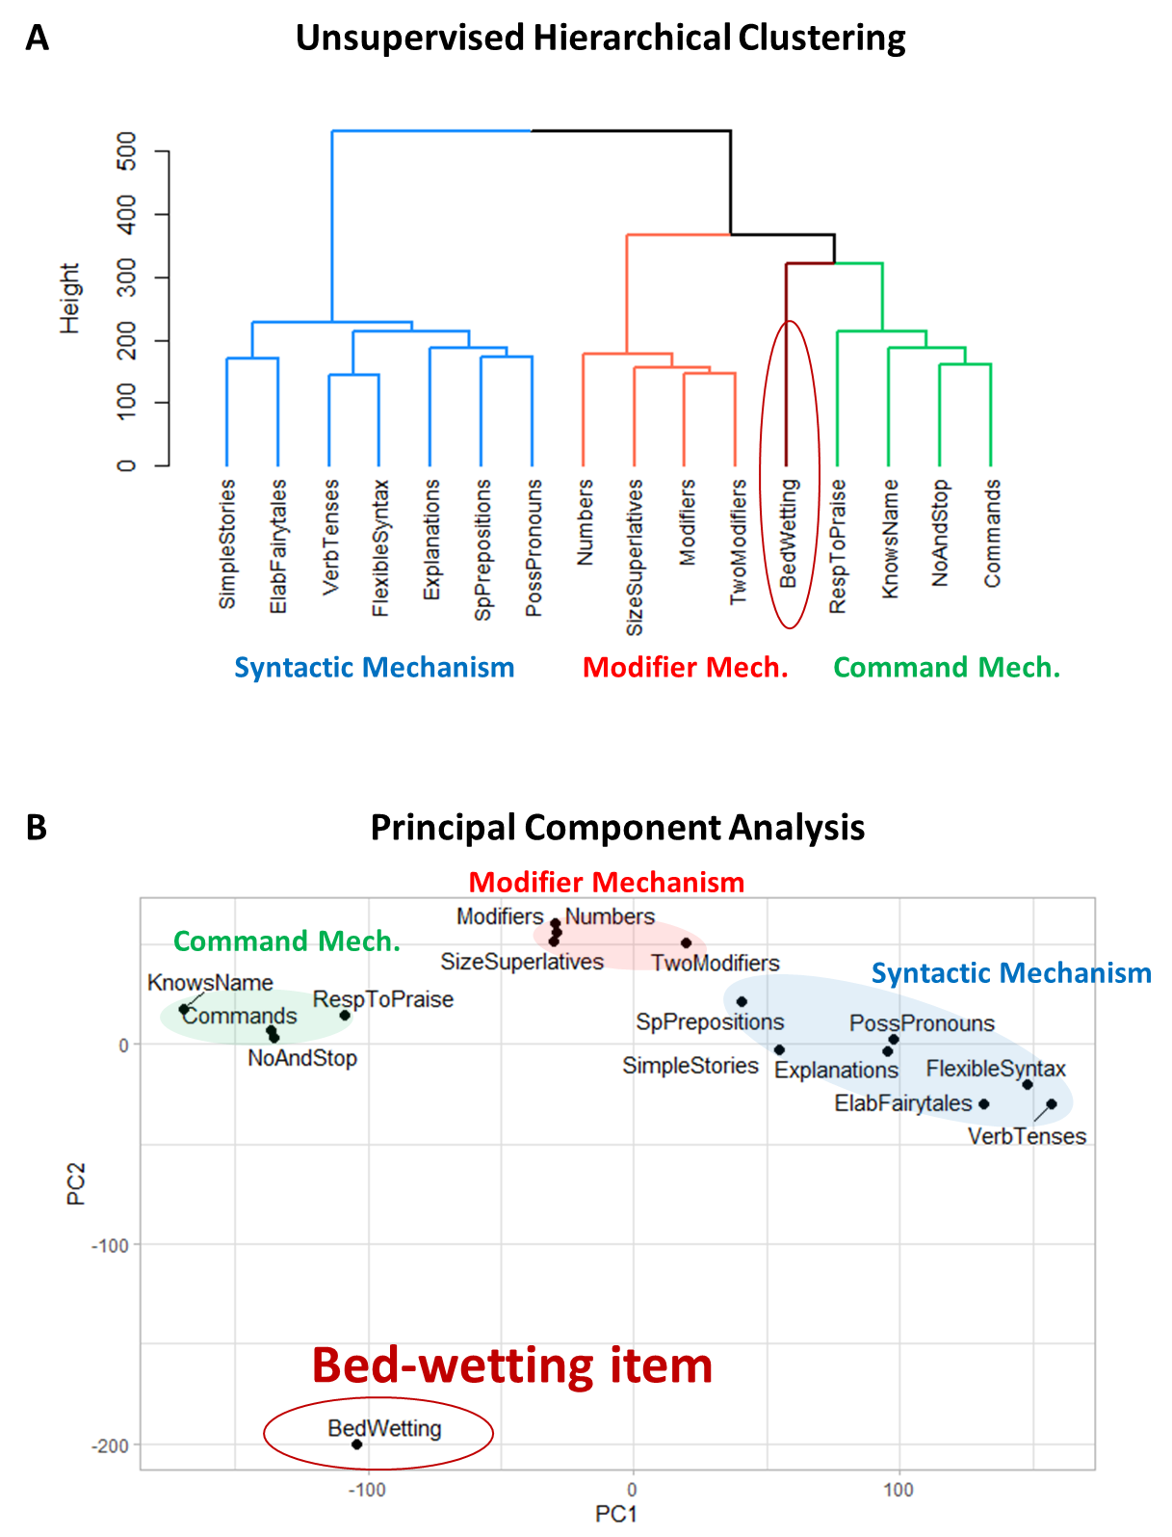
Supplementary Figure 2. Clustering analysis of 15 language comprehension items with the Bedwetting item. (A) The dendrogram representing the hierarchical clustering of language comprehension abilities. (B) Principal component analysis. Principal component 1 accounts for 39.2% of the variance in the data. Principal component 2 accounts for 12.1% of the variance in the data.

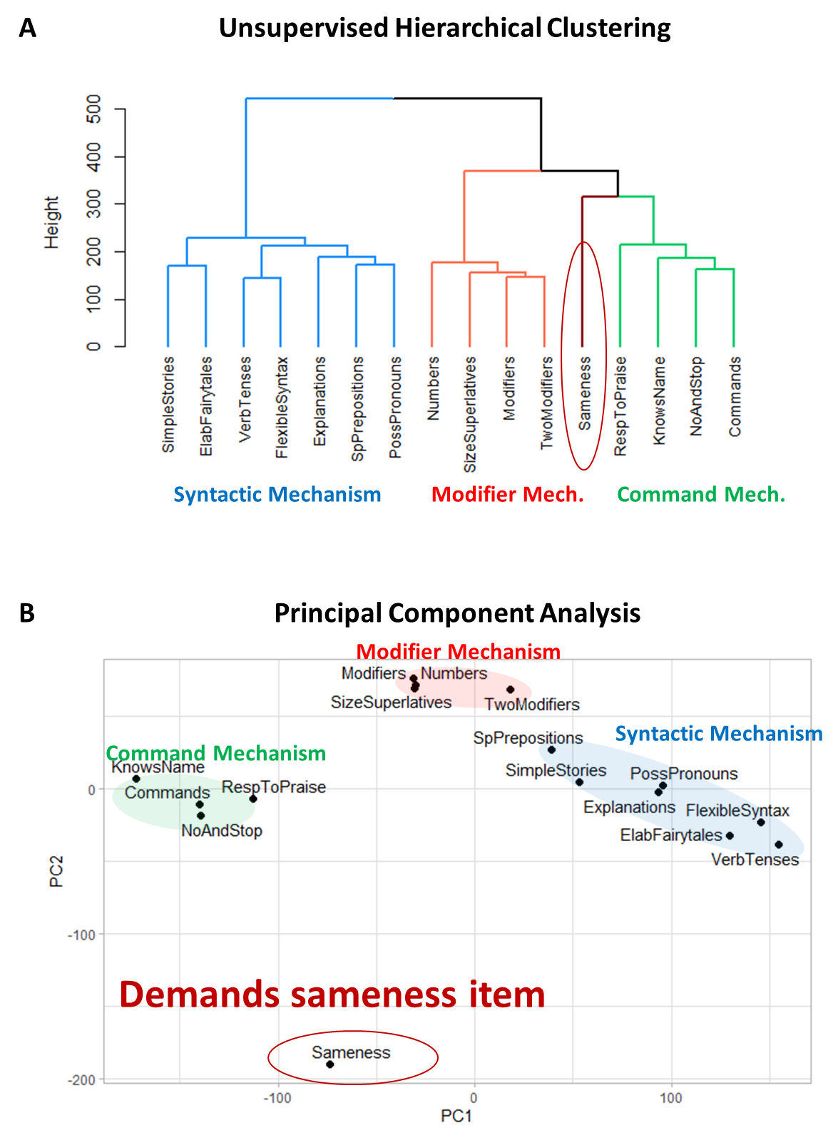
Supplementary Figure 3. Clustering analysis of 15 language comprehension items with “Demands sameness.” (A) The dendrogram representing the hierarchical clustering of language comprehension abilities. (B) Principal component analysis. Principal component 1 accounts for 42% of the variance in the data. Principal component 2 accounts for 13.7% of the variance in the data.

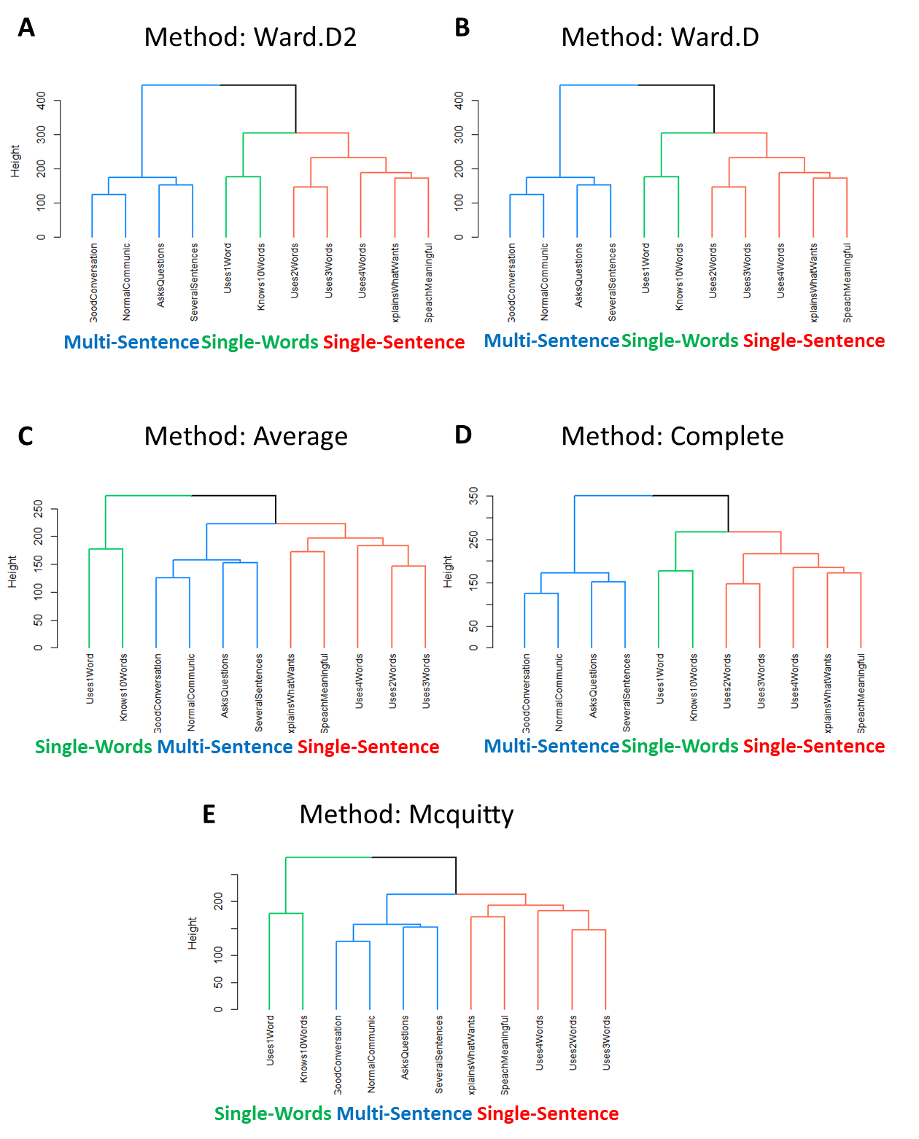
Supplementary Figure 4. The three-cluster solution of the 11 expressive language abilities was stable across different evaluation methods. A: Ward.D2. B: Ward.D. C: Average. D: Complete. F: Mcquitty.

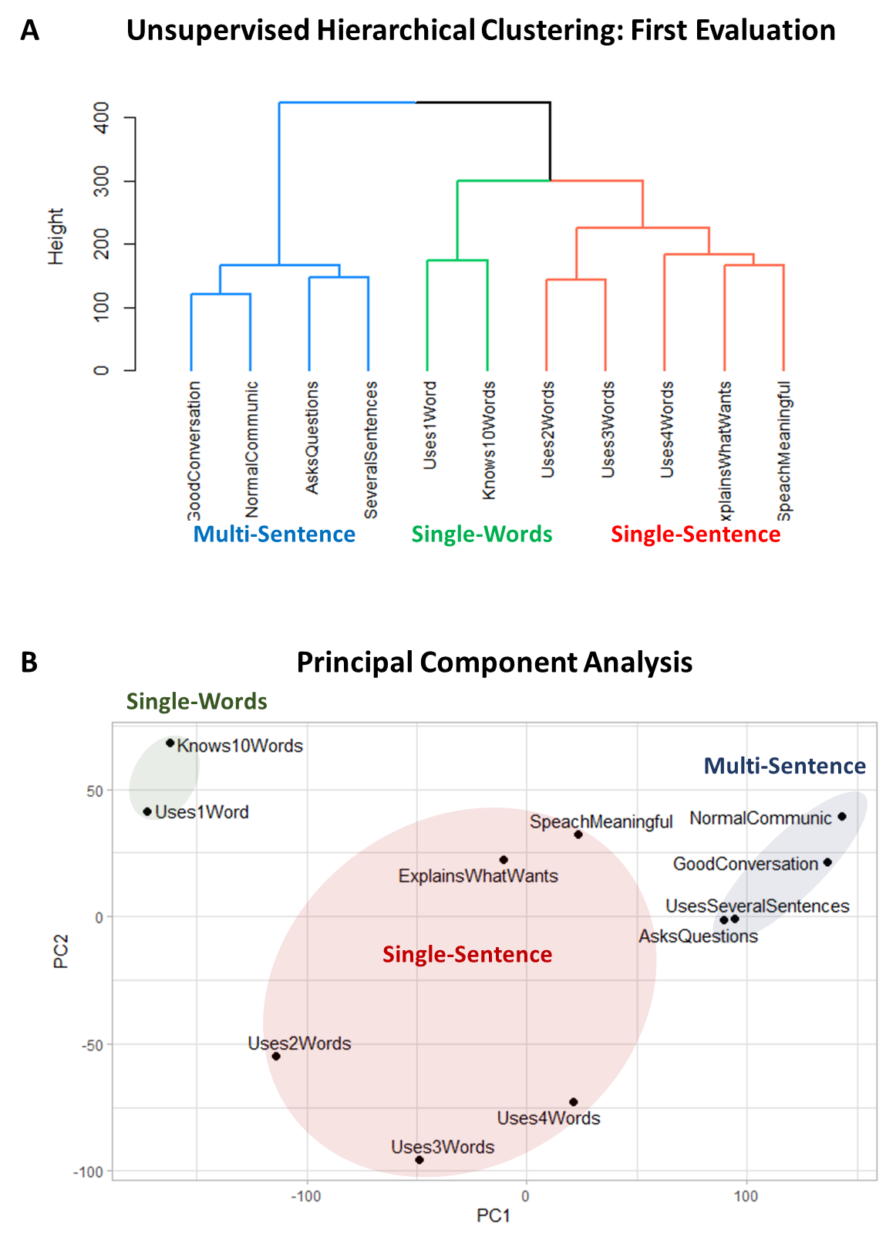
Supplementary Figure 5. Clustering analysis of 11 expressive language items (first evaluation). (A) The dendrogram representing the hierarchical clustering of expressive language abilities. (B) Principal component analysis of the 11 expressive language abilities. Principal component 1 accounts for 51.9% of the variance in the data. Principal component 2 accounts for 11.0% of the variance in the data.

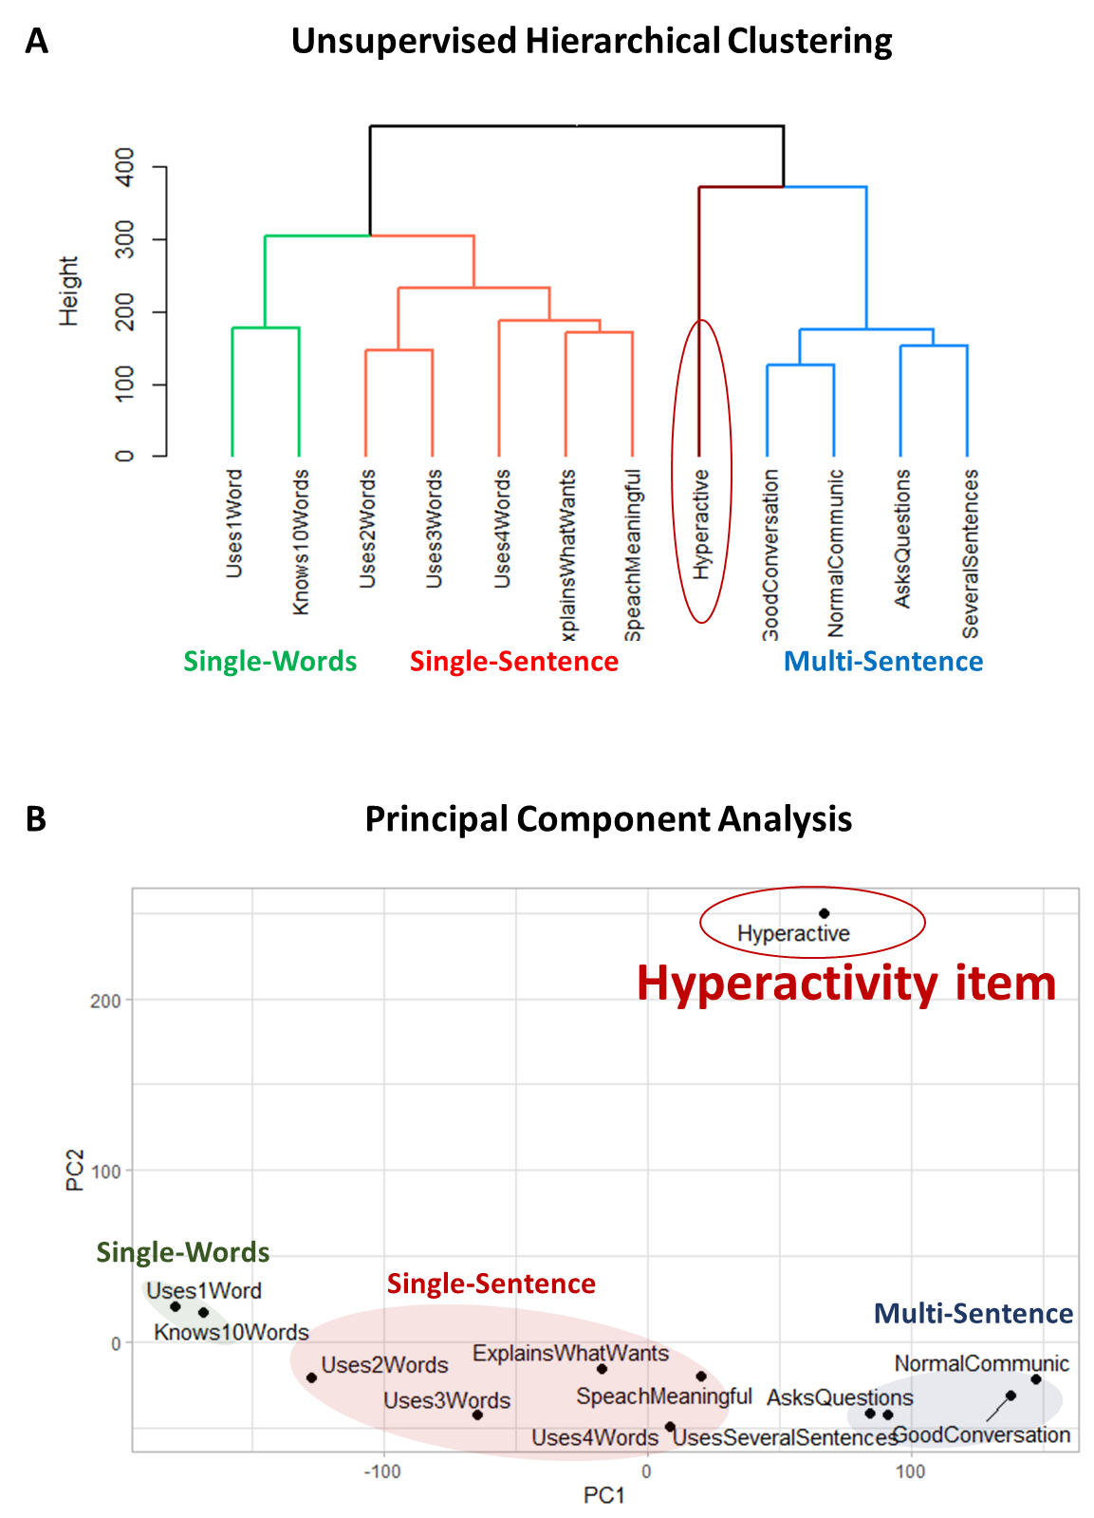
Supplementary Figure 6. The clustering solution of the 11 expressive language abilities along with the “hyperactivity” item. (A) The dendrogram representing the hierarchical clustering. (B) Principal component analysis. Principal component 1 accounts for 51.9% of the variance in the data. Principal component 2 accounts for 11% of the variance in the data. The hyperactivity item clusters into its own group at a significant distance from the three language clusters, confirming that hyperactivity item is not related to expressive language abilities.
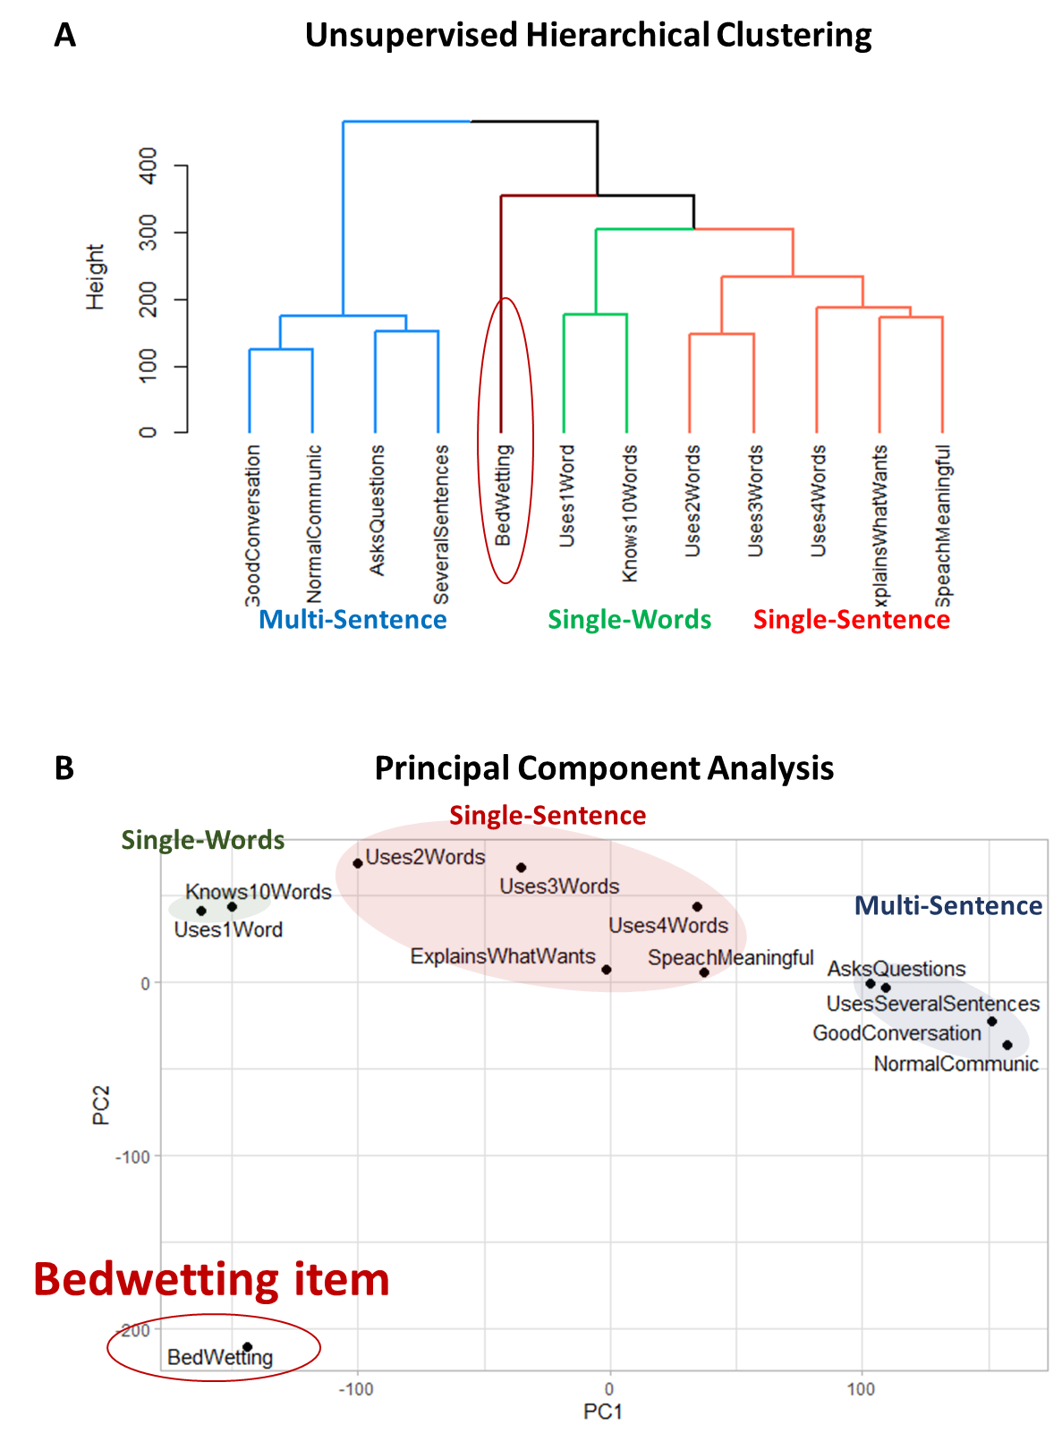
Supplementary Figure 7. The clustering solution of the 11 expressive language abilities along with the “Bedwetting” item. (A) The dendrogram representing the hierarchical clustering. (B) Principal component analysis. Principal component 1 accounts for 45.5% of the variance in the data. Principal component 2 accounts for 17.8% of the variance in the data.
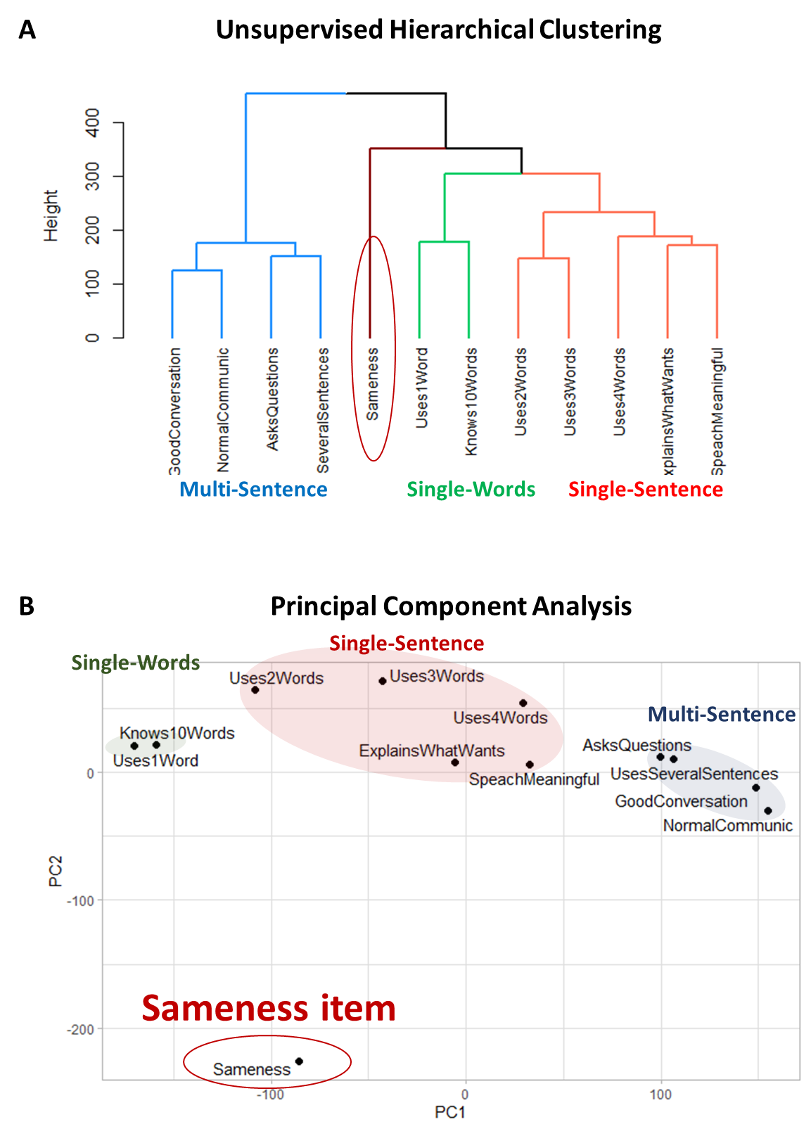
Supplementary Figure 8. The clustering solution of the 11 expressive language abilities along with the “Demands sameness” item. (A) The dendrogram representing the hierarchical clustering. (B) Principal component analysis. Principal component 1 accounts for 43.5% of the variance in the data. Principal component 2 accounts for 19.7% of the variance in the data.

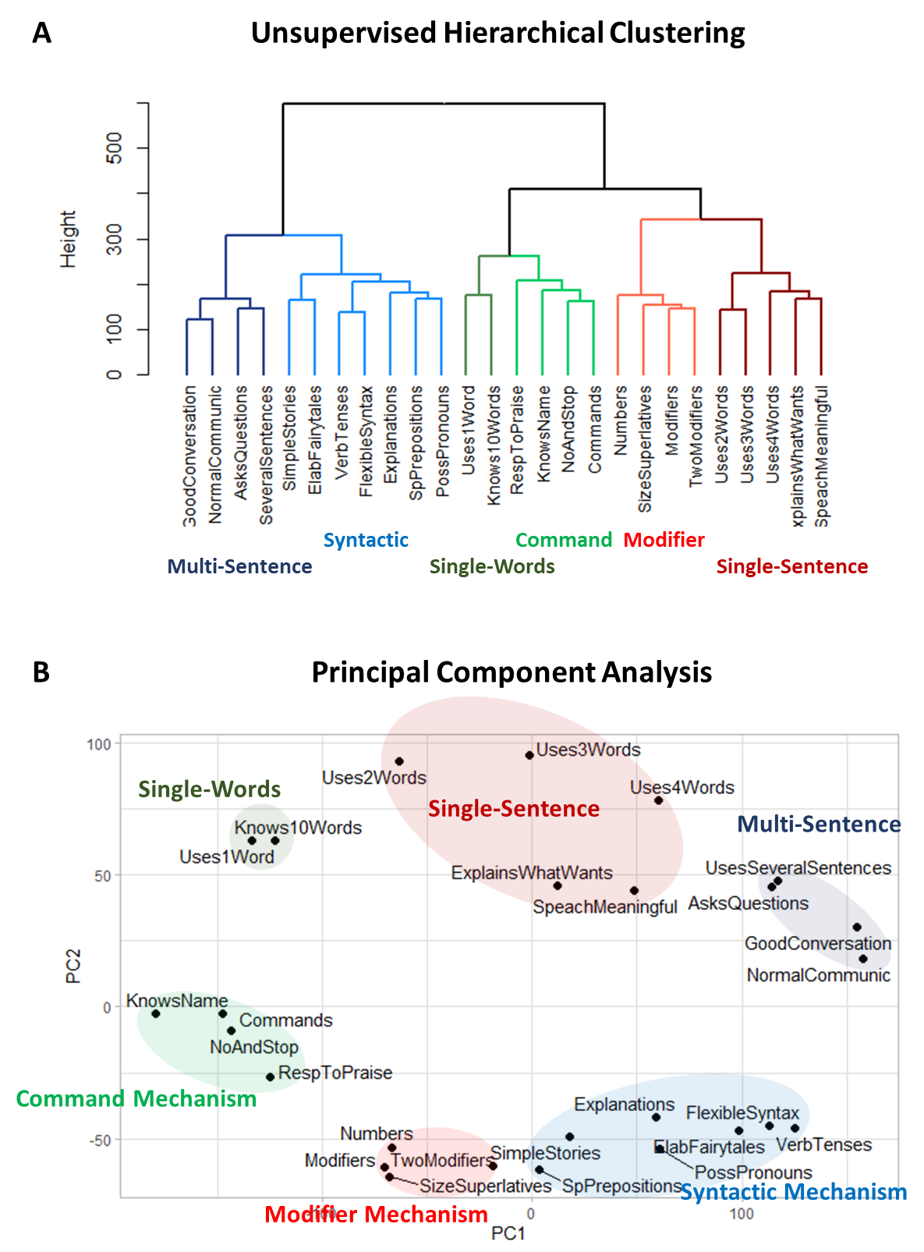
Supplementary Figure 9. Clustering analysis of 15 receptive language and 11 expressive language items (first evaluation). (A) The dendrogram representing the hierarchical clustering of expressive and receptive language abilities. (B) Principal component analysis all expressive and receptive language abilities. Principal component 1 accounts for 38.4% of the variance in the data. Principal component 2 accounts for 10.5% of the variance in the data.

