Supplementary Materials for
Magnon Gap Formation of Antiferromagnetic Topological Weyl semimetal in La_{0.1}Eu_{0.9}BiTe₃
Kwan-Young Lee¹, Kornelius Nielsch², Nicolas Perez^{2,}*, Jinwoong Hwang³, Ramatul Hidayati^{1,4}, Byeongki Cho⁴, Jong-Soo Rhyee^{1,}*

¹ Department of Applied Physics and G-LAMP NEXUS Institute, Kyung Hee University, Yongin 17104, Republic of Korea
² Leibniz Institute for Solid State and Materials Research IFW Dresden, 01069 Dresden, Germany.
³ Department of Physics and Institute of Quantum Convergence Technology, Kangwon National University, Chuncheon, Republic of Korea.
⁴School of Materials Science and Engineering, Gwangju Institute of Science and Technology, Gwangju 61005, Republic of Korea

∗Corresponding authors email addresses: n.perez.rodriguez@ifw-dresden.de (N.P.), jsrhyee@khu.ac.kr (J.-S.R.)

Materials and Methods
La_{0.1}Eu_{0.9}BiTe₃ single crystal preparation and characterization
La_{0.1}Eu_{0.9}BiTe₃ single crystal was prepared by a BiTe₁₂ flux method as following stochiometric elements using powders of La (99.9 %), granules of Eu (99.9 %), powders of Bi (99.99 %) and Te (99.99 %). Mixed elements (10 g of total mass) were placed into vacuum-sealed quartz ampoules in molar ratios of 0.1:0.9:2.5:13 under Ar atmosphere in glovebox to prevent oxidation of rare earth elements. Ampoules were sealed under the vacuum (<10⁻⁵ torr), and then heated to 700$℃$ by the rate of 50$℃$/h and held on for 30 h. Cooling the furnace to 470$℃$ by the ramp rate of 1$℃$/h, and then annealed for 200 h. After annealing, ampoules were immediately decanted with centrifuging to remove the flux. Layered single crystals with the average dimension of 5mm $×$ 5mm $×$ 1mm were then exfoliated to measure transport behaviors and magnetic properties.
The X-ray diffraction (XRD) patterns of multiple crystals (S1, S2, S3) were obtained using Cu κα radiation (D8 advance, Bruker, Germany). The microstructure and atomic concentrations were obtained by high-resolution scanning electron microscopy with energy-dispersive X-ray spectroscopy (HR FE SEM/EDX, LEO SUPRA 55, Carl Zeiss, Germany). High-resolution Transmission electron microscopy (TEM) and those selected area diffraction (SAED) pattern were obtained under a point resolution of 10nm (JEM 3010, JEOL, Japan).
The electrical properties, magnetic properties, and specific heat were measured by using a Physical Property Measurement System (PPMS Dynacool 14 T, Quantum Design, USA). The electrical resistivity was measured with four-probe method of the electrical transport option (ETO) by the PPMS Dynacool system under magnetic fields up to 14 T. The Magnetization was measured by vibrating sample magnetometer (VSM) of the PPMS Dynacool system. The specific heat was measured by the heat capacity option of the PPMS Dynacool system.

Angle-resolved photoemission spectroscopy (ARPES)
Electronic band structure of pure EuBiTe₃ and La_{0.1}Eu_{0.9}BiTe₃ are obtained by Angle-resolved photoemission spectroscopy (ARPES). ARPES measurements were taken at Beamlines 10.0.1, Advanced Light Source, Lawrence Berkeley national laboratory, California, USA, using Scienta R4000 analyzer. The base pressure was better than 4 × 10-11 Torr. The photon energy was set at 55 eV with energy and angular resolution of 15 – 25 meV and 0.1°, respectively. To achieve high-quality ARPES data of La doped EuBiTe3 single crystals, the samples were cleaved at 77 K.

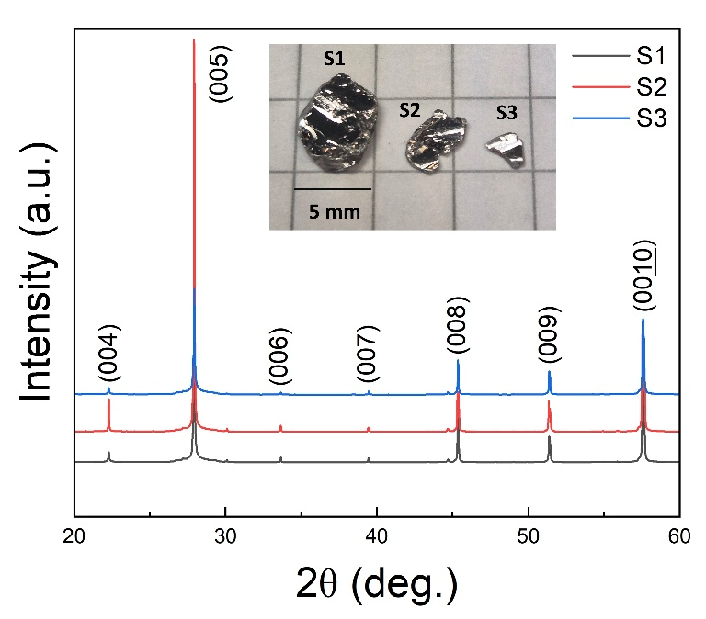
Figure S1. X-ray diffraction patterns of single crystal La0.1Eu0.9BiTe3. Inset of the figure shows typical crystals S1(black line), S2(red line) and S3(blue line).
Fig. S1 presents the single crystal X-ray diffraction patterns of the La_{x}Eu_{1-x}BiTe₃ (x = 0.1) compounds. Inset of the fig. 1 shows real appearance of single crystal what we measured on XRD. Crystals shown well aligned patterns along (00l) direction. The crystal structure is an orthorhombic structure (Pmmn, 59). The lattice parameters of pristine EuBiTe₃ is a = 4.5179 Å, b = 4.6141 Å, and c = 16.063 Å and the lattice volume is V = 334.86 Å³. La element 10 % substituted in Eu lattice site for EuBiTe₃ compound formed equivalent crystal structure comparing to pristine crystal. Lattice parameters slightly decreased comparing to pristine EuBiTe₃ due to its smaller atomic radius of La than Eu. The lattice parameters are a = 4.386(4) Å, b = 4.368 (4) Å, c = 16.05(5) Å, and its lattice volume is 307.638 $Å^{3}$, where the lattice volume is slightly decreased comparing to previous report of pristine EuBiTe₃ due to La substitution on Eu site¹.

Figure S2. Scanning electron microscopy images (a) of La doped EuBiTe3 compound. Elemental dispersive mapping of La, Eu, Bi, Te, respectively (b - e).
The compounds are comprised of 1.94 % of La, 16.61 % of Eu, 20.09 % of Bi, 61.36 % of Te, respectively. Atomic ratio of the result calculated by averaging 10 different surface points of EDX measurement, which is well aligns with original ratio of La_{0.1}Eu_{0.9}BiTe₃ compounds.

Atomic Ratio  (%) | Elements
Atomic Ratio  (%) | La | Eu | Bi | Te
Nominal Composition | 2 | 18 | 20 | 60
Measured Composition | 1.94 | 16.61 | 20.09 | 61.36
Table S1. Atomic ratio of La_{0.1}Eu_{0.9}BiTe₃ compounds.

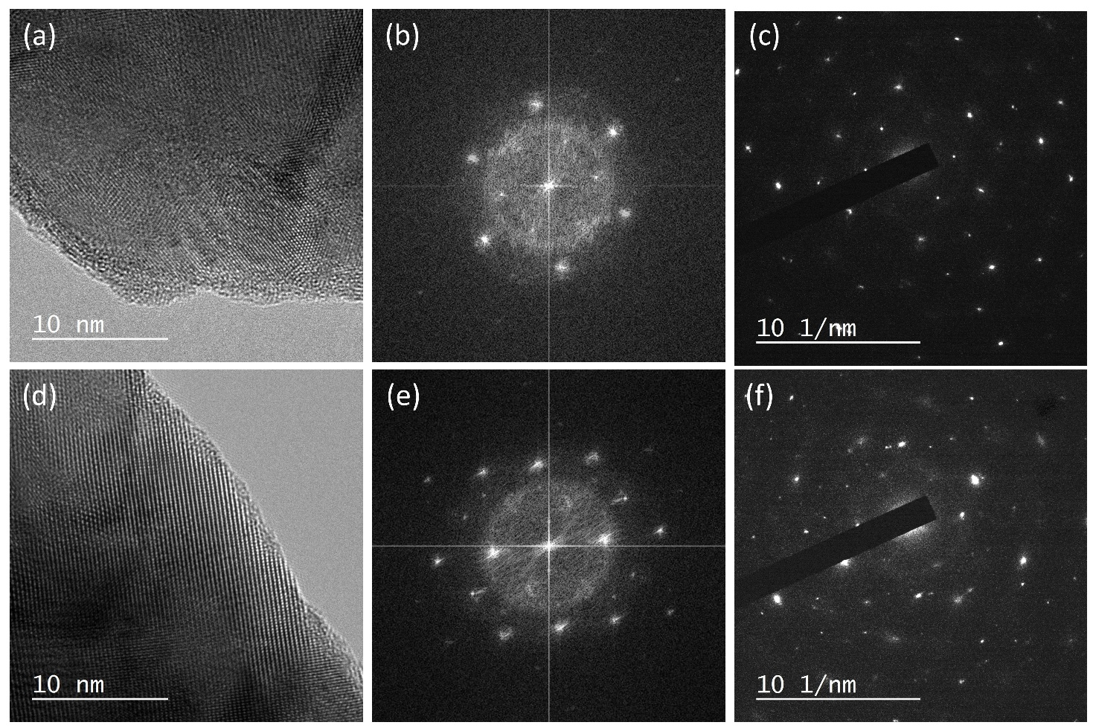
Figure S3. High resolution transmission electron microscope (HR-TEM) images, fast Fourier transform (FT) and selected area electron diffraction (SAED) pattern of pure EuBiTe₃ (a-c) and La_{0.1}Eu_{0.9}BiTe₃ (d-f), respectively.
We measured high-resolution transmission electron microscope (HR-TEM) images of pristine EuBiTe3 and La_{0.1}Eu_{0.9}BiTe₃, as shown in Fig. S3(a) and (d). It shows homogeneous phase of both crystals without any defects such as nanoclusters or misalignments in the matrix. Fast Fourier transform (FFTs) images of pristine EuBiTe3 and La_{0.1}Eu_{0.9}BiTe₃ are calculated as shown in Fig. (c) and (e) in digital micrograph, and selective area electron diffraction (SAED) patterns of pristine EuBiTe3 and La_{0.1}Eu_{0.9}BiTe₃ are represented as shown in Fig. (c) and (f), respectively.

Figure S4. Isothermal heat capacity for the temperature range of 1.8 – 2.9 K (a), 7.5 – 19.6 K (b).
Isothermal heat capacity under external magnetic field from 0 – 3 T exhibits different tendency based on its Neel temperature (T_{N} = 7 K). Above the Neel temperature, isothermal heat capacity from 7.5 – 19.6 K (b) decreases as the field increases, comparing to the temperature range of 1.8 – 2.9 K (a) which shows proportional behavior of heat capacity with following magnetic field^{2–4}.

References
1. Shon, W., Rhyee, J. S., Jin, Y. & Kim, S. J. Magnetic polaron and unconventional magnetotransport properties of the single-crystalline compound EuBiTe3. Phys. Rev. B 100, 24433 (2019).
2. Polash, M. M. H., Rasoulianboroujeni, M. & Vashaee, D. Magnon and spin transition contribution in heat capacity of ferromagnetic Cr-doped MnTe: Experimental evidence for a paramagnetic spin-caloritronic effect. Appl. Phys. Lett. 117, (2020).
3. McClarty, P. A. Topological Magnons: A Review. Annu. Rev. Condens. Matter Phys. 13, 171–190 (2022).
4. Kim, J. H., Rhyee, J. S. & Kwon, Y. S. Magnon gap formation and charge density wave effect on thermoelectric properties in the SmNiC2 compound. Phys. Rev. B - Condens. Matter Mater. Phys. 86, 2–7 (2012).

